

Rangpur Poverty Reduction Strategy
Ward Prioritization

Rangpur City Corporation
Rangpur

September 2021

Supported by:
Livelihoods Improvement of Urban Poor Communities Project (LIUPCP)
National Urban Poverty Reduction Programme (NUPRP)
Local Government Division



Table of Contents

Contents Page #

Table of Contents i
Executive Summary 1
1 Introduction 3
2 Poverty Indicators 3
3 Priority Poverty Indicators 4
4 Assigning weights and generate ward level index maps and data 5
5 Aggregate Poverty Index maps and data 7
6 Aggregate Infrastructure Index maps and data 10
7 Aggregate Livelihoods Index maps and data 13
8 Aggregate Land Tenure and Housing Index maps and data 16
9 Summary Tables for Priority Wards for Infrastructure and Livelihoods interventions 20
10 Frequency Distribution Tables by Wards and Indicators (Unweighted) 21

Executive Summary

Given how widespread urban poverty is Bangladesh, and how complex and difficult for local governments to tackle its causes and symptoms, a strategic approach to poverty reduction is useful. A Poverty Reduction Strategy can help to provide orientation as to where a local government can begin or to prioritize their activities and investments, how to coordinate actions between government agencies, and provide a clear message to citizens that the government has the intention and plan to improve the conditions of the poor. For this reason, NUPRP is supporting municipal governments to map, quantify, and organize information about urban poor settlements in maps and tables, so as to help identify areas of greatest need and how poverty is distributed across cities. This process involves citizens and elected officials to discuss and understand the context of urban poverty in each city, and to define priority issues that need urgent attention.

In this document, the ‘Rangpur Poverty Reduction Strategy – Ward Prioritization’ NUPRP has documented the results of this process. Through its local government and stakeholders met for a series of participatory workshops to develop this poverty reduction strategy. The process includes: (i) a participatory city-wide poverty mapping activity; (ii) the sharing and validation of poverty mapping data in each of the city’s wards and at the city-level; and (iii) the prioritization of city-level poverty indicators. A diverse range of stakeholders were involved throughout, they include the Mayor, counselors, key city officials, representatives of local community organizations (Community Development Committee-CDC, CDC Clusters, and CDC Town Federation), and local community surveyors. The result was the creation of a City Poverty Index that categorizes poverty levels of each of the wards into four categories, based on the relative poverty conditions. This Index visualizes varying concentrations of poverty across the city.

The categorization of the Poverty Index is based on four levels of priority, and is given by calculating the different aggregated scores of poor settlements in each ward, and also by combining important influences on poverty conditions, such as the number of urban poor, and the population density of poor settlements. The weighting of these scores is a result of a consultative process in which stakeholders prioritized the issues that define poverty in their city. For specific grants that target infrastructure and livelihoods, a separate unique index, that is narrowly focused, was created. For each of the indices, the wards of Rangpur city are categorized into (i) 1st priority - Q1 – critical development, (ii) 2nd priority - Q2 – very low development, (iii) 3rd priority – Q3 – low development, and (iv) 4th priority – Q4 – relatively high development. Based on this categorization, percentage of resources is then allocated in the following manner:

Priority Wards | Proposed resource allocation (%) | Agreed proportion of resource allocation (’20)
1st Priority Wards (Critical Development) | 50%
2nd Priority Wards (Very low development) | 30%
3rd Priority Wards (Low development) | 15%
4th Priority Wards (Relatively high development) | 5%
Total | 100% | 100%

The following table presents the priority ward lists derived through Rangpur’s Poverty Reduction Strategy process.

Priority wards of Rangpur City Corporation
Sector | Priority Wards for Rangpur
Sector | Critical Dev  (1st priority) | Very Low Dev  (2nd priority) | Low Dev  (3rd priority) | Relatively High Dev  (4th priority)
Infrastructure  (SIF) | 2, 3, 8, 10, 14, 30 | 1, 4, 7, 11, 13, 19, 20, 23, 29, 31, 32, 33 | 5, 9, 12, 15, 17, 18, 26, 27 | 6, 16, 21, 22, 24, 25, 28
Livelihood  (SEF) | 2, 8, 10, 14, 19, 26, 27, 30 | 1, 3, 5, 20, 22, 23, 28, 29, 33 | 4, 9, 12, 13, 16, 17, 31, 32 | 6, 7, 11, 15, 18, 21, 24, 25
Land Tenure and Housing | 16, 18, 20, 23, 25, 26, 27, 30 | 4, 5, 8, 10, 19, 21, 24, 28, 29 | 2, 7, 13, 14, 15, 22, 31, 33 | 1, 3, 6, 9, 11, 12, 17, 32
Overall Poverty | 2, 8, 18, 20, 23, 26, 27, 30 | 1, 3, 10, 14, 16, 19, 28, 29, 33 | 4, 12, 13, 15, 17, 22, 25, 31, 32 | 5, 6, 7, 9, 11, 21, 24

The decision about the proportion of resource allocation to the different categories of priority wards was decided upon with the Rangpur City Authority; the decision was based on understanding of the local urban context provided by the Poverty Index, as well as considering the community’s demand for the specific grants, and the readiness of community organizations to manage those grants. The comparative allocations are still aligned with the priority levels so wards with the highest priority are still set to receive the highest percentage of resources.

Introduction
National Urban Poverty Reduction Programme (NUPRP) aims at improving lives and livelihoods of 6 million Urban Poor in up to 35 cities of Bangladesh. NUPRP is working directly through the local government where concerned local government will be in the driving seat and NUPRP will be supporting them to reduce poverty in their cities. In order to cover this huge population with this significant number of cities, a well-defined poverty reduction strategy is necessary to be in place to better targeting the beneficiaries and identifying the poverty hotspots for quick and fruitful actions. As a part of poverty reduction strategy, NUPRP already completed few assessments in Rangpur city that includes (i) Participatory Mahalla and Resources Mapping, (ii) Participatory Urban Poor Settlement Mapping, (iii) Assessment of Coordination and Standing Committees, (iv) Community Development Committee (CDC) Assessment, (v) CDC Town Federation Assessment etc.

Both Mahalla and Urban Poor Settlement Mapping jointly termed as ‘Poverty Mapping’ were accomplished by following some rigorous participatory process where trained community people were mainly collecting the data from their respective wards and Ward Councillors were extensively involved with them throughout the process and at the end of the day when councillors were satisfied with the mapping and data collection, they endorsed the ward level maps and data which was later presented before the audiences at a city level result sharing workshop and mayor endorsed the city level poverty map and data.

Using the poverty mapping data, prioritization of wards of Rangpur has been done for rationale and data-informed decision making with a view to targeting the neediest first and investing more resources in the poverty hotspots for a greater impact. The prioritization of wards is a part of Rangpur Poverty Reduction Strategy.

Poverty Indicators
Data of 16 poverty indicators were collected for every single urban poor settlement during poverty mapping. The data presented here are the aggregate result of the settlements. Therefore, poverty mapping data do not represent the household level data. The indictors in a broad head covers infrastructure, livelihoods, and land tenure and housing. These 16 indicators are as follows:

Infrastructure Indicators  (7 indicators):  - Roads  - Drains  - Solid waste  - Sanitation  - Electricity  - Water supply  - Street lighting | Livelihood Indicators  (4 indicators):  - Employment  - Income  - Education (School attendance)  - Social problems | Land Tenure and Housing Indicators (5 indicators):  - Housing  - Land tenure  - Eviction  - Land Ownership  - Occupancy

Priority Poverty Indicators
Every city has its own sets of priorities to address city poverty. Some cities might have priority for solid waste while another city might have top priority for water supply based on the city’s development needs, conditions of poor settlements, geographic location of the city and so on. Therefore, it is necessary to know the priorities for the cities that will fit while developing the poverty reduction strategy for the city.

In Rangpur City Corporation, priority poverty indicators were determined in a session of the City Context Workshop. The main purpose of the city contexts workshop was to build consensus understanding about the city and fill in the gaps with supplementary knowledge about the city from the stakeholders. One of the sessions of this workshop was dedicated to defining the city-level priority poverty indicators.

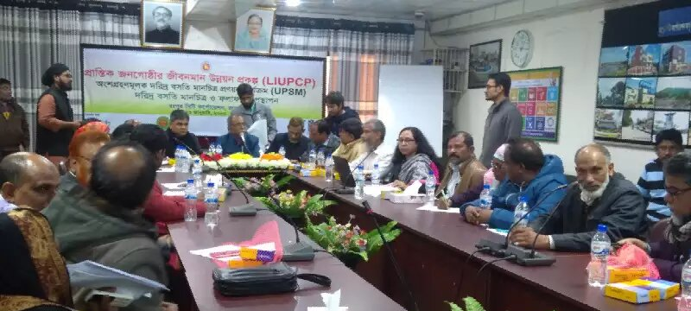
Photo: Result Sharing Workshop of Participatory Poverty Mapping in Rangpur

16 poverty indicators are divided into three categories of priority as mentioned below:

  - High priority indicators,
  - Medium priority indicators and
  - Low priority indicators.

Each of 16 poverty indicators are shown to the participants and based on the opinion of maximum people in that workshop, the indicator is put in any one of the three categories. Same process is followed for all 16 indicators and finally a list of indicators with three priority levels has been found.

City level Priority Poverty Indicators of Rangpur City Corporation
 | Top priority indicators | Medium priority indicators | Low priority indicators
Infrastructure Indicators | - Roads  - Drains  - Solid waste | - Street lighting  - Sanitation | - Electricity  - Water supply
Livelihood Indicators | - Education  - Income | - Employment | - Social problems
Land Tenure and Housing Indicators | - Land tenure  - Housing | - Land tenure  - Occupancy  - Eviction  - Land Ownership

Assigning weights and generate ward level index maps and data

Assigning weights
According to the poverty mapping scores, the settlements with the lowest scores are the poorest settlements meaning that high priority shall be given to the settlements with low scores. Therefore, when assigning the weight to the indicators, top priority indicators are assigned with lower weight and low priority indicators are assigned with higher weight. Following table presents the weight that is used for different indicators based on the priority level.

Priority | Assigned Weight
Top Priority | 0.24
Medium Priority | 0.31
Low Priority | 0.45
Total | 1.00

Creating index data sets
In order to create the index, 16 indicators are divided into three major categories if indices as mentioned below:

- Infrastructure Index
- Livelihood Index
- Land Tenure and Housing Index

For each of the indices, population and population density are also considered and they are also scored on a scale of 1 to 4 and these two indicators are weighted with low priority indicators. Following table shows the indicators for respective indices.

Indicators for Weighted Indices
Infrastructure Index | Livelihood Index | Land Tenure and Housing Index | Aggregate Poverty Index
- Roads  - Drains  - Solid waste  - Sanitation  - Electricity  - Water supply  - Street lighting  - Population  - Density | - Employment  - Income  - Education  - Social problems  - Population  - Density | - Housing  - Land tenure  - Eviction  - Land Ownership  - Occupancy  - Population  - Density | - 16 indicators  - Population  - Density

Generating ward level aggregate datasets
After assigning weight to each indicator of a single settlement, the weighted score is found for that specific settlement. Then, to generate the ward level aggregate data, the average weighted value of all the settlements under a ward is calculated. This operation has been run for all 16 indicators as well as population and density data to get the weighted value of them.

Calculating the aggregate index
The ward level aggregate weighted data of the indicators then summed up to get specific index value. For example, to get the infrastructure index of a ward, values of 7 infrastructure indictors (roads, drains, solid waste, sanitation, electricity, water supply, and street lighting) and values of population and density parameters are summed up. Same process is applied for livelihood index, land tenure and housing index as well.

Formula used for Calculating Index

Aggregate Poverty Index = sum of weighted score of 16 indicators + weighted score of population + weighted score of pop. Density

Aggregate Infrastructure Index = sum of weighted score of 7infrastructure indicators (Roads, Drains, Solid waste, Sanitation, Electricity, Water supply, and Street light) + weighted score of population + weighted score of pop. density

Aggregate Livelihood Index = sum of weighted score of 4 indicators (Employment, Income, Education, and Social problems) + weighted score of population + weighted score of pop. Density

Aggregate Land Tenure and Housing Index = sum of weighted score of 4 indicators (Employment, Income, Education, and Social problems) + weighted score of population + weighted score of pop. Density

Aggregate Poverty Index maps and data
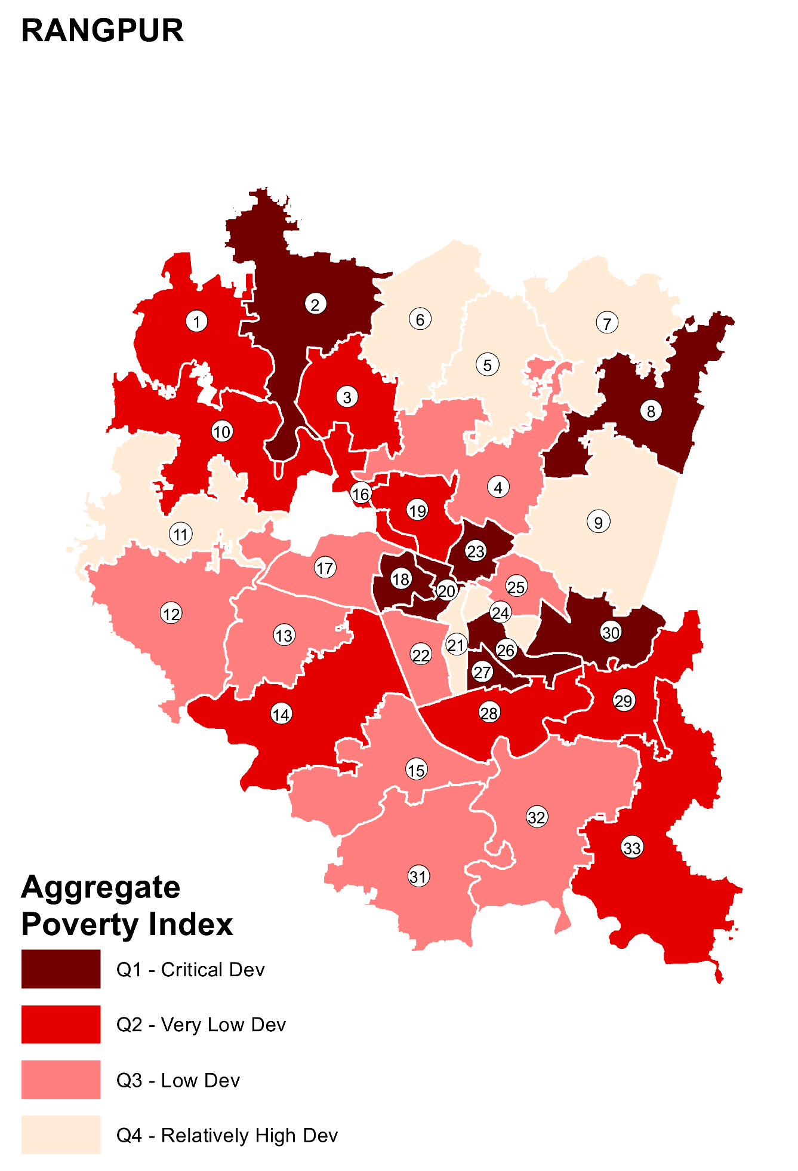

Table 01: Distribution of settlements by Ward and Weighted Poverty Index, Rangpur
Ward | Agg. Pov. Index and Quartile |  | Q1 - Critical Dev |  |  |  | Q2 - Very Low Dev |  |  |  | Q3 - Low Dev |  |  |  | Q4 - Relatively High Dev |  |  |  | Total
Ward | pov_indx_w | pov_Q_w | # Settl | # HHs | % HHs | # Popn | # Settl | # HHs | % HHs | # Popn | # Settl | # HHs | % HHs | # Popn | # Settl | # HHs | % HHs | # Popn | # Settl | # HHs | % HHs | # Popn
1 | 52 | Q2 - Very Low Dev | 15 | 610 | 3% | 2977 | 11 | 516 | 2% | 2398 | 16 | 414 | 2% | 1962 | 7 | 126 | 1% | 524 | 49 | 1666 | 2% | 7861
2 | 46 | Q1 - Critical Dev | 7 | 1191 | 5% | 5164 | 13 | 1382 | 6% | 6018 | 6 | 255 | 1% | 1091 | 0 | 0 | 0% | 0 | 26 | 2828 | 4% | 12273
3 | 53 | Q2 - Very Low Dev | 5 | 166 | 1% | 717 | 20 | 1289 | 6% | 5552 | 16 | 1028 | 6% | 3812 | 3 | 58 | 1% | 235 | 44 | 2541 | 3% | 10316
4 | 59 | Q3 - Low Dev | 4 | 190 | 1% | 930 | 7 | 405 | 2% | 1990 | 14 | 653 | 4% | 3001 | 9 | 553 | 6% | 2313 | 34 | 1801 | 2% | 8234
5 | 61 | Q4 - Relatively High Dev | 3 | 227 | 1% | 1198 | 2 | 177 | 1% | 843 | 12 | 1609 | 9% | 6288 | 11 | 892 | 9% | 3236 | 28 | 2905 | 4% | 11565
6 | 67 | Q4 - Relatively High Dev | 0 | 0 | 0% | 0 | 0 | 0 | 0% | 0 | 10 | 447 | 2% | 2059 | 34 | 445 | 4% | 2025 | 44 | 892 | 1% | 4084
7 | 62 | Q4 - Relatively High Dev | 4 | 239 | 1% | 796 | 2 | 61 | 0% | 218 | 4 | 160 | 1% | 565 | 16 | 515 | 5% | 1816 | 26 | 975 | 1% | 3395
8 | 40 | Q1 - Critical Dev | 28 | 2448 | 10% | 11383 | 9 | 394 | 2% | 1729 | 0 | 0 | 0% | 0 | 0 | 0 | 0% | 0 | 37 | 2842 | 4% | 13112
9 | 62 | Q4 - Relatively High Dev | 1 | 25 | 0% | 110 | 10 | 560 | 3% | 2278 | 13 | 455 | 3% | 1874 | 22 | 677 | 7% | 2920 | 46 | 1717 | 2% | 7182
10 | 50 | Q2 - Very Low Dev | 1 | 150 | 1% | 937 | 23 | 2293 | 11% | 9264 | 4 | 631 | 4% | 3142 | 0 | 0 | 0% | 0 | 28 | 3074 | 4% | 13343
11 | 63 | Q4 - Relatively High Dev | 1 | 100 | 0% | 450 | 2 | 85 | 0% | 380 | 16 | 727 | 4% | 3250 | 16 | 400 | 4% | 1790 | 35 | 1312 | 2% | 5870
12 | 59 | Q3 - Low Dev | 2 | 101 | 0% | 475 | 18 | 1125 | 5% | 4917 | 31 | 1460 | 8% | 5592 | 17 | 222 | 2% | 1015 | 68 | 2908 | 4% | 11999
13 | 60 | Q3 - Low Dev | 1 | 10 | 0% | 45 | 12 | 1335 | 6% | 5960 | 14 | 1030 | 6% | 4120 | 13 | 346 | 3% | 1545 | 40 | 2721 | 4% | 11670
14 | 52 | Q2 - Very Low Dev | 3 | 205 | 1% | 975 | 27 | 1910 | 9% | 7145 | 13 | 452 | 3% | 1902 | 0 | 0 | 0% | 0 | 43 | 2567 | 4% | 10022
15 | 58 | Q3 - Low Dev | 5 | 329 | 1% | 1322 | 6 | 572 | 3% | 2745 | 7 | 418 | 2% | 1479 | 12 | 233 | 2% | 1111 | 30 | 1552 | 2% | 6657
16 | 48 | Q2 - Very Low Dev | 12 | 444 | 2% | 2162 | 6 | 117 | 1% | 550 | 4 | 67 | 0% | 296 | 4 | 64 | 1% | 288 | 26 | 692 | 1% | 3296
17 | 59 | Q3 - Low Dev | 9 | 1254 | 5% | 4187 | 3 | 85 | 0% | 325 | 21 | 1336 | 7% | 4423 | 20 | 540 | 5% | 2301 | 53 | 3215 | 4% | 11236
18 | 34 | Q1 - Critical Dev | 27 | 394 | 2% | 1646 | 3 | 22 | 0% | 74 | 1 | 16 | 0% | 64 | 1 | 10 | 0% | 35 | 32 | 442 | 1% | 1819
19 | 47 | Q2 - Very Low Dev | 11 | 1208 | 5% | 4417 | 14 | 1211 | 6% | 4864 | 4 | 255 | 1% | 1020 | 3 | 97 | 1% | 398 | 32 | 2771 | 4% | 10699
20 | 31 | Q1 - Critical Dev | 31 | 436 | 2% | 2086 | 5 | 43 | 0% | 210 | 3 | 29 | 0% | 133 | 1 | 5 | 0% | 25 | 40 | 513 | 1% | 2454
21 | 68 | Q4 - Relatively High Dev | 2 | 96 | 0% | 566 | 4 | 44 | 0% | 209 | 4 | 56 | 0% | 232 | 15 | 177 | 2% | 923 | 25 | 373 | 1% | 1930
22 | 57 | Q3 - Low Dev | 2 | 28 | 0% | 114 | 4 | 105 | 0% | 487 | 9 | 491 | 3% | 2130 | 4 | 197 | 2% | 850 | 19 | 821 | 1% | 3581
23 | 46 | Q1 - Critical Dev | 11 | 1120 | 5% | 5224 | 0 | 0 | 0% | 0 | 6 | 276 | 2% | 1395 | 7 | 295 | 3% | 1304 | 24 | 1691 | 2% | 7923
24 | 70 | Q4 - Relatively High Dev | 4 | 353 | 1% | 1682 | 3 | 27 | 0% | 111 | 3 | 26 | 0% | 138 | 23 | 682 | 7% | 2836 | 33 | 1088 | 1% | 4767
25 | 59 | Q3 - Low Dev | 4 | 104 | 0% | 569 | 4 | 55 | 0% | 213 | 3 | 1120 | 6% | 3837 | 10 | 262 | 3% | 959 | 21 | 1541 | 2% | 5578
26 | 37 | Q1 - Critical Dev | 36 | 5356 | 22% | 21628 | 6 | 315 | 1% | 1405 | 2 | 64 | 0% | 235 | 8 | 274 | 3% | 1203 | 52 | 6009 | 8% | 24471
27 | 38 | Q1 - Critical Dev | 33 | 721 | 3% | 3276 | 10 | 196 | 1% | 899 | 8 | 176 | 1% | 789 | 2 | 37 | 0% | 125 | 53 | 1130 | 2% | 5089
28 | 54 | Q2 - Very Low Dev | 8 | 973 | 4% | 4285 | 22 | 903 | 4% | 4415 | 11 | 418 | 2% | 1973 | 13 | 408 | 4% | 2033 | 54 | 2702 | 4% | 12706
29 | 53 | Q2 - Very Low Dev | 21 | 2744 | 11% | 10921 | 19 | 2506 | 12% | 10988 | 10 | 370 | 2% | 1775 | 20 | 1150 | 12% | 5516 | 70 | 6770 | 9% | 29200
30 | 46 | Q1 - Critical Dev | 16 | 1657 | 7% | 6502 | 5 | 518 | 2% | 2047 | 0 | 0 | 0% | 0 | 9 | 324 | 3% | 1112 | 30 | 2499 | 3% | 9661
31 | 60 | Q3 - Low Dev | 1 | 10 | 0% | 40 | 10 | 700 | 3% | 3025 | 28 | 2285 | 13% | 9550 | 11 | 437 | 4% | 1814 | 50 | 3432 | 5% | 14429
32 | 56 | Q3 - Low Dev | 0 | 0 | 0% | 0 | 17 | 688 | 3% | 3081 | 20 | 453 | 3% | 1934 | 3 | 42 | 0% | 170 | 40 | 1183 | 2% | 5185
33 | 55 | Q2 - Very Low Dev | 9 | 1055 | 4% | 4801 | 21 | 1815 | 8% | 8298 | 18 | 833 | 5% | 3812 | 12 | 455 | 5% | 2010 | 60 | 4158 | 6% | 18921

Aggregate Infrastructure Index maps and data
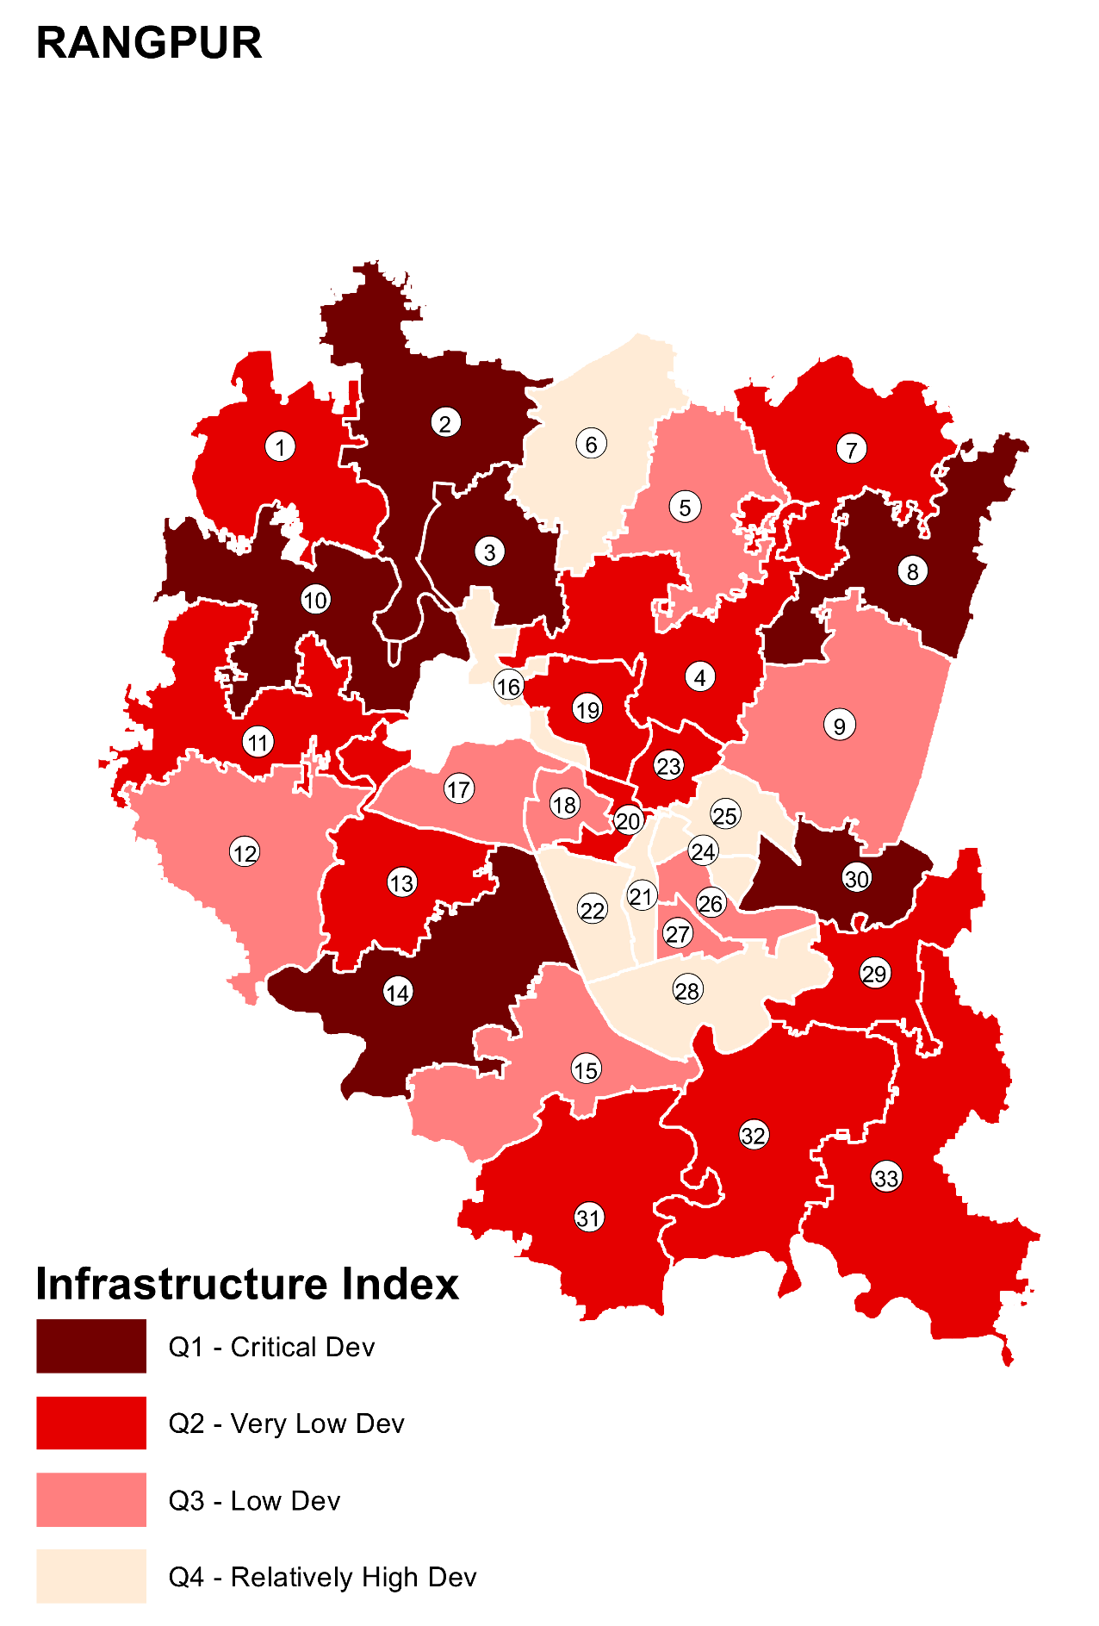

Table 02: Distribution of settlements by Ward and Weighted Infrastructure Index, Rangpur
Ward | Agg. Infra. Index and Quartile |  | Q1 - Critical Dev |  |  |  | Q2 - Very Low Dev |  |  |  | Q3 - Low Dev |  |  |  | Q4 - Relatively High Dev |  |  |  | Total
Ward | Infra_indx_w | Infra_Q_w | # Settl | # HHs | % HHs | # Popn | # Settl | # HHs | % HHs | # Popn | # Settl | # HHs | % HHs | # Popn | # Settl | # HHs | % HHs | # Popn | # Settl | # HHs | % HHs | # Popn
1 | 38 | Q2 - Very Low Dev | 16 | 889 | 3% | 4297 | 15 | 492 | 3% | 2303 | 13 | 204 | 2% | 883 | 5 | 81 | 1% | 378 | 49 | 1666 | 2% | 7861
2 | 29 | Q1 - Critical Dev | 15 | 2496 | 7% | 10980 | 7 | 261 | 1% | 993 | 3 | 65 | 1% | 281 | 1 | 6 | 0% | 19 | 26 | 2828 | 4% | 12273
3 | 37 | Q1 - Critical Dev | 19 | 1761 | 5% | 7174 | 11 | 442 | 2% | 1909 | 9 | 268 | 2% | 985 | 5 | 70 | 1% | 248 | 44 | 2541 | 3% | 10316
4 | 38 | Q2 - Very Low Dev | 12 | 698 | 2% | 3340 | 10 | 480 | 2% | 2111 | 6 | 233 | 2% | 1056 | 6 | 390 | 5% | 1727 | 34 | 1801 | 2% | 8234
5 | 43 | Q3 - Low Dev | 5 | 588 | 2% | 2685 | 4 | 341 | 2% | 1596 | 15 | 1814 | 14% | 6662 | 4 | 162 | 2% | 622 | 28 | 2905 | 4% | 11565
6 | 48 | Q4 - Relatively High Dev | 4 | 323 | 1% | 1475 | 9 | 208 | 1% | 970 | 15 | 189 | 1% | 881 | 16 | 172 | 2% | 758 | 44 | 892 | 1% | 4084
7 | 42 | Q2 - Very Low Dev | 7 | 437 | 1% | 1471 | 7 | 218 | 1% | 822 | 6 | 136 | 1% | 447 | 6 | 184 | 3% | 655 | 26 | 975 | 1% | 3395
8 | 27 | Q1 - Critical Dev | 30 | 2585 | 8% | 11992 | 5 | 187 | 1% | 871 | 2 | 70 | 1% | 249 | 0 | 0 | 0% | 0 | 37 | 2842 | 4% | 13112
9 | 43 | Q3 - Low Dev | 7 | 450 | 1% | 1834 | 12 | 590 | 3% | 2524 | 16 | 447 | 3% | 1814 | 11 | 230 | 3% | 1010 | 46 | 1717 | 2% | 7182
10 | 33 | Q1 - Critical Dev | 17 | 1813 | 5% | 8156 | 6 | 1080 | 5% | 4240 | 1 | 50 | 0% | 250 | 4 | 131 | 2% | 697 | 28 | 3074 | 4% | 13343
11 | 41 | Q2 - Very Low Dev | 7 | 530 | 2% | 2365 | 9 | 385 | 2% | 1770 | 15 | 340 | 3% | 1482 | 4 | 57 | 1% | 253 | 35 | 1312 | 2% | 5870
12 | 47 | Q3 - Low Dev | 3 | 166 | 0% | 717 | 19 | 1801 | 9% | 7428 | 21 | 573 | 4% | 2347 | 25 | 368 | 5% | 1507 | 68 | 2908 | 4% | 11999
13 | 39 | Q2 - Very Low Dev | 9 | 925 | 3% | 4120 | 20 | 1533 | 8% | 6385 | 7 | 178 | 1% | 780 | 4 | 85 | 1% | 385 | 40 | 2721 | 4% | 11670
14 | 34 | Q1 - Critical Dev | 25 | 1967 | 6% | 7505 | 11 | 455 | 2% | 1905 | 7 | 145 | 1% | 612 | 0 | 0 | 0% | 0 | 43 | 2567 | 4% | 10022
15 | 44 | Q3 - Low Dev | 8 | 1117 | 3% | 4530 | 3 | 50 | 0% | 247 | 10 | 222 | 2% | 1128 | 9 | 163 | 2% | 752 | 30 | 1552 | 2% | 6657
16 | 59 | Q4 - Relatively High Dev | 1 | 67 | 0% | 335 | 2 | 73 | 0% | 337 | 4 | 126 | 1% | 558 | 19 | 426 | 6% | 2066 | 26 | 692 | 1% | 3296
17 | 47 | Q3 - Low Dev | 5 | 277 | 1% | 1049 | 11 | 1026 | 5% | 3368 | 16 | 1360 | 10% | 4473 | 21 | 552 | 8% | 2346 | 53 | 3215 | 4% | 11236
18 | 46 | Q3 - Low Dev | 5 | 34 | 0% | 134 | 9 | 176 | 1% | 741 | 9 | 116 | 1% | 494 | 9 | 116 | 2% | 450 | 32 | 442 | 1% | 1819
19 | 39 | Q2 - Very Low Dev | 9 | 1240 | 4% | 4949 | 12 | 982 | 5% | 3553 | 5 | 370 | 3% | 1471 | 6 | 179 | 2% | 726 | 32 | 2771 | 4% | 10699
20 | 42 | Q2 - Very Low Dev | 11 | 216 | 1% | 1053 | 12 | 137 | 1% | 672 | 6 | 56 | 0% | 244 | 11 | 104 | 1% | 485 | 40 | 513 | 1% | 2454
21 | 60 | Q4 - Relatively High Dev | 1 | 80 | 0% | 470 | 3 | 57 | 0% | 342 | 4 | 34 | 0% | 168 | 17 | 202 | 3% | 950 | 25 | 373 | 1% | 1930
22 | 50 | Q4 - Relatively High Dev | 2 | 100 | 0% | 475 | 5 | 258 | 1% | 1082 | 4 | 210 | 2% | 962 | 8 | 253 | 4% | 1062 | 19 | 821 | 1% | 3581
23 | 42 | Q2 - Very Low Dev | 4 | 571 | 2% | 2644 | 9 | 658 | 3% | 3186 | 7 | 371 | 3% | 1775 | 4 | 91 | 1% | 318 | 24 | 1691 | 2% | 7923
24 | 71 | Q4 - Relatively High Dev | 2 | 325 | 1% | 1534 | 3 | 33 | 0% | 179 | 1 | 7 | 0% | 41 | 27 | 723 | 10% | 3013 | 33 | 1088 | 1% | 4767
25 | 52 | Q4 - Relatively High Dev | 1 | 60 | 0% | 305 | 3 | 98 | 0% | 428 | 8 | 1255 | 10% | 4349 | 9 | 128 | 2% | 496 | 21 | 1541 | 2% | 5578
26 | 44 | Q3 - Low Dev | 11 | 3282 | 10% | 12183 | 13 | 1536 | 8% | 7246 | 11 | 634 | 5% | 2535 | 17 | 557 | 8% | 2507 | 52 | 6009 | 8% | 24471
27 | 44 | Q3 - Low Dev | 8 | 255 | 1% | 1148 | 14 | 355 | 2% | 1639 | 17 | 330 | 3% | 1502 | 14 | 190 | 3% | 800 | 53 | 1130 | 2% | 5089
28 | 49 | Q4 - Relatively High Dev | 5 | 833 | 2% | 3481 | 10 | 568 | 3% | 2716 | 15 | 713 | 6% | 3644 | 24 | 588 | 8% | 2865 | 54 | 2702 | 4% | 12706
29 | 38 | Q2 - Very Low Dev | 28 | 4331 | 13% | 17149 | 15 | 1092 | 6% | 5491 | 14 | 848 | 7% | 4225 | 13 | 499 | 7% | 2335 | 70 | 6770 | 9% | 29200
30 | 36 | Q1 - Critical Dev | 15 | 1454 | 4% | 5824 | 5 | 655 | 3% | 2500 | 3 | 161 | 1% | 505 | 7 | 229 | 3% | 832 | 30 | 2499 | 3% | 9661
31 | 38 | Q2 - Very Low Dev | 12 | 1220 | 4% | 5340 | 22 | 1515 | 8% | 6285 | 13 | 625 | 5% | 2500 | 3 | 72 | 1% | 304 | 50 | 3432 | 5% | 14429
32 | 41 | Q2 - Very Low Dev | 8 | 405 | 1% | 1783 | 12 | 405 | 2% | 1768 | 14 | 299 | 2% | 1323 | 6 | 74 | 1% | 311 | 40 | 1183 | 2% | 5185
33 | 38 | Q2 - Very Low Dev | 17 | 1985 | 6% | 9001 | 21 | 1520 | 8% | 6973 | 17 | 513 | 4% | 2322 | 5 | 140 | 2% | 625 | 60 | 4158 | 6% | 18921

Aggregate Livelihoods Index maps and data
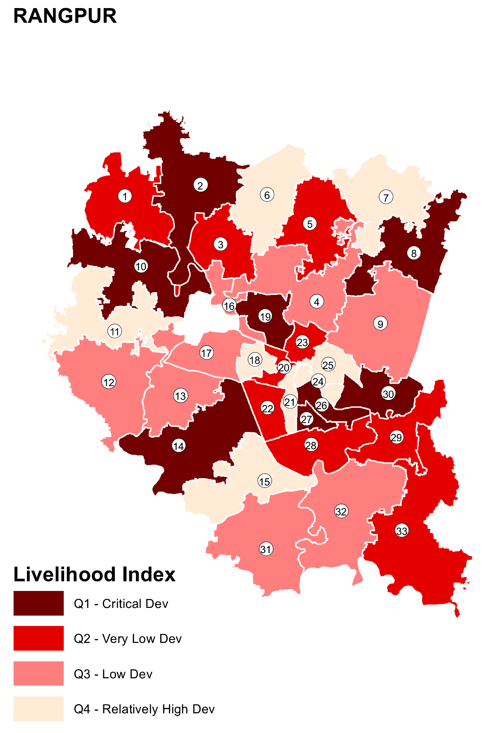

Table 03: Distribution of settlements by Ward and Weighted Livelihood Index, Rangpur
Ward | Agg. Liv. Index and Quartile |  | Q1 - Critical Dev |  |  |  | Q2 - Very Low Dev |  |  |  | Q3 - Low Dev |  |  |  | Q4 - Relatively High Dev |  |  |  | Total
Ward | Live_indx_w | Live_Q_w | # Settl | # HHs | % HHs | # Popn | # Settl | # HHs | % HHs | # Popn | # Settl | # HHs | % HHs | # Popn | # Settl | # HHs | % HHs | # Popn | # Settl | # HHs | % HHs | # Popn
1 | 54 | Q2 - Very Low Dev | 13 | 611 | 2% | 2955 | 10 | 411 | 2% | 1923 | 12 | 408 | 3% | 1911 | 14 | 236 | 4% | 1072 | 49 | 1666 | 2% | 7861
2 | 43 | Q1 - Critical Dev | 11 | 2120 | 6% | 9380 | 10 | 567 | 3% | 2258 | 4 | 116 | 1% | 510 | 1 | 25 | 0% | 125 | 26 | 2828 | 4% | 12273
3 | 50 | Q2 - Very Low Dev | 11 | 703 | 2% | 3140 | 17 | 1081 | 6% | 4446 | 11 | 647 | 5% | 2396 | 5 | 110 | 2% | 334 | 44 | 2541 | 3% | 10316
4 | 59 | Q3 - Low Dev | 5 | 330 | 1% | 1555 | 6 | 300 | 2% | 1510 | 12 | 607 | 5% | 2780 | 11 | 564 | 9% | 2389 | 34 | 1801 | 2% | 8234
5 | 48 | Q2 - Very Low Dev | 5 | 715 | 2% | 3086 | 16 | 1949 | 10% | 7471 | 6 | 224 | 2% | 896 | 1 | 17 | 0% | 112 | 28 | 2905 | 4% | 11565
6 | 74 | Q4 - Relatively High Dev | 0 | 0 | 0% | 0 | 2 | 198 | 1% | 901 | 8 | 254 | 2% | 1195 | 34 | 440 | 7% | 1988 | 44 | 892 | 1% | 4084
7 | 72 | Q4 - Relatively High Dev | 0 | 0 | 0% | 0 | 2 | 114 | 1% | 496 | 5 | 313 | 2% | 971 | 19 | 548 | 9% | 1928 | 26 | 975 | 1% | 3395
8 | 24 | Q1 - Critical Dev | 34 | 2704 | 8% | 12592 | 3 | 138 | 1% | 520 | 0 | 0 | 0% | 0 | 0 | 0 | 0% | 0 | 37 | 2842 | 4% | 13112
9 | 59 | Q3 - Low Dev | 4 | 370 | 1% | 1475 | 14 | 470 | 2% | 2002 | 15 | 595 | 5% | 2500 | 13 | 282 | 5% | 1205 | 46 | 1717 | 2% | 7182
10 | 41 | Q1 - Critical Dev | 13 | 1863 | 5% | 7854 | 12 | 1125 | 6% | 5052 | 3 | 86 | 1% | 437 | 0 | 0 | 0% | 0 | 28 | 3074 | 4% | 13343
11 | 70 | Q4 - Relatively High Dev | 1 | 100 | 0% | 450 | 0 | 0 | 0% | 0 | 14 | 749 | 6% | 3355 | 20 | 463 | 7% | 2065 | 35 | 1312 | 2% | 5870
12 | 55 | Q3 - Low Dev | 9 | 762 | 2% | 3335 | 22 | 1008 | 5% | 4725 | 24 | 1006 | 8% | 3329 | 13 | 132 | 2% | 610 | 68 | 2908 | 4% | 11999
13 | 59 | Q3 - Low Dev | 5 | 720 | 2% | 3240 | 9 | 855 | 4% | 3845 | 18 | 968 | 7% | 3775 | 8 | 178 | 3% | 810 | 40 | 2721 | 4% | 11670
14 | 44 | Q1 - Critical Dev | 19 | 1802 | 5% | 6680 | 15 | 525 | 3% | 2330 | 8 | 225 | 2% | 945 | 1 | 15 | 0% | 67 | 43 | 2567 | 4% | 10022
15 | 63 | Q4 - Relatively High Dev | 4 | 406 | 1% | 1605 | 4 | 163 | 1% | 732 | 9 | 760 | 6% | 3232 | 13 | 223 | 4% | 1088 | 30 | 1552 | 2% | 6657
16 | 61 | Q3 - Low Dev | 0 | 0 | 0% | 0 | 7 | 450 | 2% | 2174 | 12 | 183 | 1% | 857 | 7 | 59 | 1% | 265 | 26 | 692 | 1% | 3296
17 | 61 | Q3 - Low Dev | 6 | 1026 | 3% | 3540 | 15 | 1560 | 8% | 5364 | 10 | 280 | 2% | 1118 | 22 | 349 | 6% | 1214 | 53 | 3215 | 4% | 11236
18 | 63 | Q4 - Relatively High Dev | 3 | 61 | 0% | 245 | 8 | 124 | 1% | 556 | 8 | 89 | 1% | 361 | 13 | 168 | 3% | 657 | 32 | 442 | 1% | 1819
19 | 29 | Q1 - Critical Dev | 25 | 2581 | 7% | 9943 | 5 | 168 | 1% | 668 | 2 | 22 | 0% | 88 | 0 | 0 | 0% | 0 | 32 | 2771 | 4% | 10699
20 | 47 | Q2 - Very Low Dev | 6 | 189 | 1% | 946 | 23 | 229 | 1% | 1072 | 9 | 75 | 1% | 346 | 2 | 20 | 0% | 90 | 40 | 513 | 1% | 2454
21 | 82 | Q4 - Relatively High Dev | 0 | 0 | 0% | 0 | 1 | 19 | 0% | 96 | 2 | 96 | 1% | 566 | 22 | 258 | 4% | 1268 | 25 | 373 | 1% | 1930
22 | 46 | Q2 - Very Low Dev | 6 | 550 | 2% | 2380 | 11 | 251 | 1% | 1106 | 2 | 20 | 0% | 95 | 0 | 0 | 0% | 0 | 19 | 821 | 1% | 3581
23 | 48 | Q2 - Very Low Dev | 7 | 1023 | 3% | 4732 | 7 | 291 | 2% | 1472 | 10 | 377 | 3% | 1719 | 0 | 0 | 0% | 0 | 24 | 1691 | 2% | 7923
24 | 69 | Q4 - Relatively High Dev | 1 | 102 | 0% | 509 | 1 | 223 | 1% | 1025 | 8 | 537 | 4% | 2297 | 23 | 226 | 4% | 936 | 33 | 1088 | 1% | 4767
25 | 69 | Q4 - Relatively High Dev | 1 | 270 | 1% | 1080 | 3 | 930 | 5% | 3074 | 2 | 85 | 1% | 412 | 15 | 256 | 4% | 1012 | 21 | 1541 | 2% | 5578
26 | 37 | Q1 - Critical Dev | 31 | 5284 | 15% | 21289 | 12 | 432 | 2% | 1999 | 4 | 100 | 1% | 415 | 5 | 193 | 3% | 768 | 52 | 6009 | 8% | 24471
27 | 43 | Q1 - Critical Dev | 20 | 581 | 2% | 2640 | 27 | 474 | 2% | 2159 | 6 | 75 | 1% | 290 | 0 | 0 | 0% | 0 | 53 | 1130 | 2% | 5089
28 | 46 | Q2 - Very Low Dev | 19 | 1676 | 5% | 7744 | 13 | 505 | 3% | 2513 | 20 | 501 | 4% | 2357 | 2 | 20 | 0% | 92 | 54 | 2702 | 4% | 12706
29 | 51 | Q2 - Very Low Dev | 25 | 4183 | 12% | 16848 | 12 | 1077 | 6% | 5273 | 19 | 1122 | 9% | 5256 | 14 | 388 | 6% | 1823 | 70 | 6770 | 9% | 29200
30 | 43 | Q1 - Critical Dev | 15 | 1722 | 5% | 6721 | 5 | 450 | 2% | 1827 | 4 | 192 | 1% | 645 | 6 | 135 | 2% | 468 | 30 | 2499 | 3% | 9661
31 | 58 | Q3 - Low Dev | 1 | 40 | 0% | 170 | 17 | 1505 | 8% | 6345 | 21 | 1540 | 12% | 6460 | 11 | 347 | 6% | 1454 | 50 | 3432 | 5% | 14429
32 | 56 | Q3 - Low Dev | 5 | 312 | 1% | 1409 | 13 | 416 | 2% | 1838 | 14 | 314 | 2% | 1384 | 8 | 141 | 2% | 554 | 40 | 1183 | 2% | 5185
33 | 47 | Q2 - Very Low Dev | 22 | 2260 | 6% | 10334 | 16 | 1000 | 5% | 4580 | 13 | 508 | 4% | 2310 | 9 | 390 | 6% | 1697 | 60 | 4158 | 6% | 18921

Aggregate Land Tenure and Housing Index maps and data

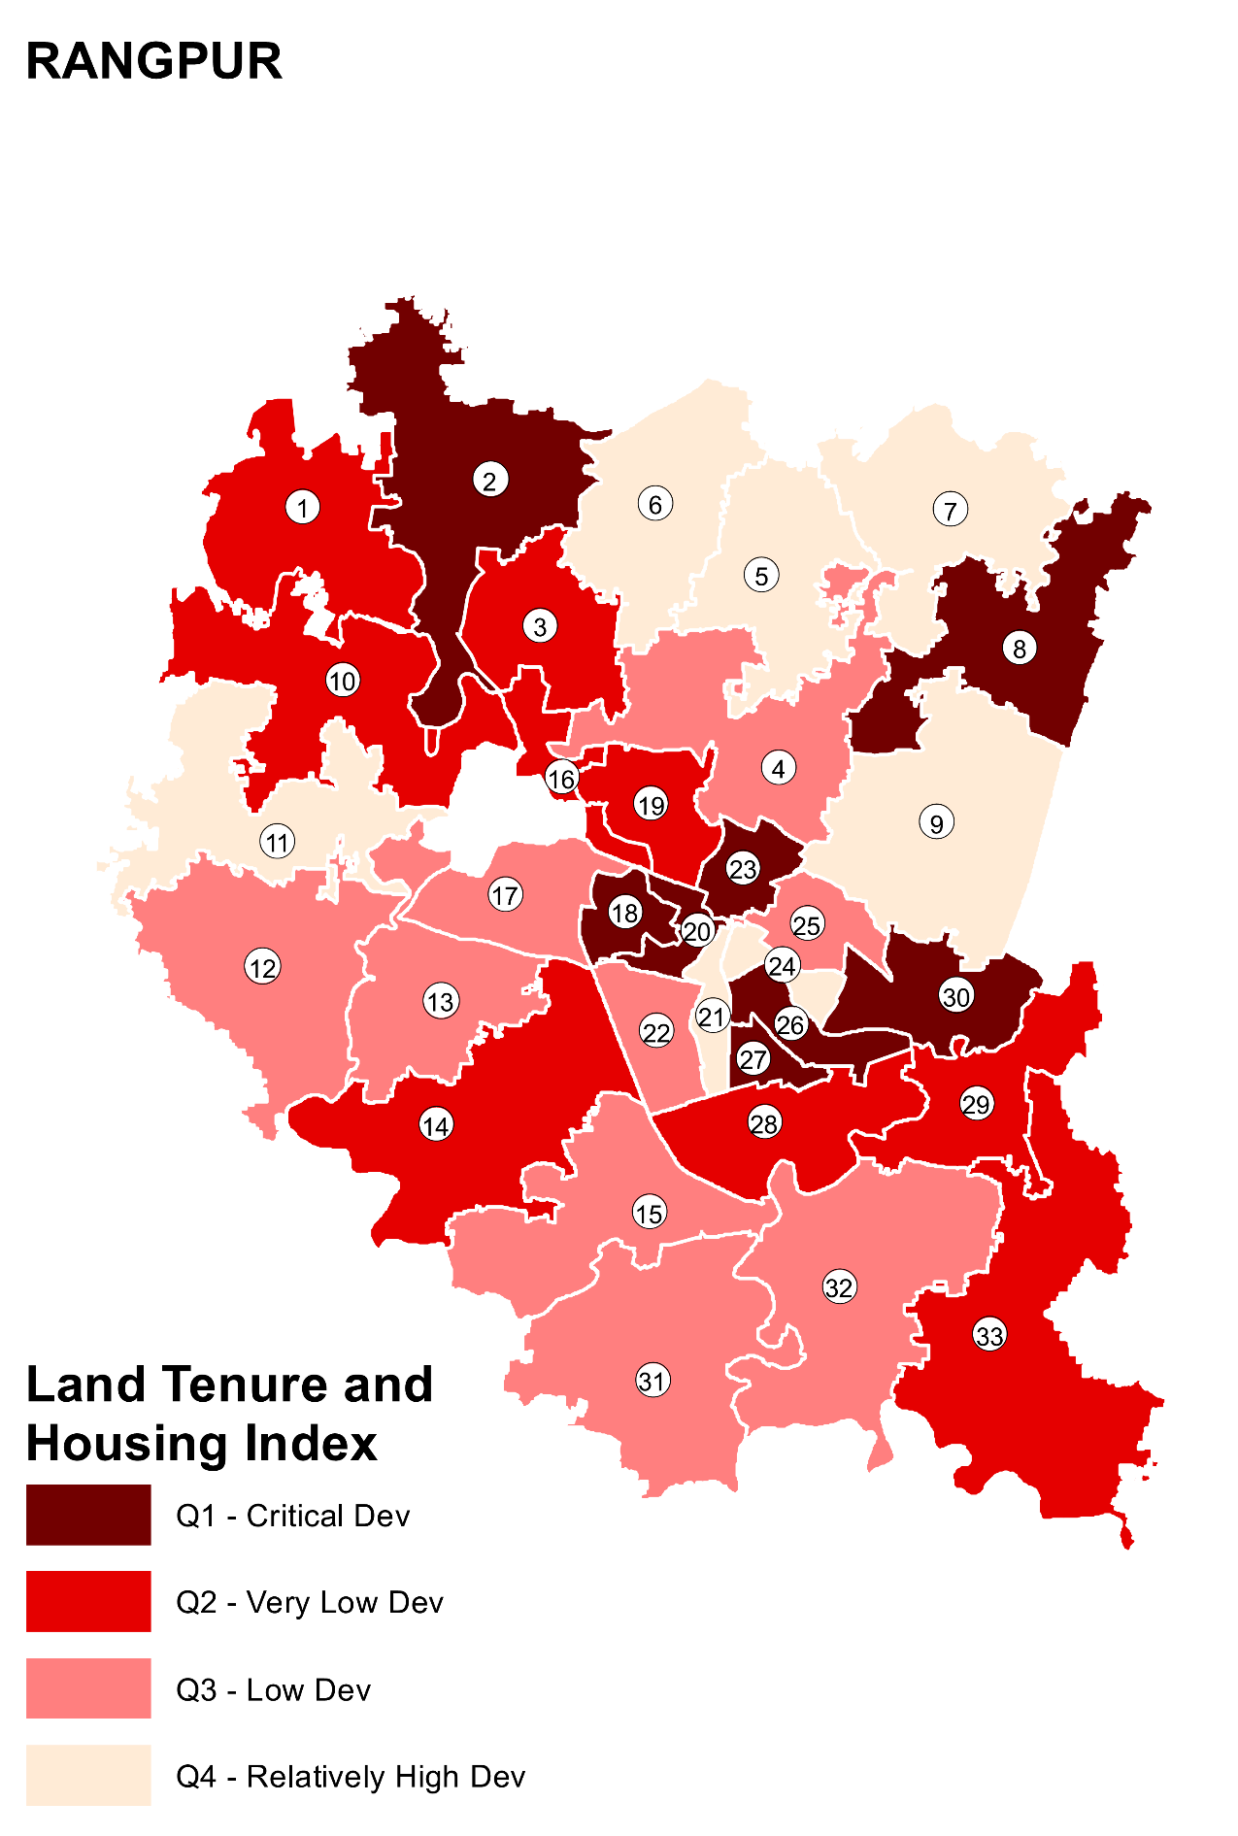

Table 04: Distribution of settlements by Ward and Weighted Land Tenure and Housing Index, Rangpur
Ward | Agg. Land-tenure and Housing Index and Quartile |  | Q1 - Critical Dev |  |  |  | Q2 - Very Low Dev |  |  |  | Q3 - Low Dev |  |  |  | Q4 - Relatively High Dev |  |  |  | Total
Ward | LH_indx_w | LH_Q_w | # Settl | # HHs | % HHs | # Popn | # Settl | # HHs | % HHs | # Popn | # Settl | # HHs | % HHs | # Popn | # Settl | # HHs | % HHs | # Popn | # Settl | # HHs | % HHs | # Popn
1 | 71 | Q4 - Relatively High Dev | 4 | 84 | 0% | 434 | 15 | 884 | 2% | 4219 | 11 | 339 | 3% | 1599 | 19 | 359 | 6% | 1609 | 49 | 1666 | 2% | 7861
2 | 66 | Q3 - Low Dev | 3 | 221 | 1% | 784 | 14 | 2301 | 6% | 10225 | 1 | 120 | 1% | 500 | 8 | 186 | 3% | 764 | 26 | 2828 | 4% | 12273
3 | 71 | Q4 - Relatively High Dev | 3 | 59 | 0% | 265 | 13 | 1521 | 4% | 6077 | 14 | 565 | 4% | 2439 | 14 | 396 | 7% | 1535 | 44 | 2541 | 3% | 10316
4 | 65 | Q2 - Very Low Dev | 2 | 70 | 0% | 330 | 17 | 1162 | 3% | 5425 | 11 | 466 | 4% | 2046 | 4 | 103 | 2% | 433 | 34 | 1801 | 2% | 8234
5 | 65 | Q2 - Very Low Dev | 2 | 140 | 1% | 700 | 15 | 2053 | 6% | 8289 | 9 | 645 | 5% | 2307 | 2 | 67 | 1% | 269 | 28 | 2905 | 4% | 11565
6 | 91 | Q4 - Relatively High Dev | 0 | 0 | 0% | 0 | 0 | 0 | 0% | 0 | 4 | 323 | 2% | 1475 | 40 | 569 | 10% | 2609 | 44 | 892 | 1% | 4084
7 | 67 | Q3 - Low Dev | 6 | 268 | 1% | 908 | 3 | 161 | 0% | 566 | 8 | 350 | 3% | 1267 | 9 | 196 | 3% | 654 | 26 | 975 | 1% | 3395
8 | 62 | Q2 - Very Low Dev | 5 | 335 | 2% | 1446 | 22 | 1815 | 5% | 8538 | 10 | 692 | 5% | 3128 | 0 | 0 | 0% | 0 | 37 | 2842 | 4% | 13112
9 | 76 | Q4 - Relatively High Dev | 1 | 25 | 0% | 110 | 8 | 630 | 2% | 2590 | 16 | 570 | 4% | 2472 | 21 | 492 | 8% | 2010 | 46 | 1717 | 2% | 7182
10 | 62 | Q2 - Very Low Dev | 1 | 50 | 0% | 250 | 23 | 2878 | 8% | 12483 | 4 | 146 | 1% | 610 | 0 | 0 | 0% | 0 | 28 | 3074 | 4% | 13343
11 | 71 | Q4 - Relatively High Dev | 0 | 0 | 0% | 0 | 14 | 860 | 2% | 3870 | 14 | 373 | 3% | 1662 | 7 | 79 | 1% | 338 | 35 | 1312 | 2% | 5870
12 | 80 | Q4 - Relatively High Dev | 1 | 76 | 0% | 365 | 12 | 1712 | 5% | 6890 | 14 | 493 | 4% | 2188 | 41 | 627 | 11% | 2556 | 68 | 2908 | 4% | 11999
13 | 67 | Q3 - Low Dev | 1 | 10 | 0% | 45 | 21 | 2195 | 6% | 9420 | 16 | 493 | 4% | 2095 | 2 | 23 | 0% | 110 | 40 | 2721 | 4% | 11670
14 | 68 | Q3 - Low Dev | 1 | 300 | 2% | 1000 | 21 | 1493 | 4% | 5850 | 17 | 704 | 5% | 2845 | 4 | 70 | 1% | 327 | 43 | 2567 | 4% | 10022
15 | 68 | Q3 - Low Dev | 4 | 264 | 1% | 1112 | 8 | 952 | 3% | 3905 | 6 | 158 | 1% | 777 | 12 | 178 | 3% | 863 | 30 | 1552 | 2% | 6657
16 | 45 | Q1 - Critical Dev | 17 | 526 | 3% | 2555 | 3 | 67 | 0% | 290 | 1 | 43 | 0% | 200 | 5 | 56 | 1% | 251 | 26 | 692 | 1% | 3296
17 | 73 | Q4 - Relatively High Dev | 9 | 1239 | 7% | 4142 | 8 | 1197 | 3% | 4167 | 5 | 215 | 2% | 828 | 31 | 564 | 9% | 2099 | 53 | 3215 | 4% | 11236
18 | 34 | Q1 - Critical Dev | 31 | 432 | 2% | 1784 | 0 | 0 | 0% | 0 | 0 | 0 | 0% | 0 | 1 | 10 | 0% | 35 | 32 | 442 | 1% | 1819
19 | 61 | Q2 - Very Low Dev | 6 | 338 | 2% | 948 | 12 | 1776 | 5% | 7104 | 13 | 650 | 5% | 2619 | 1 | 7 | 0% | 28 | 32 | 2771 | 4% | 10699
20 | 43 | Q1 - Critical Dev | 32 | 444 | 2% | 2131 | 1 | 15 | 0% | 65 | 1 | 5 | 0% | 25 | 6 | 49 | 1% | 233 | 40 | 513 | 1% | 2454
21 | 63 | Q2 - Very Low Dev | 10 | 200 | 1% | 1039 | 0 | 0 | 0% | 0 | 5 | 96 | 1% | 534 | 10 | 77 | 1% | 357 | 25 | 373 | 1% | 1930
22 | 70 | Q3 - Low Dev | 2 | 28 | 0% | 114 | 2 | 165 | 0% | 750 | 9 | 559 | 4% | 2435 | 6 | 69 | 1% | 282 | 19 | 821 | 1% | 3581
23 | 41 | Q1 - Critical Dev | 11 | 1120 | 6% | 5224 | 6 | 316 | 1% | 1560 | 6 | 235 | 2% | 1086 | 1 | 20 | 0% | 53 | 24 | 1691 | 2% | 7923
24 | 64 | Q2 - Very Low Dev | 9 | 393 | 2% | 1844 | 3 | 400 | 1% | 1720 | 2 | 91 | 1% | 357 | 19 | 204 | 3% | 846 | 33 | 1088 | 1% | 4767
25 | 57 | Q1 - Critical Dev | 8 | 179 | 1% | 867 | 3 | 1100 | 3% | 3752 | 4 | 197 | 2% | 697 | 6 | 65 | 1% | 262 | 21 | 1541 | 2% | 5578
26 | 34 | Q1 - Critical Dev | 37 | 5381 | 30% | 21723 | 2 | 91 | 0% | 475 | 6 | 429 | 3% | 1760 | 7 | 108 | 2% | 513 | 52 | 6009 | 8% | 24471
27 | 51 | Q1 - Critical Dev | 31 | 676 | 4% | 3076 | 3 | 35 | 0% | 155 | 10 | 282 | 2% | 1237 | 9 | 137 | 2% | 621 | 53 | 1130 | 2% | 5089
28 | 59 | Q2 - Very Low Dev | 15 | 1099 | 6% | 4890 | 14 | 828 | 2% | 4105 | 19 | 648 | 5% | 3101 | 6 | 127 | 2% | 610 | 54 | 2702 | 4% | 12706
29 | 58 | Q2 - Very Low Dev | 20 | 2462 | 14% | 10058 | 24 | 3212 | 9% | 14543 | 17 | 957 | 7% | 3962 | 9 | 139 | 2% | 637 | 70 | 6770 | 9% | 29200
30 | 55 | Q1 - Critical Dev | 9 | 944 | 5% | 3685 | 10 | 920 | 3% | 3647 | 6 | 490 | 4% | 1903 | 5 | 145 | 2% | 426 | 30 | 2499 | 3% | 9661
31 | 69 | Q3 - Low Dev | 2 | 210 | 1% | 740 | 24 | 2170 | 6% | 9135 | 17 | 875 | 7% | 3810 | 7 | 177 | 3% | 744 | 50 | 3432 | 5% | 14429
32 | 76 | Q4 - Relatively High Dev | 0 | 0 | 0% | 0 | 11 | 567 | 2% | 2517 | 12 | 311 | 2% | 1387 | 17 | 305 | 5% | 1281 | 40 | 1183 | 2% | 5185
33 | 68 | Q3 - Low Dev | 5 | 570 | 3% | 2666 | 27 | 2670 | 7% | 12088 | 15 | 575 | 4% | 2620 | 13 | 343 | 6% | 1547 | 60 | 4158 | 6% | 18921

Normal Distribution Charts
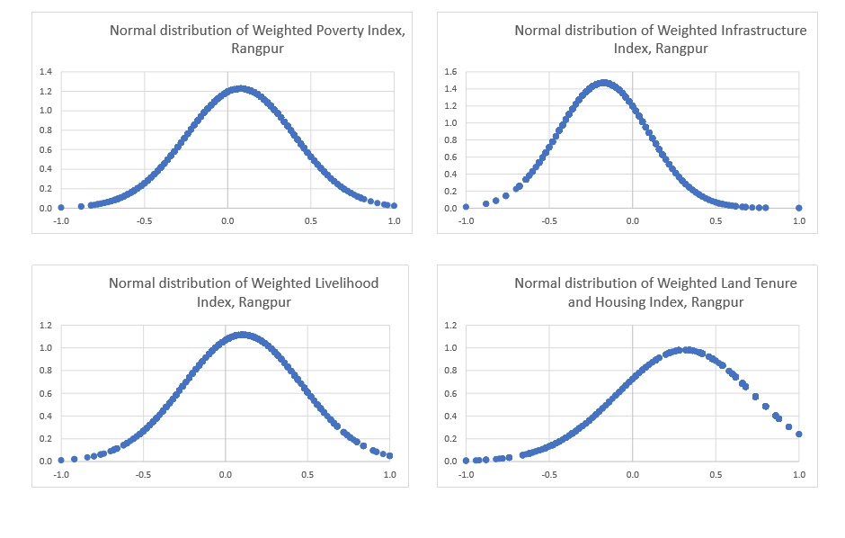

Summary Tables for Priority Wards for Infrastructure and Livelihoods interventions

Priority Wards for infrastructure and livelihoods interventions for 2020
Area/Sector | Priority Wards for Rangpur City Corporation
Area/Sector | Critical Dev (1st priority) | Very Low Dev (2nd priority) | Low Dev (3rd priority) | Relatively High Dev (4th priority)
Infrastructure (SIF) | 2, 3, 8, 10, 14, 30 | 1, 4, 7, 11, 13, 19, 20, 23, 29, 31, 32, 33 | 5, 9, 12, 15, 17, 18, 26, 27 | 6, 16, 21, 22, 24, 25, 28
Livelihood (SEF) | 2, 8, 10, 14, 19, 26, 27, 30 | 1, 3, 5, 20, 22, 23, 28, 29, 33 | 4, 9, 12, 13, 16, 17, 31, 32 | 6, 7, 11, 15, 18, 21, 24, 25
Land Tenure and Housing | 16, 18, 20, 23, 25, 26, 27, 30 | 4, 5, 8, 10, 19, 21, 24, 28, 29 | 2, 7, 13, 14, 15, 22, 31, 33 | 1, 3, 6, 9, 11, 12, 17, 32
Overall Poverty | 2, 8, 18, 20, 23, 26, 27, 30 | 1, 3, 10, 14, 16, 19, 28, 29, 33 | 4, 12, 13, 15, 17, 22, 25, 31, 32 | 5, 6, 7, 9, 11, 21, 24

Frequency Distribution Tables by Wards and Indicators (Unweighted)
Table 05: Aggregate Score of indicators by Wards (Urban Poor Settlement Mapping), Rangpur City Corporation
Ward | Poor HHs | Poor Popn | # Settlment | Settl_age | Road | Drain | Electricity | Waste | Education | Water | Toilet | Land Tenure | Housing | Eviction | Employment | Income | Social Problem | Street Light | Land Ownership | Occupancy | Total Score
1 | 1666 | 7861 | 49 | 96 | 1.63 | 1.00 | 3.88 | 1.02 | 3.18 | 1.00 | 1.22 | 3.78 | 1.24 | 3.76 | 2.61 | 1.98 | 2.14 | 1.00 | 3.73 | 3.76 | 36.94
2 | 2828 | 12273 | 26 | 78 | 2.00 | 1.00 | 3.23 | 1.00 | 2.77 | 1.00 | 1.23 | 3.69 | 1.92 | 3.65 | 2.62 | 2.04 | 1.92 | 1.00 | 3.73 | 3.65 | 36.46
3 | 2541 | 10316 | 44 | 51 | 1.48 | 1.05 | 3.84 | 1.00 | 3.07 | 1.00 | 1.45 | 3.77 | 1.91 | 3.77 | 2.77 | 2.05 | 1.95 | 1.32 | 3.80 | 3.77 | 38.00
4 | 1801 | 8234 | 34 | 46 | 1.88 | 1.26 | 3.74 | 1.00 | 3.62 | 1.09 | 1.71 | 3.85 | 1.29 | 3.85 | 3.56 | 3.32 | 2.12 | 1.59 | 3.88 | 3.82 | 41.59
5 | 2905 | 11565 | 28 | 89 | 1.86 | 1.54 | 4.00 | 1.00 | 3.11 | 1.00 | 1.71 | 3.89 | 2.14 | 3.89 | 2.64 | 1.04 | 3.57 | 3.00 | 3.89 | 3.93 | 42.21
6 | 892 | 4084 | 44 | 51 | 1.32 | 1.00 | 4.00 | 1.00 | 3.84 | 1.09 | 1.20 | 3.93 | 3.20 | 4.00 | 3.05 | 1.55 | 2.84 | 1.36 | 4.00 | 4.00 | 41.39
7 | 975 | 3395 | 26 | 68 | 1.81 | 1.23 | 3.69 | 1.00 | 3.88 | 1.12 | 1.42 | 3.54 | 2.27 | 3.42 | 3.50 | 1.35 | 3.85 | 1.85 | 3.50 | 3.46 | 40.88
8 | 2842 | 13112 | 37 | 50 | 1.08 | 1.00 | 4.00 | 1.08 | 3.73 | 1.03 | 1.14 | 3.76 | 1.49 | 3.84 | 1.59 | 1.16 | 1.14 | 1.03 | 3.84 | 3.84 | 34.73
9 | 1717 | 7182 | 46 | 48 | 2.04 | 1.04 | 3.78 | 1.00 | 2.85 | 1.00 | 1.74 | 3.78 | 2.65 | 3.93 | 3.04 | 2.83 | 2.57 | 1.83 | 3.96 | 3.93 | 41.98
10 | 3074 | 13343 | 28 | 60 | 2.18 | 1.00 | 4.00 | 1.00 | 3.82 | 1.00 | 1.57 | 3.57 | 1.04 | 4.00 | 2.57 | 3.04 | 1.14 | 1.04 | 4.00 | 4.00 | 38.96
11 | 1312 | 5870 | 35 | 66 | 1.89 | 1.00 | 3.89 | 1.00 | 3.80 | 1.00 | 1.00 | 4.00 | 1.09 | 4.00 | 3.54 | 3.03 | 2.83 | 2.14 | 4.00 | 4.00 | 42.20
12 | 2908 | 11999 | 68 | 60 | 2.01 | 1.10 | 3.57 | 1.00 | 3.07 | 1.00 | 1.50 | 3.99 | 1.90 | 3.99 | 2.56 | 2.22 | 1.93 | 2.18 | 3.99 | 3.99 | 39.99
13 | 2721 | 11670 | 40 | 58 | 2.00 | 1.18 | 3.73 | 1.00 | 3.05 | 1.00 | 2.28 | 3.93 | 1.40 | 3.93 | 2.88 | 2.93 | 3.08 | 1.30 | 3.95 | 3.93 | 41.53
14 | 2567 | 10022 | 43 | 83 | 1.93 | 1.00 | 4.00 | 1.00 | 3.74 | 1.00 | 1.37 | 3.88 | 1.49 | 4.00 | 2.49 | 1.35 | 2.14 | 1.00 | 4.00 | 4.00 | 38.40
15 | 1552 | 6657 | 30 | 90 | 1.67 | 1.13 | 3.90 | 1.00 | 3.63 | 1.00 | 2.03 | 3.70 | 1.17 | 3.67 | 2.60 | 2.40 | 2.73 | 1.23 | 3.63 | 3.67 | 39.17
16 | 692 | 3296 | 26 | 26 | 2.35 | 1.96 | 4.00 | 1.38 | 3.92 | 1.12 | 1.04 | 2.27 | 1.38 | 2.19 | 2.38 | 3.69 | 1.00 | 2.58 | 1.88 | 2.19 | 35.35
17 | 3215 | 11236 | 53 | 25 | 1.87 | 1.64 | 3.51 | 1.19 | 3.25 | 1.15 | 1.83 | 3.55 | 2.36 | 3.57 | 2.91 | 2.47 | 2.19 | 1.51 | 3.58 | 3.62 | 40.19
18 | 442 | 1819 | 32 | 27 | 1.44 | 1.06 | 3.47 | 1.06 | 3.47 | 1.03 | 1.19 | 1.56 | 1.03 | 1.59 | 2.41 | 1.09 | 2.63 | 1.72 | 1.22 | 1.69 | 27.66
19 | 2771 | 10699 | 32 | 39 | 1.78 | 1.47 | 3.75 | 1.16 | 2.63 | 1.16 | 1.47 | 3.41 | 2.53 | 3.50 | 2.28 | 1.88 | 1.09 | 2.13 | 3.53 | 3.47 | 37.22
20 | 513 | 2454 | 40 | 37 | 1.53 | 1.33 | 3.13 | 1.08 | 3.78 | 1.00 | 1.00 | 1.93 | 1.38 | 1.88 | 1.68 | 1.00 | 1.28 | 1.60 | 2.03 | 2.10 | 27.68
21 | 373 | 1930 | 25 | 63 | 2.04 | 1.84 | 3.76 | 1.84 | 3.60 | 1.04 | 2.24 | 3.00 | 2.08 | 3.12 | 3.52 | 3.20 | 3.44 | 2.52 | 3.04 | 2.96 | 43.24
22 | 821 | 3581 | 19 | 59 | 2.26 | 1.37 | 4.00 | 1.11 | 3.63 | 1.16 | 1.16 | 3.68 | 1.84 | 3.68 | 3.32 | 1.26 | 1.21 | 2.74 | 3.79 | 3.68 | 39.89
23 | 1691 | 7923 | 24 | 53 | 1.96 | 1.04 | 3.83 | 1.50 | 3.46 | 1.08 | 1.13 | 2.63 | 1.50 | 2.58 | 3.00 | 3.08 | 1.58 | 2.92 | 2.71 | 2.63 | 36.63
24 | 1088 | 4767 | 33 | 28 | 2.52 | 1.91 | 3.70 | 2.58 | 3.91 | 2.42 | 1.24 | 3.18 | 1.61 | 3.30 | 3.15 | 3.82 | 1.88 | 2.97 | 3.18 | 3.21 | 44.58
25 | 1541 | 5578 | 21 | 24 | 2.00 | 1.52 | 3.95 | 1.00 | 3.76 | 1.00 | 1.38 | 3.05 | 1.43 | 2.95 | 3.29 | 1.14 | 3.52 | 2.95 | 3.05 | 3.05 | 39.05
26 | 6009 | 24471 | 52 | 31 | 2.31 | 1.62 | 3.79 | 1.08 | 3.13 | 1.25 | 1.52 | 2.19 | 1.83 | 2.13 | 2.10 | 1.73 | 1.65 | 2.04 | 2.08 | 2.19 | 32.63
27 | 1130 | 5089 | 53 | 56 | 2.06 | 1.21 | 3.11 | 1.00 | 2.43 | 1.06 | 1.75 | 2.30 | 1.72 | 2.57 | 2.85 | 1.30 | 1.08 | 1.68 | 2.64 | 2.43 | 31.19
28 | 2702 | 12706 | 54 | 34 | 2.24 | 1.69 | 3.94 | 1.07 | 3.31 | 1.00 | 1.02 | 3.24 | 1.74 | 3.20 | 3.06 | 3.06 | 1.06 | 3.39 | 3.44 | 3.54 | 40.00
29 | 6770 | 29200 | 70 | 71 | 1.54 | 1.17 | 3.60 | 1.01 | 3.66 | 1.14 | 2.07 | 3.39 | 1.87 | 3.36 | 3.11 | 2.70 | 1.99 | 1.93 | 3.43 | 3.49 | 39.46
30 | 2499 | 9661 | 30 | 45 | 1.67 | 1.10 | 3.50 | 1.00 | 3.23 | 1.00 | 1.43 | 3.13 | 1.77 | 3.07 | 2.83 | 1.10 | 2.20 | 2.23 | 3.50 | 3.23 | 36.00
31 | 3432 | 14429 | 50 | 77 | 1.76 | 1.02 | 3.86 | 1.02 | 2.72 | 1.02 | 1.58 | 3.88 | 1.74 | 3.92 | 2.94 | 3.00 | 3.00 | 1.90 | 3.96 | 3.94 | 41.26
32 | 1183 | 5185 | 40 | 85 | 1.73 | 1.05 | 3.98 | 1.00 | 3.58 | 1.00 | 1.05 | 4.00 | 1.03 | 4.00 | 2.88 | 1.00 | 2.30 | 1.40 | 4.00 | 4.00 | 37.98
33 | 4158 | 18921 | 60 | 94 | 2.02 | 1.05 | 3.97 | 1.00 | 3.32 | 1.00 | 1.77 | 3.92 | 1.43 | 3.92 | 2.62 | 1.72 | 2.45 | 1.43 | 4.00 | 3.95 | 39.55
Total | 73331 | 310528 | 1292 | 57 | 1.87 | 1.26 | 3.76 | 1.13 | 3.39 | 1.09 | 1.47 | 3.37 | 1.71 | 3.40 | 2.80 | 2.14 | 2.17 | 1.89 | 3.42 | 3.43 | 38.30

