Pilot Plant and Process Development Centre (PP&PDC)
Bangladesh Council of Scientific and Industrial Research (BCSIR)
Dr. Qudrat-i-Khuda Road, Dhanmondi, Dhaka-1205
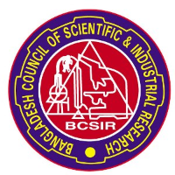

Registration Form
Title: Hands-on Training for CNC Milling M/C Operation

(Please complete the registration form and return it to the address overleaf or rupeshroy62@gmail.com or zinnah16bcsir@gmail.com )

www.pppdc-bcsir.gov.bd www.facebook.com/pppdc




Full Name (Block Letter) | Click here to enter text.
National ID No. | Click here to enter text.
Cell Phone No | Click here to enter text.
E-mail address | Click here to enter text.
Profession (Please Circle)
Educational Details | Degree:Click here to enter text.  Subject:Click here to enter text.  Institute:Click here to enter text.
Job details (for job holder) | Designation: Click here to enter text.  Organization:Click here to enter text.
Present Address | Click here to enter text.
Permanent Address | Click here to enter text.
Date with Signature
Date with Signature | Signature
Date with Signature | Date: Click here to enter a date.

