Training
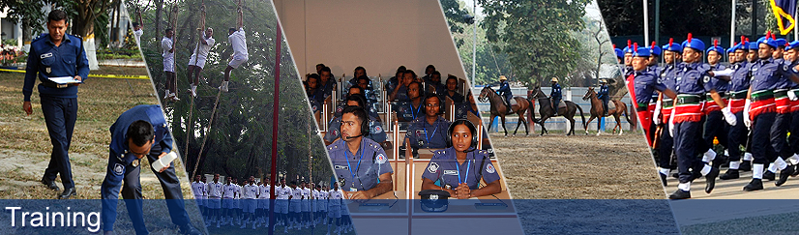

Training
In the context of changes in domestic and global demand, Bangladesh Police focuses on training programs to maintain the current power of the staff, focus is on the need based training using industrial methods and techniques state. Bangladesh Police force members are committed to helping them develop their skills and career by giving them the opportunity to participate in both internal and external training courses.

Assistant Superintendent of Police (ASP)
After participating in the service, officials came to the Bangladesh Police Academy ASP examinations through year-round primary training. There they participate in learning the knowledge and skills of law, physical training, driving, computer and cavalry, boxing etc. Later they conducted a six-month training program in a district. Then they will have to join the foundation training at Bangladesh Public Administration Training Center (B PATC). They have to participate in various in-service training courses at home and abroad. These include BME Orientation Training Courses, Surveys and Settlement Courses, Add to Good Investigation Courses, Off Protection Courses and Orientation Courses for SCO Officers, Passport Verification Roll and Third Eye Courses and Housing Courses at SB Training School. Through their professional life, they are subject to skill development training. These include investigation in Police Staff College, SB and CID, financial management, human rights, forensic and financial crime departments.

Sub inspector
The cadets from outside the Bangladesh Police Academy are following a year's training course. Immediately after that, recruiters with different police units received the longest training of the year. Sub-inspectors conduct various in-service training courses at both home and abroad. In CID, they conduct courses in women and child prevention prevention, special training courses on human rights, prosecution and investigation courses, post-explosion investigation courses, technology-based investigation training training courses, special investigation training courses, etc. SB), they run basic immigration courses, pre-immigration courses, basic intelligence courses, short-time intelligence courses, basic surveillance courses, staff development courses and third-eye courses.
Sergeant
Once appointed, the sergeant conducts six months long training program at the Bangladesh Police Academy as a testing sergeant. After departing from the academy, they are through 6 months long campaign training in their place of posting as a prospect. In addition to these training, both of the sessions have tolerated internal and external training courses both at home and abroad. These include special education courses in Human Rights at Detective Training School (DTS), CID, Basic Branch in Basic Immigration School and Refresher Course of Police Training Center, Noakhali.
Constable
After the appointed constable, after six months of basic training in different centers including the Bangladesh Police Academy, along with the training Gitan Constable (TRC), took basic training. However, during the service of different units, the constables participate in various training training courses for their skill development and professional growth program. These include Orientation Course for Orientation Course, Basic Surveillance Course, SB Protection Officer, Orientation Course for SCO Officers, Passport Verification on Orientation Course at SB Training School. Apart from this, the Constt TDS, Dhaka, MDTS, Jamalpur, BRTA and Bangladesh-German and Bangladesh-Korean Technical Training Center, Police Telecom Training School, Bangla Academy, computer training courses in Engineers Institution and in various in-service centers participate in the driving course.

