About LGED
Content: পাতা
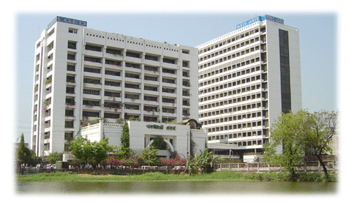
Local Government Engineering Department (LGED) is one the largest engineering agencies of the country. It began its journey in 60s as Rural Works Programme and with the passage of time its activities expanded from remotest corner of the country up to the cities.

Role of LGED in strengthening of rural economy through development of rural transportation and improvement of rural markets and growth centers are visible across the country. Contribution of these infrastructures are enormous in achieving the ever increasing national growth. People living in rural areas now have the access to metaled roads within two kilometers while the rural infrastructures play pivotal role in the improvement of lifestyle and reducing poverty.

LGED also maintains its presence in the infrastructure development in urban areas. The department is also involved in providing technical assistance, governance improvement and capacity building of Urban Local Bodies (Municipalities and City Corporations).

LGED’s role in augmenting agricultural and fish production through small scale water resources (SSWR) development projects is remarkable. These initiatives have created short and long term employment opportunities for the low income group of people. Local stakeholders are included while planning and implementing the schemes and in the operation and maintenance.

Besides, the activities mentioned above, LGED extending technical assistance to Local Government Institutions. Required technical assistance is also provided to various ministries.

LGED also develops infrastructure database, maps, technical specifications, manual etc. required for development projects. Regular training courses conducted by LGED for enhancing skill of its own employees, members of the Local Government Institutions and other stakeholders.

The area of operation of LGED is given in the following diagram.
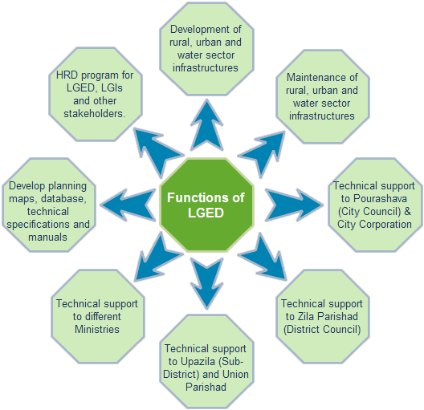
The detail functions of LGED are described under the section of ‘Functions of LGED’.

