Government and UNDP Collaborate to Advance Low-Carbon Urban Development
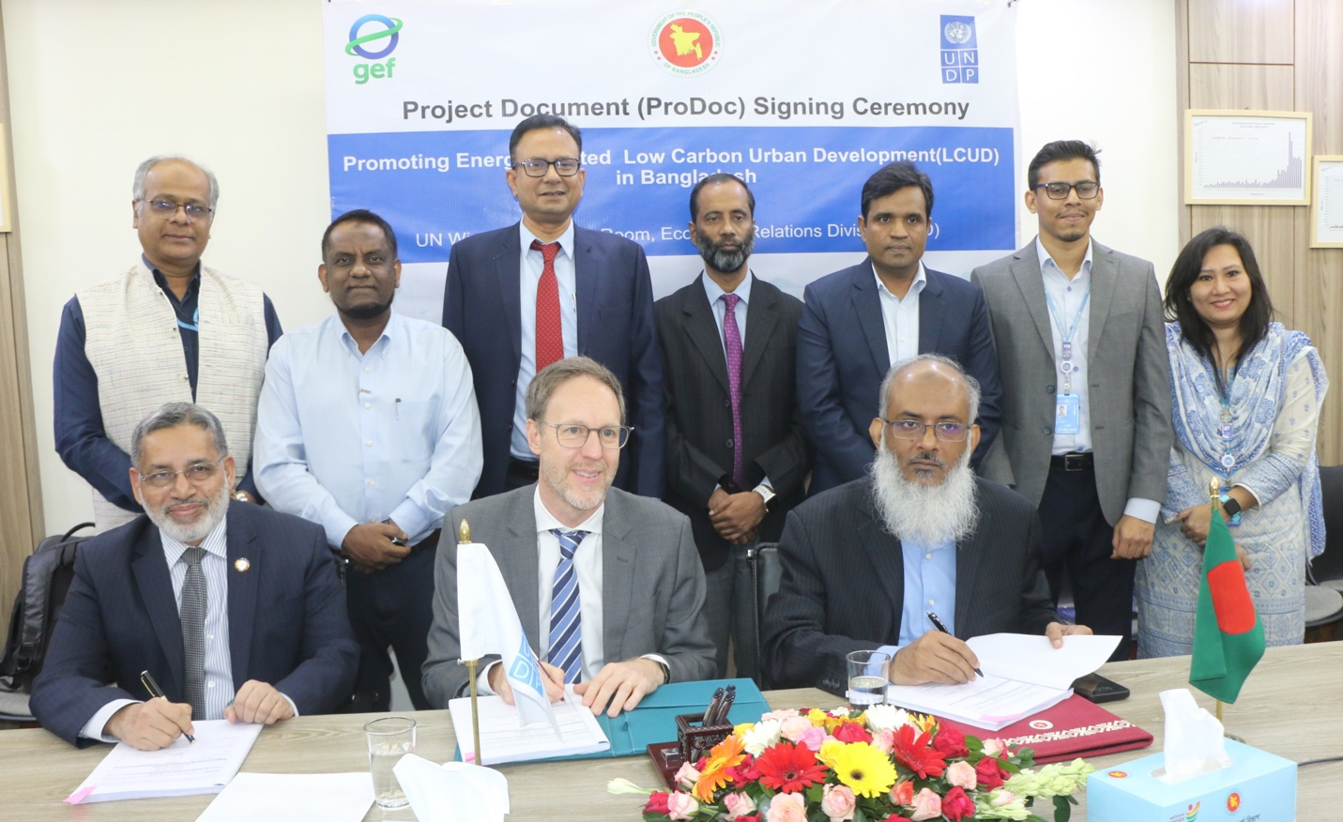
Photo: Project Document Singing Ceremony, ERD, 02 November 2025

Dhaka, November 2, 2025: The Government of Bangladesh, in partnership with the United Nations Development Programme (UNDP), has launched a new project to promote low-carbon urban development in Dhaka, Chattogram, and other major cities. Funded by the Global Environment Facility (GEF), the initiative aims to reduce greenhouse gas emissions and foster sustainable urban growth through greater investment in energy efficiency, renewable energy, and waste-to-energy solutions.

The five-year initiative titled “Promoting Energy-Related Low Carbon Urban Development (LCUD) in Bangladesh” will be executed by the Sustainable and Renewable Energy Development Authority (SREDA) under the Ministry of Power, Energy and Mineral Resources (MPEMR).
Launched ahead of the UN Climate Change Conference (COP30), the signing ceremony took place at the Economic Relations Division (ERD) conference room in Dhaka. Md. Shahriar Kader Siddiky, Secretary of the Economic Relations Division and Nur Ahmed, Additional Secretary of the Power Division, MPEMR, and Stefan Liller, Resident Representative of UNDP Bangladesh, signed the agreement on behalf of their respective organisations.

In the welcome note, AKM Sohel, Additional Secretary and UN Wing Chief, highlights that rapid urbanisation in Bangladesh necessitates a shift towards sustainable practices. He noted, “The significance of climate-resilient, low-carbon urban development, as outlined in the LCUD project, cannot be overstated, considering the country's unique challenges related to climate change and rapid urbanisation, which demand eco-friendly solutions such as renewable energy, energy-efficient buildings, and sustainable transportation.”

Speaking at the ceremony, Md. Shahriar Kader Siddiky underscored the government’s commitment to climate-smart development. “This project will build vital knowledge and capacity for better waste management and clean energy solutions in our cities. I thank UNDP for mobilising significant support for this important initiative. We must now work closely to bridge the gaps, manage resources wisely, and expand these efforts beyond Dhaka and Chattogram to ensure cleaner, healthier urban living for all.”

Stefan Liller reaffirmed UNDP’s strong collaboration with the Government of Bangladesh in advancing clean energy and sustainable urbanisation. He said, “UNDP has been working alongside the Government of Bangladesh on urban programming for over 15 years. This project adds a crucial new dimension to that collaboration advancing the kind of sustainable, low-carbon urban development that the country urgently needs. We look forward to building on this partnership to deliver results that truly make a difference.”

Nur Ahmed, Additional Secretary, Power Division, highlighted that the project would catalyse investment and innovation in low-carbon infrastructure, setting an example for other urban centres across Bangladesh. “This project focuses on three critical areas of investment that will strengthen our resilience through better infrastructure and environmental management. I am confident that its journey will be highly impactful. We have worked closely to facilitate its start, and moving forward, we will remain vigilant to ensure timely and effective implementation.”
Mohammad Razibul Islam, Joint Secretary, ERD, Mr Sardar M. Asaduzzaman, UNDP Bangladesh Assistant Resident Representative, Muzaffar Ahmad, Chairman, SREDA, Engineer Md. Mujibur Rahman, Director (Deputy Secretary), Renewable Energy Development, SREDA, were among the many who joined the signing ceremony. Dr Shah Abdul Saadi, Deputy Secretary, ERD, anchored the project document signing ceremony.

Through strategic collaboration and innovative solutions, the LCUD project is expected to create a replicable model for climate-resilient and energy-efficient cities, contributing to Bangladesh’s transition toward a greener and more sustainable future.

