

Government of the People’s Republic of Bangladesh Ministry of Local Government, Rural Development and Co-operatives
(Local Government Division)

Environmental and Social (E&S) Screening Report
on
Household Rainwater Harvesting System at Teknaf Upazila, Cox’s Bazar
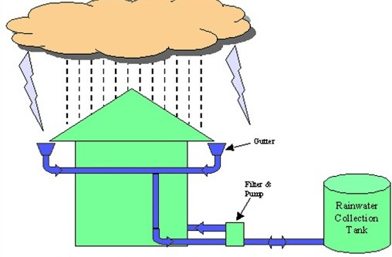

Location: Teknaf Upazila, Cox’s Bazar

(Type-A & Type-C)
Sub-project: HELP/WD-54 [RWHS -200 nos.]

Host and Rohingya Enhancement of Lives Project (GoB-WB)


Department of Public Health Engineering (DPHE)

Abbreviation and Acronyms:
BBS | Bangladesh Bureau of Statistics
BD | Bangladesh
BMD | Bangladesh Meteorological Department
CoC | Code of Conduct
CI | Corrugated Iron
DC | Deputy Commissioner
DPHE | Department of Public Health Engineering
Dia. | Diameter
DRP | Displaced Rohingya Population
EE | Executive Engineer
HELP | Host and Rohingya Enhancement of Lives Project (GoB-WB)
ERP | Emergency Response Plan
E&S | Environmental & Social
ESS | Environmental & Social Standard
ESMF | Environmental & Social Management Framework
ESMP | Environmental and Social Management Plan
FGD | Focal Group Discussion
GBV | Gender-Based Violence
GoB | Government of The People’s Republic of Bangladesh
GRC | Grievance Redress Committee
GRM | Grievance Redress Mechanism
HC | Host Community
HELP | Host and Rohingya Enhancement of Lives Project
HH | Household
HBB | Herringbone Bond
HDPE | High- Density Polyethylene
IEF | Important Environmental Feature
ISCG | Inter Sector Coordination Group
IUCN | International Union for Conservation of Nature
LGED | Local Government Engineering Department
LGI | Local Government Institution
MHPSS | Mental Health and Psychological Support
NGO | Non-Government Organization
OHS | Occupational Health and Safety
O & M | Operation and Maintenance
PCC | Participatory Community Consultations
PM | Particulate Matter
PMU | Project Management Unit
PPE | Personal Protective Equipment
RCC | Reinforcement Cement Concrete
ROW | Right of Way
RWH | Rainwater Harvesting
RWHS | Rainwater Harvesting System
SAE | Sub–Assistant Engineer
TDS | Total Dissolved Solids
TSS | Total Suspended Solids
UNFPA | United Nations Fund for Population Activities
UNHCR | United Nations High Commissioner for Refugees
UP | Union Parishad
uPVC | Un-plasticized Polyvinyl Chloride
WASH | Water, Sanitation and Hygiene
WB | World Bank
WATSAN | Water and Sanitation

HELP (DPHE part)

Environmental and Social Screening Report

- Project Description

Host and Rohingya Enhancement of Lives Project (HELP) is being implemented with the Support of GoB and the World Bank. Department of Public Health Engineering (DPHE) and Local Government Engineering Department (LGED) under the Ministry of Local Government, Rural Development and Cooperatives (MoLGRD & C), Roads and Highway Department (RHD) under the Ministry of Road Transport and Bridges (MoRTB) and Bangladesh Power Development Board (BPDB) under the Ministry of Power, Energy and Mineral Resources (MoPEMR) are the implementing agencies of the Project. The objective of the project is to improve access to basic services and enhance disaster and climate resilience of Displaced Rohingya Population (DRP) and host communities in Cox’s Bazar district and Hatiya, Suborno Char, Bhasan Char of Noakhali district.
The project aims to support Displaced Rohingya Population (DRP) residing in 33 camps in Ukhiya and Teknaf Upazilas of Cox’s Bazar District (CXB) and Hatia, Suborno Char (SC), Bhasan Char (BC) island in Noakhali, as well as the host communities (HC) in Cox’s Bazar.
Component 1 on resilient Water, Sanitation and Hygiene (WASH) is being implemented by the Department of Public Health Engineering (DPHE). Key activities under component 1 are (i) Construction of Piped Water Supply Schemes(PWSS), Community Water Options (CWO) defined as point source water options, Rain Water Harvesting Systems (RWHS), Excavation and rehabilitation of Surface Water Reservoir (SWR) etc. as well as other rehabilitation works to improve capacity of existing water supply and distribution systems, (ii) rehabilitation and improvement of existing household and public/community toilets and installation of new household and Community/ Public Toilets as well as Integrated Waste Management Facilities(IWMF), and (iii) Operations and Maintenance (O&M) of new and existing WASH facilities. Installation of Safely Managed WASH facilities and relevant support in the host community will help the government in attend the target 6.1 and 6.2 of SDG (Focuses on ensuring clean water and sanitation for all) through its scheduled project activities.
Apart from Component-01, DPHE will also implement Component-03 on Strengthening Institutional Systems to Enhance Service Provision and Support Integrated Resilient Development. The key activities of this component are (i) capacity building and technical assistance for the Government of Bangladesh, (ii) awareness raising and skills building program for Host Communities and the DRP, (iii) training of first respondents, and (iv) project management and innovative technologies for project monitoring and evaluation.
The key component of the project are to establish WASH facilities (38 Pipe water supply Schemes , 2,300 Community water options,/ DTW, 200 Rain Water Harvesting systems, 24,500 household toilets, Construction of 84 Public/Community Toilets, 7 Integrated Waste Management Systems, 2492 House Dual Pit Waste Composting (DPCS) bin, 2 Rehabilitation/excavation of existing surface water reserve etc.)along with extensive and integrated awareness creation program for hygiene promotion activities with support of technical and social firms to provide WASH technical and O&M support and to improve socio economic and environmental condition including the livelihood of the people of the project areas.

Name of Sub-project: Installation of Homestead Rainwater Harvesting System in Host Community under WD-54 at Teknaf Upazila, Cox’s Bazar.
Implementing Agency/Agencies: Department of Public Health Engineering (DPHE)
The estimated total cost of 200 nos. Rainwater Harvesting system under subject project Work Package: BDT 2, 59 17, 441.22 (Around BDT 129,587/- for each RWHS)
Estimated construction period duration: 09 (Nine months)
Estimated Operation and Maintenance (O&M) period (life of sub-project):
During the project (HELP-DPHE) period operation and maintenance (O&M) will be borne by the Contractor and local DPHE. After completion of the project the operation & maintenance (O&M) cost of the RWHS will be borne by the respective beneficiaries by their own and only technical support should be provided by DPHE. The expected lifetime of each RWHS scheme is more than 10 (ten) to 15 (Fifteen) years.
- Environmental & Social Baseline (ESS1)
(In this baseline segment of E&S Screening report, considered the ESS/ Standard 1)
  - Environmental Baseline (ESS1)
General Rainfall Pattern of Teknaf:
In Teknaf area, generally exhibits a decreasing annual rainfall trend over the past decade, though it remains a region of high precipitation in Bangladesh. Rainfall is heavily concentrated in the monsoon season, which has become more variable, leading to both instances of intense weather events and periods of deficit.

High Annual Rainfall: Teknaf is located in the southeastern coastal zone, an area known for receiving some of the highest annual rainfall in the country (often exceeding 4000 mm in some years).

Strong Seasonal Variation: The vast majority of rainfall (around 65-70%) occurs during the monsoon season, which typically runs from June to September. Other seasons like winter (December-February) are generally very dry.

Decreasing Trend: Studies indicate a long-term decreasing rainfall trend for Teknaf when analyzed over several decades. This means that while individual years may have high rainfall, the average amount has been gradually declining. The last ten years have been marked by significant variability and instances of extreme weather events, a pattern consistent with broader climate change impacts in the region.

Extremely Wet Years: Some years, such as 2016, saw a very high volume of rainfall, with records indicating up to 4299 mm for the year.

Below-Normal Months: Recent data from the Bangladesh Meteorological Department (BMD) has shown specific months with significantly below-normal rainfall. For example, in October 2025, Teknaf experienced 83% below-normal rainfall, and in May 2025, it was 74% below normal.

Above-Normal Months: Conversely, other months have experienced exceptionally heavy rain, such as July 2024, which recorded 1197 mm of cumulative rainfall, 66% above the normal for that month.

Increased Intensity: The trend suggests more intense, less predictable rainfall events rather than a steady average, leading to a higher risk of both short-duration flooding and agricultural drought conditions. The average rainfall (in mm) local data presented in Teknaf Upazila:
(Data Resources: Bangladesh Meteorological Department - BMD).

Jan. | Feb. | March | April | May | June | July | Aug. | Sept. | Oct. | Nov. | Dec.
6 | 11 | 21 | 55 | 321 | 970 | 1215 | 932 | 496 | 289 | 54 | 12

Ground Water Depth and Quality:

Groundwater depth in Teknaf varies by aquifer system, with shallow aquifers having a seasonal water table and artesian aquifers (mostly west of the highway) showing less fluctuation. Shallow groundwater is found at depths of 12-15 meters, while deep tube wells can be 100 meters or more deep. In terms of quality, shallow groundwater can contain high levels of iron, and some shallow wells may have high concentrations of uranium and thorium, especially in areas with high organic content. Deeper wells generally have fresher water, with low salinity and levels of heavy metals, nitrate, and fluoride below Bangladesh standards.

Shallow aquifers: The water table varies seasonally, dropping to its lowest point in mid-April and rising in late October. The depth is generally between 12 and 15 meters.

Deep aquifers: Deep tube wells can reach depths of 100 meters or more. Some artesian systems, often found west of the Cox's Bazar-Teknaf highway, show little seasonal variation in water level.

Ground water quality:

Shallow wells: The quality can be highly variable, with high levels of iron found in some wells immediately after construction. Uranium and thorium enrichment has been noted in shallow (<20 m) wells in certain paleo beach areas, especially where sediments are rich in organic matter.

Salinity: Generally higher than deep wells.

Deep wells: The quality generally considered to be fresh drinking water, with low salinity.
Heavy metal concentrations, including arsenic and manganese, are typically below Bangladesh standards. Iron can be high in some wells immediately after installation, but is generally below standards. Considering the other parameters, nitrate and fluoride levels are typically below Bangladesh standards.

Important considerations: There are at least two main groundwater aquifer systems in the region: a seasonal, non-artesian system and a more stable artesian system.

Vulnerability: Groundwater in some areas, particularly the Tipam Sandstone aquifer in the Whykong-Teknaf area, is vulnerable to saline intrusion. Managing the impact of deep well pumping on the water table and the risk of saline intrusion is important.

The local drainage pattern in Teknaf : Teknaf is primarily influenced by its proximity to the Naf River and the Bay of Bengal, with seasonal local streams and khals (canals) like Heccha Khal and Kayokkhali Khal serving as key drainage channels that carry water to the main river. Due to inadequate and unplanned drainage infrastructure, the area experiences drainage congestion and water logging during heavy rainfall, especially in the urban areas. The overall system is a combination of the main river system, seasonal streams, and localized, often insufficient, man-made drains. Key features of Teknaf's drainage pattern:

Regional river system: The Naf River flows north to south along the Teknaf urban area, serving as the primary natural drainage outlet into the Bay of Bengal.

Seasonal streams and khals: Seasonal local streams develop during the wet season. In the urban area, two prominent khals, Heccha Khal and Kayokkhali Khal, collect and channel storm water into the Naf River.

Urban drainage: The urban area has a network of both lined and unlined drains, but they are often inadequate and not integrated into a comprehensive plan for the entire area.

Water logging: The lack of proper, planned drainage infrastructure leads to water logging and drainage congestion after heavy rainfall events.

Coastal influence: The geographical position on the coast means that local drainage is also affected by coastal processes and storm surges.

Climatic hazard profile (cyclone, flash flood, drought) (ESS1):

Teknaf, located in the highly disaster-prone district of Cox's Bazar, faces a significant multi-hazard climate risk profile. The primary climate hazards include cyclones, flash floods, and drought, with varying levels of intensity across different local areas within Teknaf.
Cyclone:

Teknaf is highly vulnerable to tropical cyclones and associated storm surges due to its location at the northern tip of the Bay of Bengal.

Frequency and Intensity: Cyclones and strong winds have an increasing trend in the region. The area is susceptible to high wind speeds and tidal inundation.

Vulnerability: Coastal areas like the Sabrang union in Teknaf are particularly vulnerable to tidal inundation and seashore breaks caused by cyclones.

Flash Flood:

Flash floods are a recurring hazard in Teknaf, especially in certain unions.

Triggering Factors: High-intensity rainfall, often associated with monsoons and cyclones, in the hilly upstream areas can trigger rapid flash floods.

Risk Areas: Unions such as Hnila and Whykong are identified as having a moderate risk of floods and flash floods, in addition to the risks of landslides which are often linked to heavy rainfall events. The combination of flash flooding and tidal flooding amplifies the overall flood risk.

Drought:
While the region is known for floods and cyclones, agricultural drought is also a significant concern, and its incidence has reportedly increased in recent years.

Trend: Teknaf has experienced a decreasing rainfall trend compared to the general average for the Cox's Bazar district, which contributes to agricultural drought conditions.

Key climate trends exacerbating these hazards in Teknaf include:

Rising Temperatures: The rising temperature scenario in Teknaf is higher than the general average for the Cox’sbazar.

Increasing Wind Speed: There is an increasing trend in wind speeds.

Decreasing Rainfall: The overall decrease in rainfall contributes to drought conditions. These interconnected hazards mean Teknaf faces a complex multi-hazard environment, which is further complicated by socio-economic vulnerabilities, such as the presence of densely populated refugee camps in the wider Cox's Bazar district. Information on flood forecasting and warning can be found via the FFWC (Flood Forecasting and Warning Center, BWDB, Bangladesh).
Types of waste to be generated during construction and operation phase:
During construction phase waste will be generated due to construction activities. The types of wastes are uPVC pipe, concrete, corrugated/industrial iron sheet etc.
Sensitive environmental, cultural, archaeological, religious sites near (within 1km) of site including elephant migration routes and remaining forests:
At the proposed areas of Rainwater Harvesting System (RWHS) scheme there were some religious, educational institutions and business centers found like Mosques, Madrasha, Hafejkhana, Orphanage, High school, College, Primary School, Mazar Sharif, Mondir, Local Bazar, Grocery shop etc. Apart from those HH habitat, the Sea beach off-shore areas with Jhau bon (forest), some natural forest lands were found far away from the sites but their impact is low. Other than these the marine drive, pucca roads, bridge, culvert, herringbone bond road (12-15 ft. width) and electric line run very close to the proposed sub-project areas. There was no any important Environmental Features (IEFs) found near to the scheme sites. No existing trees, bushes, shelters, wild animal – insect habitat or structures will be affected or need to be remove for implementing the schemes. There is no any possibility of traffic during the construction period is assumed to be appearing which may affect this community property. However, none is going to be affected due to project intervention and no significant environmental or social disturbance is anticipated due to construction activities. In this scheme areas, no elephant migration routes exist as per report released by IUCN (ref. IUCN 2016 map-02). Union and village wise list of Household Rainwater Harvesting System (Table-01) with some picture (Fig.01) of proposed site locations including a map (Map 01) are presented below:
Table 1: Upazila and Union wise no. of Household Rainwater Harvesting System (Option Type-A) Sites, Teknaf Upazila, Cox’s Bazar
Upazila | Union | Numbers of RWHS | Type-A & Type-C
Teknaf | Baharchara | 52 | 52
Teknaf | Hnila | 49 | 49
Teknaf | Sadar, Teknaf | 54 | 54
Teknaf | Saint Martin | 15 | 15
Teknaf | Whykong | 30 | 30
Total |  | 200 | 200

  - Social - demographic Baseline (ESS1)
District: Cox’s Bazar
Sub-District (Upazila): Teknaf Upazila, Cox’s Bazar.
Name of Union: Whykong, Hnila, Baherchara, Saint Martin, Sabrang and Teknaf union of Cox’s Bazar District.

Name of Community/Local Area: Whykong, Baherchara, Saint Martin, Hnila and Sadar unions under Teknaf Upazila.
Brief description of sub-project site: (e.g., present land use, Important Environmental Features (IEFs) near site, etc.:
In the proposed locations of Whykong, Baharchara, Saint Martin, Hnila and Sadar unions of Teknaf Upazila the host communities are of different religions and ethnicity. Most of the household pattern of the scheme area were found densely populated while some areas are with scattered.
Local DPHE, PMU E&S team representatives visited the proposed locations and Two (02) consultation meetings were conducted (Total participants - 47, M-44, F-3, disable 0) with UP Chairman, Councilors, community and Local Elite personals on feasibility and potentiality of the proposed RWHS scheme over there. After conducting the consultation and discussion session, site visit and analysis of the secondary information it has been revealed that most of the underground of this Upazila is full of heavy thick layer of stone, which is rarely possible to drill and go down. There are few pocket layers/acquirers with very limited quantity of water and in most of the areas, there is no secured boreholes. So that, the Host community has been suffering from acute water scarcity. At present in these unions, local HC people meet up their daily requirement of safe water from hand tube-wells (shallow) just 25 to 20 feet below the ground which produce water with contaminated and excessive iron and in some areas with salinity. Though get directly the percolated water during rainy season but when rains off they suffer from acute scarcity even they cannot bath for a weak. People of this area have to collect safe water from the long distant source. So that, the areas are quite feasible and potential to establish the RWHS scheme for water supply and the proposed areas both densely & scattered inhabitant will be benefited from the proposed Household RWH schemes.
From discussion the selected households agreed on providing required 14 sq. meter land space from his own land at his homestead premises for installation of RWHS, reservoir and other relevant establishment. Aiming to capturing, collection and delivery system and every individual has been provided their consent to give lands of Baharchara, Saint Martin, Hnila, Whykong, Hnila, Sadar Union. The E&S Safeguard team adopt the formal land allocation & using process by the land owner. To establish the scheme no significant negative impact was found at the targeted unions of Teknaf Upazila.
Major institutions, infrastructures, Forest land existence:
At the proposed areas of Rainwater Harvesting system (RWH) scheme there were some religious, educational institutions and business centers found like Mosques, Madrasha, Hafejokhana, Orphanage, High school, College, Primary School, Mazar Sharif, Mondir, Local Bazar, Grocery shop etc. Apart from those HH habitat, Sea beach off-shore areas with Jhau bon (natural forest), some natural forest lands were found far away from the sites but their impact is low. Other than these the marine drive, pucca roads, bridge, culvert, herringbone bond road (12-15 ft. width) and electric line run very close to the proposed sub-project areas. There was no any important Environmental Features (IEFs) found near to the scheme sites. No existing trees, bushes, shelters, wild animal – insect habitat or structures will be affected or need to be remove for implementing the schemes.
The targeted local host community (HC) people of the sub-project area are very much optimistic about the success of the RWHS sub-project. The sub-project is environmentally sustainable and socially acceptable. The local DPHE, along with PMU Social & Environmental Consultant has conducted two (02) number of consultation meeting with host communities and their community representative, WATSAN committee, DPHE SAE & Mechanic, and relevant stakeholders. The outcome of the consultation meeting was approval for the construction of the RWHS scheme. During the discussion the participants also requested to involve the local community during the construction- installation work. During the consultation meeting, the Code of Conduct (CoC), Grievance Redress Mechanism (GRM), laborer conflict mitigation measures, possible social environmental and economic effects, livelihoods options, Community Safety & Security / protection concerns (i.e. SEA / SH sensitivity) Environmental and Social Management Plan (ESMP), Occupational Health and Safety (OHS) guidelines and the benefits of RWH system and etc. are consulted among the relevant stakeholders and laborers engaged the scheme.
The E&S team has been conducted a mass awareness and BCC campaign on respective community on gender roles in water collection and usage, and significantly provided special emphasis on vulnerable segments ie. Women. Elderly disables (PWD), children, as well as hardcore poor households. Before commencement of work all relevant documents shall be discussed and disclosed further among the stakeholders, community people and engaged labors etc. The E&S baseline elements has been focused on the risk screening credible and align with ESS1 and ESS10.
In terms of natural, ecological features of the area, it was observed that some natural forest lands and sea beach off-shore area with Jhau bon (natural forest) and vegetation in sand dunes located far away from the schemes area also were found. Neither significant negative impact is expected on the ecosystem and biodiversity nor agricultural land / activities or fish farming, turtle, birds or other wild animals’ habitat will be distressed, due to the establishment of the RWHS sub-projects “Type-A” and “Type-C”.
  - RWHS site selection process (ESS1):
The site selection criteria ideally covered the technical, environmental and social aspects. The technical aspect includes road condition for accessibility of the construction materials; environmental aspect includes distance from residential areas, present and future land use, availability of land, buffer zones, soil topography, ecosystems, wildlife issue, forest issue, landslide potential, drainage channel, waste, water stagnation, soil erosion, salinity (content & dose illustrated at environmental screening section) etc. social aspect includes representation of mass people (irrespective of religion, income level, education, profession, caste, socioeconomic condition of the people, un-served and served areas, safe water scarcity, HH with available corrugated iron rooftop etc. scarcity and vulnerability were considered as major site selection criterion of RWH sub-project
The E&S team and local DPHE representatives, along with LGIs have visited the proposed area repeatedly and conducted details feasibility survey through transact walk, FGD, and series of consultation sessions with stakeholders and local communities. The Environmental and Social Consultants of PMU engaged for the water option scheme. The team primarily selected the land and location of scheme to install RWHS, some Pipe Line, Water Reservoir and allied establishments, etc.
Will play as the scheme Representative of mass people (irrespective of religion, income level, education, profession, caste etc.), Union parishad, concerned WATSAN committee, local elites, community people etc. participated in the process along with support of DPHE.
In RWHS sub-project under Teknaf Upazila, Water User and WATSAN Committee will play as the scheme operating focal agency and DPHE will play as the implementing agency of the Project with the financial assistance of The World Bank and The Government of Bangladesh. After establishing the proposed unit of RWHS scheme in the area around 5-6 people will be benefited through fulfilling their safe water requirements.
- RWHS design, landscape and influence area:
Under this section illustrated the description of proposed sub-project activities (incl. type of activities, footprint area, natural resources required, etc.):
As per demand of the host communities 3 types of RWHS has been planned to be implemented in this area. (1) Type-A is designed for those who have structure with corrugated iron roof top. For this type a PVC water Tank with 5000-liter capacity, a basement of the Tank and relevant fittings and structure for Rainwater Harvesting will be provided as required. (2) Type -B is designed for those HH having structure corrugated iron roof top but required some renovation in the capture roof top area, a PVC water Tank of 5000-liter capacity, a basement of the Tank and relevant fittings and structure for Rainwater Harvesting will be provided as required. and (3) Type-C is designed for those hard-core people who don’t have available corrugated CI made roof top. In these cases, additional roof top is designed to be established for capture area. For Type C a new catchment roof top CI sheets, along with a PVC water Tank of 5000-liter capacity, a basement of the Tank and relevant fittings fixing and structure for Rainwater Harvesting will be finances and provided by HELP, as required. Note that, for Type-C, the CI made roof installation, will not be arise a significant extra OHS risks at the site.
HELP- DPHE planned to install 200 Rainwater Harvesting Systems (3 Types-A, B & C) in different Unions under Teknaf Upazila to provide safe water through harvesting rain water during rain fall and store in a capacity of 5000-liter PVC Tank aiming to mitigating water demand of the people for the dry season. In this report, two types of systems planned under type-A & Type-C based on the capacity of having corrugated iron roof top structure in the HH level.

Type ‘A’ Rainwater Harvesting System the rooftop of the Household’s existing residence shall be considered as the catchment materials such as roof top- tin sheet and other infrastructure such Mud/Tin/Straw/Bamboo etc. for Rain Water Harvesting system. Around 5 sq. m land will be required for making the Platform(2.25mX2.25m) where 5000-liter capacity of water tank shall be installed for storing water from the catchment area e runoff water flow and of the household The House of the Existing catchment materials Structure Around 14 square meter (36 sq. ft.) existing. Each RWH scheme has a provision of the influence area within the scheme area is around 14 square meters roof top per Scheme (According to the layout diagram) Around 5-6 people from families will use each water option.
Under ‘Type-C’ Rainwater Harvesting System, the existing rooftop structure of the Household’s shall not be considered proper structure (such Mud/Tin/Straw/Bamboo etc.) for Rain Water Harvesting system. Around 21 sqm land will be required for making the structure with catchment (CI/ Industrial Sheet) area (9m X 3m) of 27 sqm, 2 sqm for basin area and around 4 sqm (Dia 2.125m) platform for placing a 5000-liter LLDPE water tank as a reservoir for storing water from the catchment during rainfall. Influence area for each unit of RWH system ‘Type-C’ (as per layout diagram) is around 27 square meters. Around 5-6 people will use each water RWH system.
This report is prepared for Construction of 80 nos. Rain Water Harvesting system. (Type “A” and Type “C”) will be constructed for the host communities of Sadar (54 nos.), Baharchara (52 nos.), Hnila (49 nos.), Saint Martin (15 nos.) and Whykong (30 nos.)
In the proposed Homestead Rainwater Harvesting system in Teknaf Upazila the following interventions would be taken place:
- Installation of 200 nos. RWH system Type-A and Type-C on existing catchment materials
- Existing Catchment Materials-Tin, other infrastructure-mud/Tin/Straw/Bamboo)
- One platform upon which the water tank will be placed
- 01 no. of LLDPE Water Tank capacity 5000 Liter with collection tap,
- Flat Bar Hanger (600mmX25mmX2mm @ 2m)
- 100 mm Dia uPVC Gutter
- One Catchment area made of C. I Sheet (Existing / Treated)
- uPVC reducer Elbow (100mm*50mm uPVC)
- uPVC net (50mm union with uPVC)
- GI Pipe (38mm dia.)
- Inlet uPVC pipe 38mm
- Down pipe 50mm dia.
- Soaking pit/Drain
- uPVC Ball Valve
- Supplying, fitting & fixing of best quality materials and inspection
- Disinfecting the water supply of 50 gm of bleaching powder (33% strength),
- After ensuring proper well development, collect the water samples and sending the samples to the DPHE Cox’s Bazar Zonal Laboratory for testing
- Environmental Mitigation Works
- Operation & Maintenance work
- Fixing of Rain Water Harvesting Filtration unit: Inside volume capacity of the proposed filter will be of 6 liters having 2 filters: (1) primary filter whose mesh size will be 100 and (2) the secondary filer will be of 5 microns where flow rate will be around 5 liters/second with 2-meters head having inlet Dia is 1.5 inches.

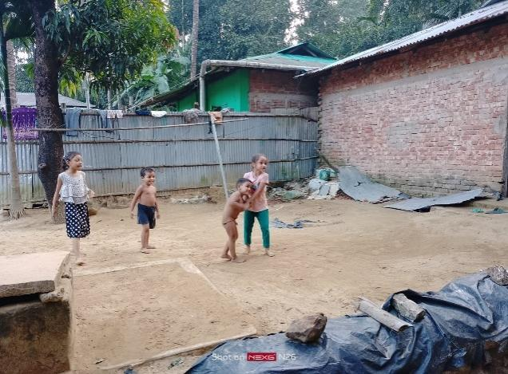
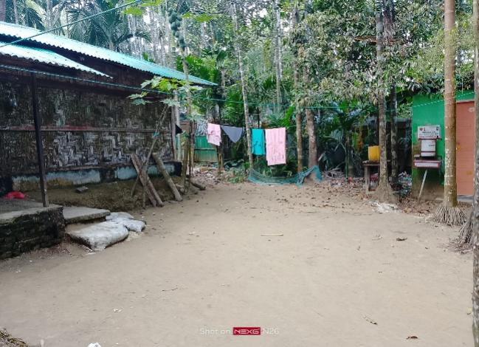
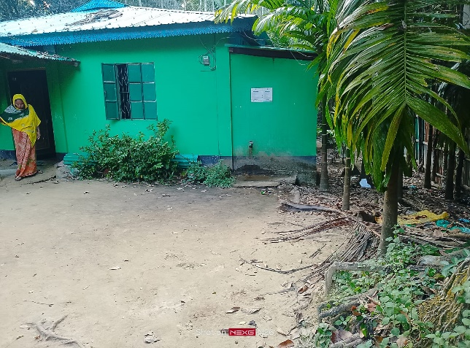
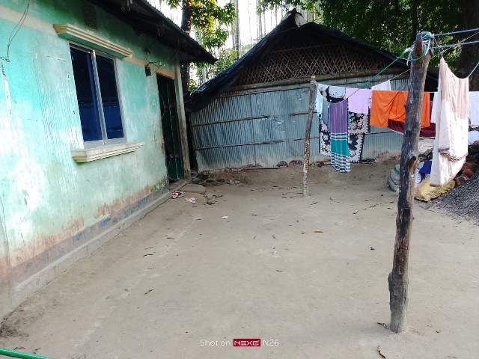
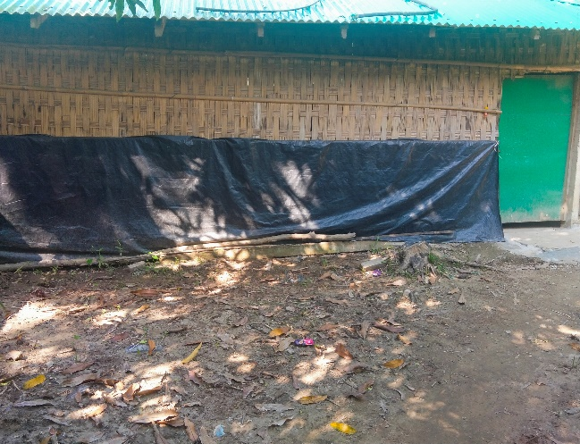
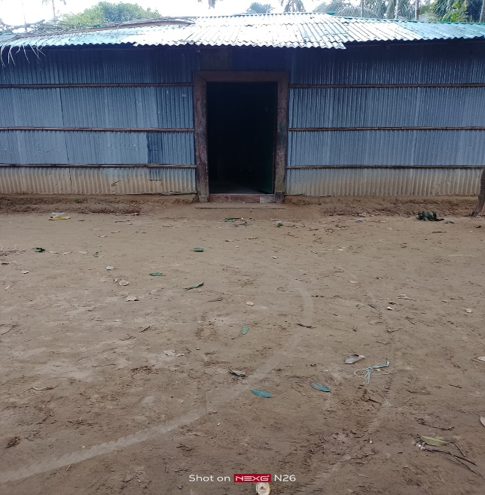
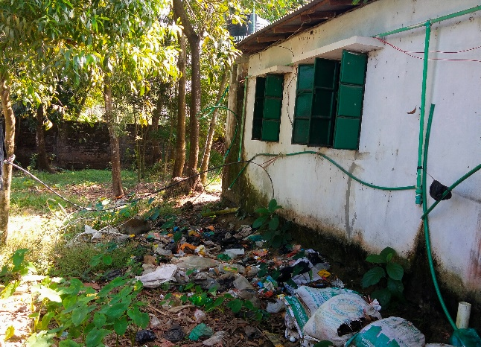
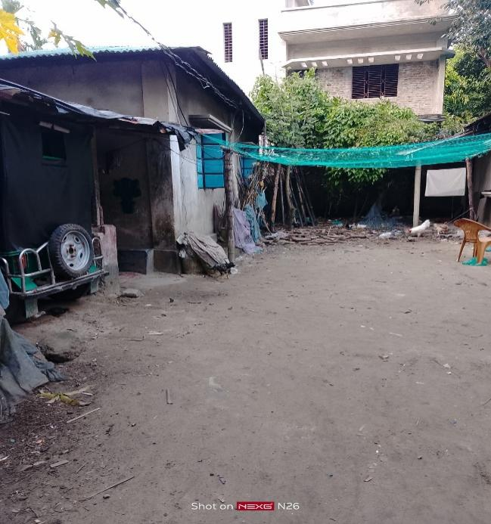

Figure_01: Pictorial presentation of proposed site locations of RWHS, Teknaf Upazila, Cox’s Bazar
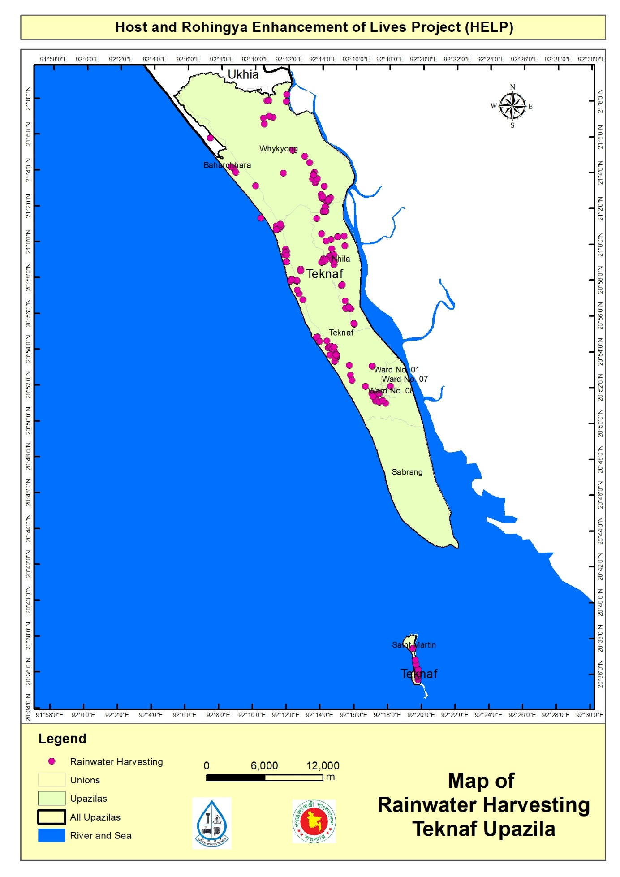
Map_01: Proposed location Map for Household Rainwater Harvesting Systems at Teknaf Upazila, Cox’s Bazar

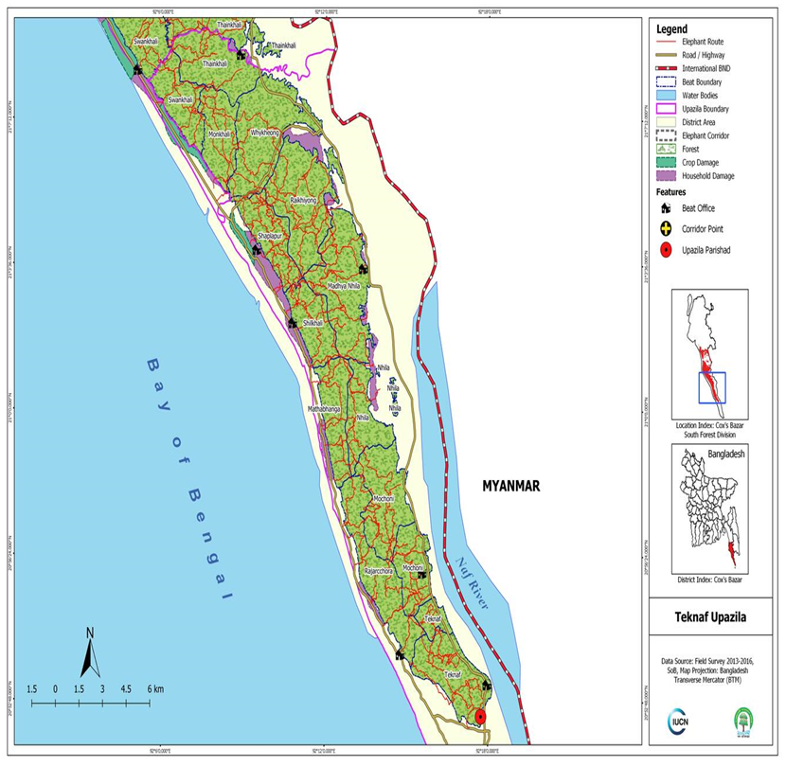
Map_02: Map of Elephant Migration Road/ Presence around, Teknaf Upazila, Cox’s Bazar (ref. IUCN report 2016)

Work Package: HELP/WD-54 (Installation of Rainwater Harvesting System Scheme)

- Environmental and Social Screening Report
4.1 Section A: Sub-Project Overview
RWHS Location: This sub-project area is located under Sadar, Whykong, HNila, Saint Martin and Baharchara Union of Teknaf Upazila, Cox’s Bazar. This E&S screening report comprises of 200 nos. Rainwater Harvesting System (RWHS) will be installed in the mentioned host community, Teknaf area. Most of the sites are plain land and some areas with medium to highland. Available LGED’s pucca road, Marine drive, HBB road, earthen road or footpaths in the targeted area.
Land ownership:
Type- A and Type-C of RWH systems are proposed for the individual Household and all components will be installed in the user’s premises. For this purpose, around 14 sqm. land is required for the installation of RWH system.
Expected construction period: 09 (Nine) months.

Description of project intervention area and project influence area with schematic diagram (where relevant, indicate distance to sensitive environmental areas such as elephant corridors, water bodies, etc. and historical or socio-cultural assets):
Adjacent to the scheme site under the RWH system option sub-project intervention area:
- Impacted area: Approx. 46 square meters per RWH
- No structures, trees and livelihood will be affected.
- Host community habitat, other assets relocation is not required.
- Influence area: According to Layout diagram, the influence area is within the scheme area of 46 square meter per RWH system
- Environmental sensitivity: Within the influence area of the sub-project no historical sites were identified. There is no evidence of presence of elephants in the sub-project influence area (checked with local IUCN representative).
vi) All selected RWH locations have a one alternative locations. Alternative locations don’t have available scope of roof top catchment area

4.2. Section B: Environmental Screening

B.1: Environmental feature of sub-project location
Description of cultural properties (if applicable, including distance from site):

At the proposed RWH system sub-project scheme areas, available Primary Schools, Collage, Local Bazar, Club, Grocery shop etc. were found. Apart from this, also found some natural forest land, Sea beach and offshore areas with Jhau forest which are far away from the proposed sites, BHH, culvert and RCC pucca, HBB or earthen road. This selected land is almost plain and close to the LGED – UP HBB and pucca roads are existed close to the scheme area. In this scheme area, no wild animals (elephant), birds, turtle nest, migrated habitat, migration routes exist. However, none will be affected due to project intervention within 1-2 km from proposed scheme site. No significant environmental or social disturbance is anticipated due to construction activities.
Location of environmentally important and sensitive areas:
This location is not environmentally important and sensitive. It is a densely populated area. It’s located in the bank of the Bay of Bengal (Western side) and some area is but the populous area is far away from the sea. The impacts are negative but small scale, site-specific within a relatively small area and adjustable by mitigation measures.
(1) Within/near Elephant Migration Routes Yes/No*:

No. According to UNHCR/IUCN prepared elephant migration route map (map attached), at present there is no Elephant corridor/ route due to deforestation.

(2) Potential impacts on remaining forests in/around unions Yes/No*:

No. At present the area has no natural forest. Some new plantations are seen raised by the inhabitants and by different organizations.

(3) Other issues: No more remarkable issues raised.

Dust: Ambient air quality data was not readily available, but the quality is apparently good. During day time the number of vehicle movement on the road is too high. Dust is generated in through movement of vehicles such as motor cycle, truck, mini truck, tempo, auto rickshaw, tractor, private car, CNG, trolley, tractor etc. over the road surface which causes air pollution.

Noise: Noise in the sub-project area is not a major concern because noise level is within the tolerance level. Vehicles such motor cycle, bus, truck, mini truck, tempo, auto rickshaw, tractor, private car, CNG, trolley, tractor etc. move on the road surface adjacent to sub-project during day and night. These vehicles generate noise adjacent to the sub-project area but in most cases noise within the tolerable limit.

Baseline soil quality:

The sub-project area is located mainly in reddish brown, muddy & sandy soil formation. The soils developing from the weathered sand stones tend to be sandy to clay loam. Presence of organic matter content in the soil is moderate.

Landslide potential:
(high/medium/low, with explanation):

Medium (description mentioned in Environment baseline segment).

Baseline surface water and groundwater quality (FE, TDS, fecal coliform, pH):

Surface water quality: No surface waters. Only rainwater will be collected and stored.

Groundwater quality: No Groundwater sources close to the project area.

*Data source: Secondary data and field survey

Status of wildlife movement:

None of the information was found about the wildlife movement in or across the area.

State of forestation:

It has been observed that, proposed areas and surrounding locations are clustered & scattered, but man-made tree plantation is covered the targeted HC habitats presents over there.

Summary of water balance analysis:

Please consider (i) water requirements of newly forested areas for plants' total evapo-transpiration, (ii) new settlements water supply requirement for drinking water, household use, bathing and sanitation, (iii) replenishment rate from annual rainfall etc.
After installation the proposed RWHS schemes in the area about 5-6 people will be benefited for 5 months during drought period and all the year round when rainfall is available. The average Annual rainfall in Cox’s Bazaar 3,524.1mm, average relative humidity 80%. Record high temperature was 37.2°C and low was 7.8°C (Data source BMD & BBS). During least season people of Teknaf Upazila face acute scarcity drinking water. In the study “Domestic water quantity, service level and health, second edition” by WHO 2020, White, Bradley & White (1972) suggested that a daily minimum water consumption in tropical climates of around 3 L/person. They also proposed that, at 25 °C with moderate activity in the sun (e.g. agricultural work), approximately 4.5 L would be required to maintain hydration of an active person. DPHE planned to provide drinking water supports during acute season through collection and storing of rainwater and use 5 liters per person per day and for a household having 5 members will be able use 25 liters per day for at least 5 months from November to March. Calculation of a “Type-A” and “Type-C” Rainwater Harvesting System, Quantity of rainwater collection would be 3750 liters (5 liters per person per day for a family comprised of 5 members for 5 months. So that the monthly and annual quantity of rainwater would be harvested according to the formula: Qty of water (Cum or Liter) =Catchment Area (A) X Average Rainfall X Runoff Factor as follows:
Month | Roof/Catchment area (sq. m) Type-A and Type-C | Average Rainfall (mm) | Run off factor | Harvested Rainwater (Cu. M.) | Quantity (Lt)
January | 46 | 6 | 0.8 | 0.2208 | 220.8
February | 46 | 11 | 0.8 | 0.4048 | 404.8
March | 46 | 21 | 0.8 | 0.7728 | 772.8
April | 46 | 55 | 0.8 | 2.024 | 2024
May | 46 | 321 | 0.8 | 11.8128 | 11812.8
June | 46 | 970 | 0.8 | 35.696 | 35696
July | 46 | 1215 | 0.8 | 44.712 | 44712
August | 46 | 932 | 0.8 | 34.2976 | 34297.6
September | 46 | 496 | 0.8 | 18.2528 | 18252.8
October | 46 | 289 | 0.8 | 10.6352 | 10635.2
November | 46 | 54 | 0.8 | 1.9872 | 1987.2
December | 46 | 12 | 0.8 | 0.4416 | 441.6
Annual quantity of Rainwater harvested |  |  |  | 161.2576 | 161257.6
The details about the proposed Rain Water Harvesting Filter- specification, filtration process and functional efficiency: The proposed rainwater harvesting filter having 6 liters of inside volume capacity containing 2 types of filters: (1) primary filter of mesh size 100 and (2) the secondary filter of 5 microns which can perform efficiently the flow rate at 5 liters/second with 2-meters head having inlet Dia of 1.5 inches. Rainwater from the rooftop surface is captured and directed into the filter system through a 2 inches inlet diameter pipeline.
During movement of rainwater, primary filter (mesh size 100) captures the large size particles and pass into the secondary filter area (size of 5 Microns) which separate the smaller particles (impurities and contaminants present in the rainwater) effectively and then the clear water is stored in the filter’s vacuum space (6 liters capacity volume) then the cleared water moves into the reservoir tank for storing and use.

4.3. B.2: Pre-construction Phase:
(RWHS concerned Construction Waste, Sludge issues -ESS3):
Information on Ancillary Facilities (e.g., status of access road or any other facility required for sub-project to be viable):

RCC/pucca and earthen road is very close to the proposed RWH scheme location on that, herringbone bond, pucca, earth road runs by the sub-project area which is the most feasible way of carrying construction materials (pipes, bricks, cement, rods, gravel, overhead tank, wooden frame and bentonite sacks, etc.) to the construction site.

Requirement of accommodation or service amenities (toilet, water supply, electricity) to support the work force during construction:

Prior to commencement of construction work, contractor shall arrange accommodation facilities with toilet, water supply, electricity for the associates’ working personnel.

Possible location of labor camp:

Within the RWHS scheme area and very close to the sub-project sites.

Requirement and type of raw materials (e.g., sand, stone, wood, etc.):

i) Bricks, ii) Sand iii) Cement iv) uPVC pipe v) Gravel vi) water vii) Bamboo & wood viii) Pump set etc. are the most common type materials used in RWHS construction and installation process.

Identification of access road for transportation (Yes/No):

Yes. Most of the RWH systems sites beside 12-15 ft wide LGED Pucca Road and HBB roads are available and close to the proposed sites.

Location identification for raw material storage:

Adjacent to the RWH system locations are very close to the construction sites and far away from steep slopes.

Type and quantity of waste generated (e.g., Solids wastes, liquid wastes, etc.):

Solid type waste: i) Bricks, ii) Sand iii) Cement iv) uPVC pipes v) Nut & bolt vi) PVC solvent cement vii) Bamboo & wood viii) Gravel. In the RWHS pre-construction is around 30 kg of waste may be produced for each site.

Approx. area (in square meters) of vegetation and soil in the right-of-way, borrow pits, waste dumps, and equipment yards:

No valuable vegetation and plants presence in proposed construction sites (approx. 5 sq. meter land per RWHS).

Possibility of stagnant water bodies in borrow pits, quarries, etc., encouraging for mosquito breeding and other disease vectors:
(High/Medium/Low with explanation):

Medium. No significant accumulation in borrow pits reported around or adjacent to the RWHS sub-project area. In the design and scheme planning, it has been taken adequate measures to prevent mosquito and other harmful pests & breeding places. By placing mosquito - proof mesh, insect/ pest sealed lids and. In the RWHS an effective drainage system, safe movement floor provision has been considered. The concerned household and targeted community been sensitized on the cleanliness of the RWHS plant. Stagnant water for short period of time during and after rain events may happen.

Disturbance or modification of existing drainage channels (rivers, canals) or surface water bodies (wetlands, marshes):
(High/Medium/Low with description):

Medium. The proposed sites are located far away from Naf River and the Bay of Bengal So that this river and channel shall not be affected by discharging waste and unwanted materials generated from construction activities.

Destruction or damage of terrestrial or aquatic ecosystems or endangered species directly or by induced development:
(High/Medium/Low with description):
Medium. The proposed site of the scheme intervention, avoid the area with presence of terrestrial, aquatic ecosystems and endangered species and there is no any possibility of destruction or damage of lives and endangered species and ecosystem. So that the impact is very low in the sites. Species and ecosystems have not been reported whose lives or movement may be disturbed (i.e., Insects - Ant, bees, earthworm, reptiles, turtle, birds etc.) by the scheme activities.
Major Terrestrial Fauna species found in sub-project area are Common Toad (Bufo melanostictus), Yellow Speckled Wolf Snake (Lycodon zara), Red-vented Bulbul (Pycnonotus cafer), Red-wattled Lapwings (Vanellus indicus) and Hoopoe (Upupa epops). Some Aquatic fauna also found in the sub-project area are Pond Heron (Ardeola), Little Cormorant (Phalacrocorax niger), White-breasted kingfisher (Halcyon smyrnensis), Common King Fisher (Alcado athis).

Major Terrestrial flora in sub-project area is Acacia (Acacia mangium), Eucalyptus (Eucalyptus citriodora), Bamboo (Bambusa sp.), Areca nut (Areca catechu), Fern (Drynaria quercifolia) and Date palm (Phoenix Sylvestris). Some Aquatic flora also found in the sub-project area are Floating Gress (Echinoclo acolonum), Kalmi (Ipomoea aquatic), Kachurypana (Eichhornia crassipes) and Topapana (Pistia strateotes).

Activities that can lead to landslides, slumps, slips and other mass movements in road cuts:

There is no such activity that cause landslide.

Describe possible traffic movement impacts on (unwanted) light, noise and air pollution: No traffic movement impacts on light but low effects of noise and air pollution.

High = Likely to cause long-term impacts or over large area (>1.00sqkm); Medium = Likely to cause temporary damage or over moderate area (0.5 to 1.00 sqkm); Low = Likely to cause little, short-term damage and over small area (<0.50 sq.km)
4.4. B.3: Construction Phase
Type and quantity of waste generated (e.g., Solids wastes, liquid wastes, etc.):
Solid waste:

i) Bricks, ii) Sand iii) Cement iv) uPVC pipes v) Iron nut & bolt vi) PVC solvent cement vii) Gravel viii) Bamboo & wood and. It is difficult to give exact figures of construction waste produced on a HH RWH system. However, 30 kg of waste may be produced from each site.

Liquid waste:

During construction period, west will be generated from labor camp for short period of time. It is estimated that, around 30 kg of waste may be produced from each RWHS site.

RWHS site Construction waste and Sludge disposal Planning:

The E&S team has been developed a comprehensive mitigation plan regarding RWHS site Construction waste and Sludge disposal. e.g. Collect and remove debris regular basis, Waste disposal systems (no disposal on slopes or drainage lines); Follow daily housekeeping at site; Sludge disposal in every three months; Households to dispose the wastes and sludge ti the designated compost pit or soak-way. It is strictly prohibited to dump wastes at nearby drains and water-bodies.

Type and quantity of raw materials used (wood, bricks, cement, water, etc.):
Raw materials:

i) Bricks, ii) Sand iii) Cement iv) HDPE pipes v) uPVC pipes with fittings vi) Nut & bolt vii) PVC solvent cement viii) gravel ix) water x) plastic tanks xi) Bamboo and other electro-mechanical equipment by the concerned contractor firm.

Quantity:
It is difficult to provide exact figures of construction materials that will be used in the construction site. However, 30 kg of raw materials may be required for each site.

Approx. area (in square meters) of vegetation and soil in the right-of-way, borrow pits, waste dumps, and equipment yards:
No valuable vegetation presence in proposed sub-project construction sites. So, vegetation will not be affected by construction work.

Possibility of stagnant water bodies in RWHS Tanks, borrow pits, quarries, etc., encouraging for mosquito breeding and other disease vectors:
(High/Medium/Low with explanation):

Medium. Under the establishment of RWHS interventions, it is strictly and importantly considered the safety and cleanliness of water of reservoir to avoid household and community health hazard (OHS) by contaminating the water and the possible stagnant water around the scheme premises. By placing mosquito - proof mesh, insect/ pest sealed lids and. In the RWHS an effective drainage system, safe movement floor provision has been considered. The concerned household and targeted community been sensitized on the cleanliness of the RWHS plant. Stagnant water for short period of time during and after rain events may happen. The top soils in the sub-project are is sandy or sandy-loam and the water will drain away quickly.

Disturbance or modification of existing drainage channels (rivers, canals) or surface water bodies (wetlands, marshes):
(High/Medium/Low with description):

Medium. It’s an island of the Bay of Bengal. But it should not be affected due to construction activities.

Destruction or damage of terrestrial or aquatic ecosystems or endangered species directly or by induced development:
(High/Medium/Low with description):

Medium. Under these scheme establishment interventions, the effect of destruction or damage of lives and endangered species ecosystem is very low in the site area. Species and ecosystems have not been reported whose lives or movement may be disturbed (i.e., Insects - ant, bees, earthworm, reptiles, turtle, birds etc.) by the scheme activities.

Activities that can lead to landslides, slumps, slips and other mass movements in road cuts:

Construction of the sub-project components can lead to low scale effects of land slide/slips. The impacts are expected to be negative, short-term, site-specific within a relatively small area and can be minimized by mitigation measures.
Erosion of lands below the road bed receiving concentrated outflow carried by covered or open drains:
(High/Medium/Low with description):

Medium. Potential erosion may occur when moderately to highly sloping terrains are disturbed for the construction of RWHS sites. The impacts are expected to be negative, small scale, site-specific within a relatively small area and minimized by mitigation measures.

Anticipated impacts on ground and surface water encouraging for disease vectors:
(High/Medium/Low with explanation):
Medium: Possible risk due to leaking or overflow of sludge from the septic tank and contaminated diseases vectors goes into the nearby drains, water-bodies or dumping into the environment or in nearby dug holes. If properly managed the leaks and sources of contamination the impact is low.
Describe possible traffic movement impacts on (unwanted) light, noise and air pollution:

No traffic movement impacts on light as all vehicular movement will be during day time. Some temporary, localized effects of noise and air pollution can occur due to truck movements.

High = Likely to cause long-term impacts or over large area (>1sqkm); Medium = Likely to cause temporary damage or over moderate area (0.5 to 1sqkm); Low = Likely to cause little, short-term damage and over small area (<0.5sqkm)

4.5. B.4: Operation Phase:
Activities leading to health hazards and interference of plant growth adjacent to roads by dust raised and blown by vehicles:

Dust may be produced but not significant if care given after collection of water and if the roof top. No dust will be Increase in dust may cause health problems to workers at O&M period. Improper use of personal protective equipment (PPE) and lack of safety procedures may cause injuries. Site-specific within a relatively small area and adjustable by mitigation measures.

Chance of long-term or semi-permanent destruction of soils:
(High/Medium/Low with description):

Low. Some localized semi-permanent destruction of soils may occur during maintenance of water option and collection points.

Possibility of odor and water, soil quality impacts from SWM and FSM disposal system
(High/Medium/Low with description):

N/A

Possibility of stagnant water bodies in borrow pits, quarries, etc., encouraging mosquito breeding and other disease vectors:
(High/Medium/Low with explanation):

Low. There are low possibilities of stagnant water occurring in the operation period if there are leakages in the RWH scheme, including overflow of overhead tanks.

Likely direct and indirect impacts on economic development in the project areas by the sub-project:

Local labor will be involved in maintenance activities. Safe drinking water supply will be helpful reduce water scarcity crisis of the host community and improve their health condition.

Extent of disturbance or modification of existing drainage channels (rivers, canals) or surface water bodies (wetlands, marshes):
(High/Medium/Low with description):

Low. It’s an important landscape beside the Bay of Bengal so that nothing shall be dumped in the drainage affected by the waste generated from the construction activities.
Extent of destruction or damage of terrestrial or aquatic ecosystems or endangered species directly or by induced development:
(High/Medium/Low with description):

Low. Operation and maintenance activities of Rainwater Harvesting system will be localized and temporary in nature. Species and ecosystems have not been reported whose lives or movement may be disturbed (i.e., Insects - Ant, bees, earthworm, reptiles, turtle, birds etc.) by the scheme activities.

Activities leading to landslides, slumps, slips and other mass movements inroad cuts:

Runoff paths may cause localized erosion. Also, leaking pipes can lead to slope instability.
Erosion of lands below the road bed receiving concentrated outflow carried by covered or open drains:
(High/Medium/Low with explanation):

Medium. Medium possibility to erosion of land at RWHS site.

Describe possible traffic movement impacts on (unwanted) light, noise and air pollution:

Localized impacts on noise and air pollution from maintenance vehicles movement can occur. All maintenance works will be conducted during daytime – so no light impacts expected.

Type and chance of hazards affecting sub-project and labor camp location (e.g., flooding, landslides, cyclones, etc.):
High/Medium/Low with description):

Hazard Type(s): Cyclone, Flash Floors and the chance of natural hazards affecting RWHS community Water Option structure and labor sheds is moderate and only possibility as seasonal basis. (details description on hazards has been mentioned in Environment Baseline segment)

Accessibility to the closest disaster shelter (Easy/Difficult with description):

In the RWH system operations phase the accessibility to the closest disaster/ cyclone shelter is almost easy for the community. Noted that active cyclone shelters, fire service center are closer to the sub-project areas.

High = Likely to cause long-term impacts or over large area (>1sqkm); Medium = Likely to cause temporary damage or over moderate area (0.5 to 1sqkm); Low = Likely to cause little, short-term damage and over small area (<0.5sqkm)

5. Section C: Social Screening:

5.1. C.1 General Labor Influx Screening

Key Screening questions | Aspects to Consider
Will the project potentially involve an influx of workers to the project location, and will the influx be considered significant for the local community? | No. Require number of total skilled and unskilled Labor for each RWH system is respectively 1-2 and 2-5. All those labors will be engaged from the Host community. No foreign labor will be engaged. All the skilled labor will be stay at labor shed if required. The size of the labor shed will be 120 square feet. So, no significant influx to be considered for the local community.
Is the project located in a rural or remote area? | Yes. The project location is in a rural area. Local Government (Union Parishad) authority and belongs to Sadar, Baharchara, Hnila, Saint Martin and Whykong Union under Teknaf Upazila mostly are semi forward to remote area. Beneficiaries are estimated around 5-6 per RWHS. The frequency and extent of the communication between the local community and outsiders are normal, and not controlled by any authority.
Based on the socioeconomic, cultural, religious and demographic qualities of the local community, population and the incoming workers, is there a possibility that their presence or interaction with the local community could create adverse impacts? | No. It is expected that the presence of the skilled and unskilled local labor (HC) will not create any adverse impacts. The project will benefit the targeted host communities. There will be a code of conduct for the labors to follow, which will be monitored by the PMU and local DPHE on a regular basis.
Consultation with Host Community People and relevant stakeholders (SH) | During screening and site identification local DPHE and PMU has conducted Two (2) consultation meetings with primary and secondary stakeholders and HCs. The stakeholders include LGIs (UP Chairman, Councilors, WATSAN committee, Local Elites, Contractor team and targeted host community. In addition to the above-mentioned meetings, the E&S team & local DPHE arranged many consultations with male and female members of the concerned host communities. Through the coordination and linkage activities of the project, some experience sharing meetings, individual household visits and other consultation meetings were held.

5.2. C.2 Land acquisition and stakeholder screening
Probable Involuntary Resettlement Effects | Yes | No | Not Known | Remarks
Involuntary Acquisition of Land/ Land Donation/ Land Taking
1. Will there be any land acquisition? |  | √ |  | No. It requires around 5 sq. meter (for installation of RWH system, Reservoir tank)
2. Is the project construction site known? | √ |  |  | Yes, site location is known and selected with consent of respective HH & Local DPHE and WATSAN committee.
3. Who manages the land? | √ |  |  | Land is owned / possesses by the HH as homestead land within his/her premises. No land acquisition required. (see site location photos).
4. Will easement be utilized within an existing Right of Way (ROW)? CRP (Common Resource Property) | √ |  |  | In the proposed HC area provision of Right of Way (ROW) is within this proposed RWHS scheme under HELP.
5. Will there be loss of Community people house, agricultural carps, trees, and other productive or fixed assets due to project intervention? |  | √ |  | No: habitat/ shelters will be affected. During construction of RWHS, no asset, or crop land will be affected, contractors are responsible to mitigate the impacts following the RPF.
6. Will there be loss of businesses or enterprises due to project intervention? |  | √ |  | No
7. Will there be loss of income sources and means of livelihoods due to project intervention? |  | √ |  | No
Involuntary restrictions on land use or on access to legally designated parks and protected areas
8. Will people lose access to natural resources, communal facilities and services? |  | √ |  | No
Information on Displaced Persons:
9. Any estimate of the likely number of persons that will be displaced by the Project? [√ ] No [] Yes If yes, approximately how many?
10. Are any of them poor, female-heads of households, or vulnerable to poverty risks? [√] No [ ] Yes
11. Are any displaced persons from indigenous or ethnic minority groups? [√ ] No [ ] Yes
12: Who are the stakeholders of the project? Please provide a summary of consultation meetings with stakeholders and the affected community.

Under HELP Rainwater Harvesting System of Teknaf Upazila the key stakeholders are local community, Labors, communities/organizations within the project influence area indirectly affected by project activities. Also, the, relevant Government line departments/agencies, Environment and Forest Department and, NGOs involved at WASH interventions of host communities. For determining the environmental and social impacts associated with RWHS implementation. The PMU has been providing importance on stakeholder’s engagement of the scheme area. To collect local scenario of water options for baseline conditions, perceptions of the community regarding impact significance, propose meaningful mitigation measures. During E&S Screening, an attempt has been made to consult with relevant stakeholders to obtain their views on RWHS interventions.

The Community consultations were conducted through a mix of conventional approach, meeting with male and female members, one-to one interview, during the environmental and social survey of the proposed conformity with the ESS guidelines. However, 2 (Two) consultations were conducted with local community have been conducted on RWHS (Appendix-2).

Aiming to establish the RWHS, UP and DPHE assigned HC area by the respective WATSAN Committee, under HELP (DPHE part) initially GIS specialist, hydrogeologist located the scheme area, E&S consultants, By the consultations with the targeted host community on the following issues: HELP project introduced Social and Environmental safeguarding, grievance redress mechanism (GRM), possible social environmental and economic effects, livelihoods options. Also, some discussions held on minimizing the laborer conflict among local host communities, WASH establishments, hygiene, gender-based violence (GBV), forestation, elephant corridor, waste, sludge & waste management, benefits of RWHS schemes. The respective Local elites, community man & women also participated in the consultations meeting.
Noted that, most of these interventions are to be situated on the HC areas individual household member occupied land. The E&S screening team have followed ESS and PMU consent.

In the consultation session E&S aspects of the project interventions, above-mentioned issues were discussed as potentially occurring at the project sites of HC. The community welcomed and appreciated the HELP initiatives on RWHS. Safe water and improved sanitation were considered as one of their priority needs for secured and better livelihoods aspects. They opined that there are no Elephant corridor and no scope of Elephant/Human conflict over there. Through the consultation meeting, the host community were made aware of and sensitized on E&S safeguard issues, precautions, child safety, any chances of displacement of various structures, relocation of local institutions if any objection and complaints.

The community consultations were conducted with the following objectives: (i) to intrude awareness of the stakeholders on Rain Water Harvesting System sub-project (ii) to identify the need and concern beneficiaries, (iii) to assess cultural patterns and behavior of local communities. Stakeholder consultation was targeted at people/communities who may – directly or indirectly, positively or negatively- be affected by the outcomes of the RWHS. The consultations were conducted at two different tiers of stakeholders: Local people and different organization representatives who are concerned about the RWHS. All of the proceedings and interactions of consultation have been recorded.
Feedback, Suggestions, and Recommendations of the Participants:

The participants’ feedback, suggestions, and recommendations listed below:

- During consultation the participants were requested to provide support to establish Rainwater Harvesting System to have provision of safe water at Teknaf Upazila and cooperate in O&M properly.
- The participants opined to search employment opportunities to engage labor from local community so that they can manage their livelihood.
- During construction work they also request to maintain and obey the proper safety and security measures

Most of the participants opined that RWHS will make them benefited through safe water availability at proposed areas.

Individual level consultation with project interest and influence parties (UP, WATSAN Committee, Local DPHE) representatives were conducted in consistence with consultation objective during sub-project selection stage to have their idea, concern, segregation about the proposed sub-project. Consultation outcome with them is consolidated here in below:

Responds of WATSAN Committee members / UP Chairman:

UP and WATSAN Committee members are ready to support HELP-DPHE, if they face any obstacle to implementing the RWH system;

Create opportunity to engage the Local community in implement activities of the RWHS sub-project.

To keep temporary bin for waste collection during scheme implementation should arrange and regular disposal also need to be assured;

Construction wastes to be generated should be disposed regularly at designated sites.
13: What social and cultural factors affect the ability of stakeholders to participate or benefit from the proposed policy or project?

None.

14: Are project objectives consistent with their needs, interests and capacity?

Yes, the HELP project’s objectives are consistent with the respective stakeholders, host community, needs, interests and capacity in the project areas.

15: What will be the impact of the project or sub-project on the various stakeholders, especially women and vulnerable groups?

In the whole E&S screening process (ESS5), it has been revealed that a very positive impact would be created in the host community by establishing the Rainwater Harvesting system sub-project. The E&S team has considered to minimize the vulnerability of the host community especially the old aged person, disabled, and children as well the women as the vulnerable group. Under the sub-project of the host community, the stakeholder’s perception is that the overall project impacts will be positive and they expected to have the project be implemented. The influx is straining existing infrastructure and degrading the already resource-constrained social service delivery system and the overall environment at HC areas. Access to improve water quality and quantity is a priority of these sub-projects. Some households may struggle with the operations & maintenance, cleaning, water storage safely, required costs for repair / O&M etc.
Positive Impact:
In the context of environmental and social aspects, HELP project RWHS component it has been identified and welfare & supportive plan, for the adjustment of host communities in Teknaf, Cox’s Bazar. Provided emphasis especially to address & establish need-based Social Protection system, ie. Person with disabilities (PWD), old & elderly people, widows, female-headed households, ultra-poor segment of the targeted community which would organize the victim vulnerable groups.
The RWHS schemes at different locations of Teknaf area people will be access to safe water for drinking & cooking which will lessen their suffering of water scarcity. This RWH system will ensure pollution free potable water for the targeted community. Through the extensive and root-level awareness and BCC campaign the community will sensitize on effective utilization RWHS and its timely O&M by their own effort.

Negative Impact:
Due to operation of RWHS scheme, the adverse impact will be almost zero. There will have no any significant negative impact. If any impact anticipated that will be short-term and localized. Further, if construction site is not fenced properly, then children, pet animal may face accident.
16: Has social risks might affect project or sub-project success?
As per the visit findings and consultation meeting with targeted host community and different stakeholders, Under the RWH system screening process it has been revealed that very few social risks might occur to establish the scheme interventions.
GRM and GRC (ESS2 & ESS4):
Under the HELP-DPHE, considering the ESS2 & ESS4 an effective, practical grievance redress mechanism has been introduced, including simple appeal process, complaint channels, confidentiality issues. In order to implement the RWHS scheme undertaking, additional labor from outside such as technicians, masons will be engaged over the site, It might be caused a potential risk of local communal and social conflict.
The gender and GBV, SH issues (i.e., human trafficking, eve teasing, etc.) are being addressed through need-based activities. As a mitigation measure, the Social Safeguard team and grievance redress committee (GRC) will be developed. A complete Gender action plan has already been developed and approved; a full time Social Development consultant has been assigned to oversee and solicit /mitigate the GBV based issues for this community water option sub-project. The respective E&S based GRM, is keeping abreast on GBV, SH occurrences and will guide the community through consultation meetings and counseling. The E&S team and local DPHE will concern consideration on the proposed host community areas on social, cultural, religious, gender, disabilities, orphaned and vulnerable children related sensitive issues. However, by adopting the project E&S safeguard and through community consultation, the LGIs-UP, community leader and local DPHE representatives may determine possible ways and options to mitigate solicit the constraints and risks during the RWHS implementation.

5.3. C.3. Social Capital Format
The objective is to list various types of social institutes/bodies working in the host community, intended RWH system influence areas to enlist them for the possible inclusion in the management, and monitoring of the projects. List the name of social institutes/ bodies under the given categorization along with the following information. Use separate sheet for each category of social institute/body. The information can be collected through secondary sources such as LGIs and UN agencies or different development organizations that are involved with the Rohingya crisis projects, etc.
Type of Social Institutes/bodies | Name of Institution | Contact Person and Address and phone number | Primary areas of Work | Coverage areas in the camp and communities
Government Organizations | SAE, DPHE  UNO  EE, DPHE  DC | Md. Faruk Hossain  Sub-Assistant Engineer, DPHE, Teknaf, Cox’s Bazar  farukce69@gmail.com  --------------------------------------------  Sk. Ahsan Uddin  UNO, Teknaf Upazila,  Cox’s Bazar  unoteknaf@mopa.gov.bd  ……………………………………..  Md. Ibne Mayaz Pramanik,  Executive Engineer, Cox’s Bazar,  mayaz,pramanik@gmail.com  ------------------------------------------  M. A. Mannan  DC, Cox’s Bazar  dccoxsbazar@mopa.gov.bd | Overall Coordination of GOB dept, Dev partners, NGO, INGO, Volunteers,  Management of HOST Crisis in BD. Refugee Relief and Repatriation, Site management, | Host Community, synchronizing with Host, E&S aspects, Elephant corridors, conserves NR. Establish proper road communication.
National Organizations | Not yet on boarded | the database web link:  https://www.humanitarianresponse.info/en/operations/bangladesh/document/wash-sector-coxs-bazar

6. Section D: Environmental and Social Screening Summary

6.1. Environmental Screening Summary:
Based on the above environmental and social screening, potential impact of implementing the proposed intervention on different parameters of environmental and social aspect with their consequence; mitigation measures and suggestive monitoring plan with responsible parties of implementation and supervision of Rainwater Harvesting system sub-project have been summarized as below:
Section | Main Env. and Social Impacts | Impact Significance* | Suggested Mitigation Measures | Person/ Institution Responsible | Monitoring Suggestions
 |  |  |  |  | Indicators | Frequency
1: Sub-Project Interventions | Air Quality | Under the sub-project intervention the overall score is low. | - Limited earthworks shall be ensured;  - Watering of dry exposed surfaces and stockpiles of aggregates at least twice daily, as necessary;  - More details are provided in ESMP  - Very few constructions vehicles movement will be there in access roads and work sites. | Construction Contractor monitored by Environmental Consultant of PMU | - Location of stockpiles;  - Number of complaints from stakeholders; Covering of trucks;  - Records of air quality inspection; | If possible, air quality test (CO, PM) once in the construction period in the winter season.
1: Sub-Project Interventions | Soil contamination and erosion | Under the sub-project intervention, the overall score is moderate. | - Making sure prior to schedule excavation to reduce erosion when there is minimal rainfall soil  - Very few excavations will require so no remarkable soil erosion is expected  - Disturbed soil will be covered with vegetation/geo-textile membrane to hold the soil  - The earthwork sites where the exposed land surface is vulnerable to runoff shall be consolidated and/or covered.  - More details provided in ESMP | Construction Contractor monitored by Environmental Consultant of PMU | - No visible degradation to nearby drainages,  - Canals or water bodies due to soil erosion. | Weekly, especially after rain events.
 | Hydrology (Rainwater) | Under the sub-project intervention, the overall score is low. | - All precautions to store Rainwater free from chemicals/oil/fuel properly so that no chance of contamination.  - Monitor water quality according to the environmental management plan.  - More details provided in ESMP | Construction Contractor. Shall be monitored by Environmental Consultant of PMU | - Records of water quality inspection; Water Quality Test  parameters like pH, TSS etc. | If needed water quality test after reserving the tank.
2. Pre-construction Phase | Sanitation, water supply | Under the sub-project intervention, the overall score is low. | - Provide suitable housing, adequate supplies of potable water, and toilet and bathing facilities within the housing area for the assigned laborer.  - Provide means for disposing of wastewater from toilets, baths and food preparation areas either through a septic tank and soak away, or holding tank with removal by vacuum truck.  - More details provided in ESMP. | Construction Contractor and monitored by Environmental Consultant of PMU | - Site-specific H & S Plan;  - Records of supply of uncontaminated water;  - Record of Health & Safety orientation training;  - Condition of sanitation facilities for workers | Visual inspection monthly basis
2. Pre-construction Phase | Impact on Existing drainage: drain may block, due to storage of construction materials on or next to the drain. | Under the sub-project intervention, the overall score is moderate | - Construction materials will not be allowed to store close to the drains  - Regular monitoring is essential  - If any materials fall within the drain, contractor will clean the drain immediately. | Contractor and monitored by Environmental Consultant and PMU | - List of materials and sources of materials;  - Storage site away from the drain | Weekly
2. Pre-construction Phase | Transportation impacts | Under the sub-project intervention, the overall score is moderate. | Require no significant vehicle movement.  - Speed needs to be limited to 20kmph  - Contractor’s responsibility to verify the suitability carrying, loading and unloading of materials by trucks or others transport and head load arrangement. | Construction Contractor and monitored by Environmental Consultant and PMU | - Check the vehicle pool.  - Record of regular inspection.  - Record of accidents/ incidents | Monthly monitoring.
2. Pre-construction Phase | Storage of construction materials can cause pollution or land slips | Under the sub-project intervention, the overall score is moderate. | - The contractor shall submit a plans for storage of hazardous materials (fuels, oils, and chemicals) and emergency procedures.  - Proper stockpiling/ storage of construction materials at the site by the contractor & approved by the Environmental Consultant of PMU.  - Proper covering of dust producing materials with polythene sheet,  - Spills/ hazardous substances should be disposed of at the site proposed by the contractor & approved by the Environmental Consultant of PMU to avoid soil/ water contamination. | Contractor and monitored by Environmental Consultant and PMU | - List of materials and sources of materials;  - Storage site away from steep slopes and has proper bonding | Weekly
 | Destruction/ damage of terrestrial/ aquatic ecosystems | Under sub-project intervention, the overall score is moderate. | - Vegetation clearing work will be done only where sub-project intervention will take place.  - More details provided in ESMP | Contractor and monitored by Environmental Consultant of PMU | - Ground openness in the intervention area | Weekly
3. Construction Phase | Wastes (CI sheet cutting, UPVC Bricks, etc.) | Under the sub-project intervention, the overall score is moderate. | - Wastes must be placed in the designated bins and be regularly emptied.  - All waste must be removed from the site and transported to a disposal site.  - More details provided in ESMP | Construction Contractor and monitored by Environmental Consultant of PMU | - Complaints from community;  - Regular inspect and keep record of waste management | As work weekly progresses
3. Construction Phase | Storage of materials  (Creating dust/ air pollution spillage of liquid | Under the sub-project intervention, the overall score is moderate. | - By the Union Parishad and DPHE to identify the storage site and other requirements, which will be approved by PMU and consultants  - More details provided in ESMP | Construction Contractor and monitored by Environmental Consultant of PMU | - List of materials and sources of materials; | Monthly basis during implementation phase.
3. Construction Phase | Impact on Drain & Aquatic Environment by discharging solid & liquid wastes from construction site & labor camp into nearby drain & through the drain those wastes can fall into canal water | Under the sub-project intervention, the overall score is low | - Generated waste and construction debris shall be properly disposed in accordance with the approved designated disposal site(s);  - Separate waste collection bins, for organic and inorganic wastes, shall be provided throughout the construction sites, whereby all waste collection bins be regularly emptied and cleaned;  - Contractor will be responsible to control the workers from discharging of construction waste into water bodies. | Contractor and monitored by Environmental Consultant and PMU | - Frequency of emptying the waste bin  - Existence of waste bin | Monthly basis during implementation phase.
3. Construction Phase | Erosion of land | Under the sub-project intervention, the overall score is low | - Control surface run off to reduce soil erosion through mulching, temporary retaining wall made of bamboo and sheet though there are less possibilities of happening such situation.  - Safe disposal of drainage water to avoid stagnation | Construction Contractor foreman and monitored by Consultant and PMU | - No visible degradation to nearby drainages or water bodies due to soil erosion at/near sub-project site. | Daily during earth excavation work & work below GL
3. Construction Phase | Noise pollution | Under the sub-project intervention, the overall score is low. | - Consultation with affected people; not to operate noisy equipment during working and operations time (17:00 – 06:00);  - Sound suppression for equipment;  - Ear protection for workers.  - Conduct noise quality monitoring as per ESMP. | Construction Contractor and monitored by Environmental Consultant of PMU | - Number of complaints from stakeholders; Use of silencers in noise-producing equipment and sound barriers;  - Noise Level following decibel meter (dB) | Inspection by PMU and supervision consultants on monthly basis;
3. Construction Phase | Incidental or Accidental issues:  Injuries of staffs and workers in the site | Under the sub-project intervention, the overall score is moderate. | - Make sure to carry out a risk assessment on risk and possible dangers  - Make sure to provide appropriate training to the engaged staffs and labors.  - Provision to maintain proper PPE wherever necessary  - Any incidents or accidents shall be recorded, documented and reported to the Bank through PMU, HELP within 24 hours of event happened. | Construction Contractor and monitored by Environmental Consultant of PMU and update the bank through PMU/DPHE | - No of accidents or incidents, Record register | Inspection by PMU and daily update from site
3. Construction Phase | Safety Issues /impact may decline if construction management not works rightly. | Under the sub-project intervention, the overall score is low. | - Make sure to available safety materials to the construction site and all laborers adhere to safety requirements during construction.  - Safety managers monitor the construction activities on a regular basis.  - Unauthorized entry to the site area shall completely be prohibited and the site will be properly fenced with a single entry.  - Properly maintained instruments as well as hazardous materials on the site | Construction contractor | - Environmental Consultant of PMU | Regularly basis
3. Construction Phase | Air pollution | Under the sub-project intervention, the overall score is low. | - Water spraying for dust control; construction materials with potential for significant dust generation shall be covered; no smoke emitting equipment; and limiting speed of construction vehicles in access roads and work sites to maximum of 20 kph.  - More details provided in ESMP | Construction Contractor and monitored by Environmental Consultant of PMU | - Location of stockpiles;  - Number of complaints from stakeholders;  - Records of air quality inspection and test report | Air Quality: PM₁₀ PM_{2.5,} SPM and SO₂ test once in construction period.
 | New impact identified in the field | Under the sub-project intervention impact | - If any new impact identified in the field during construction shall be screened which shall be included in the ESMP  - Environmental and Social Management Plan (ESMP) will be updated as needed to address the new identified impacts.  - Updated ESMP shall be shared with the bank through proper authority. | Construction Contractor and monitored by Environmental Consultant of PMU and update the bank through PMU/DPHE | New impact and suggested measures recorded and documented for ESMP | During containment
4. Operational Phase | Health & Safety Hazard | Site staff can be seriously hurt by accidents and overall score is moderate. | - Ensure proper training given to all staff  - Ensure PPE used by staff | DPHE, XEN | - Accidents register | During containment cleaning work.
4. Operational Phase | Destruction of soil | The operation period soil damage may occur in the project areas by rainstorms overall score is moderate. | - Safeguards actions shall be taken when a rainstorm is imminent or forecast.  - More details are provided in ESMP. | Construction Contractor weekly monitored by Environmental Consultant and PMU | - No visible degradation to nearby drainages or water bodies due to soil damage at pipe laying area. | If need or possible, Site inspection weekly/2-weekly in rain season.
4. Operational Phase | Noise pollution | Overall score of the sub-project intervention is low. | - limiting speed of maintenance vehicles in access roads and work sites to maximum of 20 kph. | Long-term responsibility shall be determined by DPHE | - Noise from maintenance vehicle | During Maintenance work (if need)
4. Operational Phase | Accident or Injuries | Under the sub-project intervention, the overall score is Medium. | Ensure proper training given to all staff  Ensure PPE used by all staff  For any accidental issue occurred in the site shall be informed to the DPHE within 24 hours of the event. | Contractor: up to contractor’s liability period Long-term responsibility shall be determined by DPHE | - Records of accidents and safety inspection; | Environmental Consultant of PMU
4. Operational Phase | Air pollution | Under the sub-project intervention, the overall score is low. | - Limiting speed of construction vehicles in access roads and work sites to maximum of 20 kph.  - More details provided in ESMP | Construction Contractor up to defect liability period. Consultant and PMU | - Dust due to vehicular movement | If need or possible, During Maintenance vehicle movement
5: Potential Natural Hazards | Cyclone | Seasonal or weather depression and the overall score is moderate. | - Measures shall be taken at any time of year when cyclones are likely to happen.  - People need to ensure the safety of valuable resources before increasing the signal.  - Organizations concerned with disaster management must be prepared. The disaster management committee at all levels shall meet in a meeting and keep all preparations for possible response activities. | Construction Contractor for monitored by Environmental Consultant and PMU  Long-term responsibility shall be determined by DPHE and PMU | - Weather Forecasting procedure/ Depression | Site inspection weekly and monthly basis.
5: Potential Natural Hazards | Flash Flooding | May occur due to runoff from rainstorms and the overall score is moderate. | - Protection shall be taken at any time of year when rainstorms are likely.  - If there is a heavy rainfall in a higher area, it affects the lower areas. Therefore, if there is heavy rainfall in any high area, advance warning measures shall be taken in the lower areas. | Contractor for monitor by Environmental Consultant and PMU  Long-term duties shall be determined by DPHE and PMU | - Weather Forecasting procedure, Rainstorms | Site inspection weekly and monthly basis on rainy season or during heavy rainfall.
5: Potential Natural Hazards | Fire | The main cause of fire is carelessness. Ignorance goes hand in hand with carelessness.  The overall score is low. | - Turn off the stove after cooking. Avoid using open lamps.  - Continue to extinguish the fire until the arrival of the fire service vehicles.  - Old fittings should be checked at least once a month, replaced if necessary.  - Establishments should have adequate fire extinguishers stocked and trained personnel. | Construction Contractor up to defect liability period. Consultant, DPHE and PMU | - Recorded any fire.  - Recorded complaint if any | Regular visual monitoring will be required.
5: Potential Natural Hazards | Land sliding | Land slide may occur due to runoff from rainstorms and the overall score is moderate. | - Protection shall be taken at any time of year when rainstorms are likely, actions shall be taken when a rainstorm is imminent or forecast, and actions shall be taken during or after rainstorms.  - Prohibition of human settlement and other social activities in hilly areas.  - Planned intensive afforestation in hilly areas. | Construction Contractor for first 2 years monitored by Environmental Consultant. Long-term responsibility shall be determined by DPHE and PMU | - Visible sliding prone Land (Hill or Tilla) area to nearby sites scheme area. | Site inspection weekly and monthly basis on rainy season or during heavy rainfall.

* Overall Impact Score: High = Likely to cause long-term E&S impacts; Medium = Likely to cause temporary impacts; Low = Likely to cause little, short-term impacts

6.2. Social Screening Summary:

To deliver the details of Rainwater Harvesting System scheme’s social screening, the ESM Framework has been followed focusing on major social impacts and significance of the sub-projects (equity, labor influx, population coverage, easy access, GBV, impact mitigation measures, referral, monitoring suggestions. No any land acquisition is required for this RWH scheme sub-project, so the VLD (voluntary land donation) form fill-up is not applicable for this E&S screening process. Provision of utilizing existing Right of Way is available for RWHS sites within this area. RWH sub-project location was selected by the respective HHs with the support of E&S screening team, UP Chairman, WATSAN Committee and local DPHE. Some need-based consultation meeting has also been conducted 2 (Two) with local HHs along with users, related to the RWHS sub-project. The E&S consultants and local DPHE, UP Chairman and member’s team have visited the proposed RWH system and targeted ten HH homesteads and surroundings and site of RWH. Initially the E&S team have surveyed the locality and primarily sorted (2-3) sites to establish – installation of the water option scheme. It has been sorted out the exact situation on safe water provision through consultation meeting with the community HHs. The targeted households are being using almost unsafe (light iron, turbidity contaminated) water for their daily drinking and water purposes. As per SDG -6 Bangladesh the DPHE (Government of Bangladesh) is obviously committed to ensure safe water for all within 2030.

6.2.1. Land and Household Impact Issues (ESS5):
Details of the RWH scheme especially the land issue was clearly spelled out herein. The required space is located at homestead premises of nominated water user HH following all required procedures of land allocation as per PMU & E&S criteria. So, the E&S Safeguard team adopt the proposed HH to provide safe water supply by Rainwater Harvesting system for the HHs of proposed areas. All of the RWHS structures are situated at selected local host community of Sadar, Baharchara,Hnila, Saint Martin and Whykong union of Teknaf Upazila, Cox’s Bazar.

In the E&S screening process, was revealed that a very positive impact would be created in the host community by establishing the RWHS sub-project. The E&S team has considered to minimize the vulnerability of the host community especially the old aged person, disabled, and children as well the women as the vulnerable group. Under the sub-project of the host community, the stakeholder’s perception is that the overall project impacts will be positive and they expected to have the project be implemented. The influx is straining existing infrastructure and degrading the already resource-constrained social service delivery system and the overall environment at HC areas. Access to improve water quality and quantity is a priority of these sub-projects. Some households may struggle with the operations & maintenance, cleaning, water storage safely, required costs for repair / O&M etc. In the context of environmental and social aspects, HELP RWHS component it has been identified and welfare & supportive plan, for the adjustment of host communities in Teknaf. Provided emphasis especially to address & establish need-based Social Protection system, ie. Person with disabilities (PWD), old & elderly people, widows, female-headed households, ultra-poor segment of the targeted community which would organize the victim vulnerable groups. The RWHS schemes at different locations of Teknaf area people will be access to safe water for drinking & cooking which will lessen their suffering of water scarcity. This RWH system will ensure pollution free potable water for the targeted community. Through the extensive and root-level awareness and BCC campaign the community will sensitize on effective utilization RWHS and its timely O&M by their own effort. In case of RWHS scheme, the adverse impact will be almost zero. There will have no any significant negative impact. If any impact anticipated that will be short-term and localized. Further, if construction site is not fenced properly, then children, pet animal may face accident.

6.2.2 Worker - Community Interface and Community Health Safety Gap issues (ESS2 & ESS4):
Worker and community interface issues as defined by the ESS and ESS4 primarily involve managing the risks and impacts that arise when project activities interact with both the project's workers and the local host community. Aiming to ensuring WB ES standard HELP -DPHE adopted the integrated management to ensure the safety, health, and fair treatment of workers and to protect the HC from project-related harm. The core interface issues often involve the overlap between labor conditions and community safety concerns, requiring coordinated management through instruments like a LMP and a SEP.
It is essential to assess the labor risks. These interconnected standards require a holistic approach to environmental and social risk management, emphasizing the need for robust planning and clear communication channels with both workers and the affected communities. Under the HELP (DPHE) RWHS intervention component, it has been taken care of worker and targeted host community for every RWHS Scheme, the assigned contractor team will engage skilled & unskilled labors. The number of unskilled labor 3-5 and 1-2 skilled labor will be engaged from the local/host community/other places of Bangladesh. No foreign labors is required. Since the number of skilled & unskilled workers will be very few and working for short periods of time (more than 3 months). The sub-project will not create any influx of workers. The contractor will prepare labor shed for both male (15ftX15ft) and females (15ftX12ft), if necessary. All laborers (skilled and unskilled) who will be engaged must be provided with training on construction-related risks, hazardous activities, OHS, GRM, SEA/SH, etc. and other issues and appropriate knowledge pertaining to Labor Code of Conduct (CoC). And make sure to available safety materials to the construction site and all laborers adhere to safety requirements during construction. The ‘Labor Code of Conduct (CoC)’ as well as GRM procedure’ attached in Appendix 06.
6.2.3. Community Health Safety (CHS) Gap issues (ESS4):
In-case of HELP-DPHE RWHS - its CHS risk issues considerations are, as a whole, the key CHS risks & hazards that may be included as Tank placement causing tripping hazards, Children climbing tanks, slippery platforms, Gender safety issues with male workers, Contamination during operation, drainage overflow etc. And, to overcome the hazards and risks on E&S aspects, should keep the Water reservoir tank in visible location within the scheme compound. The concern household to be alert to refrain their kids in climbing over the water tanks. The mason / technicians to adopt the civil works as anti-slip floor/ platform over the RWHS scheme premises; safety clearance (around 1.2 meter around the reservoir tank). Aiming to sensitize the HH and the community, the HELP (DPHE) to organize adequate no. of awareness training and BCC campaigning on hygiene practices and O&M of the RWHS systems.
OHS impacting the host community (HC): We are conversant that, Inadequate OHS measures for workers, such as improper waste management or lack of infection control procedures, can pose health risks to nearby communities. Community Health and Safety Plan: Details the specific measures to prevent community risks, address emergency response, and protect the community from project-related impacts like pollution, noise, or safety hazards.
Labor Influx: The arrival of project workers from outside the community can lead to social tensions, increased demand for local services, and risks of sexually transmitted diseases or sexual exploitation and abuse/sexual harassment (SEA/SH). Labor Influx Management and Mitigation Measures: To address these issues, projects are required to implement specific plans and procedures. Also adopted the LMP, described how workers will be managed in compliance with ESS2 and ESS4 objectives, covering working conditions, fair treatment, non-discrimination, and grievance mechanisms for site workers.
Security Arrangements: The interaction between project security personnel and the community must be managed to ensure security is provided in a manner that respects human rights and avoids harm to local people. In the E&S screening process SEA/SH action plan has been considered to have specific measures and procedures for preventing and responding to SEA/SH risks, which are particularly relevant where labor influx is a concern. In the entire process followed the specific GRMs for both project workers and community members to raise concerns. Encourage to adopt HELP - SEP to ensure ongoing consultation and information disclosure to the community, helping to manage expectations and address concerns proactively.
Safety issues: Safety issues in the construction site hinder the intervention and influence on the time frame and concentration as such keep monitoring of safety related issues in the construction activities on a regular basis as per CoC. Always keeping in mind, to assess the workers age verification, aiming to ensure that ‘No Child’ and or ‘Forced Labor’ allowed. Contractor firm/ team to demark Worker’s skill level (skilled, un-skilled, locality etc. Regarding the Workers friendly accommodation, considering the Laborer residence areas overall ventilation, hygienic toilet facilities, provision of safe drinking water and waste disposal
.
Note that, under WB introduced ESS2: Labor and Working Conditions and the Environmental and Social Standards (ESSs), which form part of the World Bank’s 2016 ESF. The Guidance Notes help to explain the requirements of the ESSs; they are not Bank policy, nor are they mandatory. The Guidance Notes do not substitute for the need to exercise sound judgment in making HELP project decisions. In case of any inconsistency or conflict between the Guidance Notes and the ESSs, the provisions of the ESSs prevail.

6.2.4. Stakeholders Engagement (ESS10):

The E&S Screening team has been elaborately discussed and disclosed through community consultations, BCC campaigning under the HELP-DPHE host community Stakeholders Engagement issues. In the entire awareness program, it has been priotarized the engagement and participation of women segments and provided emphasis on women’s input on RWHS placement and usage of the systems

Linkage with other stakeholders: The team has provided emphasis to keep better linkage with related stakeholders (i.e., LGIs, UP, WATSAN Committee, Host Community, INGO & Elites etc.). The team conducts required consultation meeting with them group/individually for any social, geographical issues.

6.2.5 GBV / SH issues (ESS4):

The GBV risk for the project is assessed as low at the host community. The HELP-DPHE activities will involve major civil works through skilled and unskilled laborer from the local host community. Although a strict labor code of conducted will be enforced, a key concern is the potential exposure to SEA, SHA and GBV in the area. During the construction of the RWHS, many women and vulnerable groups in the project location may be exposed to male laborers, which may lead to sexual harassment of varying degrees. A GRM will be established to deal with related issues. If any GBV issue or grievance appeared that shall be shall be recorded and documented properly. The team will conduct consultation meetings with the Host communities, contractors and labor to address GBV. Several discussion sessions were conducted on the respective CoC and ‘dos and don’ts’ during implementation of the RWHS intervention to mitigate all the GBV issues. The expected impact of the sub-project on the various stakeholders, women and vulnerable groups is expected to be positive. If any adverse situation appears, the GRC will minimize the issue following the ESF & ESS standards and GRM. If any private land/land leases issues required, the team will be conducted consultation meeting with the owner and related stakeholders according to the resettlement guidelines.

This project is a part of the Gender Component of the UNFPA 9th Country Program and will contribute to achieve the CP outcome 3 ‘‘Advanced gender equality, women’s and girls’ empowerment, and reproductive rights, including for the most vulnerable and marginalized women, adolescents and youth’’. In case of any GBV it will be communicated with UNFPA through proper channels to resolve the issue as earliest possible. In this project, WFS will be fully operational, providing comprehensive GBV case management services such as lifesaving information, community and outreach initiatives, community-based psycho-social support, community engagement in GBV prevention activities through SASA, community engagement in safety audit, and strengthening of community-based support mechanism for women and girls through women support groups and adolescence support groups. The staff’s capacity will be developed to adequately handle GBV case management, coaching, mentoring, supervision, GBVIMS and GBVIMS+ to ensure comprehensive case management services through proper supervision. Capacity development will also focus on inclusion of people with disability into response and prevention work for GBV. Various tools will be developed/adapted to facilitate GBV services, MHPSS services and engaging men and boys into GBV prevention work. Along with the GBV case management services mentioned above, GBV and labor code of conduct awareness programs will be implemented, where all stakeholders including the host communities, labor engaged for the project, site management, the WB and DPHE can participate. They will also implement the preparedness/ contingency plans for any and upcoming disasters. Finally, close monitoring and supervision initiatives will be in place to ensure any arising issues are averted and to facilitate smooth project processes.

Grievance recording and Reporting: The E&S team to ensure in make sure all grievances are recorded, addressed and reported throughout the construction and operational periods.
Under the HELP, the DPHE has initiated elaborate consultations with various level of stakeholders relevant to the project for the Rainwater Harvesting scheme site management. These include GIS specialist (initially), Hydrogeologist located in the scheme area, E&S consultants, local DPHE authorities, other development partners. During consultation meeting the topics were discussed and disclosed among the relevant stakeholders about the HELP introduced E&S safeguard issues, CoC, GRM, possible social environmental and economic effects, livelihoods options, ESMP, OHS, Structure and laborer conflict mitigation measures among host communities and labors and the benefits of safe drinking water options through installing the RWHS Type-A and Type- C modality. The benefits of safe drinking water options through installing the RWHS were discussed. It was also determined that there are no Elephant corridor and no scope of Elephant/Human conflict in the site area. The local community were sensitized and aware on E&S safeguard issues, precautions, child safety, avoiding resettlement, re-locations of local institutions (mosques, school & others), any restrictions for the host community, compensation mechanism if any complaints. The targeted local host community welcomed and appreciated the HELP initiatives on WASH sector RWHS sub project. In their opinion, the safe water and improved sanitation is considered one of the priorities needs for them for secured and better livelihoods aspects.

6.2.6 GRM and GRC issues (ESS4):

Thus, future consultations during the lifetime of the project are expected to ensure that negative E&S impacts are being mitigated and community needs and opinions are being considered. Consultations will involve determining with the site management team whether proper signage is being used (e.g. for occupational hazard) and whether a properly GRM system is being implemented through an efficient GRC. The GRM will be developed to serve as an integral tool of engaging various stakeholders during project activities and its implementation. A complaints book will be kept for stakeholders and institutionalization of GRM with qualified personnel having adequate training in handling relevant complaints should be ensured. Each and every complaint and way of addressing the complaints will clearly be spelled out in the complaint book. The GRM will be available for a wide array of issues such as malpractice, labor issues and GBV/SH.

6.2.7. Incident/or Injuries Documented and Reporting:

The Contractors must carry out a risk assessment and do what’s needed to take care of the health and safety of labors, employees and visitors. If any accidents or injuries happens it should be recorded, documented and reported to the Bank through PMU, HELP within 24 hours of event happened.

Any new impacts identified and updating ESMP incorporating the new impact:

Any new impacts identified will be screened, and the Environmental and Social Management Plan (ESMP) will be updated to address those impacts.

Labor and Contractors management during COVID-19 and other communicable diseases:

Projects awarded contractors will develop specific procedures or plans so that adequate precautions are in place to prevent or minimize an outbreak of COVID-19, and what should be done if a worker gets sick.:
- Assessing the characteristics of the workforce, including those with underlying health issues or who may be otherwise at risk
- Confirming workers are fit for work, to including temperature testing and refusing entry to sick workers
- Considering ways to minimize entry/exit to site or the workplace, and limiting contact between workers and the community/general public
- Assessing risks to continuity of supplies of medicine, water, fuel, food and PPE, taking into account national and local supply chains
- Adjustments to work practices, to reduce the number of workers and increase social distancing
- Expanding health facilities on-site compared to usual levels, developing relationships with local health care facilities and organize for the treatment of sick workers
- Establishing a procedure to follow if a worker becomes sick (following WHO guidelines)

6.2.8. Community Health Safety (CHS) issues (ESS4):

For supporting health facilities, plans or procedures will be in place to address the following issues:
- Obtaining adequate supplies of medical PPE, including gowns, aprons, curtains; medical masks and respirators (N95 or FFP2); gloves (medical, and heavy duty for cleaners); eye protection (goggles or face screens); hand washing soap and sanitizer; and effective cleaning equipment. Where relevant PPE cannot be obtained, the plan should consider viable alternatives, such as cloth masks, alcohol-based cleansers, hot water for cleaning and extra hand-washing facilities, until such time as the supplies are available.
- Conducting enhanced cleaning arrangements, including thorough cleaning (using disinfectant) of catering facilities/canteens/food/drink facilities, latrines/toilets/showers, common areas, including door handles, floors and all surfaces that are touched regularly.
- Training and providing cleaning staff with adequate PPE when cleaning consultation rooms and facilities used to treat infected patients.

Recommendation for further environmental and social assessment and/or site specific environmental and social management plan: Yes/No
(*If yes, please specify what assessments/plans would be required. Mention some recommendation on E&S assessment …. ESMP)
Yes. By following site specific environmental and social management plan (ESMP) any negative impacts can be mitigated and monitored. The ESMP is attached as annex-01.

Appendix -01 Environmental and Social Management Plan (ESMP) of this Sub project:
Considering the intervention wise installation activities of proposed site potential impact with consequence mitigation measures have been designed (as ESMP) in the following table for RWHS: Sadar, Baharchara, Saint Martin and Whykong union Teknaf Upazila, Cox’s Bazar.
Project Stage | Potential Environmental & Social Impacts/Issues | Proposed Mitigation Measures/indicators | Institutional Responsibilities | Supervision Responsibility
Pre-Construction Stage | Assessment of Social Impacts and Risks | To meet the requirements for disadvantaged and vulnerable directive:  - Include COVID 19 positive individuals, clusters as vulnerable categories in Social Assessment TORs, surveys and consultations (particularly relating to social stigma);  - Consult with such COVID 19 positive households to Identify specific support mechanisms that projects could support;  - Add tribal communities in self-isolation under vulnerable groups who may need suitable and socially acceptable support;  - Use alternative and virtual and video means for consultations and interactions. | PMU | Social Development & Hygiene Promotion Consultant of PMU
Pre-Construction Stage | Loss/source of livelihoods | - Under this sub-project, there is no scope of negative impact of host community livelihoods.  - Ensure engagement of local labor as unskilled worker. | Contractor | Social Development & Hygiene Promotion Consultant of PMU
Pre-Construction Stage | Loss of land/and other physical assets | - No land acquisition will be required.  - As, there were no any mitigation measures according to this impact. | PMU | Social Development and Hygiene Promotion Consultant of PMU
Pre-Construction Stage | Stakeholders Engagement | - All the project stakeholders will be engaged in consultation process  - Individual/Separate community level consultation meeting will be held with the potential affected HHs  - Consultation meeting with HC male and female about the project safeguard documents will be disclosed to the stakeholders  - HC people will involve with the GRM, formed GRC  - Consultation meeting with will be held contractors and labors about safe guard issues. | PMU & Contractor | Social Development & Hygiene Promotion Consultant of PMU
Pre-Construction Stage | Loss of Access rights | - Prior to start the work, contractor will inform the community people to use alternative roads;  - Construction work will be completed in quick time as much as possible to reduce the hassle of community  - Project to ensure thorough analysis of alternatives that access enjoyed by the community remains intact.  - In case of unavoidable circumstances, alternative access will be provided. | Contractor | Social Development & Hygiene Promotion Consultant of PMU
Pre-Construction Stage | Improper site selection for proposed intervention can be a cause of HEC at subproject site. | - Selection of sub-project sites will be outside of the elephant route/corridor/influenced area.  - Before finalized the location of sub-project must be contact with UP Chairman & SAE, DPHE.  - Every Union Parishad area already delineation the union boundary. Sub-project Interventions will be also included in this area. So, no need to take any further consent for that purpose, if any circumstance arisen. | PMU | Environmental Consultant of PMU
Pre-Construction Stage | Site Preparation: Soil Erosion; Alteration of natural drainage | - Always try to avoid any disruption of socially sensitive areas with regard to human and biodiversity.  - If trees on private lands are damaged during construction operations, compensation shall be paid to the owner as determined by the appropriate authority.  - The contractors shall ensure that site preparation activities not lead to disruption of activities for the local residents and biodiversity. | PMU& Contractor | Environmental Consultant of PMU, SAE, DPHE
Pre-Construction Stage | Accommodation, Sanitation & Water Supply for labor. | - The contractors shall provide suitable housing, adequate supply of potable water, toilet and bathing facilities within the laborer housing area.  - Safe drinking water will be made available at site for the drinking purpose of laborer.  - The contractors shall provide the disposing of waste water from toilets, baths and food preparation areas either through a septic tank and soak away, or holding tank with removal by vacuum truck. | PMU & Contractor | Environmental Consultant of PMU, SAE, DPHE
Pre-Construction Stage | Transportation | - Contractors to provide transportation management plans which shall be approved by relevant authorities.  - All vehicle movement be done during the day.  - Speed needs shall be limited to 20kmph.  - Adequate road signs shall be planted on access roads signs to limit vehicular speeds.  - Contractors’ responsibility to verify the suitable carrying, loading and unloading of materials by trucks or others transport and head load arrangement. | PMU & Contractor | Environmental Consultant of PMU, SAE, DPHE
Pre-Construction Stage | Storage of construction materials | - Orient to the concerned person, team assigned for the work.  - The constructors will control unauthorized entry to the site area is completely prohibited and the site will be properly fenced with a single entry, for these purposes.  - The contractors will properly maintain and control store house, storage instruments as well as hazardous materials on the site. | PMU & Contractor | Environmental Consultant of PMU
Construction Activity | Noise pollution will occur due to use of diesel-based construction equipment/vehicles movement | - Construction activity will be finished at daytime.  - Contractor will confirm proper measures for avoiding any disturbance of residents, biodiversity.  - Personal Protective Equipment (PPE) will be ensured in sub-project site before starting any kind of construction activities. | Contractor | Environmental Consultant of PMU
Construction Activity | Air quality will degrade due to dust blowing from earthwork, transportation of waste or fine material and emission of construction vehicles. | - Construction machinery shall be properly maintained to minimize exhaust emissions of Carbon di Oxide (CO₂₎, particulate matter (PM_{2.5} and PM₁₀) and Hydrocarbons.  - Dust generated as a result of clearing, leveling and site grading operations shall be suppressed using water sprinklers.  - Dust generation due to vehicle movement on haul roads/access roads shall be controlled through regular water sprinkling. | Contractor | Environmental Consultant of PMU
Construction Activity | Safety Issues /impact may be decline if construction management not works rightly | - Unauthorized entry to the site area is completely prohibited and the site will be properly fenced with a single entry, for this purpose.  - Properly maintained and control store house, storage instruments as well as hazardous materials on the site  - Health and safety training will be arranged for the HC communities’ labors before project intervention started.  - Labour will keep proper IDs and wear during entry in the sub-project area.  - Child labors will not allow for any kind of activities  - Site shall be secured by ensure proper fencing. | Contractor | Environmental Consultant of PMU
Construction Activity | Traffic Management | - Contractors shall provide traffic management plans and must be approved by relevant authorities.  - Adequate alternative arrangements will be made to minimize impact on motorists and pedestrians.  - Adequate road signs shall be planted on access roads to limit vehicular speeds.  - Traffic signs will be made in Bangla language. | Contractor | Environmental Consultant of PMU
Construction Activity | Increase in road accidents | - The movement of heavy machinery and equipment will be restricted to defined routes.  - Proper signage shall be displayed by the contractor at major junctions.  - Road diversions and closures shall be informed well in advance to the local community.  - The vehicular movement will be controlled near sensitive locations viz. schools, colleges, hospitals, mosques identified along designated vehicular transportation routes.  - Local community will be trained up about traffic management and awareness. | Contractor | Environmental Consultant of PMU
Construction Activity | Social conflict may arise between outsider workers and local residence due to different behavior or custom of outsider worker (if any) as well as consumption of natural resource by the local worker | - An alternate arrangement for fuel wood, heating & cooling required to meet fuel requirement of the labor camps.  - Contractor will closely monitor all workers so that they do not involve with local politics as well as sexual harassment, trafficking of women and children.  - Contractor will be arranged an awareness building training for the workers about nutrition, disaster risk resilience or mitigation, adoption of clean energy for cooking; and prevention of child abuse, child marriage, GBV, sexual harassment, trafficking of women and children as well as illegal drug trade.  - Work force should be prohibited from disturbing the flora, fauna including hunting of animals, wildlife hunting, poaching and tree felling. | Contractor | Social Development & Hygiene Promotion Consultant of PMU
Construction Activity | Incidental or accidental injuries to staffs and workers | - Make sure to available safety materials to the construction site and all laborers adhere to safety requirements during construction.  - Safety managers monitor the construction activities on a regular basis.  - Proper signpost any slippery areas will be ensured in construction site.  - For any incidents immediately inform to the WB through DPHE PMU within 24 hours.  - Ensure first aid on site with adhesive bandages, antibiotic ointment, antiseptic wipes, aspirin, non-latex gloves, scissors, thermometer, etc.  - Ensure all equipment is suitable for jobs | Construction Contractor | Environmental Consultant and Social Development & Hygiene Promotion Consultant of PMU
Construction Activity | Construction and Waste from labor camp  Impact is low | Preparation of a waste management plan covering the following aspects:  - Ring slab septic tank will be installed before starting construction works in order to provide a better sanitation facility to the workers and staffs  - Working areas are kept clean and tidy at all times.  - Construction site shall be checked for spills of substances i.e., chemical, oil, paint, etc.  - Bins and/ or skips should be emptied regularly and waste/ debris should be disposed of at waste disposal areas and/ or at the site. | Contractor | Environmental Consultant and Social Development & Hygiene Promotion Consultant of PMU, and DPHE
Construction Activity  Construction Activity | Safety and Security Issues:  Exposure to health events during construction activities such as manual handling and musculoskeletal disorders, hand-arm vibration, temporary or permanent hearing loss, heat stress, and dermatitis. | - Carry out fire risk assessment for the construction areas, identify sources of fuel and ignition and establish general fire precautions including, means of escape, warning and fighting fire.  - This sub-project has Proper communicative emergency response plan (ERP) with all parties.  - Construction equipment shall be properly inspected.  - Proper signpost any slippery areas shall be ensured in construction site.  - Make sure safety managers monitor the construction activities on a regular basis.  - Make sure to train workers on safety and security for 10/15 minutes every day before starting work. | Construction Contractor; shall be monitored by Environmental Consultant of PMU and update the bank through PMU/DPHE | Environmental Consultant and Social Development & Hygiene Promotion Consultant of PMU
Construction Activity  Construction Activity | Accident or Injuries to operation and maintenance workers | - Ensure proper training given to all staff  - Ensure PPE used by all staff  - For any accidental issue occurred in the site shall be informed to the DPHE within 24 hours of the event. | Contractor: up to contractor’s liability period Long-term responsibility shall be determined by DPHE | Environmental Consultant of PMU
Construction Activity  Construction Activity | New impact identified in the field  Under the sub-project intervention impact | - Appearing of any new impact in the field during construction shall be screened & include in the ESMP  - ESMP will be updated as needed to address the new identified impacts.  - Updated ESMP shall be shared with the bank through proper authority. | Construction Contractor and monitored by Environmental Consultant of PMU and update the bank through PMU/DPHE | New impact shall be recorded & updated the ESMP with suggested measures and reported to the Bank through PMU, HELP within 24 hours.
Operation & Maintenance | Noise disturbances to fauna is low | - Provision to maintain noise from the O&M of machinery and equipment by noise dampeners  - Provision to take necessary lighting, caution for the works and most of the time contractor will avoid the night time construction works.  - Contractors will ensure device to determine the noise level in sub-project area.  - Regularly third-party will be monitored the noise level in this sub-project area. | Contractor for first 2 years  Long-term responsibility shall be determined by DPHE | Environmental Consultant of PMU
Operation & Maintenance | Drinking water parameter test like pH, (TDS), (BOD), (COD), (TSS), Turbidity, Lead etc. shall be tested. | - Drinking water (before use or during operation with defined frequency and parameters) will be tested. | Contractor for first 2 years.  For Long-term shall be determined by DPHE | Environmental Consultant of PMU
Operation & Maintenance | Injuries to operation and maintenance workers | - Ensure proper training given to all O & M staff  - Ensure PPE used by all O & M staff  - For any incident or accident shall be inform immediately to the EB through DFPE/PMU within 24 hours of event | Contractor: up to contractor’s liability period. Long-term  shall be determined by DPHE | Environmental Consultant of PMU
Operation & Maintenance | Erosion of land | - Ensure effective protection measures as required of year when rainstorms are likely, actions shall be taken when a rainstorm is imminent or forecast and actions shall be taken during or after rainstorms. | Contractor for first 2 years. Long-term responsibility shall be determined by DPHE | Environmental Consultant of PMU
Decommissioning | The impacts are similar to those listed in construction stage: Health & Safety risks to workers and local community | - Provision to proper measure of mitigation and monitoring to minimize or reduce the environmental and social impacts during decommissioning are anticipated to be similar to those identified for the construction phase. | Long-term responsibility shall be determined by DPHE | Environmental Consultant of PMU, DPHE
Potential Natural Hazards  Potential Natural Hazards | Cyclone | - Make sure that the beneficiary and the working force at the site shall be aware about the early cyclone/ disaster warnings and take actions for safety and security of manpower and other resources.  - Mobilize and coordinate with the disaster management team for integrated preparedness activities and responses. | Construction Contractor, monitored by Environmental Consultant and PMU. Long-term responsibility be determined by DPHE PMU. | Environmental Consultant of PMU
Potential Natural Hazards  Potential Natural Hazards | Flash Flooding | - May occur from rainstorms, the overall score is low.  - Keep protection for any time of the year when rainstorms are likely, actions shall be taken during imminent rainstorm.  - Heavy rainfall in a higher area affects the lower areas. So, if heavy rainfall occurs in higher area, precautionary measures should be taken accordingly  - The embankment shall be constructed considering the damage caused by flash floods. | Construction Contractor, monitored by Environmental Consultant and PMU. Long-term responsibility shall be determined by DPHEPMU. | Environmental Consultant of PMU
Potential Natural Hazards  Potential Natural Hazards | Land sliding | - Land slide may occur due to runoff from rainstorms and the overall score is low.  - Protection shall be taken at any time of year when rainstorms are likely, actions shall be taken when a rainstorm is imminent or forecast.  - Identification of vulnerable population living in hilly areas.  - Establish clear accountability in private ownership for relocation of vulnerable populations from mountains owned by private organizations or individuals.  - Strengthen inter-departmental coordination in landslide early warning and early action.  - Prohibition of human settlement and other social activities in hilly areas.  - Planned intensive afforestation in hilly areas. Land slide may occur due to runoff from rainstorms and the overall score is low. | Construction Contractor , for monitored by Environmental Consultant and PMU.  Long-term responsibility determined by DPHE and PMU. | Environmental Consultant of PMU
Potential Natural Hazards  Potential Natural Hazards | Fire | - To keep fire extinguishers/prevention system at every site.  - Train and aware the labors handling of chemicals and fuels and to turn off the stove after cooking and avoiding open lamps in the shed.  - Extinguishing the fire until the arrival of Fire service vehicles. | Construction Contractor & shall be monitored by and PMU. | Environmental Consultant of PMU

Key Monitoring Indicators:
Considering the following issues and indicators, has been created the single integrated ESMP covering both E&S issues.
Issue | Indicator
Water safety | pH, turbidity, TDS, Coliforms
Tank cleaning | Cleaning log
Mosquito control | Mesh integrity
Sludge disposal | Record of disposal
Labor management | Attendance, CoC compliance
GRM | Complaints resolved
CHS | Trip/fall hazards

Appendix-02: Consultation Meeting Photos with UP Chairman, Members, Local Elites & WATSAN Committee Representatives:

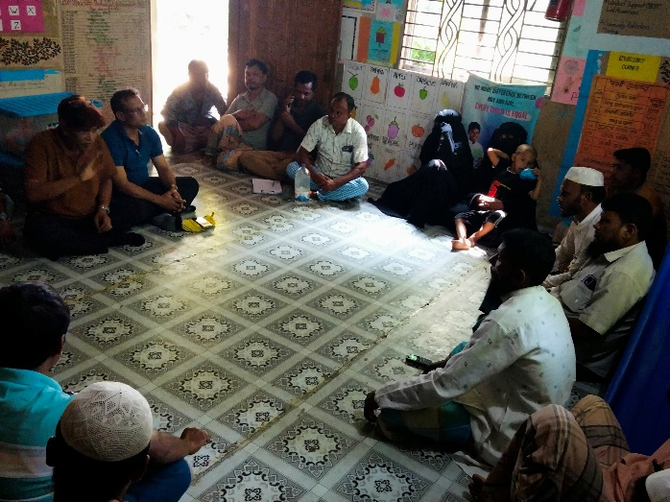 | 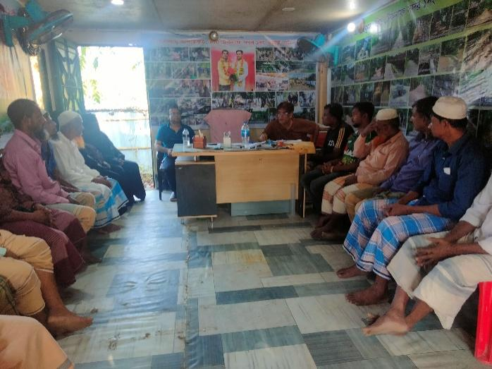

Figure_02: Consultation Meeting with Community, UP Chairman, Members, Local Elites & WATSAN Committee Representatives at Teknaf Upazila

Appendix-03: List of personnel attended in the Consultation Meeting at Teknaf Upazila:
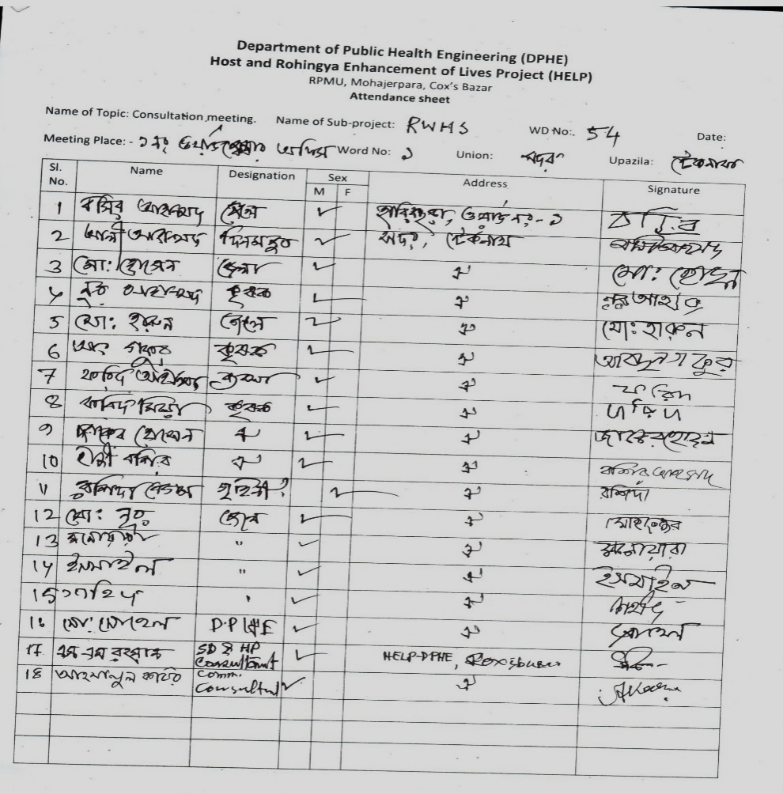

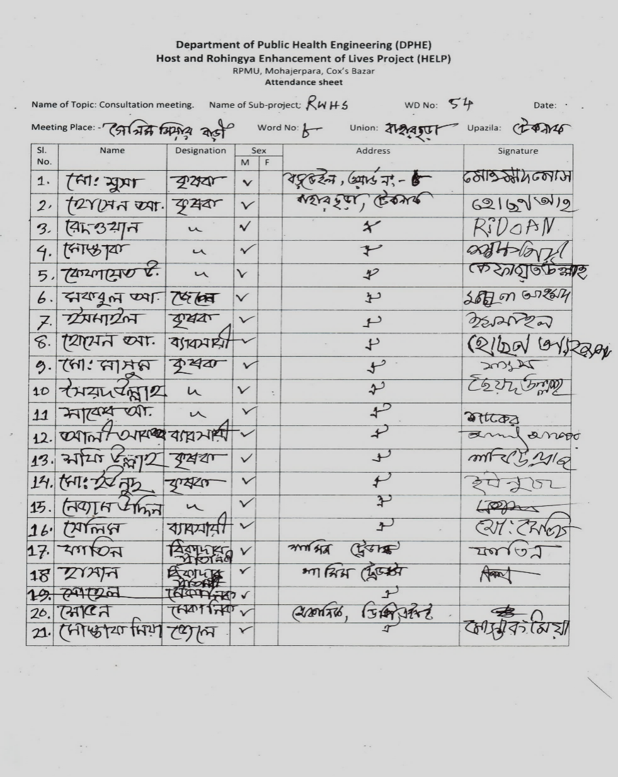
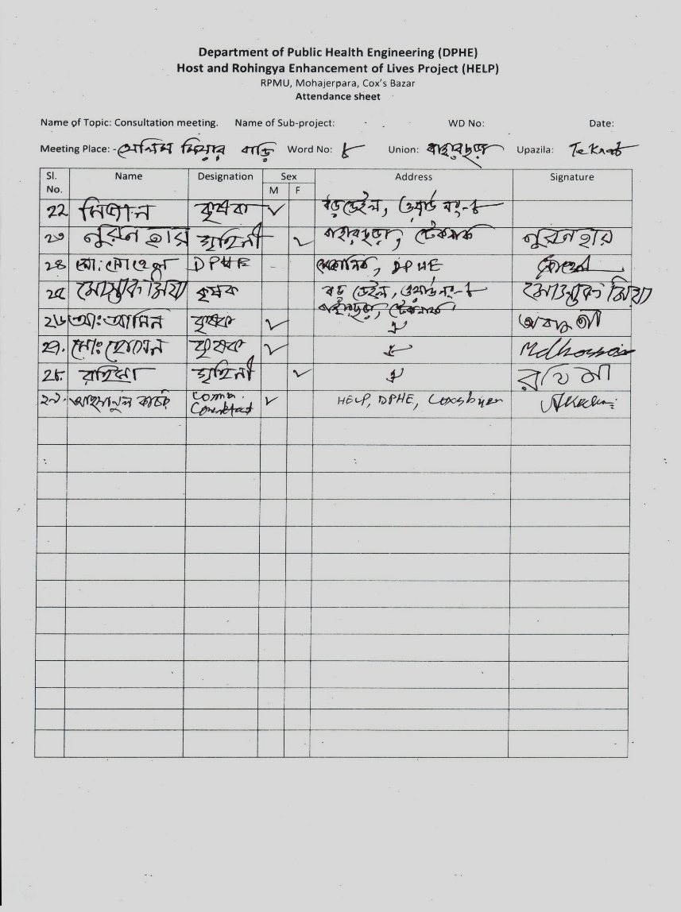

Appendix-04: Proposed design of Rainwater Harvesting System Type-A and Type. -C
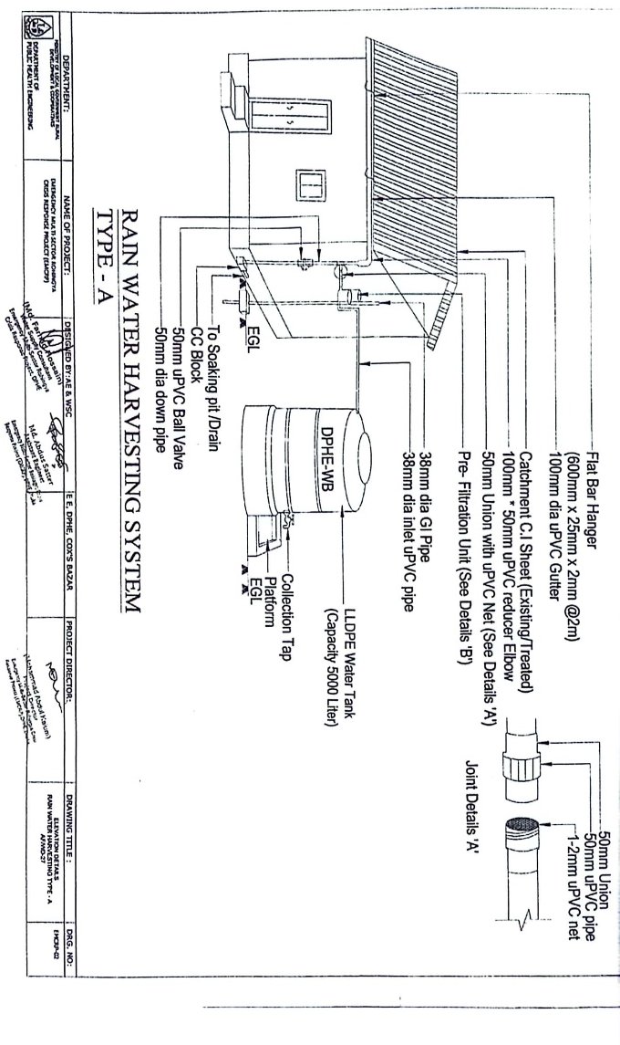
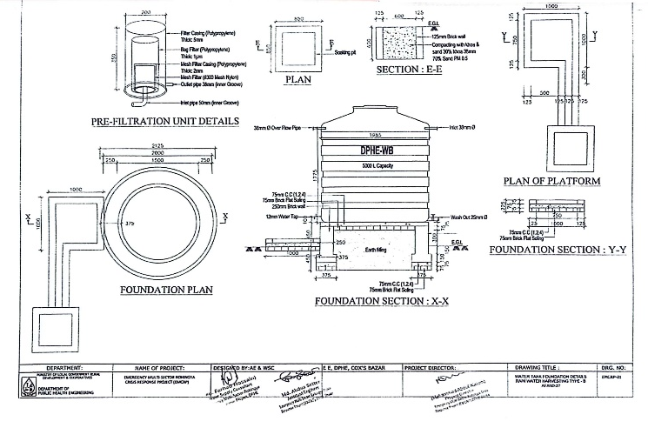
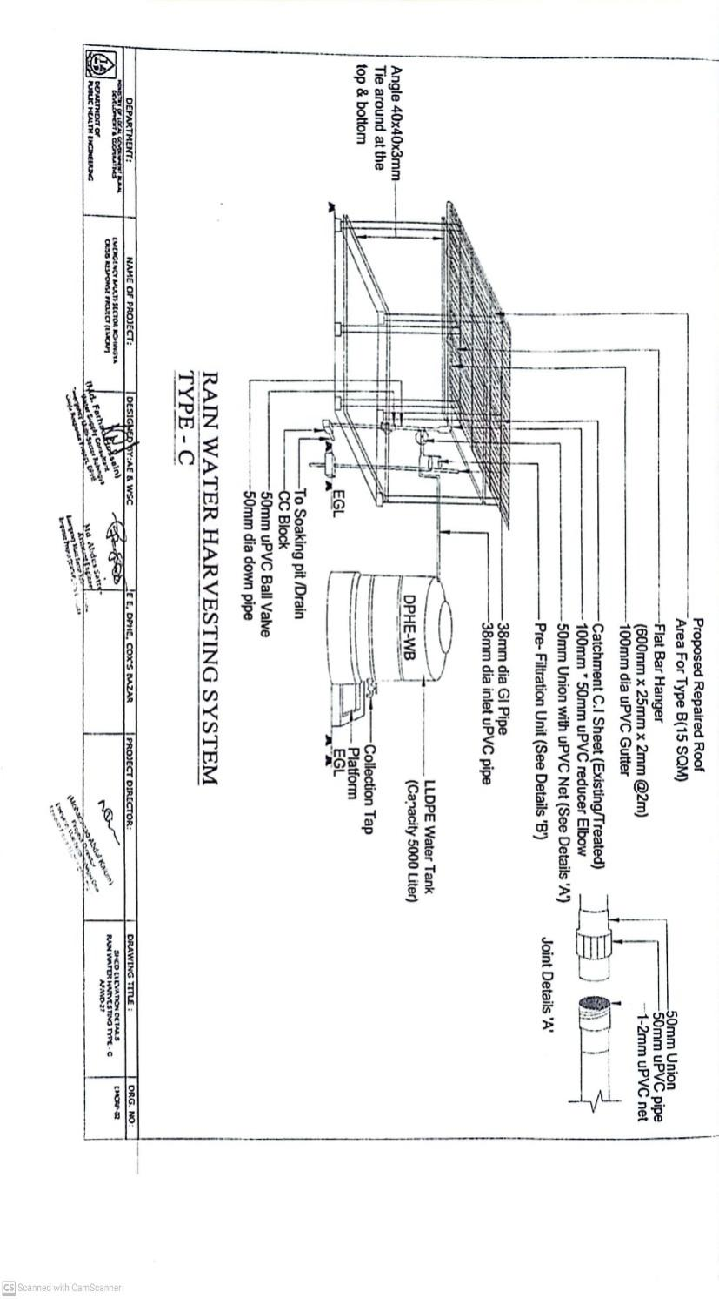
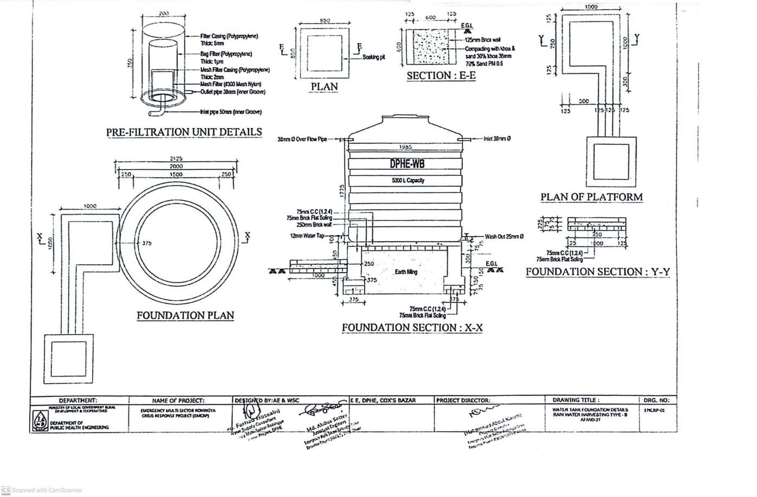

Appendix 06: Labor's Code of Conduct (CoC):

Code of Conduct (CoC)
(CoC for Contractor)

Location:
Contracting Organization:
I am . . . . . . . . . . . . . . . . . . . undertake to abide by the following orders, instructions and prohibitions at all times while working at the site.

1. Always treat all local communities with courtesy, courtesy and respect.
2. Under no circumstances will create any kind of relationship with local women, children.
3. Will not take any kind of help or assistance from local people intentionally or unintentionally.
4. Under no circumstances shall give any assurance or undertaking to the local people.
5. Will not harm animals, plants and the environment at work.
6. Always wear and use safety clothing and equipment at work.
7. Always display and save ID Card in the work place.
8. Under no circumstances will indulge in any kind of anti-social activities and any kind of disputes with local people.
9. In case of taking any emergency decision will prior discuss with concerned officer.
If any exception to the above matters occurs or occurs, then I will be obliged to accept the legal punishment or solution taken by the administration in this regard.

…………………….
Signature and Date

What must be kept in the project site are as follows:
1. List of workers and officers
2. Attendance Register
3. Leave Register
4. Register for recording details of accidents
5. Register for recording complaints
6. Contract Related particulars
7. In case of emergency contact mobile numbers with names and designations of at least 2 officials shall be displayed in large letters in Bengali and English at visible place.
8. For emergency contact with nearest hospital, police station and doctor their mobile/telephone number shall be displayed at visible place in Bengali and English big letters.
9. Placement of full information and scope of work at work site shall be displayed with a banner at visible place.
10. Provision of safety signs, warning information and safety fencing shall be provided.
11. Keeping safety materials and equipment and first aid arrangements.
12. Provision of arrangement of car or motor cycle for emergency use.
13. Provision of easily identifiable signs or safety lights at work hazardous places for day and night.
(N.B. The name and location of each organization should be mentioned on the register book)
Environmental Precautions for the work place: -
- No fire shall be ignited unless necessary
- Animals should never be injured
- Shall avoid all types of pollution
- No tree can be cut or damaged without permission
- Resources should be used appropriately
- Try to use renewable resource at the best possible way
- At the end of the work, the previous environment should be in place as much as possible.

Report Prepared by:

Syed Mostamsirur Rahman
SD & HP Consultant
RPMU, HELP (DPHE Part)

Email: smrahman515@gmail.com

(Mahbubul Alam)
Hydrogeological Consultant
RPMU, HELP (DPHE Part)
Email: alam.mahbubgeo@gmail.com

Reviewed by:



(Md. Muktadir Harun)
Social and Environmental Safeguard Officer,
HELP, DPHE, Dhaka.
Email: mh.dphe@gmail.com

Approved by:



(Noor Ahmed)
Project Director,
HELP Project, DPHE, Dhaka.
Email: pddphe.help@dphe.gov.bd

