CSL SOFTWARE RESOURCE LTD.



E-Store Management

User Manual

- Master Group: This form preserves various type of information regarding to Master Group with which the concern industry is related. Few examples are appended below-
Master Group:
Stationary
Electric
Furniture’s

Information required for Master Group – Group Name, Short Name.
- Click on new icon to add Master Group.
- Group ID is System Generated.
- Input Group Name.
- Input Short Name.
- Input Remarks (optional).
- Checkbox is available for Inactive option.
- Click on “Create” Button to save the Master Group.

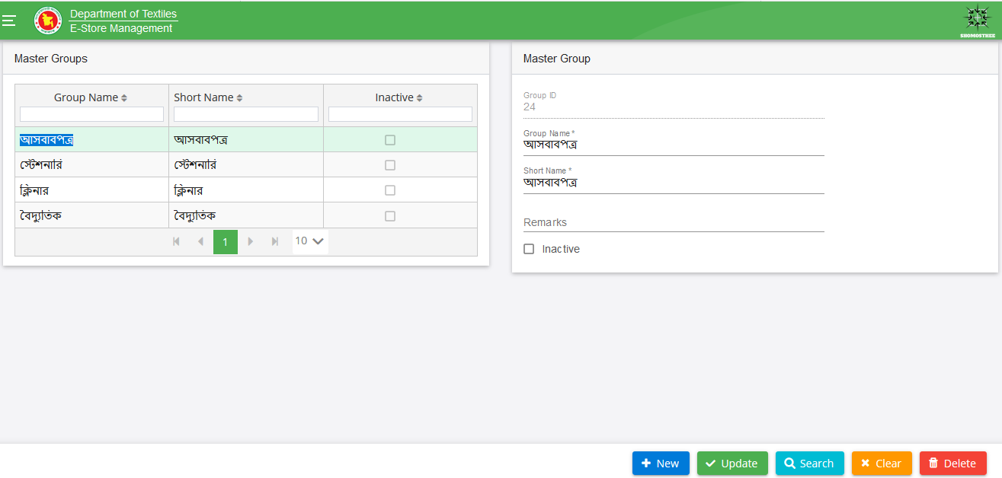
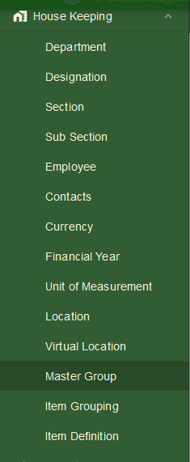

- Item Grouping: This form preserves various type of information regarding to Item Group with which the concern industry is related. Few examples are appended below-
Item Group:
Diary
HP Computer
Table

Information required for Item Group – Group Name, Description, Short Code, Master Group, Item Prefix, Unit Set, Reporting UOM, Valuation Type, Valuation Method, HS Code, Group Type, and Group Nature.

- Click on new icon to add Item Group.
- Group ID is System Generated.
- Input Group Name.
- Input Description.
- Input Short Code.
- Select Master Group from Drop Down.
- Input Item Prefix.
- Select Unit Set, Valuation Type, Valuation Method, Group Type, Group Nature from Drop Down.
- Checkbox is available for Serialize, User Item Code, Item Description & Active options.
- Sub Group Grid option is also available (optional).
- Click on “Create” Button to save the Item Group.

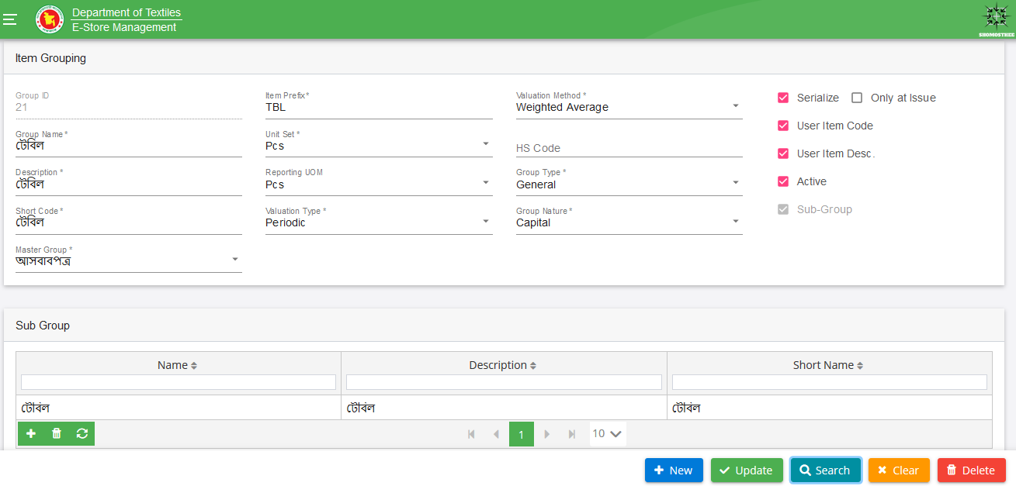
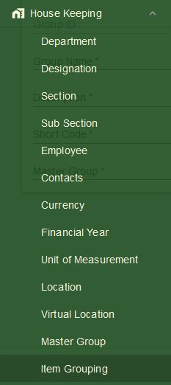

- Item Definition: This form preserves various type of information regarding to Item Definition with which the concern industry is related. Few examples are appended below-
Item Definition:
Computer Table
Reading Table
Matador Ball Pen
Register Book

Information required for Item Definition – Item Group, Subgroup, and Unit Set.
- Click on new icon to add Item Definition.
- Input Item Code, Display Code, Display Description, Short Description, Select Item Group, Subgroup, HS Code (optional) Unit Set, Transaction UOM, Reporting UOM, Stock Keeping UOM, Level UOM, Active, Purchase, add Item Image and click on “Create” button.
- After saving, Item will be saved and shown in left panel.
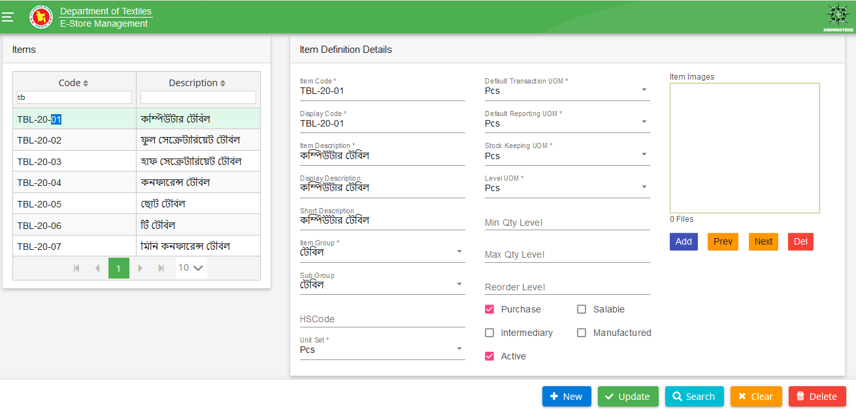
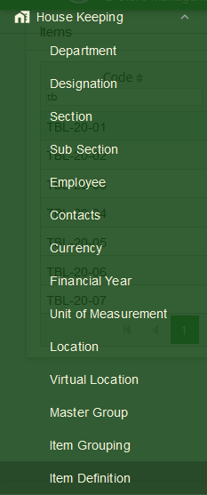

- Opening Balance: It is the interface where we input the item wise opening balance. Few examples are appended below-

Information required for- Opening Balance
Opening Balance:
Store Location
Item Definition

  - Now Click “New” button.
  - Select Store Location.
  - Input opening balance date, Financial Year, User Ref. No.
  - Select Item Code, UOM, and Input the opening balance Qty in Opening Balance Details and click on “Create” button.
  - Approval is needed.

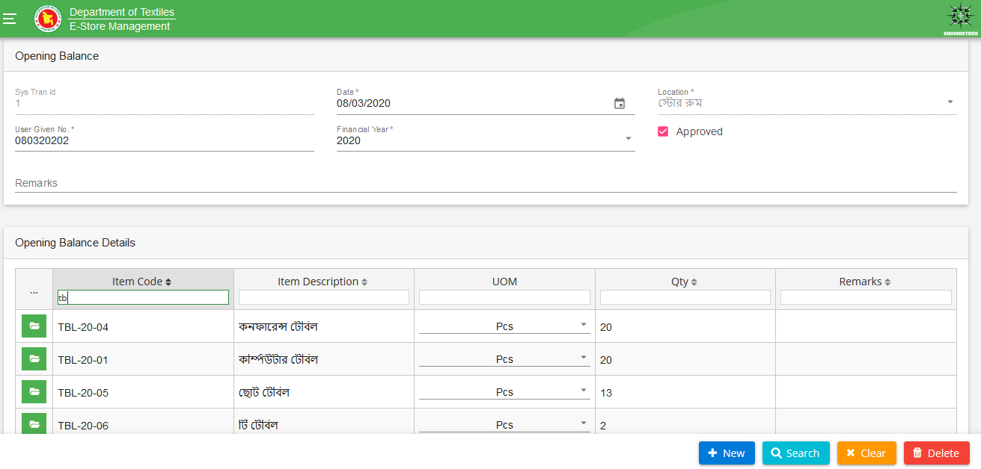
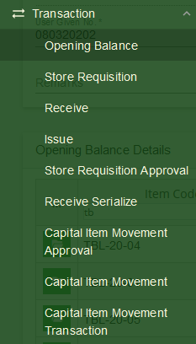

- Receive with QC: In this interface we will receive item with chalan wise:

Information required for- Receive
Receive with QC:
Store Location
Item Definition

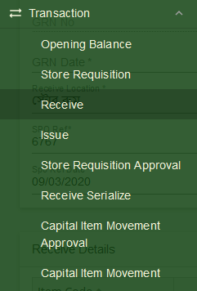
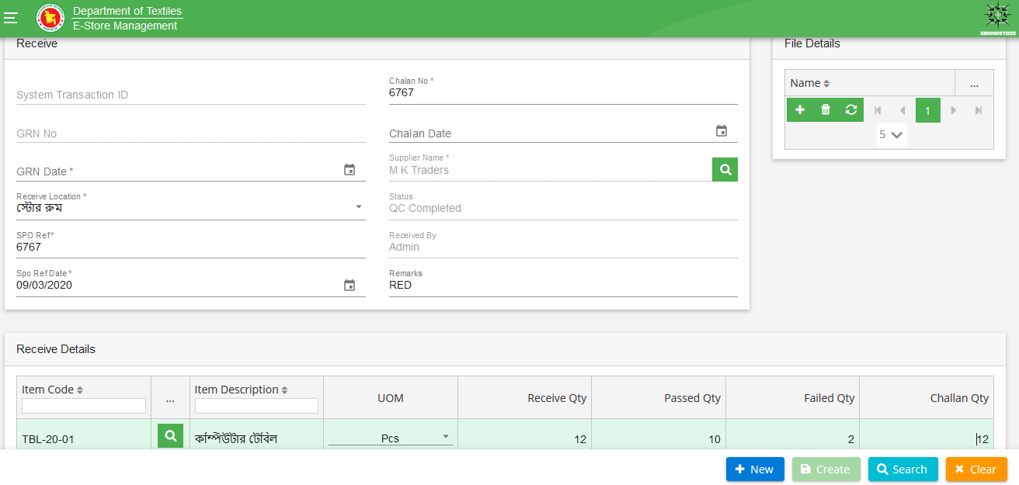
- Click on “New” button.
- Select Receive with QC panel.
- Enter SPO Ref, Select SPO Ref Date.
- Select Supplier Name.
- Select Receive Location from drop down.
- Select GRN Date. GRN No will be auto-filled.
- Enter Chalan No. and select Chalan Date.
- Enter remarks in Remarks field (optional).
- Status and Received By will be auto-filled.
- Select “+” button from Receive Details Panel. A row will be expanded to enter data.
- Select Item Code by clicking on search button. Item Code, Item Description and UOM fields will be populated with data.
- Enter Receive Qty, Passed Qty and Failed Qty. Challan Qty is auto-filled
- Click on “Create” button. This transaction will be completed.

6. Store Requisition: In this interface we will Store Requisition for the Item:

Store Requisition:
Store Location
Item Definition
Information required for Store Requisition

- Now Click “New” button.
- Select Store Requisition panel.
- Enter SR No., Select SR Date (By default today’s date is auto-selected). User can change the date.
- Select Department, Purpose, Group Master, SR Raised By from drop-down.
- Check the Approved Check box (optional).
- Select Approved By name from drop-down (optional).
- Select Approved Date (optional).
- Add Remarks if it is needed.
- Select “+” button from Store Requisition Details Panel. A row will be expanded to enter data.
- Select Item Code by clicking on search button. Item Code and Item Description, In Stock, Free Stock fields will be populated with data.
- Select UOM, enter SR Qty (SR Qty cannot be greater than Free Stock), Issue against SR, add Remarks if it is needed.
- Click on “Create” button.
- After create you needs approval for transaction completed.

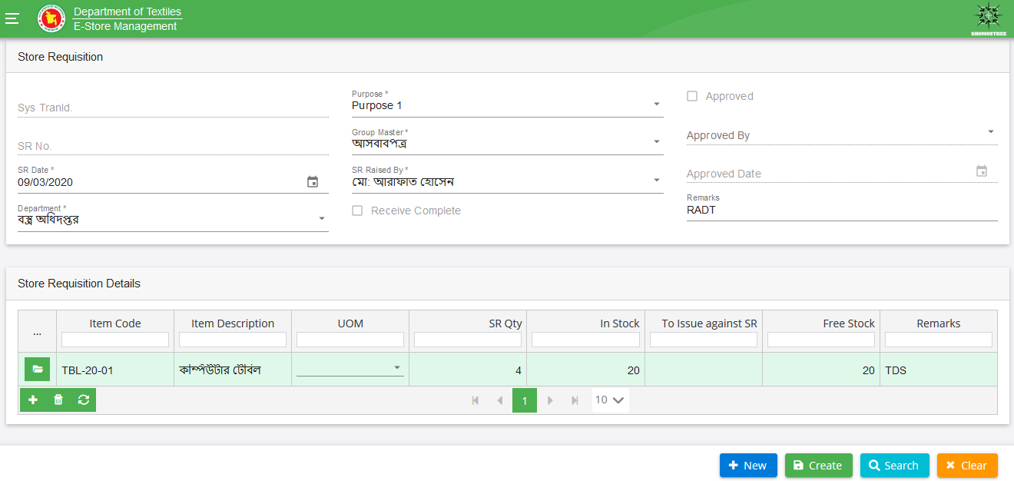
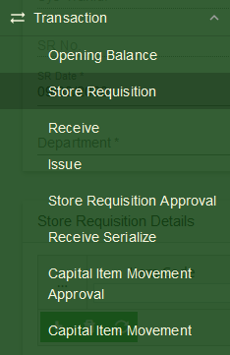
7. Issue: In this interface we will Issue the Item:

Information required for Issue:
Issue:
Store Location
Item Definition

  - Click on “New” button.
  - Select Issue panel.
  - Enter SI No., Issue Date- by default today’s date is auto-selected and non-editable.
  - Select Indent No; Purpose, SR By, SR Department will be auto-filled.
  - Select Location from drop-down.
  - Add Remarks if it is needed.
  - Enter Received By name.
  - In Issue Items panel, enter Item Code, Item Description, UOM SR Qty, Already Issued, In Stock, Issue Qty and add Remarks if it is needed.
  - Click on “Create” button. This transaction will be completed.
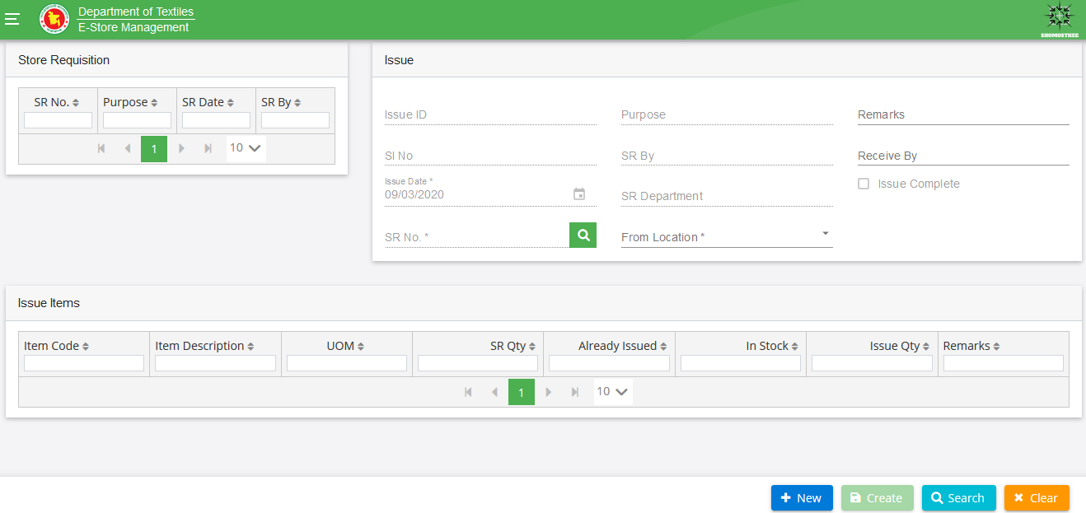
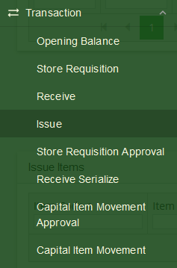

8. Receive Serialize:
In this interface we will serialize the receive item or opening stock:
Information required for Serialize:
Receive Serialize:
Item Receiving/Opening Stock
GRN/Opening No.

  - Click on “New” button.
  - Click the check box of opening item if opening stock will serialize.
  - No need to click the check box if receive item will serialize.
  - Pick the GRN/Opening No. from search filed.
  - Item quantity can be change if needed.
  - Then click the “Generate Number” button.
  - Serial number will be generating at “Serial Number” column.
  - Then click the “Create” button.
  - This transaction will be completed.

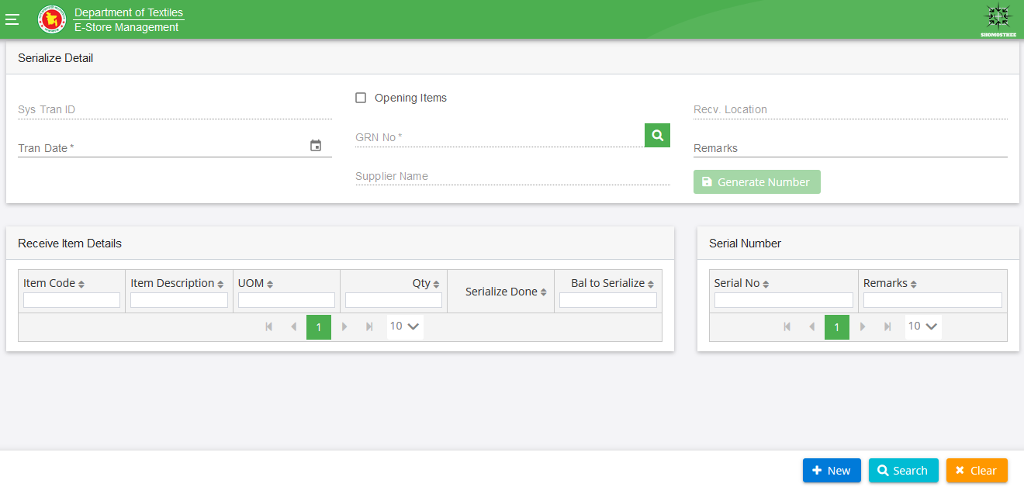
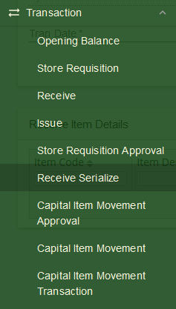
9. Capital Item Movement: In this interface we will Issue the Item:
Capital Item Movement:
From & To Department
From & To Store Location
Pick Item

Information required for Issue

  - Click on “New” button.
  - Select ‘From Department’.
  - Select ‘To Department’.
  - Select ‘From Location’.
  - Select ‘To Location’.
  - Pick item from Movement Requested Item Details.
  - Input ‘Qty To Move’, it’s can’t be more than current qty.
  - Then click the ‘Create’ button.
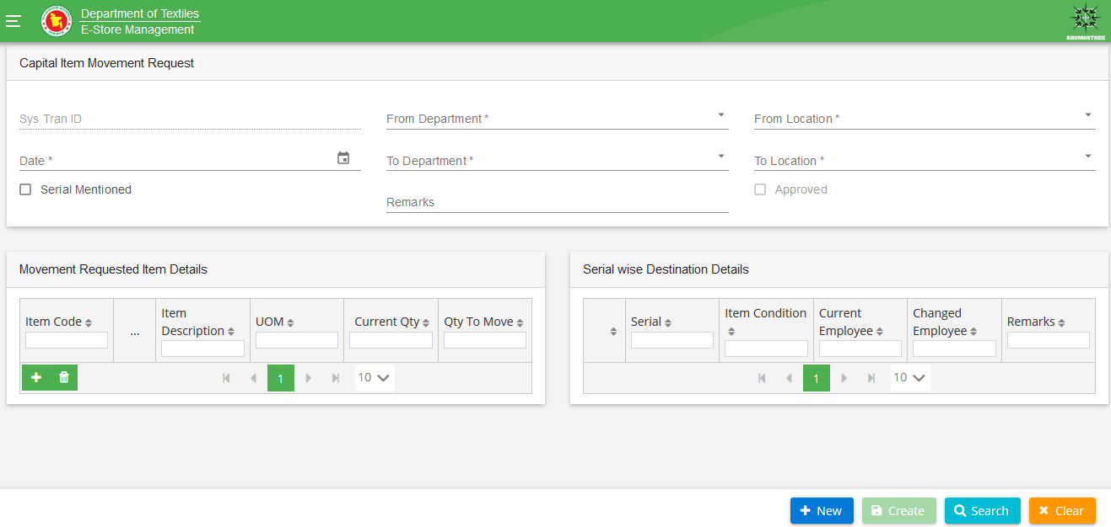
  - After create needs approval for transaction completed.
