Table of Contents

1 INTRODUCTION 1
1.1 Background 1
1.2 Purpose of the Study 1
1.3 Scope of the Work 1
1.4 Approach and Methodology 2
1.4.1 Approach 2
1.4.2 Methodology 2
2 POLICY, LEGAL, AND ADMINISTRATIVE FRAMEWORK 5
2.1 Regulatory Requirements for the Project 5
2.2 GOB Environmental Policy, Regulations, and Guidelines 5
2.2.1 National Environmental Policy, 1992 5
2.2.2 National Environmental Management Action Plan, 1995 5
2.2.3 Environmental Conservation Act (ECA), 1995 5
2.2.4 Environmental Conservation Rules (ECR), 1997 and Amendments 6
2.2.5 Bangladesh Climate Change Strategy and Action Plan 6
2.2.6 Building Construction Act, 1952 6
2.2.7 The Town Improvement Act (TI), 1953 6
2.2.8 Building Construction Rules 2008 6
2.2.9 Bangladesh National Building Code (BNBC) 6
2.2.10 Land Development Rules for Private Housing, 2004 6
2.2.11 Relevant other Regulatory Requirements for the Project 6
2.2.12 International Treaties 6
2.2.13 Administrative Framework 6
2.3 World Bank’s Safeguard Policies 6
2.3.1 OP/BP 4.01 Environmental Assessment 6
2.3.2 OP/BP 4.04 Natural Habitats 6
2.3.3 OP/BP 4.11 Physical Cultural Resources 6
2.3.4 OP/BP 4.36 Forestry 6
2.3.5 OP/BP 4.12 Involuntary Resettlement 6
2.3.6 WB Group Environmental, Health and Safety Guidelines 6
2.4 Occupational Health and Safety 6
2.5 IEE Requirement 6
3 PROJECT DESCRIPTION 6
3.1 Project Site 6
3.2 Project Design 6
3.3 Construction Material and Sources 6
3.4 Justification of the Project 6
4 DESCRIPTION OF THE ENVIRONMENT 6
4.1 Physical Environment 6
4.1.1 Climate 6
4.1.2 Physiographic Features 6
4.1.3 Topography 6
4.1.4 Geology & Soil 6
4.1.5 Seismicity 6
4.1.6 Water Resources and Hydrology 6
4.1.7 Ambient Air Quality 6
4.1.8 Noise Level 6
4.2 Biological Environment 6
4.2.1 Bio-ecological Zones 6
4.2.2 Diversity of Terrestrial Floral and Faunal Species 6
4.2.3 Diversity of Aquatic Flora and Fauna 6
4.2.4 Protected Areas and Red Book Species 6
4.3 Socio-Economic Environment 6
4.3.1 Employment and Income 6
4.3.2 Settlement and Housing Pattern 6
4.3.3 Land Use Patterns 6
4.3.4 Water Supply and Sanitation 6
4.3.5 Utilities (Electricity, Gas & Telephone) 6
4.3.6 Transport and Communication 6
4.3.7 Archaeological, Historical and Cultural Sites/Resources 6
4.4 Environmental Hot Spots 6
5 ENVIRONMENTAL IMPACTS AND MITIGATION MEASURES 6
5.1 Identification of Potential Environmental Impacts 6
5.2 During Pre-Construction Stage 6
5.2.1 Land Acquisition and Loss of Structures 6
5.2.2 Removal of Utilities 6
5.2.3 Removal of Trees 6
5.3 During Construction Stage 6
5.3.1 Drainage Congestion 6
5.3.2 Ground Water/Drinking Water 6
5.3.3 Air Pollution 6
5.3.4 Noise and Vibration 6
5.3.5 Waste Pollution 6
5.3.6 Sewerage Pollution/Sanitation Hazards 6
5.3.7 Road and Traffics 6
5.3.8 Construction Materials 6
5.3.9 Landscape 6
5.3.10 Job Opportunities 6
5.3.11 Community Health & Safety 6
5.3.12 Occupational Health & Safety 6
5.4 During Operation Stage 6
5.4.1 Drainage Congestion 6
5.4.2 Noise Pollution 6
5.4.3 Air Pollution 6
5.4.4 Waste Pollution 6
5.4.5 Tree Re- plantation 6
5.4.6 Landscape 6
5.4.7 Arrangement of Utility 6
5.4.8 Occupational Health & Safety 6
5.4.9 Community Health & Safety 6
6 ANALYSIS OF ALTERNATIVES 6
6.1 The Proposed Development Alternative 6
6.2 Relocation Alternative 6
6.3 The No Action Alternative 6
7 ENVIRONMENTAL MANAGEMENT PLAN (EMP) 6
7.1 Objective of EMP 6
7.2 Environmental Management Plan (EMP) 6
7.3 Environmental Monitoring Plan (EMoP) 6
7.3.1 Objectives 6
7.3.2 Monitoring Measures 6
7.3.3 Monitoring and Reporting Procedures 6
7.4 Institutional Arrangement 6
7.5 Environmental Monitoring Cost 6
8 PUBLIC CONSULTATION AND DISCLOSURE 6
8.1 General Consideration 6
8.2 Focus Group Discussions (FGD) 6
8.3 Stakeholder Consultations (SC) 6
8.3.1 Mitigation and Management of Key Stakeholder Concerns 6
9 CONCLUSION AND RECOMMENDATION 6
9.1 Conclusion 6
9.2 Recommendations 6
REFERENCES 6
APPENDICES 6

List of Tables
Table 2.1: Applicability of Key Environmental Legislation 6
Table 2.2: Relevant International Treaties, Conventions and Protocols signed by Bangladesh 6
Table 2.3: Relevant Occupational Health and Safety Laws and Rules 6
Table 4.1: Monthly average maximum and minimum temperature (°C) recorded in 1991-2012 6
Table 4.2: Monthly average total rainfall (mm) recorded in 1991-2012 6
Table 4.3: Monthly average humidity (%) recorded in 1991-2012 6
Table 4.4: Monthly average maximum wind speed (knots) recorded in 1991-2012 6
Table 4.5: Test results of groundwater 6
Table 4.6: Test result of ambient air quality 6
Table 4.7: Result of Sound Level Monitoring 6
Table 4.8: Tree species living in the proposed building area 6
Table 4.9: List of common wildlife living in the PIA 6
Table 4.10: List of the environmental hot spots with location 6
Table 7.1: Environmental Management Plan 6
Table 7.2: Environmental Monitoring Plan 6
Table 7.3: Cost of environmental monitoring during construction and operation 6
Table 8.1: Details of FGDs 6
Table 8.2: Summary of the FGDs 6
Table 8.3: Participation List of Stakeholder Consultations Undertaken 6
Table 8.4: Key Stakeholder Concerns and Management and Mitigation Measures 6

List of Figures
Figure 2.1: Environmental Clearance Procedure 6
Figure 3.1: Architectural Design of Proposed DoE New Office Building 6
Figure 3.2: Department of Environment (DOE) New Office Building 6
Figure 4.1: Location of the DoE office building project area in the Climatic Zones Map of Bangladesh 6
Figure 4.2: Monthly average maximum and minimum temperature (°C) recorded in 1991-2012 6
Figure 4.3: Monthly average total rainfall (mm) recorded in 1991-2012 6
Figure 4.4: Monthly average humidity (%) recorded in 1991-2012 6
Figure 4.5: Monthly average maximum wind speed (knots) recorded in 1991-2012 6
Figure 4.6: Topographic map of the project area 6
Figure 4.7: General soil types of Bangladesh 6
Figure 4.8: Major fault lines prone to seismic activity 6
Figure 4.9: Seismic zones of Bangladesh 6
Figure 4.10: Bio-ecological zones of Bangladesh 6
Figure 4.11: List of the protected areas, eco-parks and safari park showed in the map of Bangladesh 6
Figure 4.12: Environmental hot spots remained in the PIA 6
Figure 7.1: EMP Implementation Organogram 6

List of Photographs
Photograph 4.1: Fish pond located inside the area of Bangladesh Radio 6
Photograph 4.2: Sampling of ground water for analysis 6
Photograph 4.3: Ambient air quality monitoring in the project area 6
Photograph 4.4: Sound level monitoring inside of the project area during day (left) and night time (right) 6
Photograph 4.5: Sound level monitoring outside of the project area during day (left) and night time (right) 6
Photograph 4.6: Diverse floral species in the project area 6
Photograph 4.7: Faunal species found in the project area during field visit 6
Photograph 4.8: Multi-storied administrative structure (west side) and slum housing pattern (east side) 6
Photograph 4.9: Land use pattern in all sides of the project area 6
Photograph 8.1: Photos of Focus Group Discussions (FGD) 6

List of Appendices
Appendix A: Detailed Design of Proposed Building with Floor Layout 6
Appendix B: Checklist for Screening of Significant Impacts due to the Proposed DoE Office Building 6
Appendix C: Tree Plantation Plan 6
Appendix D: Participants Lists of Focus Group Discussions (FGD) 6
Appendix E: Guidance for Contractor on Environmental Issues during Construction Activities 6

Abbreviation

BMD | Bangladesh Meteorological Department
BNBC | Bangladesh National Building Code
BOD | Biochemical Oxygen Demand
BRTA | Bangladesh Road Transport Authority
BRTC | Bangladesh Bureau of Research and Testing Centre
BTCL | Bangladesh Telecommunications Company Limited
CASE | Clean Air and Sustainable Environment
COD | Chemical Oxygen Demand
CSC | Construction Supervision Consultant
DCC | Dhaka City Corporation
DESCO | Dhaka Electricity Supply Company Limited
DF | Department of Forest
DO | Dissolved Oxygen
DOE | Department of Environment
DWASA | Dhaka Water Supply and Sewerage Authority
EA | Environmental Assessment
EC | Electrical Conductivity
ECA | Environmental Conservation Act
ECR | Environment Conservation Rules
EIA | Environmental Impact Assessments
EMoP | Environmental Monitoring Plan
EMP | Environmental Management Plan
FAO | Food and Agricultural Organization
FC | Fecal Coliform
FGD | Focus group discussions
GOB | Government of Bangladesh
GSB | Geological Survey of Bangladesh
IECs | Important Environmental Components
IEE | Initial Environmental Examination
IUCN | International Union for Conservation of Nature
MOEF | Ministry of Environment and Forest
NEMAP | National Environmental Management Action Plan
NEP | National Environmental Policy
PIA | Project Influence Area
PIU | Project Implementation Unit
SC | Stakeholder Consultations
SEI | Significant Environmental Impacts
TC | Total Coliform
TDS | Total Dissolved Solids
TOR | Terms of Reference
TSS | Total Suspended Solids
UNDP | United Nations Development Program

Executive Summary

INTRODUCTION
Background: As part of institutional strengthening of the Department of Environment (DOE) under the Clean Air and Sustainable Environment (CASE) project, the DOE has undertaken the design of a central office building which will incorporate the principals of environment friendly green building concept. The design will conform to the requirement of fire and general safety, handicap accessibility and all the other regulations of the Bangladesh National Building Code (BNBC). The design will also reflect the concerns for the environment in terms of energy use, waste management & other ecological considerations.
Purpose of the Study: Construction of DOE office building along with other facilities involves a considerable amount of construction activities which have both negative and positive impacts on environment. To mitigate the negative environmental impacts and enhance the positive environmental impacts due to construction of the DOE office building, EIA is required.
Scope of the Work: Scope of works of EIA for the construction DOE multistoried office building under the CASE project is as follows:
- Review of existing information (relevant all documents);
- Provide a full description of the project (such as project location, layout, components, construction materials, etc.);
- Provide a description of the environment (such as baseline data on physical, biological and socioeconomic characteristics of the building site along with area of influence);
- Analysis of alternatives to the proposed project;
- Address occupational health and safety (H & S) requirements;
- Identify relevant stakeholders to be consulted during preconstruction, construction and operation phases of the project;
- Design and conduct a public consultation programme in accordance with provisions of WB OP 4.01 and in collaboration with DOE;
- Ensure that all provisions of GOB and WB applicable policies are complied with,
- Devise a mitigation plan for all project-related impacts;
- Prepare IEE in accordance with the DOE Policies;
- Prepare EIA in accordance with the WB Safeguard Policies;
- Development of an Environmental Management Plan; and
- Assess DOE’s institutional capacity to execute and monitor the EMP and recommend necessary institutional capacity building including additional professional for environmental Management.
Approach and Methodology: The EIA study has been conducted in accordance with Environment Conservation Rules, 1997, Government of Bangladesh (GOB) EIA Guidelines, 1997, and World Bank (WB) Safeguard Policies. The study is based on both primary and secondary data and information. The primary data includes data collected from field observations and secondary data includes review of the Bangladesh statistical and relevant information from Government Departments. Discussions were held with stakeholders including government officials, community representatives and a wide range of road users and roadside dwellers. The main purpose of this approach was to obtain a fair impression on the people’s perceptions of the project and its environmental impacts.
POLICY, LEGAL, AND ADMINISTRATIVE FRAMEWORK
Regulatory Requirements for the Project: Regulatory requirements toward protection and conservation of environment and various environmental resources and also toward protection of social environment from adverse impact of projects and activities associated with them have been enunciated by the GOB as well as the WB Pertinent requirements are summarized below.
- GOB Environmental Policy, Regulations, and Guidelines
- National Environmental Policy, 1992
- National Environmental Management Action Plan, 1995
- Environmental Conservation Act (ECA), 1995
- Environmental Conservation Rules (ECR), 1997 and Amendments
- Bangladesh Climate Change Strategy and Action Plan
- Building Construction Act, 1952
- The Town Improvement Act (TI), 1953
- Building Construction Rules 2008
- Bangladesh National Building Code (BNBC)
- Land Development Rules for Private Housing, 2004
- Relevant other Regulatory Requirements for the Project
- Environment Court Act, 2000 and subsequent amendments in 2002
- Bangladesh Wildlife Preservation Order 1973 and Revision 2008 (Draft)
- The National Water Policy, 1999
- The Brick Burning (Control) Act, 1989
- The Brick Burning (Control) Amendment Act, 1992 and 2001
- Water Pollution Control Ordinance 1970
- Bangladesh Labour Law, 2006
- National Land use Policy, 2001
- National Forest Policy and Forest Sector Review (1994, 2005)
- The Forest Act 1927, Amendment 2000 (Protected, village Forests and Social Forestry)
- National Biodiversity Strategy and Action Plan (2004)
- Wetland Protection Act 2000
- The ground Water Management Ordinance 1985
- Vehicle Act 1927 and Motor vehicle ordinance 1983
- International Treaties
- On protection of birds (Paris), 1950
- Occupational hazards due to air pollution, noise and vibration (Geneva), 1977
- Occupational safety and health in working environment (Geneva), 1981
- Occupational health services (Geneva), 1985
- International convention on climate changes (Kyoto Protocol), 1997
World Bank’s Safeguard Policies: The Bank requires environmental assessment (EA) of projects proposed for Bank financing to ensure that they are environmentally sound and sustainable, and thus to improve decision making. The World Bank's environmental assessment policy and recommended processing are described in Operational Policy (OP)/Business Procedure (BP) 4.01: Environmental Assessment. This policy is considered to be the umbrella policy for the Bank's environmental "safeguard policies" which among others include: Natural Habitats (OP 4.04), Forests (OP 4.36), Pest Management (OP 4.09), Physical Cultural Resources (OP 4.11)), and Safety of Dams (OP 4.37). Operational Policies (OP) are the statement of policy objectives and operational principles, including the roles and obligations of the Borrower and the Bank, while as Business Procedures (BP) are the mandatory procedures to be followed by the Borrower and the Bank. OP/BP 4.01 issued in January 1999 is the central document defining the Bank’s environmental assessment requirements. The following are the WB’s environmental policy guidelines:
  - OP 4.01 Environmental Assessment
  - OP 4.04 Conservation of Natural Habitats
  - OP 4.36 Forestry
  - OP 4.37 Safety of Dams
WB Group Environmental, Health and Safety Guidelines: The Environmental, Health and Safety (EHS) Guidelines of the WB Group, 2008 is the safeguard guidelines for environment, health and safety for the development of the industrial and other projects. They contain performance levels and measures that are considered to be achievable in new facilities at reasonable costs using existing technologies.
Occupational Health and Safety: During construction, the project will conform to the labor laws and occupational and health related rules
- Bangladesh Labor Act, 2006
- Labor Relations under Labor Laws, 1996
- Public Health (Emergency Provisions) Ordinance, 1994
- The Employees State Insurance Act, 1948
- The Employer's Liability Act, 1938
- Maternity Benefit Act, 1950
- Bangladesh Factory Act, 1979
IEE Requirement: Legislative bases for IEE in Bangladesh are the Environmental Conservation Act 1995 (ECA'95) and the Environmental Conservation Rules 1997 (ECR'97). Department of Environment (DOE), under the Ministry of Environment and Forest (MOEF), is the regulatory body responsible for enforcing the ECA'95 and ECR'97. It is the responsibility of the proponent to conduct an IEE of development proposal and the responsibility to review IEEs for the purpose of issuing Environmental Clearance Certificate (ECC) rests on DOE. According to the ECR’97 construction of multi-storied building is considered as the ‘Orange B’ category. DOE defines more than 10 storied building as the multi-storied building. Since the proposed the multistoried building will exceed 10 storey, for which GOB clearance will be applicable.
PROJECT DESCRIPTION
Project Site: The area/site for the proposed DOE new office building area is located at She-e-Bangla Nagar Thana of Dhaka North City Corporation, Dhaka. The latitudes and longitudes of the proposed building site is 23°46'37.46"N and 90°22'17.97"E. The boundaries of the proposed building area are: existing DOE office building at east side; 20m wide main bituminous paved road at west side; Atomic Energy Commission building at the North Side and 6m wide narrow bituminous paved road at the south side.
Project Design
The proposed DoE new office building planned to develop as ‘Green Building’. There should be all facilities as like a modern office building. The considered facilities are use of solar energy and day light, proper solid waste management etc. However, the provision of these facilities has been considered in environment friendly manner.
DESCRIPTION OF THE ENVIRONMENT
Physical Environment
Climate: The climate of Bangladesh is heavily influenced by the Asiatic monsoon. The monsoonal influence results in three distinct seasons: Pre-monsoon hot season (from March to May); Rainy monsoon season (from June to October); and Cool dry winter season (from November to February).
The pre-monsoon hot season is characterized by high temperatures and thunderstorms. April is the hottest month in the country with mean temperatures ranging from 27°C in the east and south, to 31°C in the western and central parts of the country. After April, increasing cloud-cover reduces the temperature. Wind direction is variable during this season, especially during the early part. Rainfall, mostly caused by thunderstorms, at this time can account for 10-25% of the annual total. The proposed DoE office building project lies in the South Central Climatic Regions of Bangladesh (referred to map 4.1 in the main EIA report). In order to depict climatic condition of the project area, the data of temperature, rainfall, humidity and wind speed recorded at Dhaka Weather Station from 1991 to 2012 have been collected from Bangladesh Meteorological Department.
Physiographic Features: The DoE office building project area is located in the sub region “Madhupur Tract” which is another large Pleistocene inlier within Bengal Basin with an area of about 2558 square kilometre (Rashid, 1991). This tract is slightly elevated which has been thought as the result of the tectonic movements to which the Bengal Basin is being subjected.
Topography, Geology & Soil: The elevation of the existing land where the DoE office building has been proposed to be constructed is around 10.1 m (source: Google Earth). The western part of the project area (up to 300 m radius) is comparatively less elevated (lowest elevation is around 8.23 m). The northern, eastern and southern areas (upto 500 m radiuses) of the project location are comparatively more elevated (where highest elevation is about 14 m). In Bangladesh, 21 different general soil types have been categorized based on the diagnostic horizons and diagnostic properties of the soil (FAO-UNDP, 1988). According to this classification, soil type of the project area is defined under Non-calcareous Dark Grey Floodplain soil (referred to figure 4.7 in the main EIA report).
Seismicity: Bangladesh has been divided into three Seismic Zones, as described by the ranges of the seismic coefficient. Zone I is the most severe area for earthquake intensity and frequency and Zone III is the least severe (GSB, 1979). The project area falls within Zone II, which is comprised of the northern and eastern regions of Bangladesh, and is the second most seismically active region in the country.
Surface and Ground Water Resources: The surroundings of the project area are being mostly occupied by commercial, residential, and cultural structures. Turag is the closest river to the project area which is around 2.87 km away from the project area in the west. In the project influence area, tap water supplied by Dhaka WASA is being used for drinking and other household purposes. The DoE uses ground water (pumped through deep tube well located in their premises) and this ground water is being used for drinking and other purposes. There is one submergible pump (which pumps water at depth 80 m) and there is also one bore pump which (pumps water at depth 91 m). The ground water from the above stated deep tube well source has been collected for laboratory analysis at BUET. According to the test result of the ground water it has been seen that the ground water is free from Arsenic and Iron but the water contains 98 (CFU/100 ml) total coliform and 44 (CFU/100 ml) fecal coliform which does not comply with drinking water quality standard guided in ECR (1997). The rest of the ground water parameters satisfy the drinking water quality standard.
Ambient Air Quality & Noise: Based on the physical observation during field visit it can be said the ambient air quality in the project area is comparatively good except some anthropogenic sources of dust flow and pollutants from the vehicles. The proposed project area is located just beside the 18 m paved road (in the west side), hence emission from the vehicles and dust flow on the road are main sources of air pollution. However, to assess the baseline condition of the ambient air in the project area the air has been sampled and analyzed at spot using machines and experts of the Bureau of Research, Testing & Consultation (BRTC) laboratory of BUET. The result of analysis of ambient air quality shows that all the parameters except SO₂ were found within the allowable limit as per the ambient air quality standard guided in ECR (1997, amendment in 2005).
The main source of noise is the vehicles running on the roads in the west side (Shahid Shahabuddin Road) and south side (the road which goes towards Islamic Foundation) of the project location. Noise level has been monitored at inside and outside of the project location during day and night time. The results show that time weighted average value of the sound (L_{Aeq}) monitored at inside and outside of the project area did not exceed the standard fixed for the commercial area.
Biological Environment
The land for the proposed DoE Office Building is being used for gardening. Therefore, this garden provides not only aesthetic beauty but also provides good terrestrial habitat for the floral and faunal species. Diverse floral and faunal species were found during the visit of the project area. The proposed project area is a good habitat for terrestrial life and there are very few aquatic habitats for the species. Nevertheless, the proposed project area is not only provides good habitat for lives but also it provides aesthetic beauty. There are diverse fruit trees, woody trees, wood cum fuel trees and trees with aesthetic significance. In the proposed project area (where the building will be built excluding the trees on the boundary line) 301 number of fruit, woody and aesthetic plants has been counted during field visit.
The proposed project area is being currently used for gardening to enhance aesthetic beauty in the existing area of the DoE administrative office building. Therefore, the project area also provides good habitat for the diverse faunal species. During the field visit in mid-September 2013, there have been found different types of wildlife (e.g. birds, butterfly, frog, etc.) species in the project area. Based on the map showing all of the protected areas, eco-parks and safari park it can be concluded that there is no such protected area in and surrounding the project area (referred to the figure 4.11 in the main EIA report).
Socio-Economic Environment
The surroundings of the project area have been occupied by mostly administrative offices of the Government of Bangladesh. In the north-western and western sides of the project area there are some small enterprises (e.g. workshop, grocery shop, tea stall etc.). Therefore, public service is the main employment opportunity and income source in the project influence area (considering 500 m buffer zone). The project influence area (PIA) is covered by multi-storied administrative structures except a few exceptions. The north-western side (which is around 50 m from the project boundary) is densely covered by residential buildings. In the eastern side, there are slum type houses. The existing land for the proposed multi-storied DoE office building is a vacant land and it has been used for gardening. Most of the land areas in the PIA (min 500 m radiuses) have been occupied by administrative structures of the GoB.
Water supply in the project area and PIA is tap water reticulation system as like as other parts of the Dhaka city. The existing DoE office building uses own source deep tube well water. There is also a sewerage system passing through the existing paved road (in the west) which is connected with the large sewerage canal in the back side of the Institute of Neuro Science. In the project area there have access to electricity, gas and telephone connection. Dhaka Electricity Supply Company (DESCO) supplies electricity through grid line in the project area. DoE has also installed solar PV on their roof top. Titas Gas Transmission and Distribution Company supplies gas connection through pipe line. Surrounding the project area there is good road communication system. In the western side of the project there is a paved road (width 18.2m) which is connected with Agargaon to Shyamoli main road. In the southern side of the project area there is also another paved road (width 6.1m).
According to the Department of Archaeology, Bangladesh, there is no places of archaeological, historical and cultural resources/sites, situated within or nearby the project area or PIA (<500m). Surrounding the proposed multi-storied DoE office building’s area there are some environmentally and socially critical areas in accordance with the project activities. These critical areas include administrative building, cultural & community infrastructure (e.g. hospital, mosque, school) wave broadcasting (Radio), and research institute (Atomic Energy, Neuro Science, SAARC Meteorology Research Center and so on). A list of the major environmental hot spots has been presented in the table 4-10 of the EIA report.
ENVIRONMENTAL IMPACTS AND MITIGATION MEASURES
Identification of Potential Environmental Impacts: Identification of potential impacts due to the project site development has been done using checklist for the DoE Multi-storied Office Building. In the checklist, activities, which may affect the environment due to various stages of the project actions, are listed and the degrees of Significant Environmental Impacts (SEIs) are shown. The terms “none”, “insignificant”, “moderate” and “significant” are used in the checklist to classify the magnitude of SEIs. Environmental impacts can be broadly classified as those taking place during pre-construction, construction and operational phases of the project.
During Pre-construction Stage: During the pre-construction stage of the project the major impacts have been identified which are relocation of utilities (gas transmission pipeline in particular which passes underneath the project area), removal of 301 trees (of which 5 trees is medium, 150 trees is small and 146 trees are saplings in size of fruit, timber and aesthetic tree species). Removal of trees will cause permanent loss of vegetation and this will also cause habitat loss of different wild life species.
The proposed project of constructing multi-storied building of DoE will not require any land acquisition and will not cause any loss of physical structure. Relocation of gas pipeline will have to be done with the help of the gas distributing company. To compensate the loss caused due to felling of 301 number of trees, DoE in its own land will be needed to plant trees in the operation stage as per the prescription of Forest Department (FD) (e.g, minimum two tree seedlings to be planted for each tree felled during starting of the operation stage but plantation is better during monsoon period.

During Construction Stage
Drainage Congestion: Construction of the proposed DoE multi-storied building will significantly impact upon the existing drainage pattern through impedance to natural flow conditions. Temporary drainage congestion will occur especially during monsoon period due to excavation of earth from the foundation trench of the proposed DoE building. Temporary storm water drainage congestion in the proposed DoE multi-storied building area due to rainwater should be removed by pumping of rain water from the foundation trench by pump. Drainage congestion at the labor camp and construction yard should be removed by temporary earth or brick drain. Storm water, rainwater, waste water, etc. will be drained out by the sewerage pipelines of the DWASA.
Ground Water: The proposed DoE multi-storied building’s location can affect the ground water resources due to uncontrolled extraction of groundwater for construction purpose. Groundwater will be required for construction in absence of surface water availability in this area. The contractor will make arrangement for water required for construction in such a way that the water availability and supply to nearby communities remain unaffected. It means that due to construction works the nearby communities will not be affected by water scarcity. If GW scarcity in the locality is occurred in that case the contractor should use quality surface water (SW) from nearby sources. Prior to use such SW, quality of SW should be ensured by testing.
Air Pollution: Air quality may be affected for short duration in and around the construction site due to various construction activities and construction vehicular movement. The pollutants of primary concern include SOx and Suspended Particular Matter (SPM). Another possible source of air pollution will be dust due to handling of sand, cement, breaking of bricks/boulders, mixing of concrete ingredients and burning of bitumen for internal roads. In order to keep the pollution level within acceptable limit, construction related emissions should be regulated. Regular water spray on dusty surfaces during dry season to reduce dust generation must be practiced.
Noise & Vibration: A significant increase in noise is expected during construction. Noise levels in and around the construction sites could further increase as a result of operating construction vehicles/equipment and during unloading and loading of construction materials. Since the noise pollution already exceeds the standard, therefore strict measures for noise pollution control need to be undertaken during construction activities. The Contractor should be asked for consideration of this aspect; and should apply optimum site activities and site layout so as not to exacerbate existing noise levels at sensitive receptor sites (e.g. Atomic Energy Office, Bangladesh Betar).
Others: Apart from the above stated major environmental problems there will be caused some other environmental problems such waste pollution, pollution caused by sewerage water, road accident caused by the movement of heavy vehicles used for construction, storage of construction materials, landscape change, community & occupational health and safety. There will be created some job opportunities during construction phase of the project.
During Operation Stage
Drainage Congestion: Drainage congestion may occur during operation period in surrounding the proposed DoE Multi-storied Office Building area if all the drains are not adequate in size and are not covered with provision of several adequate round holes as well as not connected with the DWASA drain properly. The adequate sizes of drains with holes should be provided and connected with the DWASA drain and maintained regularly so that solid wastes such as papers, tree leafs, food grains etc. cannot enter into the drain and cannot create blockage.
Tree Re-plantation: A total 301 trees (including banana and papaya) will be removed due to construction of the proposed DoE Multi-storied Office Building and as a result terrestrial ecosystem of this area will be disrupted. To compensate the loss caused due to felling of 301 number of trees, DoE will replant trees in the areas as mentioned below according to the prescription of Forest Department (FD) e.g., minimum two tree seedlings to be planted for each tree felled during monsoon period (June to August).
Waste Pollution: The wastes (solid wastes: organic waste such as waste foods, fruits etc. and inorganic waste such as waste papers, damaged electronic goods, containers etc. and liquid waste: waste water, oil, paint etc.) will be generated mainly from the cafeterias, office rooms, IT section, conference room etc. during the operation stage, which need to be collected and disposed effectively and timely manner. Improper management of solid wastes may lead to soil and ground water contamination through the generation of leachate.
Appropriate waste collection and disposal system has to be developed for the proposed DoE Multi-storied Office Building. Setting up of separate covered system waste collectors (one for organic and other for inorganic wastes) in each office room and corridor, IT section, conference room, cafeterias, parking area, both sides of the gate, etc.
Others: Apart from the above stated impacts there will be caused some other environmental problems during operation stage of the project which are air & noise pollution, landscape change, utility connection (e.g. electricity, gas, water, telephone), and health & safety to the employee of the office building and to the nearby community.
ANALYSIS OF ALTERNATIVES
The Proposed Development Alternative: This EIA report will be presented to the Department of Environment (DOE). This will help in evaluating and examining the effects of the project on the environment. After the evaluation and under the proposed development alternative and Environmental Clearance Certificate (ECC) would be issued. This way, DOE would approve for the implementation of the project. However, the development has to ensure that all environmental measures are complied with during the construction period and during occupation and operation.
Relocation Alternative: Relocation option to a different site is an option available for the project implementation. At the moment, there are no alternative sites for the proposed development (i.e. the project proponent doesn’t have an alternative site). This means that the proponent has to look for the land if relocation is proposed and land is not available and if available it will be too expensive for the proponent to realize his dream.
The No Action Alternative: The No Action Alternative in respect to the proposed project implies that the status quo is maintained. This option is most suitable alternative from an extreme environmental perspective as it ensures non-interference with the existing conditions. However, the project activities have already been started. The No Project Option is the least preferred from the socio-economic and partly environmental since if the project is not done.
ENVIRONMENTAL MANAGEMENT PLAN (EMP)
Environmental Management Plan (EMP): The EMP is necessary on the grounds that it will manage the environment by off-setting the negative impacts with possible mitigation measures and enhancing the positive impacts within the allocated fund from the project. The relevant parts of EMP will be included in the bid documents of contractor and will become a part of the civil works contract during construction. The strict implementation of the EMP and project management’s strict enforcement of the adequate construction practices and standards will greatly reduce the negative impacts of the Project.
On the basis of identification of the environmental impacts and recommended mitigation measures linked with the project activities, an EMP has been prepared which will be followed at the pre-construction, construction and operation stages. While preparing the EMP, medium and significant impacts are taken into consideration to recommend possible mitigation measures. A mitigation measure will be considered as successful when it complies with the Environmental Quality Standards (EQS), policies, legal requirements set by World Bank Safeguard Policies and DoE environmental guidelines and other relevant GoB legal requirements. In absence of DoE’s own EQS, other relevant international or other recognized organization’s quality standard will be applied.
Environmental Monitoring Plan (EMoP): Environmental monitoring is a very important aspect of environmental management to safeguard the environment. During construction, environmental monitoring will ensure the protection of water, air and noise pollution, drainage congestion, and degradation of environmental quality. The objective of environmental monitoring during the construction and operation phases is to compare the monitored data against the baseline condition collected during the study period to assess the effectiveness of the mitigation measures and the protection of the ambient environment based on national standards.
Institutional Arrangement: Institutional Arrangement (IA) has to be ensured for EMP implementation and for conducting meaningful environmental monitoring. Well defined roles and responsibilities and adequate institutional arrangements are central to the effective implementation of the environmental safeguard measures.
Environmental Monitoring Cost: The achievement of environmental performance will be ensured through proper operation and maintenance of final design components and utilities. The associated costs will be integrated within the capital and operating budgets of the campus. The total cost for implementation of the monitoring is estimated as BDT 11,00,600/= during construction and operation/yr.
PUBLIC CONSULTATION AND DISCLOSURE
Public Consultations such as Focus Group Discussions (FGDs), individual local people and Stakeholder Consultations (SCs) have been conducted continuously during the EIA study in conformity with the WB and DOE guidelines to achieve the following objectives:
- To enhance the sustainability of project by ensuring that interventions are relevant to the objectives of the project and will be beneficial to the people of the area.
- To determine potential environmental, social, economic, cultural impacts and develop their mitigation plans including potential negative impacts along with mitigation and positive impacts along with enhancement.
CONCLUSION AND RECOMMENDATION
Conclusion: The new office building of DOE is not expected to result in significant adverse environmental impacts. The results of the EIA support DOE’s Category ‘Orange B’ classification of the project. Effective mitigation measures will be taken to reduce impacts on air quality, water quality, and the physical environment. DOE is committed to implementing best practices and to meeting national/international standards for environment, health and safety. Significant benefits are expected as a result of the building construction and operation including comfortable and smooth work environment for the DOE employees.
Recommendations: Based on the findings of this EIA study, the following items are recommended:
- BNBC planning and norms and should be followed strictly during planning, design, construction and operation of DOE new office building;
- Solar panel installation on the roof top of the DOE building can be done to ensure sustainable energy use;
- To ensure that the proposed mitigation measures including occupational and community H&S will be included in the contract document and implement accordingly.
- With incorporation of the updated baseline data, the EIA report needs to be updated during detailed design of the DOE office building.
- Considering this project as “orange B” category under GOB, IEE is sufficient as the environmental assessment for this project. Other than updating during detailed design, no further detailed studies are required.

INTRODUCTION

Background
As part of institutional strengthening of the Department of Environment (DOE) under the Clean Air and Sustainable Environment (CASE) project, the DOE has undertaken the design of a central office building which will incorporate the principals of environment friendly green building concept. The Department of Environment has already completed the design of the proposed energy efficient eco-friendly office building at the premises of Department of Environment. The design will conform to the requirement of fire and general safety, handicap accessibility and all the other regulations of the Bangladesh National Building Code (BNBC). The design will also reflect the concerns for the environment in terms of energy use, waste management & other ecological considerations.

Purpose of the Study
Construction of DOE office building along with other facilities involves a considerable amount of construction activities which have both negative and positive impacts on environment. To mitigate the negative environmental impacts and enhance the positive environmental impacts due to construction of the DOE office building, EIA is required.
In this report, the different activities that are likely to take place to achieve the project objectives in DOE multistoried building were analyzed and the potential impacts that may accompany them have been assessed.
The proposed building will take place in a small inhabited area. Considering the flood threat and effect of climate change on flooding tendencies, hydrological, climate change and ecological studies have been undertaken to suggest appropriate designing measures.
Assessment has been carried out to identify the impacts of the proposed building on terrestrial and aquatic ecology, land use, air, water, and noise quality. In order to mitigate the potential impacts, appropriate measures have also been proposed in the Environmental Management Plan (EMP). Extensive public consultations undertaken as part of the EIA work have been considered for identifying the mitigation measures.

Scope of the Work
Scope of works of EIA for the construction DOE multistoried office building under the CASE project is as follows:
- Review of existing information (relevant all documents);
- Provide a full description of the project (such as project location, layout, components, construction materials, etc.);
- Provide a description of the environment (such as baseline data on physical, biological and socioeconomic characteristics of the building site along with area of influence);
- Analysis of alternatives to the proposed project;
- Address occupational health and safety (H & S) requirements;
- Identify relevant stakeholders to be consulted during preconstruction, construction and operation phases of the project;
- Design and conduct a public consultation programme in accordance with provisions of WB OP 4.01 and in collaboration with DOE;
- Ensure that all provisions of GOB and WB applicable policies are complied with,
- Devise a mitigation plan for all project-related impacts;
- Prepare IEE in accordance with the DOE Policies;
- Prepare EIA in accordance with the WB Safeguard Policies;
- Development of an Environmental Management Plan; and
- Assess DOE’s institutional capacity to execute and monitor the EMP and recommend necessary institutional capacity building including additional professional for environmental Management.

Approach and Methodology

Approach
The EIA study has been conducted in accordance with Environment Conservation Rules, 1997, Government of Bangladesh (GOB) EIA Guidelines, 1997, and World Bank (WB) Safeguard Policies. The study is based on both primary and secondary data and information. The primary data includes data collected from field observations and secondary data includes review of the Bangladesh statistical and relevant information from Government Departments. Discussions were held with stakeholders including government officials, community representatives and a wide range of road users and roadside dwellers. The main purpose of this approach was to obtain a fair impression on the people’s perceptions of the project and its environmental impacts.

Methodology
The following methodology was adopted for carrying out the EIA study of the proposed project:
- Orientation
Meetings and discussions were held among the members of the EIA Consulting Team. This activity was aimed at achieving a common ground of understanding of various issues of the study.
- Data Collection Planning
Subsequent to the concept clarification and understanding obtained in the preceding step, a detailed data acquisition plan was developed for the internal use of the EIA Consulting Team. The plan included identification of specific data requirements and their sources; determined time schedules and responsibilities for their collection; and indicated the logistics and other supporting needs for the execution of the data acquisition plan.
- Data Collection
In this step, primary and secondary data were collected through field observations, environmental monitoring in the field, concerned departments and published materials to establish baseline profile for physical, biological and socioeconomic environmental conditions. Following activities were performed for data collection:
  - Site Reconnaissance
  - Analysis of Maps and Plans
  - Literature Review
  - Desk Research
  - Public Consultations
  - Field Observations and Studies
  - Laboratory Analysis
Physical Environment
Information was collected on the existing physical environment, particularly as related to geology, topography, soils, hydrology and drainage, water quality, air quality and noise.
Geology, Topography, Soils
Data related to geology, topography and soil was collected to establish the baseline of the project area and further to find out the impacts of the Project during the construction and operational phases.
Hydrology and Drainage
Data related to hydrology and drainage was collected to identify the elements of the hydrological cycle that are likely to have impacts on the project and the possible impacts that the project could have on the hydrological regime. Field assessments included a determination and verification of all the existing inflows into the drain, assessment of drainage issues, interviews with local community members, and roundtable discussions with stakeholders.
Air Quality
Ambient air quality measurements are essential to provide a description of the existing conditions, to provide a baseline against which changes can be measured and to assist in the determination of potential impacts of the proposed construction on air quality conditions. Ambient air quality was continuously monitored for carbon monoxide (CO), carbon dioxide (CO₂), sulphur dioxide (SO₂), hydrogen sulphide (H₂S), nitrogen oxide (NO), nitrogen dioxide (NO₂), particulate matter (PM₁₀), suspendate particulate matters (SPM) for 24 hours. In order to monitor air quality, the field investigation was undertaken on 21 October, 2013. The high volume sampler, Envirotech APM 460NL with serial no. 446-DTA-2008, has been used to collect particulate matters in air Wolfpack Area Monitor whose serial no. is P10038 has been used.
Noise
The noise monitoring was performed by a trained specialist, using a calibrated SVAN 949 Sound Level Meter set to A-weighting, fast response and statistical analysis settings. The Sound Level Meter (SLM) was mounted on a tripod at a height of approximately 1.5m, facing in the direction of the apparent predominant noise source. The SLM was programmed to record statistical noise levels for 15 minutes at each location and was calibrated before and after the survey; no significant drift was detected.
Ground /Drinking Water Quality
Sampling and analysis of ground/drinking water has been carried for the following parameters: pH, color, Manganese (Mn), Arsenic (As), Turbidity, Chloride (Cl⁻), Total Iron (Fe), Total Dissolved Solids (TDS), Total Hardness (as CaCO3), Total Coliform (TC) and Fecal Coliform (FC).
Biological Environment
The status of the flora and fauna of the project area were determined by an ecological survey, review of literature relevant to the area, and an assessment of terrestrial environment.
Flora
The vegetative communities were identified and classified into community types. Identification was carried out of dominant tree species, assessment of stage of growth (mature or sapling) and assessment of canopy cover.
Fauna
Information on fauna was gathered from existing literature on reported species as well as observations in the field.
Socio-Cultural Environment
The Consultant utilized a combination of desk research, field investigations, census data, structured interviews, maps, reports to generate the data required for description of the existing social environment and assessment of the potential impacts due to the construction of the project. Data was collected on the following aspects given below:
- Employment and income
- Settlement and housing pattern
- Land use patterns
- Water supply and sanitation
- Transport and communication
- Archaeological and cultural heritage
- Public Consultation
Public consultation is an important component of the EIA preparation activities. The Public Consultations have been conducted based on World Bank OP 4.01 and in collaboration with DOE with the following group of people:
- Stakeholder Consultations with DOE, Bangladesh Atomic Energy Commission (BAEC) and Department of Archaeology;
- Individual Interviews (local people); and
- FGDs (people living near the DOE, and local small businessmen).
Detailed description of public consultation has been presented at Chapter 8.

POLICY, LEGAL, AND ADMINISTRATIVE FRAMEWORK

Regulatory Requirements for the Project
Regulatory requirements toward protection and conservation of environment and various environmental resources and also toward protection of social environment from adverse impact of projects and activities associated with them have been enunciated by the GOB as well as the WB Pertinent requirements are summarized below.

GOB Environmental Policy, Regulations, and Guidelines

National Environmental Policy, 1992
Bangladesh has adopted a National Environmental Policy (NEP) in 1992 aimed at sustainable development. The NEP sets out the basic framework for environmental action together with a set of broad sectoral guidelines for action. Major elements of the policy are as follows:
- maintaining the ecological balance for ensuring sustainable development;
- protection of the country against natural disasters;
- identifying and controlling activities which are polluting and destroying the environment;
- ensuring environment-friendly development in all sectors;
- promoting sustainable and sound management of natural resources; and
- active collaboration with international initiatives related to the environment.
With regard to the transport sector, the environmental policy aims at prevention of pollution and degradation of resources caused by roads and inland waterways transport. The policy mentions that Environmental Impact Assessments (EIA) should be conducted before projects are undertaken.

National Environmental Management Action Plan, 1995
The National Environmental Management Action Plan (NEMAP) builds on the NEP and was developed to address specific issues and management requirements during the period 1995-2005. The plan includes a framework within which the recommendations of a National Conservation Strategy (NCS) are to be implemented. The NEMAP was developed with the following objectives:
  - to identify key environmental issues affecting Bangladesh;
  - to identify actions to halt or reduce the rate of environmental degradation;
  - to improve management of the natural environment;
  - to conserve and protect habitats and bio-diversity;
  - to promote sustainable development; and
  - to improve the quality of life.

Environmental Conservation Act (ECA), 1995
12. The ECA is currently the main legislation relating to environment protection in Bangladesh. This Act is promulgated for environment conservation, environmental standards development and environment pollution control and abatement.
The main objectives of ECA are:
- Conservation and improvement of the environment; and
- Control and mitigation of pollution of the environment.
The main focuses of the Act can be summarized as:
- Declaration of ecologically critical areas and restriction on the operations and processes, which can or cannot be carried out/ initiated in the ecologically critical areas (ECA);
- Regulations in respect of vehicles emitting smoke harmful for the environment;
- Environmental clearance;
- Regulation of industries and other development activities’ discharge permits;
- Promulgation of standards for quality of air, water, noise and soil for different areas for different purposes;
- Promulgation of a standard limit for discharging and emitting waste; and
- Formulation and declaration of environmental guidelines.
Before any new project can go ahead, as stipulated under the ECA, the project promoter must obtain Environmental Clearance from the Director General (DG), DOE. An appeal procedure does exist for those promoters who fail to obtain clearance. Failure to comply with any part of this Act may result in punishment to a maximum of 5 years imprisonment or a maximum fine of Tk.100, 000 or both. The DOE executes the Act under the leadership of the DG. The Project will be undertaken in line with the aims and objectives of the Act by conserving the environment and controlling and mitigating potential impacts throughout the drilling program.
- Environmental Conservation Act (Amendment 2000)
The Bangladesh Environment Conservation Act Amendment 2000 focuses on ascertaining responsibility for compensation in cases of damage to ecosystems, increased provision of punitive measures both for fines and imprisonment and the authority to take cognizance of offences.
- Environmental Conservation Act (Amendment 2002)
The 2002 Amendment of the ECA elaborates on the following parts of the Act:
- Restrictions on polluting automobiles;
- Restrictions on the sale, production of environmentally harmful items like polythene bags;
- Assistance from law enforcement agencies for environmental actions;
- Break up of punitive measures; and
- Authority to try environmental cases.
- Environmental Conservation Act (Amendment 2010)
This amendment of the act introduces new rules & restriction on:
- No individual or institution (Gov. or Semi Gov, / Non Gov. / Self Governing) cannot cut any Hill and Hillock. In case of national interest; it can be done after getting clearance from respective the department
- Owner of the ship breaking yard will be bound to ensure proper management of their hazardous wastes to prevent environmental pollution and Health Risk
- No remarked water body cannot be filled up/changed; in case of national interest; it can be done after getting clearance from the respective department; and
- Emitter of any activities/incident will be bound to control emission of environmental pollutants that exceeds the existing emission standards.

Environmental Conservation Rules (ECR), 1997 and Amendments
These are a set of rules, promulgated under the ECA, 1995 and its amendments. The Environment Conservation Rules provide categorization of industries and projects and identify types of environmental assessment required against respective categories of industries or projects. The Rules set:
- The National Environmental Quality Standards (NEQS) for ambient air, various types of water, industrial effluent, emission, noise, vehicular exhaust etc.;
- The requirement for and procedures to obtain environmental clearance; and
- The requirement for IEE and EIA according to categories of industrial and other development interventions.
The Environment Conservation Rules, 1997 were issued by the GOB in exercise of the power conferred under the Environment Conservation Act (Section 20), 1995. Under these Rules, the following aspects, among others, are covered:
- Declaration of ecologically critical areas;
- Classification of industries and projects into 4 categories;
- Procedures for issuing the Environmental Clearance Certificate (ECC); and
- Determination of environmental standards.
Rule 3 defines the factors to be considered in declaring an 'ecologically critical area’ as per Section 5 of the ECA (1995). It empowers the Government to declare the area as the Ecologically Critical Areas (ECA), if it is satisfied that the ecosystem of the area has reached or is threatened to reach a critical state or condition due to environmental degradation. The Government is also empowered to specify which of operations or processes may be carried out or may not be initiated in the ecologically critical area. Under this mandate, the Ministry of Environment and Forest (MOEF) has declared Sunderban, Cox's Bazar-Tekhnaf Sea Shore, Saint Martin Island, Sonadia Island, Hakaluki Haor, Tanguar Haor, Marzat Baor and Gulshan-Baridhara Lake as ecologically critical areas and prohibited certain activities in those areas.
Rule 7 of the 1997 ECR provides a classification of industrial units and projects into four categories, depending on environmental impact and location. These categories are:
- Green;
- Orange A;
- Orange B; and
- Red.
The categorization of a project determines the procedure for issuance of an Environmental Clearance Certificate (ECC). All proposed industrial units and projects that are considered to be low polluting are categorized under "Green" and shall be granted Environmental Clearance. For proposed industrial units and projects falling in the Orange-A, Orange-B and Red Categories, firstly a site clearance certificate and thereafter an environmental clearance certificate will be required. A detailed description of those four categories of industry/project is in Schedule-1 of ECR (1997). The Rules were essentially developed for industrial developments, but under Schedule 1 of the Guidelines (Clauses 63 and 64) the following falls into the Orange B Category.
All existing industrial units and projects and proposed industrial units and projects, that are considered to be low polluting are categorized under "Green" and shall be granted Environmental Clearance. For proposed industrial units and projects falling in the Orange- A, Orange- B and Red Categories, firstly a site clearance certificate and thereafter an environmental clearance certificate will be issued. A detailed description of those four categories of industries has been given in Schedule-1 of ECR'97. Apart from general requirement, for every Red category proposed industrial unit or project, the application must be accompanied with feasibility report on Initial Environmental Examination, Environmental Impact Assessment based on approved TOR by DOE, Environmental Management Plan EMP etc.
The ECR'97 also contains the procedures for obtaining Environmental Clearance Certificates from the Department of Environment for different types of proposed units or projects. Any person or organization wishing to establish an industrial unit or project must obtain ECC from the Director General. The application for such certificate must be in the prescribed form (provided later in this chapter) together with the prescribed fees laid down in Schedule 13, through the deposit of a Treasury Chalan in favor of the Director General. Rule 8 prescribes the duration of validity of such certificate (3 years for green category and 1year for other categories) and compulsory requirement renewal of certificate at least 30 days before expiry of its validity.
Depending upon location, size and severity of pollution loads, projects/activities have been classified in ECR, 1997 into four categories: Green, Orange A, Orange B and Red respectively, to nil, minor, medium and severe impacts on important environmental components (IECs). Corresponding categories of multistoried building projects are based on:
Orange B Category
- Item 8: include Hotel, Multi-stored Commercial and Apartment Building. So, IEE study and ECC are required from the DOE.

Bangladesh Climate Change Strategy and Action Plan
The GOB also prepared the Bangladesh Climate Change Strategy and Action Plan (BCCSAP) in 2008 and revised in 2009. This is a comprehensive strategy to address climate change challenges in Bangladesh. Bangladesh Climate Change Strategy and Action Plan built on and expanded the NAPA. It is built around the following six themes:
- Food security, social protection and health to ensure that the poorest and most vulnerable in society, including women and children, are protected from climate change and that all programs focus on the needs of this group for food security, safe housing, employment and access to basic services, including health.
- Comprehensive disaster management to further strengthen the country’s already proven disaster management systems to deal with increasingly frequent and severe natural calamities.
- Infrastructure to ensure that existing assets (e.g., coastal and river embankments) are well maintained and fit for purpose and that urgently needed infrastructure (cyclone shelters and urban drainage) is put in place to deal with the likely impacts of climate change.
- Research and Knowledge management to predict that the likely scale and timing of climate change impacts on different sectors of economy and socioeconomic groups; to underpin future investment strategies; and to ensure that Bangladesh is networked into the latest global thinking on climate change.
- Mitigation and low carbon development to evolve low carbon development options and implement these as the country’s economy grows over the coming decades.
- Capacity building and Institutional strengthening to enhance the capacity government ministries, civil society and private sector to meet the challenge of climate change.
There are 44 specific programs proposed in the BCCSAP under the above six themes.

Building Construction Act, 1952
The Act provided regulations regarding setbacks, building heights etc. in urban areas. The act also provided for prevention of haphazard construction of buildings and excavation of tanks which are likely to interfere with the planning of certain areas in Bangladesh and enables government through Section 16 to make any substantial rules for carrying out the purposes of this Act.

The Town Improvement Act (TI), 1953
It is the first statute which recognized the need for planning approach and created a special agency7 for development such as preparation of master plans, improvement schemes, and their implementations. The objective of the TI act, 1953 is to;
- Develop, improve and expand city of Dhaka by opening up congested areas
- Laying out of altering streets
- Providing open spaces for the purpose of ventilation or recreation
- Demolition or construction buildings
- Acquiring land for the said purpose and for
- Re‐housing of persons displaced by the exclusion of improvement schemes.

Building Construction Rules 2008
These rules superseded the previous Building Construction (BC) rules of 1984. These rules seek to control development plot‐by‐plot and case‐by‐case. It controls development by imposing conditions on setbacks, site coverage, construction of garages, access to plot, provision of lift, land use of that particular plot and height of building. Restricting the height of a building in BC Rules 1996 helps to control the density of an area and manage the growth of the city in some way.
The Dhaka Metropolitan Building Construction Rules 2008 superseded the earlier set of rules issued in 1996 for the Dhaka Metropolitan Area and provided more authority to RAJUK in the following way;
- Clear‐cut responsibility to monitor the development of the city,
- Spread out the responsibilities to various actors,
- Spelled out responsibilities of building designers, structural engineers, site supervisors and their penalties etc.
One of the most significant improvements is the introduction of Floor Area Ratio (FAR). To manage the growth of the city it provides rules of building coverage area, allowable floor space and relation among building height ‐ road width and plot size.
Effectiveness of the new BCR rules will depend on how successfully implementation of these rules can be effected by RAJUK in a transparent way and keeping themselves away from corruption.

Bangladesh National Building Code (BNBC)
In order to ensure optimum return of substantial portion of national resource invested in building construction, in both public and private sectors and to achieve satisfactory performance of any building, construction needs to be controlled and regulated.
These instruments needed updating, rationalization and unification. It was therefore felt that a comprehensive building code would serve the purpose of a uniform national standard. The work to develop the Code began in 1992 and was completed by the end of 1993.
The purpose of the Code is to establish minimum standards for design, construction, quality of materials, use and occupancy, location and maintenance of buildings within Bangladesh in order to safeguard, within achievable limits, life, limb, health, property and public welfare.

Land Development Rules for Private Housing, 2004
This is a legal instrument for controlling land development in private sector housing. It provides procedures and guidelines for land development protecting the environment. It also spells out the percentages of land that must be kept for community facilities, amount of land to be sold out, school sites, road hierarchy and importantly planning standards, for example, allocation of land per 1000 population.

Relevant other Regulatory Requirements for the Project
The Government of Bangladesh has framed various laws and regulation for protection and conservation of natural environment. The legislation with applicability to this project is summarized below in Table 2.1.
Table 2.1: Applicability of Key Environmental Legislation
No. | Act/Rule/Law/Ordinance | Responsible Agency-Ministry/  Authority | Key Features-Potential Applicability
1 | Environment Court Act, 2000 and subsequent amendments in 2002 | Ministry of Environment and Forest | GOB has given highest priority to environment pollution and passed Environment Court Act, 2000 for completing environment related legal proceedings effectively
2 | Bangladesh Wildlife Preservation Order 1973 and Revision 2008 (Draft) | Ministry of Environment and Forests | Restricts people from damaging or destroying vegetation in wildlife sanctuaries and hunting and capturing of wild animals
3 | The National Water Policy, 1999 | Ministry of Water Resources | Protection, restoration and enhancement of water resources;  Protection of water quality, including strengthening regulations concerning agro-chemicals and industrial effluent;  Sanitation and potable water;  Fish and fisheries; and Participation of local communities in all water sector development.
4 | The Brick Burning (Control) Act, 1989  The Brick Burning (Control) Amendment  Act, 1992 and 2001 | Ministry of Environment and Forest (MOEF) | Control of brick burning  Requires a license from the MoEF for operation;  Restricts brick burning with fuel wood
5 | Water Pollution Control Ordinance 1970 | Ministry of Water Resources | Prevents water pollution
6 | Bangladesh Labour Law, 2006 | Ministry of Labor | This Act pertains to the occupational rights and safety of factory workers and the provision of a comfortable working environment and reasonable working conditions.
7 | National Land use Policy, 2001 | Ministry of Land | The plan deals with land uses for several purposes including agriculture (crop production, fishery and livestock), housing, forestry, industrialization, railways and roads, tea and rubber. The plan basically identifies land use constraints in all these sectors.
8 | National Forest Policy and Forest Sector Review (1994, 2005) | Forest Department,  MOEF | - Afforestation of 20% land.  - Bio-diversity of the existing degraded forests  - Strengthening of agricultural sector  - Control of global warming, desertification, control of trade in wild birds and animals  - Prevention illegal occupation of the forestlands, tree felling and hunting of wild animals.
9 | The Forest Act 1927, Amendment 2000 (Protected, village Forests and Social Forestry) | Forest Department, MOEF | Declare any forests land or wasteland as protected forests.  May stop public or private way or watercourse in the interest of preservation of the forest  Declare a reserved forest area as Village Forests  Declare an area as Social forests or launch a social forestry programme in Govt. land or private land with permission
10 | National Biodiversity Strategy and Action Plan (2004) | MOEF | - Conserve, and restore the biodiversity of the country;  - Maintain and improve environmental stability of ecosystems;  - Ensure preservation of the unique biological heritage of the nation for the benefit of the present and future generations;  - Guarantee safe passage and conservation of globally endangered migratory species, especially birds and mammals in the country;  - Stop introduction of invasive alien species, genetically modified organisms and living modified organisms.
11 | The ground Water Management Ordinance 1985 | Ministry of Water Resources | Focuses on management of Ground Water Resources. Disallows digging of tube wells without permission from the Upazilla Parishad
12 | Vehicle Act 1927 and Motor vehicle ordinance 1983 | BRTA | Road/traffic safety  Vehicular air and noise pollutions  Fitness of vehicles and registration

Under the Environmental Conservation Act (1995) and Rules (1997), the project will be required to obtain a site clearance as well as an environmental clearance. The procedure for obtaining environmental clearance is given in the Figure 2.1.

APPLICATION TO DOE
GREEN
AMBER A
AMBER B
RED
The application should enclose:
- General information.
- Description of raw material and finished products.
- An NOC
The application should enclose:
- General information.
- Description of raw material and finished products.
- An NOC
- Process flow diagram, layout plan, effluent.
The application should enclose:
- Feasibility Study Report (for proposed industry/project)
- Initial Environmental Examination.
- Environmental Management Plan Report.
- An NOC.
- Pollution minimization plan.
- Outline of relocation plan etc.
The application should enclose:
- Feasibility Study Report (for proposed industry/project)
- Initial Environmental Examination report and Environmental Impact Assessment Report.
- Environmental Management Plan Report.
- An NOC.
- Pollution minimization plan.
- Outline of relocation plan etc.
Obtaining Environmental Clearance
Obtaining Site Clearance
Clearance subject to renewal every three years
Applying for Environmental Clearance
Obtaining site clearance
Obtaining site clearance
Obtaining Environmental Clearance
Applying for Environmental Clearance
Applying for Environmental Clearance
Clearance subject to annual renewal
Obtaining Environmental Clearance
Obtaining Environmental Clearance
Clearance subject to annual renewal
Clearance subject to annual renewal
Figure 2.1: Environmental Clearance Procedure

International Treaties
Bangladesh has signed most international treaties, conventions and protocols on environment, pollution control, bio-diversity conservation and climate change, including the Ramsar Convention, the Bonn Convention on migratory birds, the Rio de Janeiro Convention on biodiversity conservation and the Kyoto protocol on climate change. An overview of the relevant international treaties and conventions signed by GOB is shown in Table 2.2.
Table 2.2: Relevant International Treaties, Conventions and Protocols signed by Bangladesh
Treaty or Convention | Year | Brief description | Responsible Agency
On protection of birds (Paris) | 1950 | Protection of birds in wild state | DOE/DOF
Occupational hazards due to air pollution, noise and vibration (Geneva) | 1977 | Protect workers against occupational hazards in the working environment | MOHFW
Occupational safety and health in working environment (Geneva) | 1981 | Prevent accidents and injury to health by minimizing hazards in the working environment | MOHFW
Occupational health services (Geneva) | 1985 | To promote a safe and healthy working environment | MOHFW
International convention on climate changes (Kyoto Protocol) | 1997 | International treaty on climate change and emission of greenhouse gases | DOE/MOEF

Administrative Framework
Bangladesh has a very clear administrative framework regarding environmental aspect. It has strong interface between local government and federal Government. Department of Environment is responsible for grant of environmental clearance to a project. In addition there are other ministries to deal with specific area of importance to the country like Forests, Water and others. The administrative stages for grant of clearance of a project are also shown in Figure 2.1.

World Bank’s Safeguard Policies
The Bank requires environmental assessment (EA) of projects proposed for Bank financing to ensure that they are environmentally sound and sustainable, and thus to improve decision making. The World Bank's environmental assessment policy and recommended processing are described in Operational Policy (OP)/Business Procedure (BP) 4.01: Environmental Assessment. This policy is considered to be the umbrella policy for the Bank's environmental "safeguard policies" which among others include: Natural Habitats (OP 4.04), Forests (OP 4.36), Pest Management (OP 4.09), Physical Cultural Resources (OP 4.11)), and Safety of Dams (OP 4.37). Operational Policies (OP) are the statement of policy objectives and operational principles, including the roles and obligations of the Borrower and the Bank, while as Business Procedures (BP) are the mandatory procedures to be followed by the Borrower and the Bank. OP/BP 4.01 issued in January 1999 is the central document defining the Bank’s environmental assessment requirements. The following are the WB’s environmental policy guidelines:
  - OP 4.01 Environmental Assessment
  - OP 4.04 Conservation of Natural Habitats
  - OP 4.36 Forestry
  - OP 4.37 Safety of Dams
The relevant World Bank policy for DDM activities is OP 4.01 Environmental Assessment. Environmental Assessments are used by the World Bank to identify, avoid, and mitigate the potential negative environmental impacts associated with Bank lending operations. The EA follows a process whose breadth, depth, and type of analysis depend on the nature, scale, and potential environmental impact of the proposed project. EA evaluates a project's potential environmental risks and impacts in its area of influence; examines project alternatives; identifies ways of improving project selection, siting, planning, design, and implementation by preventing, minimizing, mitigating, or compensating for adverse environmental impacts and enhancing positive impacts; and includes the process of mitigating and managing adverse environmental impacts throughout project implementation. EA takes into account the natural environment (air, water and land); human health and safety; social aspects (involuntary resettlement, indigenous peoples and physical cultural resources); and trans-boundary and global environmental aspects. The borrower is responsible for carrying out the EA and the Bank advises the borrower on the Bank’s EA requirements.

OP/BP 4.01 Environmental Assessment
The Bank requires Environmental Assessment (EA) of projects proposed for Bank support to ensure that they are environmentally sound and sustainable, and thus to improve decision making. The EA is a process whose breadth, depth, and type of analysis depend on the nature, scale, and potential environmental impact of the proposed project. The EA evaluates a project's potential environmental risks and impacts in its area of influence; examines project alternatives; identifies ways of improving project selection, siting, planning, design, and implementation by preventing, minimizing, mitigating, or compensating for adverse environmental impacts and enhancing positive impacts; and includes the process of mitigating and managing adverse environmental impacts throughout project implementation. The EA takes into account the natural environment (air, water and land); human health and safety; social aspects (involuntary resettlement, indigenous peoples and physical cultural resources); and transboundary and global environmental aspects. The borrower is responsible for carrying out the EA and the Bank advises the borrower on the Bank’s EA requirements.
The Bank classifies the proposed project into three major categories, depending on the type, location, sensitivity, and scale of the project and the nature and magnitude of its potential environmental impacts.
- Category A: The proposed project is likely to have significant adverse environmental impacts that are sensitive, diverse, or unprecedented. These impacts may affect an area broader than the sites or facilities subject to physical works.
- Category B: The proposed project’s potential adverse environmental impacts on human population or environmentally important areas-including wetlands, forests, grasslands, or other natural habitats- are less adverse than those of Category A projects. These impacts are site specific; few if any of them are irreversible; and in most cases mitigatory measures can be designed more readily than Category A projects.
- Category C: The proposed project is likely to have minimal or no adverse environmental impacts. Beyond screening, no further EA action is required for a Category C project.
- Category FI: A proposed project is classified as Category FI if it involves investment of Bank funds through a financial intermediary, in subprojects that may result in adverse environmental impacts.

OP/BP 4.04 Natural Habitats
The conservation of natural habitats, like other measures that protect and enhance the environment, is essential for long-term sustainable development. The Bank therefore supports the protection, maintenance, and rehabilitation of natural habitats and their functions in its economic and sector work, project financing, and policy dialogue. The Bank supports, and expects borrowers to apply, a precautionary approach to natural resource management to ensure opportunities for environmentally sustainable development. The Bank promotes and supports natural habitat conservation and improved land use by financing projects designed to integrate into national and regional development the conservation of natural habitats and the maintenance of ecological functions. Furthermore, the Bank promotes the rehabilitation of degraded natural habitats. The Bank does not support projects that involve the significant conversion or degradation of critical natural habitats.

OP/BP 4.11 Physical Cultural Resources
Physical cultural resources are defined as movable or immovable objects, sites, structures, groups of structures, and natural features and landscapes that have archaeological, paleontological, historical, architectural, religious, aesthetic, or other cultural significance. Their cultural interest may be at the local, provincial or national level, or within the international community. Physical cultural resources are important as sources of valuable scientific and historical information, as assets for economic and social development, and as integral parts of a people's cultural identity and practices. The Bank assists countries to avoid or mitigate adverse impacts on physical cultural resources from development projects that it finances. The impacts on physical cultural resources resulting from project activities, including mitigating measures, may not contravene either the borrower's national legislation, or its obligations under relevant international environmental treaties and agreements. The borrower addresses impacts on physical cultural resources in projects proposed for Bank financing, as an integral part of the environmental assessment (EA) process. The following projects are classified during the environmental screening process as Category A or B, and are subject to the provisions of this policy: (a) any project involving significant excavations, demolition, movement of earth, flooding, or other environmental changes; and (b) any project located in, or in the vicinity of, a physical cultural resources site recognized by the borrower. Projects specifically designed to support the management or conservation of physical cultural resources are individually reviewed, and are normally classified as Category A or B. When the project is likely to have adverse impacts on physical cultural resources, the borrower identifies appropriate measures for avoiding or mitigating these impacts as part of the EA process. These measures may range from full site protection to selective mitigation, including salvage and documentation, in cases where a portion or all of the physical cultural resources may be lost.

OP/BP 4.36 Forestry
The Policy envisages the protection of forests through consideration of forest-related impact of all investment operations, ensuring restrictions for operations affecting critical forest conservation areas, and improving commercial forest practice through the use of modern certification systems. In the process of forest conservation interventions, especially the local people, the private sector and other pertinent stakeholders should be consulted. In general, the Policy aims at reducing deforestation and enhancing the environmental and social contribution of forested areas. Experience with the Bank reveals that the Bank does not support commercial logging in primary tropical moist forest.

OP/BP 4.12 Involuntary Resettlement
This Policy is based on assisting the displaced persons in their efforts to improve or at least restore their standards of living. The impetus of this Policy is that development undertakings should not cause the impoverishment of the people who are within the area of influence of the undertakings. In cases where resettlement of people is inevitable, or in cases where loss of assets and impacts on the livelihood of the PAPs is experienced, a proper action plan should be undertaken to at least restore, as stated above, their standard of life prior to the undertakings.
Concerning public consultation, resettlers as well as the host communities should be consulted for the successful implementation of the resettlement process. The views of the consulted resettles and the host communities should be incorporated into the Resettlement Action Plan (RAP) including the list of their choices.

WB Group Environmental, Health and Safety Guidelines
The Environmental, Health and Safety (EHS) Guidelines of the WB Group, 2008 is the safeguard guidelines for environment, health and safety for the development of the industrial and other projects. They contain performance levels and measures that are considered to be achievable in new facilities at reasonable costs using existing technologies.

Occupational Health and Safety
During construction, the project will conform to the labor laws and occupational and health related rules as outlined in Table 2.3.
Table 2.3: Relevant Occupational Health and Safety Laws and Rules
Title | Overview
Bangladesh Labor Act, 2006 | Provides for safety of work force during construction period. The act provides guidance of employer’s extent of responsibility and the workman’s right to compensation in case of injury caused by accident while working.
Labor Relations under Labor Laws, 1996 | General concerns during the project implementation state that the project manager must recognize labor unions.
Public Health (Emergency Provisions) Ordinance, 1994 | Calls for special provisions with regard to public health. In case of emergency, it is necessary to make special provisions for preventing the spread of disease, safeguarding the public health, and providing adequate medical service, and other services essential to the health of respective communities and workers during construction-related work.
The Employees State Insurance Act, 1948 | Health, injury and sickness benefit should be paid.
The Employer's Liability Act, 1938 | Covers accidents, risks, and damages with respect to employment injuries
Maternity Benefit Act, 1950 | Framed rules for female employees, who are entitled to various benefits for maternity
Bangladesh Factory Act, 1979 | Workplaces provisions: these Act and Labor Laws require medical facilities, first aid, accident and emergency arrangements, and childcare services to be provided to the workers at workplace.

IEE Requirement
Legislative bases for IEE in Bangladesh are the Environmental Conservation Act 1995 (ECA'95) and the Environmental Conservation Rules 1997 (ECR'97). Department of Environment (DOE), under the Ministry of Environment and Forest (MOEF), is the regulatory body responsible for enforcing the ECA'95 and ECR'97. It is the responsibility of the proponent to conduct an IEE of development proposal and the responsibility to review IEEs for the purpose of issuing Environmental Clearance Certificate (ECC) rests on DOE. According to the ECR’97 construction of multi-storied building is considered as the ‘Orange B’ category. DOE defines more than 10 storied building as the multi-storied building. Since the proposed the multistoried building will be 12 storey, for which GOB clearance will be applicable, accordingly IEE has been prepared.

PROJECT DESCRIPTION

Project Site
The area/site for the proposed DOE new office building area is located at She-e-Bangla Nagar Thana of Dhaka North City Corporation, Dhaka (Figure 3.1). The latitudes and longitudes of the proposed building site is 23°46'37.46"N and 90°22'17.97"E. The boundaries of the proposed building area are: existing DOE office building at east side; 20m wide main bituminous paved road at west side; Atomic Energy Commission building at the North Side and 6m wide narrow bituminous paved road at the south side.

Project Design
The proposed DoE new office building planned to develop as ‘Green Building’. There should be all facilities as like a modern office building. The considered facilities are use of solar energy and day light, proper solid waste management, etc. However, the provision of these facilities has been considered in environment friendly manner. An architectural view of the proposed building has been presented in Figure 3. 1. A detailed design with every floor plan (primarily up to 4th floor) has been given in Appendix 1.
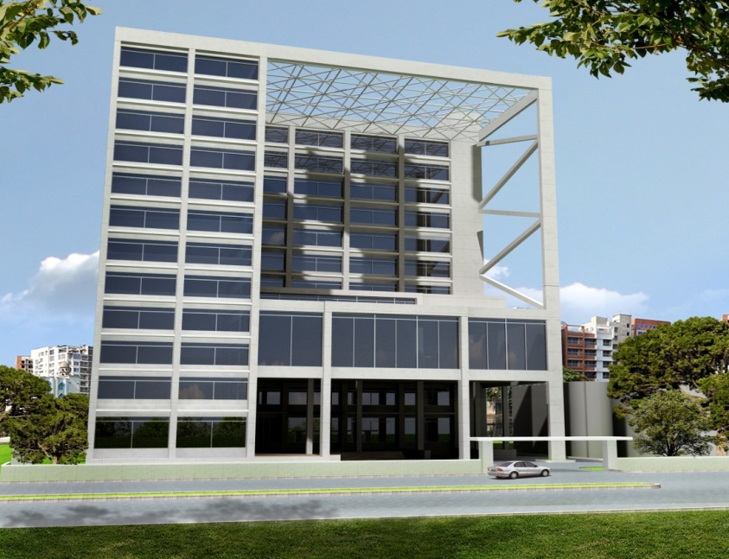
Figure 3.1: Architectural Design of Proposed DoE New Office Building

Construction Material and Sources
Sand: River sand quite abundant in the various riverbeds in Bangladesh. For this project sand will be collected from these sources.
Brick: There are several numbers of brick field around Dhaka city from where brick might be collected. However, it is better to collect the brick from environmental friendly brick field.
Concrete Aggregate: Stone aggregates from Sylhet quarries are commonly used for the manufacture of normal and high strength concrete and it is proposed to be used for the project well.
Cement and Steel Reinforcement: Bangladesh produces different classes of EN and ASTM standard cement and high strength deformed bar of 40, 60 and 75 grades. These materials are readily available in the project area.

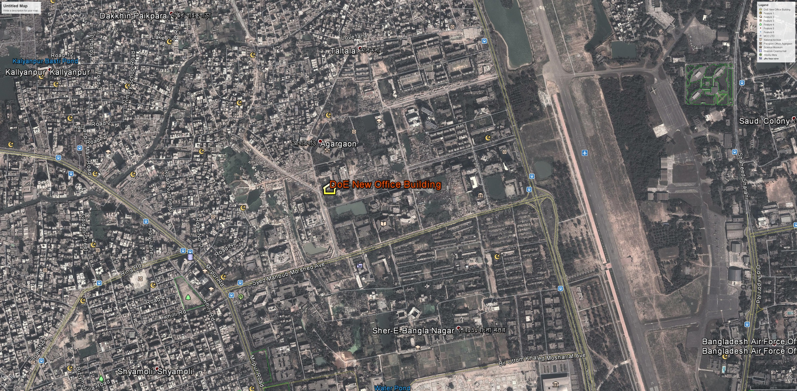
Figure 3.2: Department of Environment (DOE) New Office Building

Justification of the Project
There has been a marked change in the approach of office developments in the urban areas and mostly within the major Bangladeshi cities. Increasingly, there has been a strong tendency to develop office areas with secure infrastructure within the confines of fenced boundaries with restricted and well-guarded entrances. The prevailing circumstances render this type of development popular in the cities. These types of development are a practical response to the growing insecurity in the urban areas. The project is development of offices from an open area which has been used as a garden by the DOE.
The new developments are coming up with modern and efficient drainage and sewerage systems with high factors of safety to handle the ever-escalating volumes of waste materials. They are also installed following guidelines from DOE, which aim at improving the general environmental quality. Landscaping and waste management are given first hand consideration to ensure sustainable use of the environment.
These kinds of developments are also backing up the government’s initiative and policy on providing additional employment. It is a great initiative aimed at providing offices units to the urban society in order to decongest our City Center (this is for the case of Dhaka). In the near future, statistics have shown that nearly half of the world population will be living in urban areas. The proposed office blocks development therefore is a welcome idea that will go a long way in easing pressure to the existing office infrastructure.
It is noted that urbanization is increasing at a first rate. This brings in new classes of people with specialized demands for new and sophisticated lifestyles. People are considering working in places with standard infrastructure i.e. telephone, power and special shop and office design. Again the desire of working in groups to enjoy much security and socialization makes life more interesting to the urban society. With the increasing traffic congestion and especially during peak hours, people have opted to move from the city centers to look for offices in areas like calm and less congested areas. This is the area with less congestion on the road as people now prefer to work in areas with good road networks and have become the hub of official activities.

DESCRIPTION OF THE ENVIRONMENT

Physical Environment

Climate
The climate of Bangladesh is heavily influenced by the Asiatic monsoon. The monsoonal influence results in three distinct seasons:
- Pre-monsoon hot season (from March to May);
- Rainy monsoon season (from June to October); and
- Cool dry winter season (from November to February).
The pre-monsoon hot season is characterized by high temperatures and thunderstorms. April is the hottest month in the country with mean temperatures ranging from 27°C in the east and south, to 31°C in the western and central parts of the country. After April, increasing cloud-cover reduces the temperature. Wind direction is variable during this season, especially during the early part. Rainfall, mostly caused by thunderstorms, at this time can account for 10-25% of the annual total.
Southerly or south-westerly winds, very high humidity, heavy rainfall and long periods of consecutive days of rainfall characterize the rainy season, which coincides with the summer monsoon. This is caused by the tropical depression that enters the country from the Bay of Bengal. About 80% of the annual precipitation occurs during the five month monsoon season from May to September.
Low temperatures, cool air blowing from the west or northwest, clear skies and infrequent rainfall characterize the cool dry season. The average temperature in January varies from 17°C in the northwest and north-eastern parts of the country to 20°C to 21°C in the coastal areas. Minimum temperatures in the extreme northwest in late December and early January reach between 3°C to 4°C.
The proposed DoE office building project lies in the South Central Climatic Regions of Bangladesh (Figure 4-1). The project area is located closest to the Dhaka Weather Station (of Bangladesh Meteorological Department, BMD). In order to depict climatic condition of the project area, the data of temperature, rainfall, humidity and wind speed recorded at Dhaka Weather Station from 1991 to 2012 have been collected from Bangladesh Meteorological Department. Analysis along with illustration has been presented in the following section.
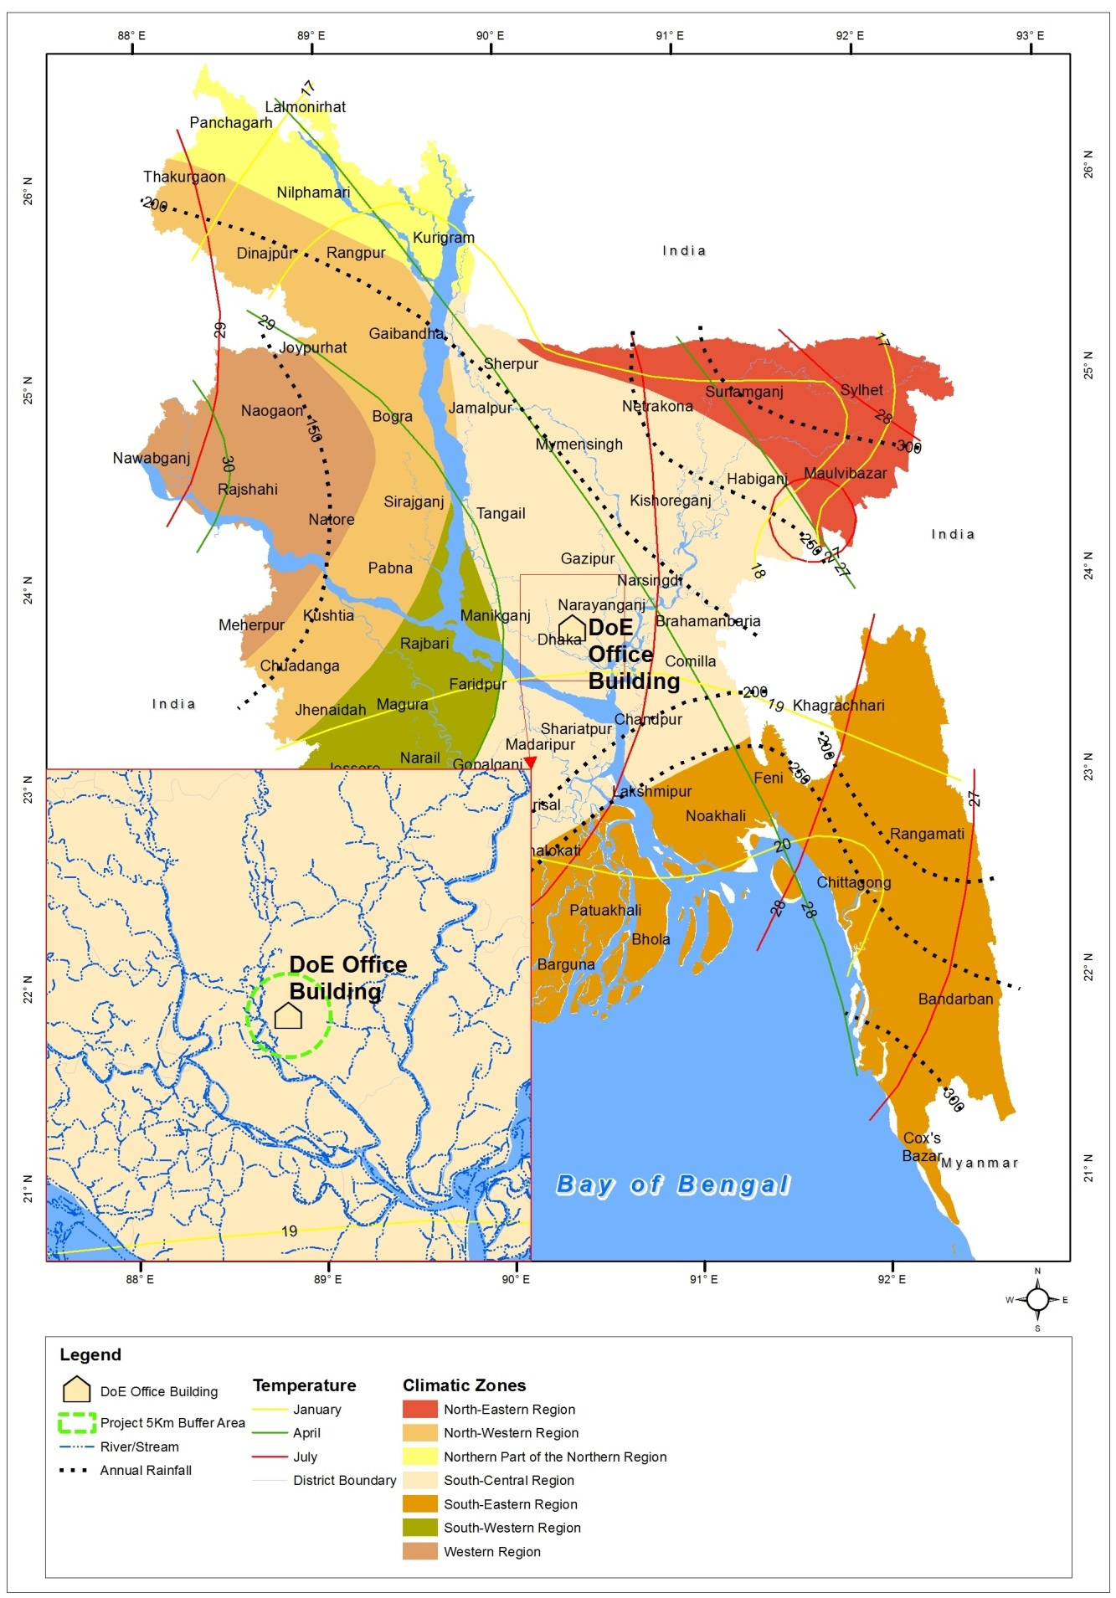
Figure 4.1: Location of the DoE office building project area in the Climatic Zones Map of Bangladesh

Temperature
Temperature data recorded at Dhaka Weather Station from 1991 to 2012 have been collected and analyzed to depict maximum and minimum temperature trend of the project area. The temperature data recorded during the above period reflects that the monthly average maximum temperature recorded at the station was 36.9 °C in April (Table 4.1). The monthly average minimum temperature recorded at the station was 9.5 °C in January. The project area faces maximum hot weather from March to May and the coolest weather remains in the project area from December to February (figure 4.2) in a year.
Table 4.1: Monthly average maximum and minimum temperature (°C) recorded in 1991-2012
Month | Jan | Feb | Mar | Apr | May | Jun | Jul | Aug | Sep | Oct | Nov | Dec
Maximum | 28.3 | 31.8 | 36.1 | 36.9 | 36.5 | 35.6 | 34.6 | 34.9 | 35.1 | 34.8 | 32.5 | 29.2
Minimum | 9.5 | 12.0 | 16.0 | 19.0 | 20.6 | 22.9 | 24.1 | 24.1 | 23.7 | 20.5 | 15.6 | 11.5
Source: BMD, 2013

(Source: BMD, 2013)
Figure 4.2: Monthly average maximum and minimum temperature (°C) recorded in 1991-2012
Rainfall
Based on the rainfall data recorded during the period 1991-2012 at Dhaka weather station the monthly average maximum rainfall was recorded 384 mm in July (table 4-2). During the above period heavy rainfall (more than 300 mm in a month) started to occur from May in Dhaka and continued till September in the area (figure 4.3).
Table 4.2: Monthly average total rainfall (mm) recorded in 1991-2012
Month | Jan | Feb | Mar | Apr | May | Jun | Jul | Aug | Sep | Oct | Nov | Dec
Rainfall (mm) | 8 | 20 | 53 | 119 | 273 | 324 | 384 | 322 | 318 | 180 | 25 | 12
Source: BMD, 2013

(Source: BMD, 2013)
Figure 4.3: Monthly average total rainfall (mm) recorded in 1991-2012
Humidity
The highest relative humidity ranges from 75% to 86% was recorded at Dhaka Weather Station in the month of May to October during the period 1991 to 2012 (table 4-3). The maximum relative humidity for Dhaka is about 82% recorded in July. In project the area, relative humidity rises over 75% from May and continues to rise to 86% in October in a year (figure 4.4).
Table 4.3: Monthly average humidity (%) recorded in 1991-2012
Month | Jan | Feb | Mar | Apr | May | Jun | Jul | Aug | Sep | Oct | Nov | Dec
Humidity (%) | 70 | 62 | 60 | 69 | 75 | 81 | 82 | 81 | 81 | 78 | 72 | 72
Source: BMD, 2013

(Source: BMD, 2013)
Figure 4.4: Monthly average humidity (%) recorded in 1991-2012
Wind Speed
The monthly maximum wind speed data recorded at Dhaka weather station reflects that the area faced highest wind speed ranges from 6.3 to 9.6 knots in September, October and November accordingly during the period 1991-2012 where 9.6 knots wind speed hit the area in October (table 4.4 and figure 4.5).
Table 4.4: Monthly average maximum wind speed (knots) recorded in 1991-2012
Month | Jan | Feb | Mar | Apr | May | Jun | Jul | Aug | Sep | Oct | Nov | Dec
Wind speed (knots) | 2.8 | 3.0 | 3.7 | 3.7 | 3.6 | 3.2 | 3.2 | 3.1 | 3.3 | 3.2 | 2.7 | 2.5
Source: BMD, 2013

(Source: BMD, 2013)
Figure 4.5: Monthly average maximum wind speed (knots) recorded in 1991-2012

Physiographic Features
The physiography is the form of the earth’s surface. In Bangladesh this may be classified into three distinct physiographic regions (a) floodplains, (b) terraces, and (c) hills. Each physiographic region has unique distinguishing characteristics. The three main physiographic regions can be further subdivided into 24 sub-regions and 54 sub-units. As the Project is based in a defined area it is most useful to describe the physiography based on the smallest category, the physiographic sub-units (Rashid, 1991).
The DoE office building project area is located in the sub region “Madhupur Tract” which is another large Pleistocene inlier within Bengal Basin with an area of about 2558 square kilometre (Rashid, 1991). This tract is slightly elevated which has been thought as the result of the tectonic movements to which the Bengal Basin is being subjected. The Madhupur Tract has also four units which are (a) Northern Tract, (b) Central Tract, (c) Southern Tract, and (d) Eastern Tract.

Topography
The elevation of the existing land where the DoE office building has been proposed to be constructed is around 10.1 m (source: Google Earth). The western part of the project area (up to 300 m radius) is comparatively less elevated (lowest elevation is around 8.23 m). The northern, eastern and southern areas (upto 500 m radiuses) of the project location are comparatively more elevated (where highest elevation is about 14 m). Considering 5 km buffer area, the western region of the project area has been characterized by mostly water courses (e.g. river, khal, canal etc.) and the rest three regions represent elevated land form. Figure 4.6 represents the project’s location in the topographic map.
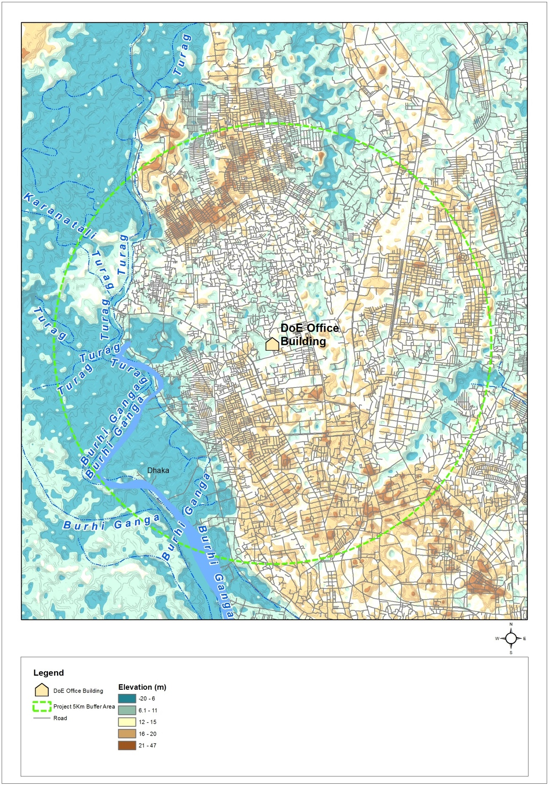
Figure 4.6: Topographic map of the project area

Geology & Soil
According to the physiographic divisions of Bangladesh (Khan, 1991) the project area including other surrounding areas of the City of Dhaka falls under Table Land category. Table Land is a product of Pleistocene vertical upheaval which looks like a chain of isolated circular or elongated low hillocks standing at a higher level than the surrounding flat alluvium. The table land and the sediments underlying it are affected by a series of faults. The average elevation of the Table Land is most likely to be more than 15 m above mean sea level. Small swamps have formed in the shallow valleys of the Table Land due to poor drainage. In Bangladesh, 21 different general soil types have been categorized based on the diagnostic horizons and diagnostic properties of the soil (FAO-UNDP, 1988). According to this classification, soil type of the project area is defined under Non-calcareous Dark Grey Floodplain soil (Figure 4.7).
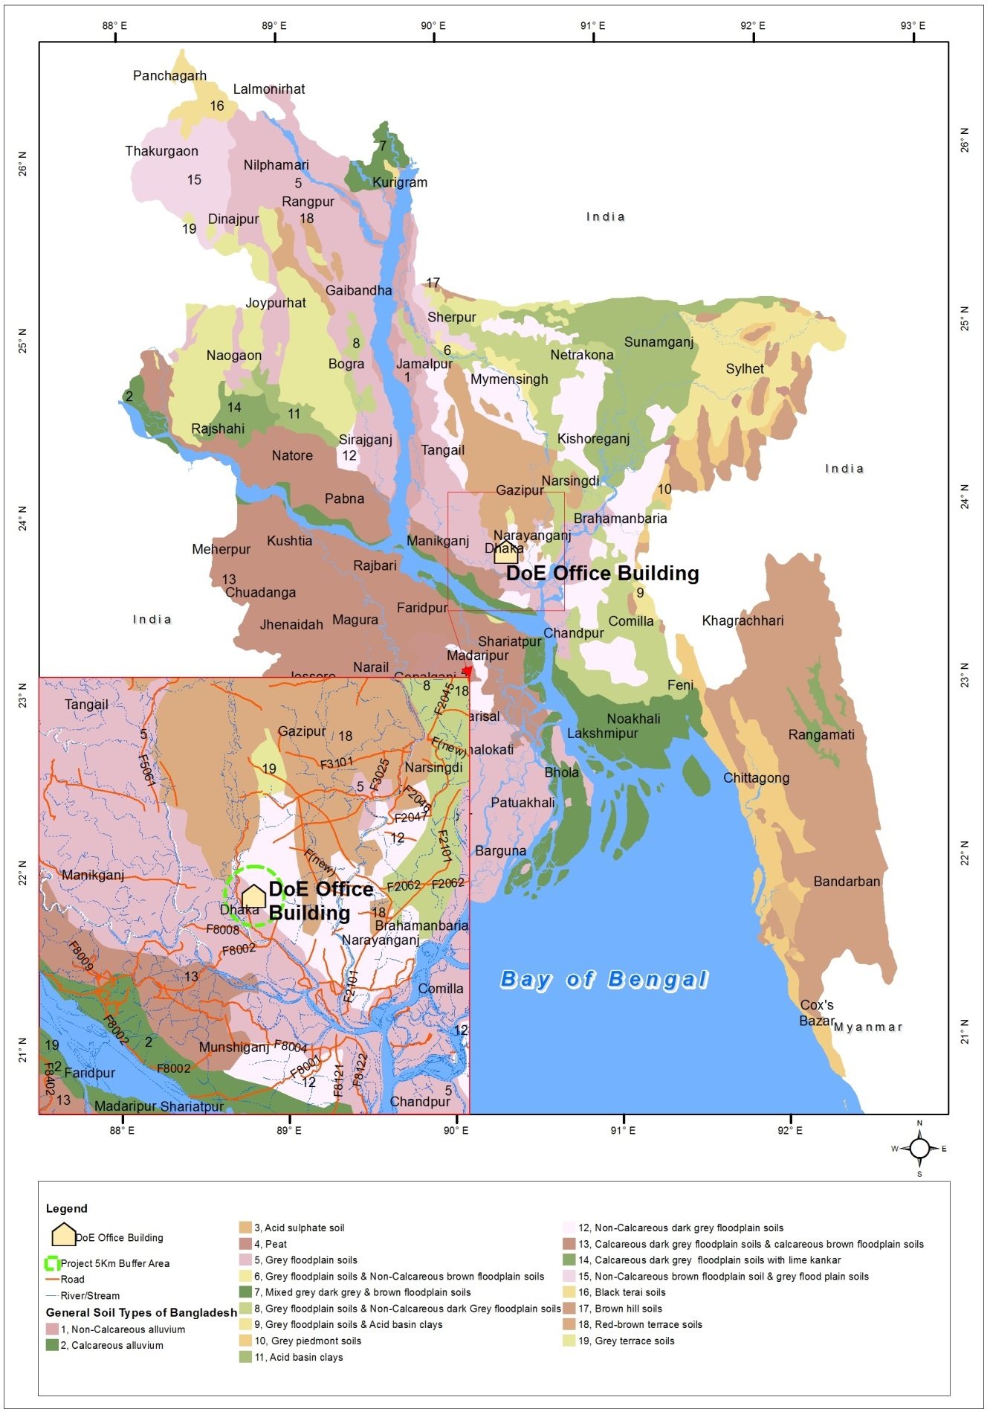
Figure 4.7: General soil types of Bangladesh

Seismicity
Bangladesh is situated in one of the most tectonically active regions in the world. Here three major tectonic plates (the Indian Plate, the Tibet Sub-Plate, and the Burmese Sub-Plate) collide and thrust over each other. Earthquakes occur frequently in the wider region. The project area is located over the Indian plate, in the vicinity of the Sylhet fault (depicted as L3 in Figure 4.8). The typical maximum magnitude of earthquakes experienced around this fault line is between 4 to 6 on the Richter scale.
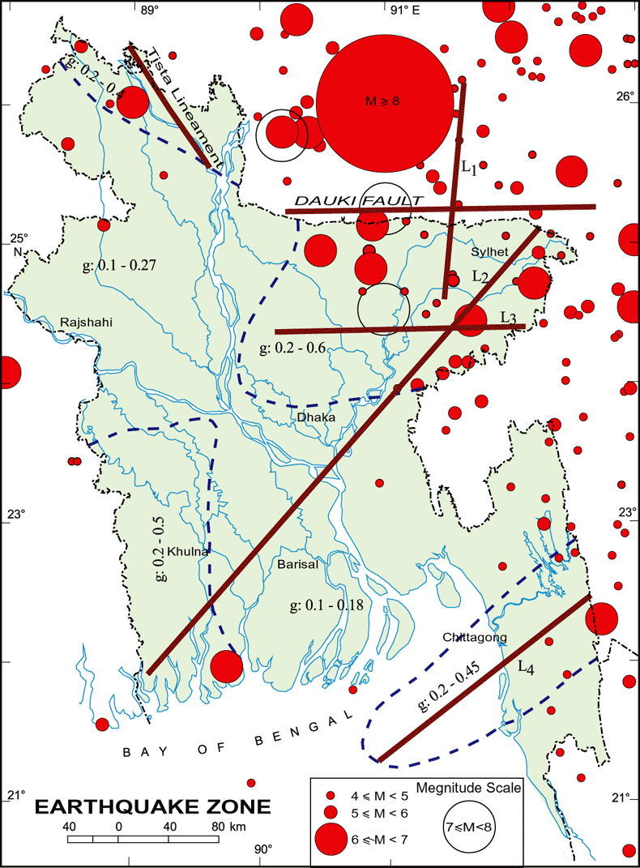

Figure 4.8: Major fault lines prone to seismic activity
Bangladesh can be divided into three Seismic Zones, as described by the ranges of the seismic coefficient. Zone I is the most severe area for earthquake intensity and frequency and Zone III is the least severe (GSB, 1979). The study area falls within Zone II, which is comprised of the northern and eastern regions of Bangladesh, and is the second most seismically active region in the country (Figure 4.9).
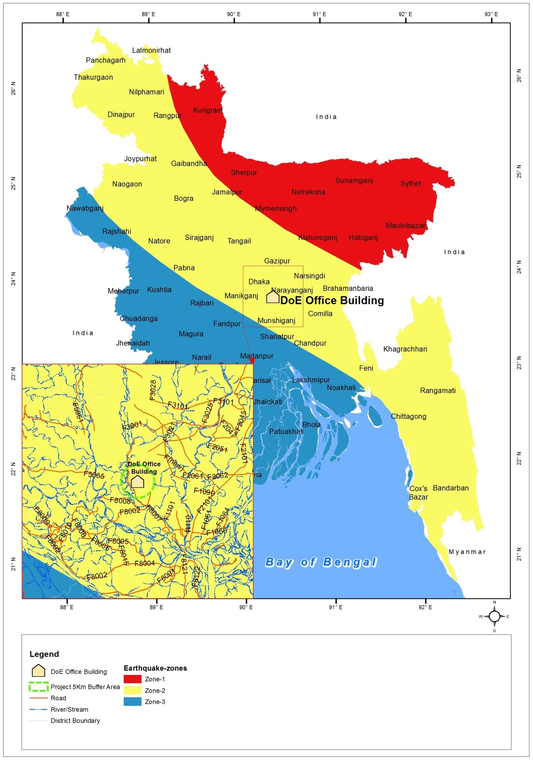
Figure 4.9: Seismic zones of Bangladesh

Water Resources and Hydrology
Surface Water
The surroundings of the project area are being mostly occupied by commercial, residential, and cultural structures. Turag is the closest river to the project area which is around 2.87 km away from the project area in the west. There is a large pond near to the project area (50 m in the south) which is located inside the area of Bangladesh Betar (Radio) and this pond is being used for culture fish farming. In the western side (about 150 m distance) of the project area, there is a sewerage canal which flows north to south. In the southern side (attached with) the existing DoE boundary wall there is a small pond which was found nearly in anoxic condition during field visit in the mid-September 2013. The nearest surface water source in the project area is the fish pond inside the Bangladesh Radio’s compound.
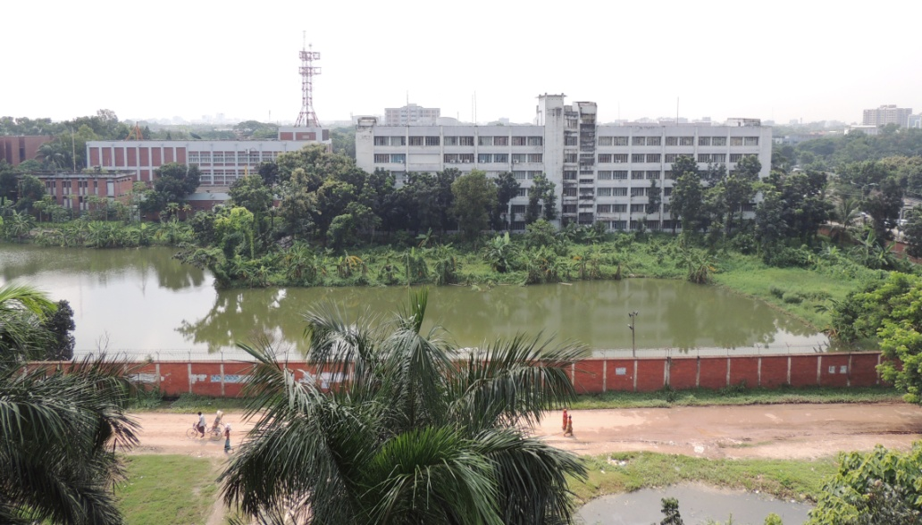
Photograph 4.1: Fish pond located inside the area of Bangladesh Radio
Ground Water
In the project influence area, tap water supplied by Dhaka WASA is being used for drinking and other household purposes. The DoE uses ground water (pumped through deep tube well located in their premises) and this ground water is being used for drinking and other purposes. There is one submergible pump (which pumps water at depth 80 m) and there is also one bore pump which (pumps water at depth 91 m).
The ground water from the above stated deep tube well source has been collected for laboratory analysis. The ground water sample has been collected by the environmental specialist and then sample was sent to the Bureau of Research, Testing & Consultation (BRTC) laboratory of BUET to assess the quality of the ground water for the parameters pH, Manganese (Mn), Arsenic (As), Iron (Fe), Chloride (Cl⁻), Ammonia-Nitrogen (NH₃-N), Total Hardness (as CaCO₃), Total Coliform (TC), and Fecal Coliform (FC) of the water have been analyzed. According to the test result of the ground water (table 4-5) it has been seen that the ground water is free from Arsenic and Iron but the water contains 98 (CFU/100 ml) total coliform and 44 (CFU/100 ml) fecal coliform which does not comply with drinking water quality standard guided in ECR (1997). The rest of the ground water parameters satisfy the drinking water quality standard.
Table 4.5: Test results of groundwater
Water Quality Parameters | Unit | Concentration in Water Sample | Drinking Water Quality Standard, DOE | Method of Analysis
pH | - | 6.97 | 6.5-8.5 | USEPA 150.1; SM 4500-H+ B
Color | Pt-co | 8 | 15 | USEPA 110.2; SM 2120 C
Turbidity | NTU | 0.73 | 10 | USEPA 180.1 Rev 2; SM 2130 B
Total Hardness (as CaCO₃) | mg/l | 88 | 200-500 | USEPA 130.2; SM 2340 C
Chloride (Cl⁻) | mg/l | 24 | 150-600 | USEPA 325.6; SM 4500-Cl-
Total Dissolved Solid (TDS) | mg/l | 183 | 1000 | USEPA160.2; SM 2540 B-D
Manganese (Mn) | mg/l | <MDL | 0.1 | USEPA 200.9 ; SM 3111 B
Arsenic (As) | mg/l | 0.001 | 0.05 | USEPA 206.2; SM 3113 B
Iron (Fe) | mg/l | 0.04 | 0.3-1.0 | USEPA 200.9 ; SM 3111 B
Total Coliform (TC) | CFU/100  ml | 98 | 0 | USEPA 9132; SM 9221 E
Fecal Coliform (FC) | CFU/100  ml | 44 | 0 | SM 9222 G
Source: Lab Analysis at BUET, September 2013

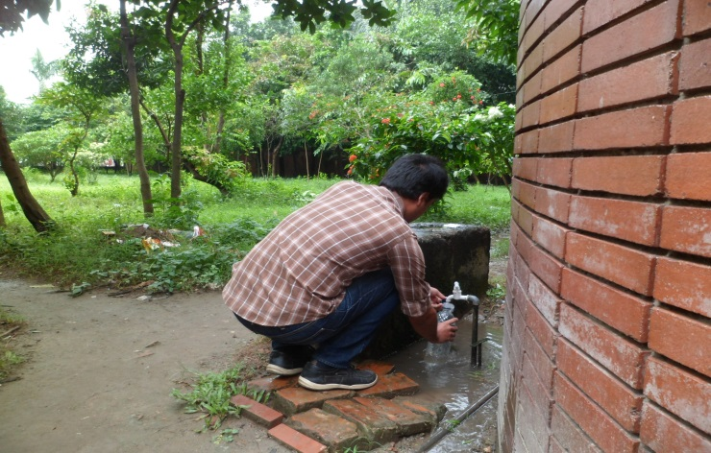
Photograph 4.2: Sampling of ground water for analysis

Ambient Air Quality
Based on the physical observation during field visit it can be said the ambient air quality in the project area is comparatively good except some anthropogenic sources of dust flow and pollutants from the vehicles. The proposed project area is located just beside the 18 m paved road (in the west side), hence emission from the vehicles and dust flow on the road are main sources of air pollution. There are no other anthropogenic sources (e.g. industry, brickfield etc.) for air pollution in the area of 1 km buffer zone.
However, to assess the baseline condition of the ambient air in the project area the air has been sampled and analyzed at spot using machines and experts of the Bureau of Research, Testing & Consultation (BRTC) laboratory of BUET. Ozone (O₃), Nitrogen Dioxide (NO₂), Nitric Oxide (NO), Hydrogen Sulphide (H₂S), Sulfur Dioxide (SO₂), Carbon Mono-oxide (CO), Carbon Dioxide (CO₂), Total Volatile Organic Carbon (TVOC), Particulate Matter (PM₁₀), and Suspended Particulate Matter (SPM) have been taken into analysis to assess the ambient air quality. The result of analysis of ambient air quality shows that all the parameters except SO₂ were found within the allowable limit as per the ambient air quality standard guided in ECR (1997, amendment in 2005)
Table 4.6: Test result of ambient air quality
Air Quality  Parameters | Unit | Ambient Air Quality  (Maximum Level) | Bangladesh  Standard  (ECR 1997, Amendment in 2005)
PM₁₀ | µg/m³ | 50 | 50 (annual average)  150 (24-hr average)
SPM | µg/m³ | 128 | 200 (8-hr average)
CO | ppm | 0 | 9 (8-hr Average)  35 (1-hour Average)
SO₂ | ppm | 0.7 | 0.03 (Annual Average)  0.14 (24-hour)
NO_{x} | ppm | 0 | 0.053 (annual)
O₃ | ppm | 0.06 | 0.08 (8-hr Average)  0.12 (1-hr Average)
H₂S | ppm | 0.73 | Standard Not Set Yet
Temperature | °C | 31 | Standard Not Set Yet
O₂ | %vol | 0.3 | Standard Not Set Yet
CO₂ | ppm | 361 | Standard Not Set Yet
TVOC | ppb | 1582 | Standard Not Set Yet
Source: Lab Analysis at BUET, October 2013
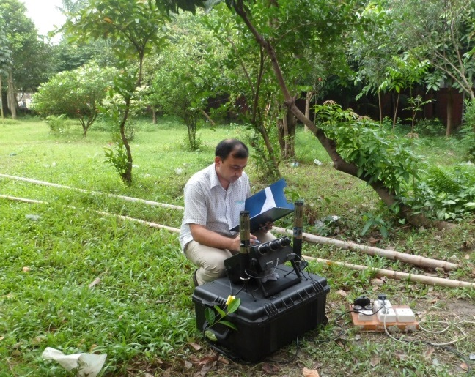 | 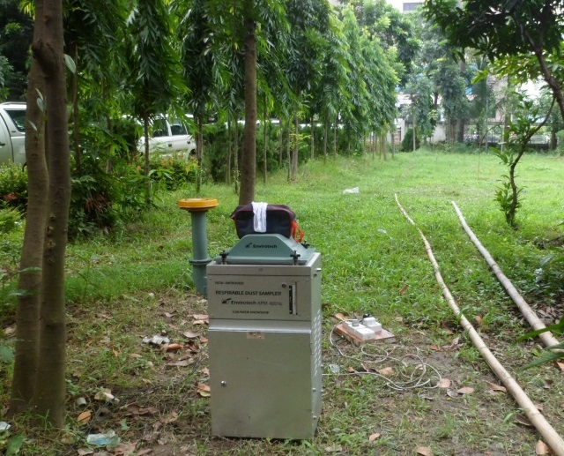
Photograph 4.3: Ambient air quality monitoring in the project area

Noise Level
Excessive noise is a potential issue for both human and biological receivers and can result in a range of negative issues, from mild annoyance and moderately elevated levels of aggression to significant disturbance of behavioral patterns and – in severe cases – hearing loss. The main source of noise is the vehicles running on the roads in the west side (Shahid Shahabuddin Road) and south side (the road which goes towards Islamic Foundation) of the project location. Noise level has been monitored at inside and outside of the project location during day and night time. Results of the noise level monitored along with details of the sampling locations have been showed in table 4-7. The results show that time weighted average value of the sound (L_{Aeq}) monitored at inside and outside of the project area did not exceed the standard fixed for the commercial area. It can be mentioned that maximum noise level recorded (L_{A10}) at every location exceeded sound level standard for commercial area.
Table 4.7: Result of Sound Level Monitoring
Location | GPS Location | Land Use Category | ID | Date | Time | Period | Noise Level Description (dBA)
 |  |  |  |  |  |  | L_{A10} | L_{A90} | L_{Aeq}
Inside of the Project Area (DoE) | 23°46'37.61"N  90°22'18.53"E | Commercial area | RES63 | 21/10/2013 | 11.30 | Day | 70 | 45 | 53
Inside of the Project Area (DoE) | 23°46'37.61"N  90°22'18.53"E | Commercial area | RES64 | 21/10/2013 | 09.30 | Night | 73 | 41 | 53
Outside of the Project Area (DoE) | 23°46'37.07"N  90°22'17.00"E | Commercial area | RES62 | 06/10/2013 | 12.00 | Day | 87 | 51 | 64
Outside of the Project Area (DoE) | 23°46'37.07"N  90°22'17.00"E | Commercial area | RES65 | 21/10/2013 | 10.00 | Night | 83 | 45 | 59
Notes:
- Land use category is based on the classification provided in the Noise Pollution Control Rules (2006)
- Shaded cells indicate noise levels in excess of Noise Pollution Control Rules ambient noise limits for a given land use area
- The sound level standards for commercial area are 70 dBA at day time 60 dBA at night time
- L_{Aeq} is the average noise level recorded over the duration of the monitoring period
- L_{A10} is the noise level exceeded for 10% of the monitoring period
- L_{A90} is the level exceeded for 90% of the monitoring period
Source: On Site Monitoring, October 2013, EIA Study Team
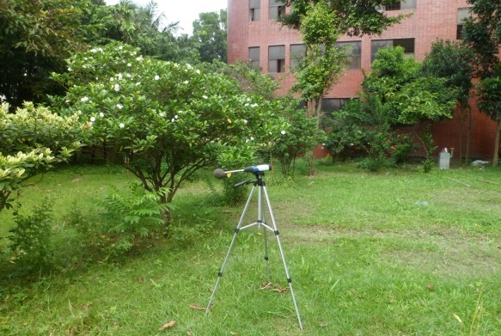 | 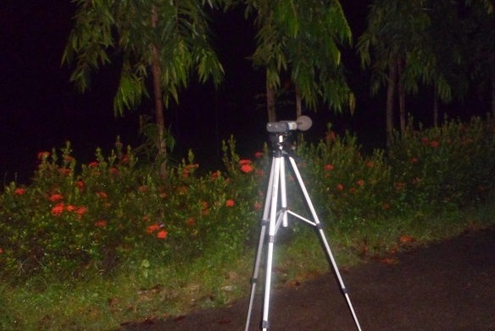
Photograph 4.4: Sound level monitoring inside of the project area during day (left) and night time (right)
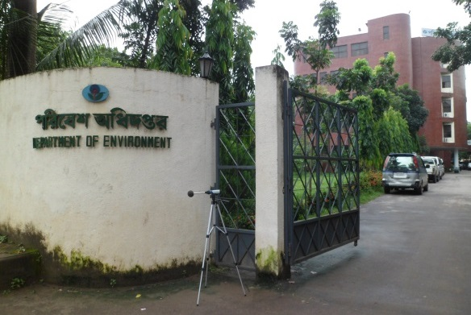 | 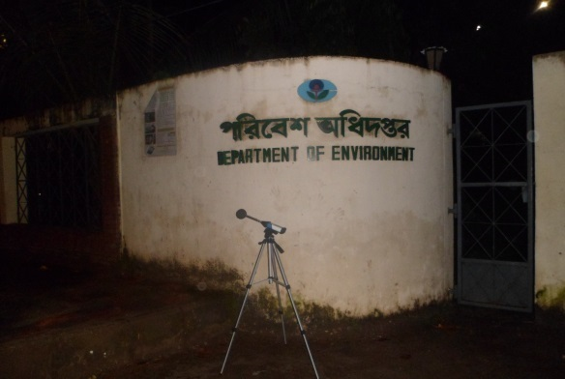
Photograph 4.5: Sound level monitoring outside of the project area during day (left) and night time (right)

Biological Environment

Bio-ecological Zones
The bio-ecological component generally refers to flora and fauna, their present status, description and habitats based on the nature and type of the project activities. Temperature, rainfall, physiographic variations in soil and different hydrological conditions play vital roles in forming diverse ecosystems in the different geographic areas in Bangladesh. The ecosystems of Bangladesh could be categorized into two major groups, i.e. (i) land based and (ii) aquatic. The land-based ecosystems include forest and hill ecosystems, agro-ecosystems and homestead. Ecosystem; while seasonal and perennial wetlands, rivers, lakes, coastal mangroves, coastal mudflats and chars, and marine ecosystems fall into the aquatic category.
Each of the above ecosystems has many sub-units with distinct characteristics as well. IUCN Bangladesh in 2002 classified the country into twenty five bio-ecological zones (Figure 4.10). The project area falls under Brahmaputtra-Jamuna Floodplain sub-category.
The status of the flora and fauna of the project area is determined by specific assessment of both the terrestrial and aquatic environments, review of literatures relevant to the location and identification of species through primary (transit walk, interviews) and secondary sources but there have been identified only terrestrial environment in the project influence area (PIA).
The land for the proposed DoE Office Building is being used for gardening. Therefore, this garden provides not only aesthetic beauty but also provides good terrestrial habitat for the floral and faunal species. Diverse floral and faunal species were found during the visit of the project area (photo 4.6 & photo 4.7).
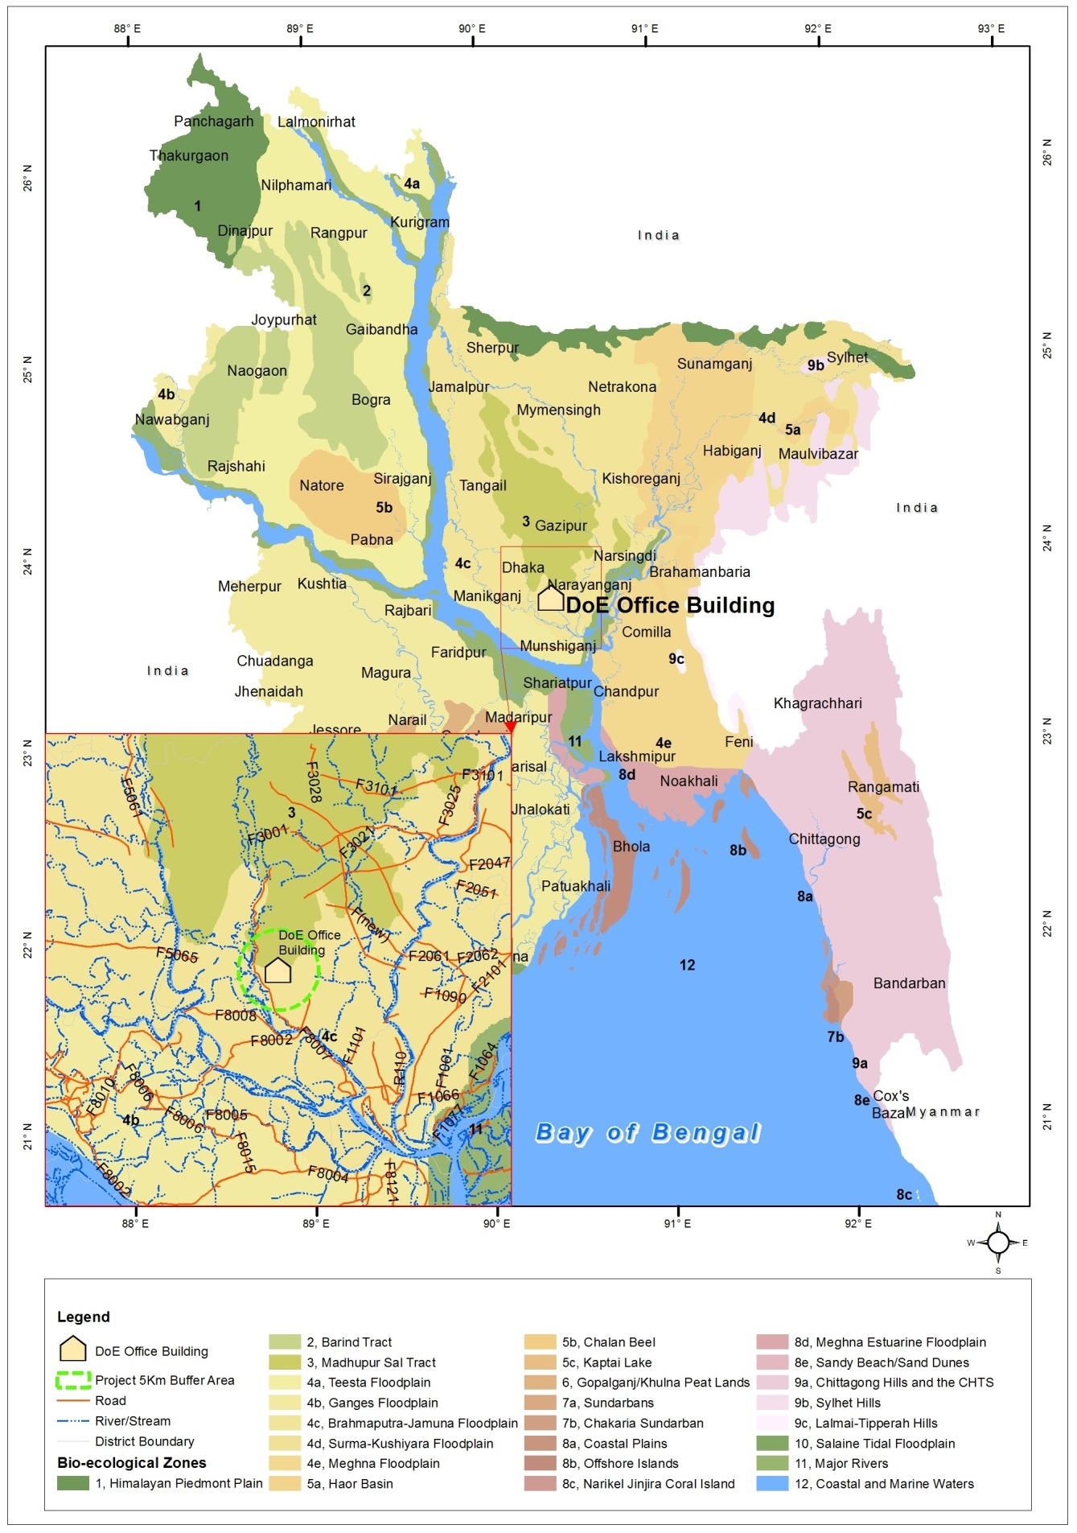
Figure 4.10: Bio-ecological zones of Bangladesh

Diversity of Terrestrial Floral and Faunal Species
The project area is located in such a PIA where most of the land features are occupied by structures. The proposed project area is a good habitat for terrestrial life and there are very few aquatic habitats for the species. Nevertheless, the proposed project area is not only provides good habitat for lives but also it provides aesthetic beauty. There are diverse fruit trees, woody trees, wood cum fuel trees and trees with aesthetic significance (Photograph 4.6). In the proposed project area 301 number of fruit, woody and aesthetic plants has been counted during field visit. Including the trees on the boundary line of the proposed building site there are 301 numbers of trees where 15 types of fruit trees, 6 types of woody trees and 7 types of aesthetic plants are present in the proposed building area (Table 4.8).
Table 4.8: Tree species living in the proposed building area
Type | Local Name | Scientific Name | Number of Trees
Type | Local Name | Scientific Name | Large | Medium | Small | Saplings
Fruit | Jamrul | Syzygiumsamarangense | - | - | 4 | -
Fruit | Bel | Aeglemarmelos | - | - | 1 | -
Fruit | Jolpai | Elaeocarpusrobustus | - | - | - | 1
Fruit | Lebu | Citrus aurantifolia | - | 1 | 1 | -
Fruit | Jam | Syzygiumcumini | - | - | 2 | -
Fruit | Batabi Lebu |  | - | - | 3 | -
Fruit | Kamranga | Averrhoacarambola | - | - | 5 | -
Fruit | Kathal | Artocarpusheterophyllus | - | - | 11 | 2
Fruit | Aam | Mangiferaindica | - | - | 8 | 3
Fruit | Khejur | Phoenix sylvestris | - | - | - | 1
Fruit | Boroi | Zizyphusmauritiana | - | - | 2 | -
Fruit | Pepe | Carica papaya | - | - | - | 1
Fruit | Peyara | Psidiumguajava | - | 1 | 21 | 0
A. Sub Total |  |  | - | 2 | 58 | 8
Timber | Mehogoni | Swieteniamahagoni | - | 1 | 11 | 2
Timber | Chapa |  | - | - | 1 | -
Timber | Dumur | Ficushispida | - | - | 1 | -
Timber | Jarul |  | - | - | 7 | -
Timber | Jirbot |  | - | 1 | 1 | 0
B. Sub Total |  |  | - | 2 | 21 | 2
Aesthetic | Shefali |  | - | - | 1 | -
Aesthetic | Rongon |  | - | - | - | 135
Aesthetic | Mehendi | Lawseniainermis | - | - | - | 1
Aesthetic | Debdaru |  | - | - | 47 | -
Aesthetic | Joba |  | - | - | 2 | -
Aesthetic | Belly |  | - | - | 1 | -
Aesthetic | Patabahar | Codiaeumvariegatum | - | - | 3 | -
Aesthetic | Jhaw | Casuarinalittorea | - | - | 15 | -
Aesthetic | Gondhoraj | Gardenia coronaria | - | - | 2 | -
Aesthetic | Tagor |  | - | 1 | - | -
C. Sub Total |  |  | - | 1 | 71 | 136
Grand Total (A+B+C) |  |  | - | 5 | 150 | 146
Number of trees remained in the Proposed DoE Office Building Project area |  |  |  |  |  | 301
Note: Size of the trees refer here circumference of the trees which are: Large=5' and Above; Medium= 2'7''-5'; Small= 7''-2'7''; Saplings= <6''
Source: Field Survey, September 2013

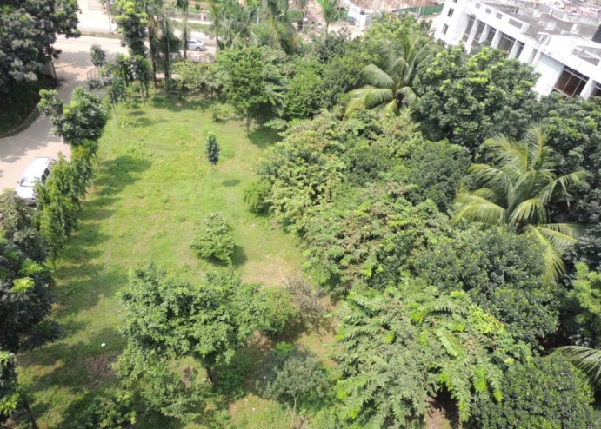 | 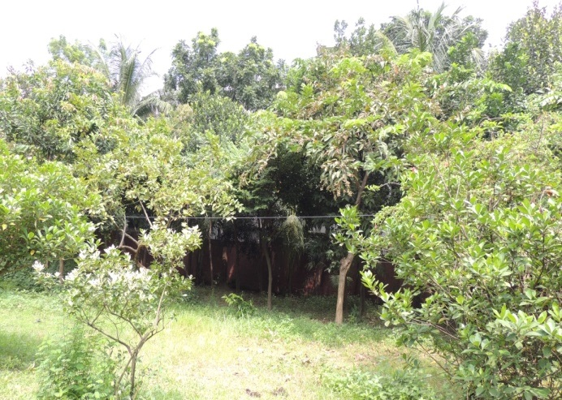
Photograph 4.6: Diverse floral species in the project area
As mentioned in the above section that the proposed project area is being used for gardening to enhance aesthetic beauty in the existing area of the DoE administrative office building. Therefore, the project area also provides good habitat for the diverse faunal species. During the field visit in mid-September 2013, there have been found different types of wild lives (e.g. birds, butterfly, frog etc.).
Table 4.9: List of common wildlife living in the PIA
Sl. No | Local name | Scientific name | Observation Status (During Field Visit)
Mammals

 | Kathbiral | Ratufa bicolor | -
 | NengtiIndur | Musmusculus | -
 | MethoIndur | Musbooduga | -
 | Biral | Filisdomesticus | √
 | Begi | Herpestesedwardsi | -
 | chika/chucho | Suncusmurinus | -
Reptiles
 | Dura Shap | Enhydrisenhydris | -
 | TikTiki | Hemidactylusflaviviridis | -
 | Rokto-chosha | Calotesversicolor | -
Amphibians
 | Kuno Bang | Bufomelanostictus | -
 | Sona Bang | Ranacyanophyctis | -
Avian
 | Shalik (Indian myna) | Acridotheres fuscus | √
 | Charai (Sparrow) | Passer domesticus | √
 | Tiye (Parrot) | Psittaciformes | -
 | PatiKak (Crow) | Corvus splendens | √
 | Doyel (Magpie) | Copsychus saularis | -
 | Choto Machranga (Kingfisher) | Alcedo athis | -
Source: Baseline Environmental Survey, September 2013
 | 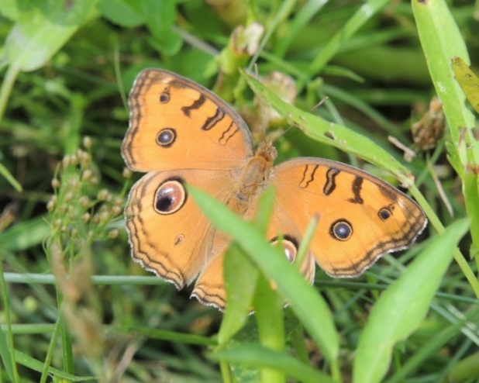
Photograph 4.7: Faunal species found in the project area during field visit

Diversity of Aquatic Flora and Fauna
The proposed multi-storied DoE office building project area is situated in an area where there are no such fresh water bodies (except the pond inside the Bangladesh Radio’s compound) which could provide aquatic ecosystem for the aquatic flora and fauna. A few amphibian species such as frog can be found during rainy season in the marsh land area. In the pond of the Bangladesh Radio (located in the south side of the project area), some fish species and some other aquatic floral and faunal species can be found.

Protected Areas and Red Book Species
Based on Bangladesh Wildlife Preservation Order, 1973 Protected Areas (PAs) is classified into national parks, wildlife sanctuaries, game reserves and private game reserves. Bangladesh has 56 nationally designated protected areas where 17 are national parks and 34 are wildlife sanctuaries. Based on the map showing all of the protected areas, eco-parks and safari park it can be concluded that there is no such protected area in and surrounding the project area (Figure 4.11).
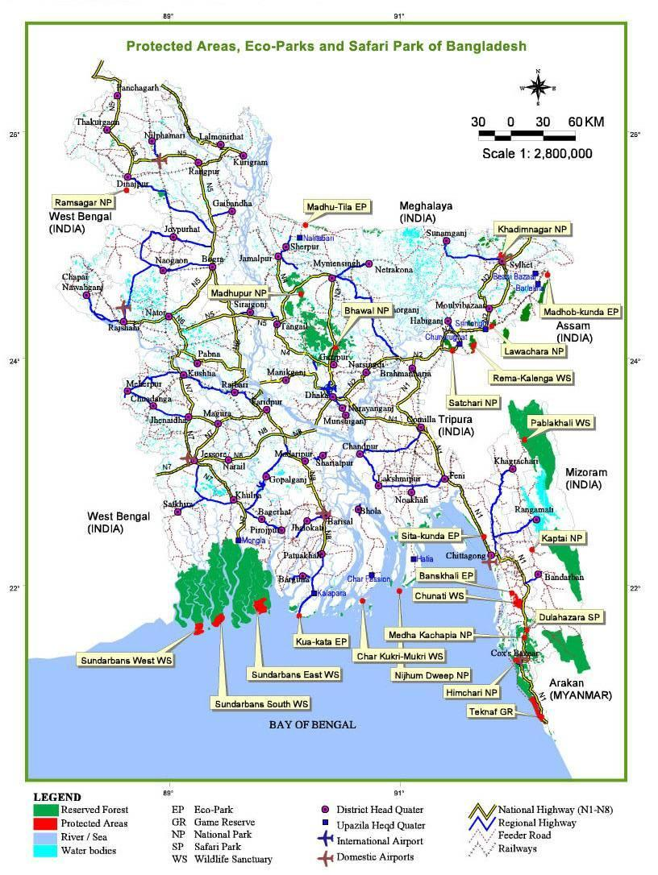
Figure 4.11: List of the protected areas, eco-parks and safari park showed in the map of Bangladesh

Socio-Economic Environment

Employment and Income
The surroundings of the project area have been occupied by mostly administrative offices of the Government of Bangladesh. In the north-western and western sides of the project area there are some small enterprises (e.g. workshop, grocery shop, tea stall etc.). Therefore, public service is the main employment opportunity and income source in the project influence area (considering 500 m buffer zone). It can be noted that there some slums in the eastern side of the existing DoE office building.

Settlement and Housing Pattern
The project influence area (PIA) is covered by multi-storied administrative structures except a few exceptions. The north-western side (which is around 50 m from the project boundary) is densely covered by residential buildings. In the eastern side, there are slum type houses.
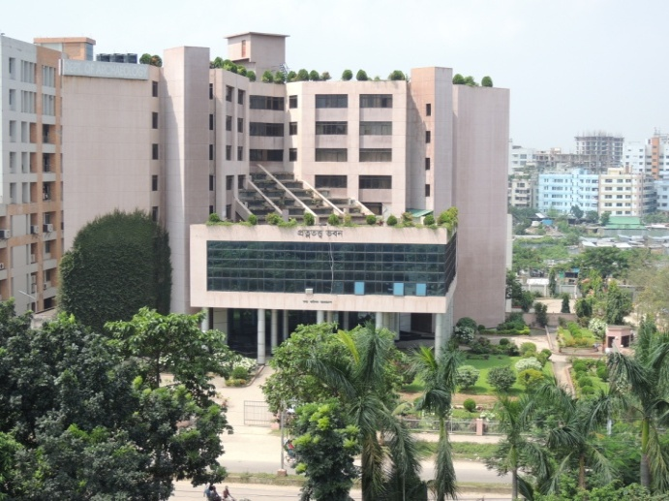 | 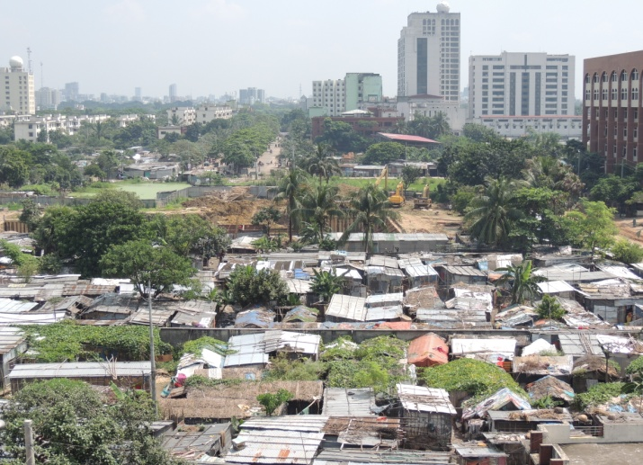
Photograph 4.8: Multi-storied administrative structure (west side) and slum housing pattern (east side)

Land Use Patterns
The existing land for the proposed multi-storied DoE office building is a vacant land and it has been used for gardening. Most of the land areas in the PIA (min 500 m radiuses) have been occupied by administrative structures of the GoB. There are also some exceptions in the land use pattern in PIA. In the eastern side of the existing DoE building there are many slums. In the north-western side of the project area, densely residential buildings can be found. Within minimum 500 m PIA in the north, south, east and west sides all of the land areas have been used for Government’s administrative purposes.
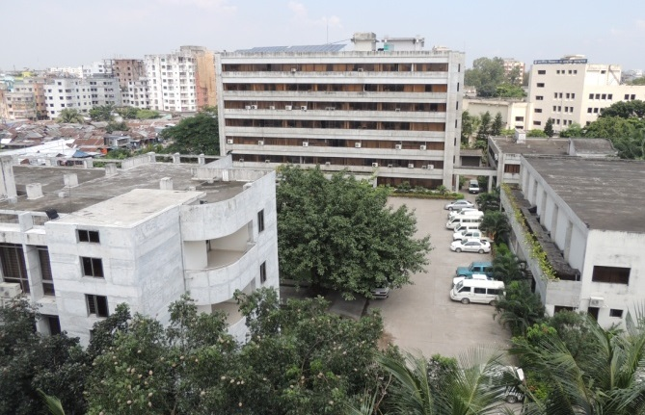North Side | 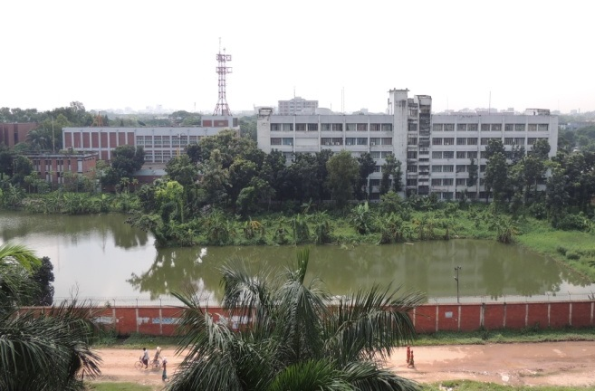South Side
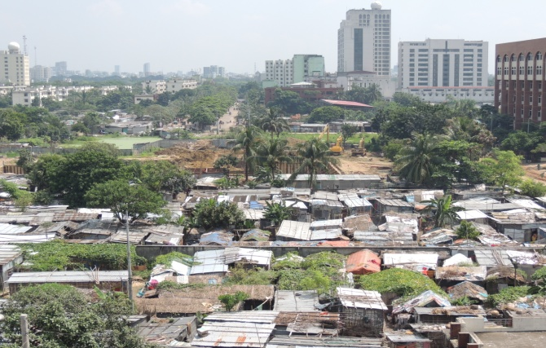East Side | 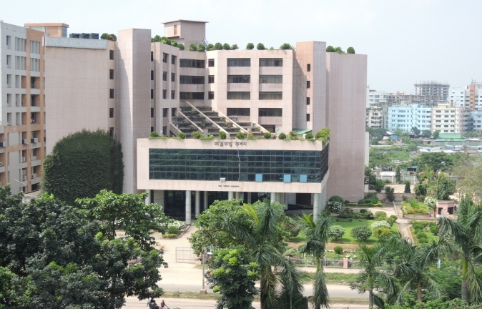West Side
Photograph 4.9: Land use pattern in all sides of the project area

Water Supply and Sanitation
Water supply in the project area and PIA is tap water reticulation system as like as other parts of the Dhaka city. The existing DoE office building uses own source deep tube well water. There is also a sewerage system passing through the existing paved road (in the west) which is connected with the large sewerage canal in the back side of the Institute of Neuro Science. All households, offices, and others in these areas have hygienic latrines.

Utilities (Electricity, Gas & Telephone)
In the project area there have access to electricity, gas and telephone connection. Dhaka Electricity Supply Company (DESCO) supplies electricity through grid line in the project area. DoE has also installed solar PV on their roof top. Titas Gas Transmission and Distribution Company supplies gas connection through pipe line. In the proposed office building area there is gas pipe line beneath the earth surface which comes from gas transmission line and goes to the existing DoE office building. DoE office building is also connected with the telephone connection of Bangladesh Telecommunication Company Limited (BTCL).

Transport and Communication
Surrounding the project area there is good road communication system. In the western side of the project there is a paved road (width 18.2m) which is connected with Agargaon to Shyamoli main road. In the southern side of the project area there is also another paved road (width 6.1m). There are good opportunities of road networks and transports to go any places in the City of Dhaka and also to go outside of the city. Both public and private transports of different types (bus, minibus, microbus, car, CNG, covered van, motorcycle, auto-rickshaw, rickshaw etc.) move on those roads.

Archaeological, Historical and Cultural Sites/Resources
According to the Department of Archaeology, Bangladesh, there is no places of archaeological, historical and cultural resources/sites, situated within or nearby the project area or PIA (<500m).

Environmental Hot Spots
Surrounding the proposed multi-storied DoE office building’s area there are some environmentally and socially critical areas in accordance with the project activities. These critical areas include administrative building, cultural & community infrastructure (e.g. hospital, mosque, school) wave broadcasting (Radio), and research institute (Atomic Energy, Neuro Science, SAARC Meteorology Research Center and so on). All of those environmentally and socially critical areas have been listed in table 4.10 and showed in figure 4.12.
Table 4.10: List of the environmental hot spots with location
Sl. No. | Name & Description | Location & Direction Subject to the Project’s Location | Distance from the Project’s Boundary (m)
 | Bangladesh Atomic Energy Regulatory Authority Office Building | Adjacent to the project in the north side | 2
 | National Museum of Science & Technology | North Side | 123
 | Coast Guard Head Quarters | North side | 20
 | Shahid Shahabuddin Memorial School | North side | 286
 | Baitun Aman Jamey Mosque | North side | 300
 | Department of Archaeology | West side | 30
 | National Institute of Neuro Science | West side | 65
 | Bangladesh Radio | South side | 52
 | Tuberculosis Clinic | West side | 380
 | National Institute of Ophthalmology | West side | 275
 | National Children Hospital | South-western side | 460
 | National Orthopedics Hospital | South-western side | 430
 | SAARC Meteorological Research Center | South-eastern side | 140
 | Islamic Foundation Building | South-eastern side | 250
 | Bangladesh Institute of Development Studies | North-eastern side | 192
 | University Grants Commission | North-eastern side | 330
 | Bangladesh Computer Council | North-eastern side | 285
 | Bangladesh National Library | South Eastern side | 205
 | National Archive Building | South Eastern side | 305
 | Shere E Bangla Girls’ High School | South Eastern side | 330
 | Asian Development Bank Office | South Eastern side | 300
 | World Bank | South Eastern side | 375
Source: Field Survey (September 2013) and Google Earth 2013

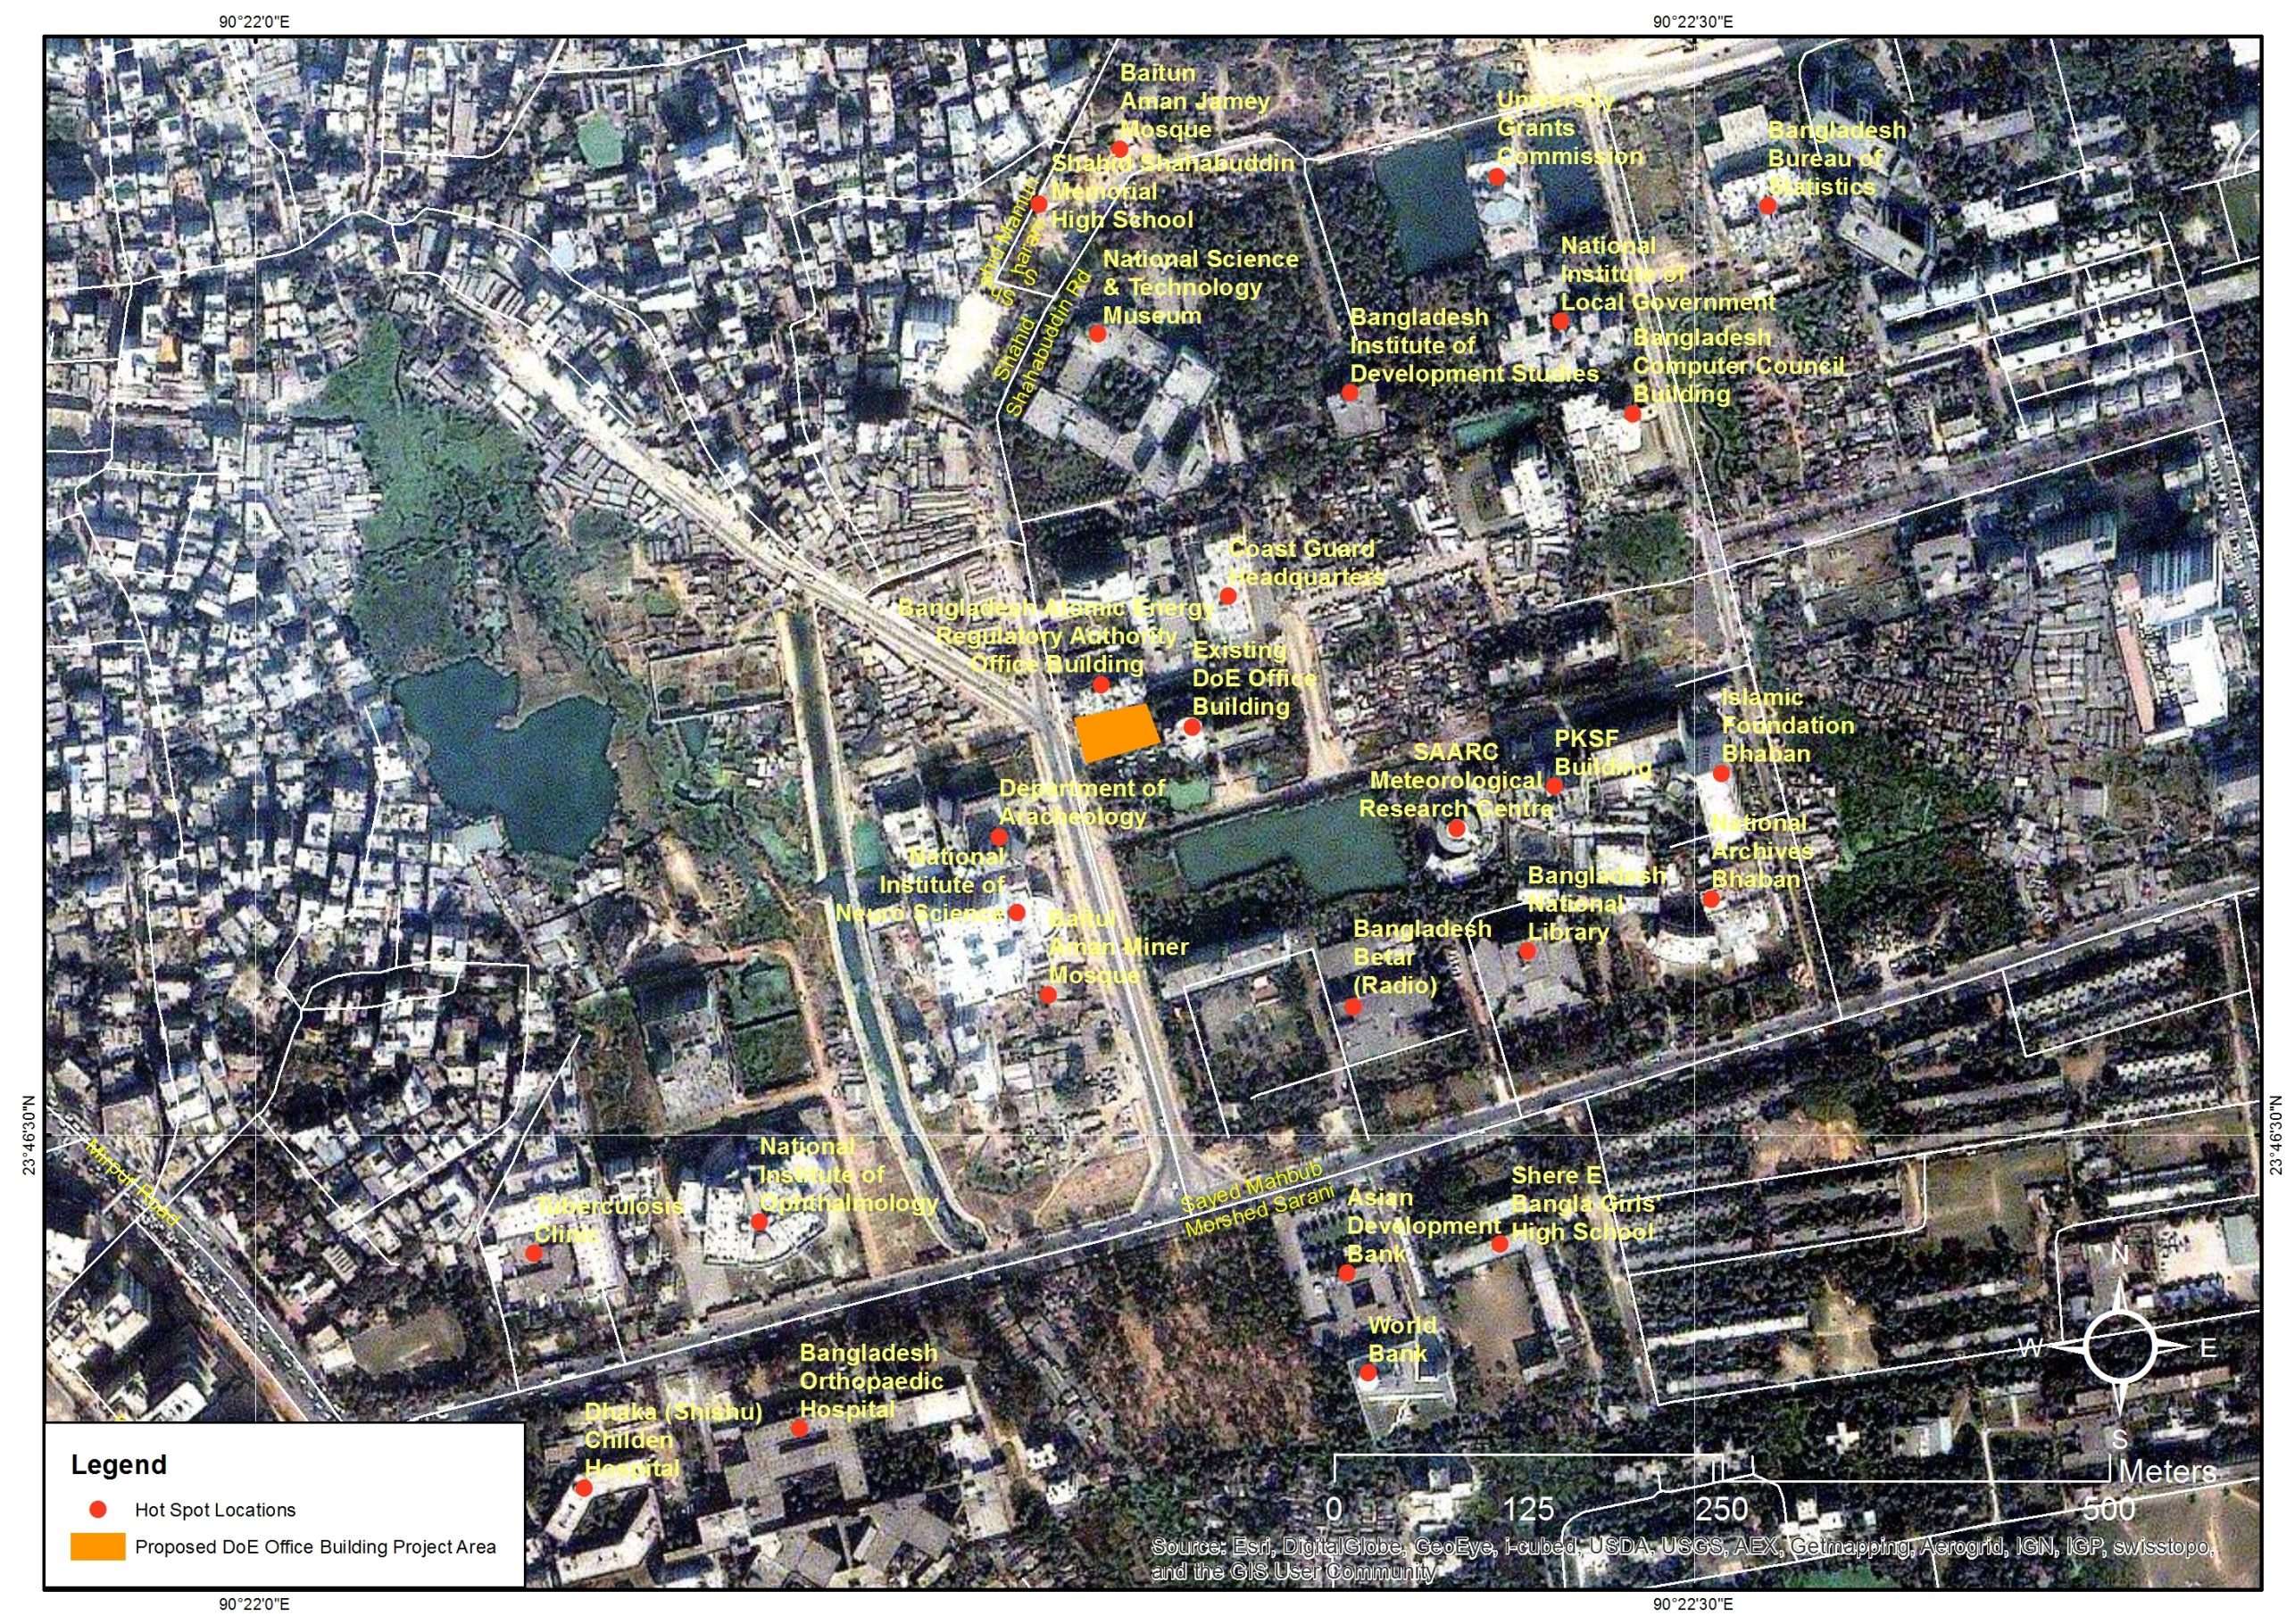

Figure 4.12: Environmental hot spots remained in the PIA

ENVIRONMENTAL IMPACTS AND MITIGATION MEASURES

Identification of Potential Environmental Impacts
This chapter identifies the potential impacts related with project location, design, construction, and operation phases of the project on the physical, biological and socioeconomic domains in the existing environment of the project. An environmental impact is defined as any change to an existing condition of the environment. Identification of potential impacts has been done on the basis of baseline data collected from secondary and primary sources. Identification of potential impacts due to the project site development is shown in checklist for the DoE Multi-storied Office Building (Appendix B). In the checklist, activities, which may affect the environment due to various stages of the project actions, are listed and the degrees of Significant Environmental Impacts (SEIs) are shown. The terms “none”, “insignificant”, “moderate” and “significant” are used in the checklist to classify the magnitude of SEIs. Environmental impacts can be broadly classified as those taking place during pre-construction, construction and operational phases of the project. Activities involved affecting environmental components at different phases of the project implementation as well as potential /significant environmental impacts are discussed in the following sections.

During Pre-Construction Stage

Land Acquisition and Loss of Structures
Impact: The construction of the Multi-storied Office Building of DoE will be constructed on the vacant land current used for gardening (west side of the existing building) inside the premises of DoE. The land required for the proposed project has been owned by DoE. To store construction materials (e.g. sand, bricks, cement & rod) there will be required particular area inside or outside of the project premises. Storing construction materials on the existing public roads (south & west side) will cause disturbance to the traffic moving on the road and also to the pedestrians. The proposed project will not cause any loss of physical structures.
Mitigation: Storage of construction materials should not be done on the public roads. In any case of loading/unloading of trucks containing construction materials the issue of smooth movement of the traffics and pedestrian along with safety measures will have to be ensured. In case of using public places to stock construction materials and equipment respective must be informed in advance.

Removal of Utilities

Electric Lines
Impact: There is heavy electricity transmission line outside of the proposed project area which has passed across over the main entrance of DoE’s premises. Dhaka Electricity Supply Company Limited (DESCO) is the authority of electricity transmission. There are a few internal electric poles inside the project boundary in the west side of the project area.
Mitigation: During transporting drilling and piling machineries in the project site through the main entrance special care must be taken as it does not touch the electricity transmission ware. In any case of relocating electric pole, DESCO will have to be informed in advance.

Gas Pipelines
Impact: Gas pipeline passed into the DoE’s main building underneath the earth on the left side along the main internal road (in the west side). TITAS Gas Company is the authority of the gas distribution. During site preparation, relocation of this gas transmission line will have to be ensured first.
Mitigation: Relocation of gas pipeline will have to be done with the help of the gas distributing company.

Water Supply & Sewerage Pipelines
Impact: Inside the land of the proposed project there is water supply pipeline and tape. This water supply pipeline supplies water in the garden and the deep tube well of the DoE is the source of this water.
Mitigation: Before commencing preparation of the site, relocation of the water supply pipeline has to be ensured.

Removal of Trees
Impact: According to the tree assessment conducted on the land of the proposed project it can be said that site preparation for the construction of the building will cause removal of total 301 numbers of trees of which 5 trees is medium, 150 trees is small and 146 trees are saplings in size of fruit, timber and aesthetic diverse tree species (table 4-9). Removal of trees will cause permanent loss of vegetation and this will also cause habitat loss of different wild life species.
Mitigation: To compensate the loss caused due to felling of 301 number of trees, DoE in its own land will be needed to plant trees in the operation stage as per the prescription of Forest Department (FD) (e.g, minimum two tree seedlings to be planted for each tree felled during starting of the operation stage but plantation is better during monsoon period. Tree cutting should be done by experienced labors and carrying of trees should be done by trucks at night time to avoid any road accident. For cutting trees, first all the affected trees should be marked by numbering in red color by the relevant persons of the FD. After that the relevant workers of FD can cut the marked trees by the electric cutter in such a way so that no accident is occurred due to tree cutting. The roots of the trees will have to be removed from ground. Just after cutting the trees, all these trees can be carried properly by trucks during nighttime for storing at the designated area of the DoE from where the trees can be sold by offering quotation.

During Construction Stage

Drainage Congestion
Impact: Construction of the proposed DoE multi-storied building will significantly impact upon the existing drainage pattern through impedance to natural flow conditions. Temporary drainage congestion will occur especially during monsoon period due to excavation of earth from the foundation trench of the proposed DoE building. In addition, drainage congestion resulting in to stagnant water or local flooding also may be occurred in the places such as construction yard and labor’s camp. The drainage system on the surrounding of the proposed DoE building area will be affected by construction activities.
Mitigation: Temporary storm water drainage congestion in the proposed DoE multi-storied building area due to rainwater should be removed by pumping of rain water from the foundation trench by pump. Drainage congestion at the labor camp and construction yard should be removed by temporary earth or brick drain. Alternative temporary drain close to inside the boundary should be provided up to the outfall in case of existing drain is closed/dismantled. Storm water, rainwater, waste water etc. will be drained out by the sewerage pipelines of the DWASA.

Ground Water/Drinking Water
Impact: The proposed DoE multi-storied building’s location can affect the ground water resources due to uncontrolled extraction of groundwater for construction purpose. The water table in this area like other areas of Dhaka city is constantly depleting due to extraction of ground water (GW) for drinking, bathing, cooking etc. Groundwater will be required for construction in absence of surface water availability in this area. In addition, ground water will be required for domestic and drinking purposes for the workers. Once the required quantity of water for the construction purpose (only for mixing of concrete, curing and washing of stone chips) will not be high, impact on quantity of GW will be insignificant. Quality of drinking water (DW)/GW as presented in Table 4-5 shows that tested value of all parameters remained within DoE drinking water quality standard except total coliform and fecal coliform. In the test of the ground water sample, the sampled water contains 98 total coliform and 44 fecal coliform. Drinking and domestic water requirement for workers camp will be arranged by the contractor. Contamination of groundwater is not envisaged since construction camp will have septic tanks or mobile toilets depending on the number of workers in the camp. However, accidental spillage of hazardous liquid on the construction yard may contaminate the GW/DW.
Mitigation: The contractor will make arrangement for water required for construction in such a way that the water availability and supply to nearby communities remain unaffected. It means that due to construction works the nearby communities will not be affected by water scarcity. If GW scarcity in the locality is occurred in that case the contractor should use quality surface water (SW) from nearby sources. Prior to use such SW, quality of SW should be ensured by testing. Handling and storage of the potential contaminants (such as hazardous chemicals, fuels, lubricants, acids, paints etc.) has to be organized under strict condition to avoid water pollution during construction of the proposed DoE multi-storied office building. Handling and storage of the potential contaminants should be done by the experienced workers. Proper monitoring should be done by the experienced person. As the proposed DoE multi-storied office building area is not connected with any major water body, no direct impact on the surface water quality are introduced by the construction of the proposed DoE multi-storied office building. DW/GW quality monitoring should be carried out quarterly during construction. If monitored parameters as mentioned in Table 4-5 are not within the DOE standard limit, the contractor should provide potable water for all workers at construction site. Handling of hazardous liquid should be done carefully by the experienced labors.

Air Pollution
Impact: Air quality may be affected for short duration in and around the construction site due to various construction activities and construction vehicular movement. The pollutants of primary concern include SOx and Suspended Particular Matter (SPM). The construction equipment/vehicles, using fuel and diesel and movement of vehicles will also contribute to air pollution releasing hazardous air emissions such as NOX, SO2, etc. This will impact the air quality affecting the immediate vicinity (especially governmental institutions) of the working area.
Another possible source of air pollution will be dust due to handling of sand, cement, breaking of bricks/boulders, mixing of concrete ingredients and burning of bitumen for internal roads. However, due to the openness of construction sites and wind conditions, the dust and engine emissions are expected to have limited effects on the existing air quality. The anticipated air quality problem will be short lived, localized and minor lasting mainly during the construction.
Mitigation: In order to keep the pollution level within acceptable limit, construction related emissions should be regulated. Regular water spray on dusty surfaces during dry season to reduce dust generation must be practiced. The rules and regulations of the building specification guideline as mentioned in BNBC should be followed especially by the contractors. Loading and unloading of construction materials likely to generate fugitive emission, shall be done in covered area or provisions of water fogging arrangement may be made around these areas. Regular maintenance of machinery and equipment and vehicular pollution check shall be made mandatory. Ambient air quality monitoring should be carried out quarterly during construction. If monitored parameters are above the DOE standard, suitable control measures must be taken by the contractor.

Noise and Vibration
Impact: A significant increase in noise is expected during construction. Noise levels in and around the construction sites could further increase as a result of operating construction vehicles/equipment and during unloading and loading of construction materials. A number of vehicles and equipment will be required for the construction of the proposed DoE Multi-storied Office Building and will depend upon the construction methodology for various types of works. However, the equipment will broadly consist of mixture machine, concrete vibrator, brick/boulder breaking machine, crane etc. and construction vehicles will consist of dump trucks, transport vehicles, etc. which will cause noise pollution. Most of these will use diesel engines that generate noise and exhaust emissions. As mentioned in Table 4-7, the ambient noise level already exceeds the DOE standards of 60 db (for mixed area) monitored at west side of DoE premises. Main source of existing noise pollution is passing vehicles using hydraulic horns.
Mitigation: Since the noise pollution already exceeds the standard, therefore strict measures for noise pollution control need to be undertaken during construction activities. The Contractor should be asked for consideration of this aspect; and should apply optimum site activities and site layout so as not to exacerbate existing noise levels at sensitive receptor sites (e.g. Atomic Energy Office, Bangladesh Betar, and Archeological Department). Since there is radio station adjacent to the proposed DoE Multi-storied Office Building area boundary, temporary noise barrier (such as wooden screen, heavy jute screen, heavy plastic screen etc.) can be constructed to protect the nearby sensitive areas from noise pollution. If temporary noise barrier is not feasible then regulate construction activities and timing (from 7:00 to 20:00) so as the impact intensity is minimized. Undesirable noise should be avoided by confining the source of noise. Brick breaking machine should be confined within a temporary shed so that noise pollution could be kept minimum. In no case such machine should be allowed to operate at night. Protection devices (ear plugs or ear muffs) shall be provided to the workers operating in the vicinity of high noise generating machines during construction. Construction equipment and vehicles shall be fitted with silencers and maintained properly.

Waste Pollution
Impact: The construction process will take about 2 years and as a result, the worker camp will take a semi-permanent appearance. The majority of waste generated will include construction wastes (solid wastes: piece of rods, woods, bricks, stones, containers etc. liquid waste: paint, bitumen, oil etc.) and general wastes (solid wastes: papers, plastic containers, residues of food, fruits etc. and Liquid waste: from kitchen and bathroom etc.). These wastes will be generated due to construction camp, construction activities and materials used for construction. If inadequate arrangements exist for the disposal of above mentioned wastes, there will be negative impact on the soil, aesthetic beauty of area and workers‟ health and safety. Possibilities of bitumen and oil leaks spread of contaminants brought through material transport also may be occurred.
Mitigation: Solid wastes collection system will be essential, which should include separation and collection of solid wastes in the dustbins/ waste containers throughout the work site, construction yard/labor camp. The wastes such as piece of rods and woods, newspapers, containers etc. can be sold to the venders and rest wastes can be dumped into the nearby road side waste containers of the Dhaka city corporation (DCC) from where DCC will send these wastes to the nearby waste dumping site. A log of the disposal of toxic and other waste materials is to be kept by the Contractor. Waste water from the labor camp should be disposed through sewerage pipeline. Prior to transport, container of all liquid materials such as bitumen, oil etc. should be checked by experienced persons properly.

Sewerage Pollution/Sanitation Hazards
Impact: During construction stage, the proposed DoE Multi-storied Office Building area shall be occupied by the construction workers (about 50 person/day). Inadequate and unhygienic sanitation facility can pollute the surrounding area as well as various diseases might be spread out among the workers. Sewerage waste also might be the source of odor pollution to the local environment.
Mitigation: Sewage disposal should follow accepted practice (through sewerage pipe) and avoid ground water contamination.

Road and Traffics
Impact: The heavy construction vehicles would be required during construction for carrying of various construction materials and equipment. The existing 18.2 m wide bituminous paved road which connects the proposed DoE Multi-storied Office Building area in the west with the 6.1 m wide paved road at south side. Presently the 18.2 m road is the most widely connecting road for the proposed DoE Multi-storied Office Building area. Traffic survey carried out during field survey and observed that almost all types of vehicles such as buses, minibuses, microbuses, Jeeps, cars, rickshaws, motor cycles, rickshaw vans and workers use both of the two roads. The construction vehicles will add more traffic and as a result, traffic congestions may be occurred. In addition, road accidents may be happened due to movement of construction vehicles with construction materials and equipment.
Mitigation: Proper Traffic Management Plan (TMP) should be prepared during detailed design stage and act accordingly during construction stage of the project. In this TMP, the road safety measures such as speed breakers, warning signs/lights, road safety signs, zebra crossing; flagman etc should be included to ensure uninterrupted traffic movement during construction. Traffic congestions should be minimized by adopting proper planning. Timing schedule for arrival of construction materials can be adjusted so that interruption with the public utilities will be minimal. The public must also be informed about the timing of the movement of the construction vehicles in order to minimize inconveniences. In addition, Bangladesh Road Transport Authority (BRTA) rules and regulations should be strictly followed.

Construction Materials
Impact: Improper selection of construction materials may threat the environment. For example traditional brick making process involve burning of trees, emission of sulphur through coal burning, emission of dust etc. which are considered to be detrimental to health and environment.
Mitigation: Hollow cement bricks as partition materials against bricks may be used. Steel shuttering and steel props can be used instead of wood and bamboo.

Landscape
Impact: Construction activities especially excavation of foundation trench, stock piling of construction materials, placing of construction equipment, parking of construction vehicles etc. will change the local landscape temporarily.
Mitigation: Stockpiling of construction materials, placing of equipment, parking of vehicles etc. should be done in systematic way to enhance the aesthetics of the site. Duration of stockpiling of construction materials should be minimized as much as possible.

Job Opportunities
Impact: At the peak of construction phase, it is likely to provide employment of minimum 50 personnel in various positions. The contractor will be responsible for creating these employment opportunities. Priority will need to be given to the local community for unskilled labor. This may result in an increase on household income. At the time of construction, business opportunity in this area will also be increased.
Recommendation: Based on the nature of job, adequate salary with other social benefits should be ensured for the men and women workers in time. In addition to adequate salary, equal pay for same type of work between men and women should also be provided. The demand may create short-fall for the people in the area, as well as people can enhance their businesses in supplying daily needed commodities, over-the-counter medicines, fast/ dry foods and training accessories. The local inhabitants can also boost up their business through laundry and washing facilities during construction. Job opportunities should be arranged for the PAPs (if any).

Community Health & Safety
Impact: Improper health and safety (H&S) policy maintained at the site may lead to outbreak of different diseases to the surrounding communities through the sick construction workers. From the traffic survey, it is known that all types of motorized transports such as jeeps, pick up, cars, taxi-cabs, auto rickshaws, tempo and motor cycles move on the surrounding roads of the project area and as a result, traffic jams may occur frequently especially during 8:00 to 10:00 and 17:00 to 21:00 on these roads.
Mitigation: Proper TMP and health and safety should be prepared during design and take action accordingly during construction to avoid road accidents and health hazards of the surrounding project community. In addition, mitigation measures, such as health screening tests for the workers and proper designation and signage of restricted areas for general public to avoid accidents and injuries.

Occupational Health & Safety
Impact: Construction workers may face occupational health hazards such as minor or major injuries due to lack of general safety requirements and precautions applicable for such sites, malfunctioning equipment, careless use of equipment and vehicles, etc. At the construction site, camp will be constructed for temporary accommodation for about 50 workers. Poorly designed temporary camp and sanitation facilities may pose a health threat and nuisance to the workers. Uncontrolled vending of food and drinking water on the work site may also pose a risk with respect to the transmission of contagious diseases like Typhoid, Diarrhea, Malaria, Dengue, etc. Construction workers will be required to handle hazardous materials such as cement, bitumen, paints, chemicals, fuels, etc., therefore increasing health risks of workers. In addition, construction workers will be affected if adequate mitigation measures are not taken surrounding the buildings.
Mitigation: A proper Occupational Health and Safety (H&S) Plan should be prepared and follow it to avoid health hazard of the workers. First Aid Box and Personnel Protective Equipment (PPE) such as ear plugs, helmets, hand gloves, safety shoes, goggles, raincoats (during rains) etc. are provided for the workers on construction site. The safety belts and harnesses must be worn by the workers, working at heights at all times and safe anchorage points provided. Plastic net should be provided surrounding the buildings. In case of major accident, transport should be made available to take the patient to the nearest hospital. Health and Safety Manager (H&SM) should be engaged for the construction period of the project. Workers operating the equipment and drivers driving the construction vehicles at construction site should be skilled. Proper H&S signboards and appropriate information to the local people about the construction activities should be provided.

During Operation Stage
Operational impacts continue during the life of the project after the completion of construction stage and these impacts are long lasting and in some cases permanent. Following sub-sections provide the following potential impacts along with mitigation measures.

Drainage Congestion
Impact: Drainage congestion may occur during operation period in surrounding the proposed DoE Multi-storied Office Building area if all the drains are not adequate in size and are not covered with provision of several adequate round holes as well as not connected with the DWASA drain properly.
Mitigation: The adequate sizes of drains with holes should be provided and connected with the DWASA drain and maintained regularly so that solid wastes such as papers, tree leafs, food grains etc. cannot enter into the drain and cannot create blockage.

Noise Pollution
Impact: The source of noise in the DoE Multi-storied Office Building area can be divided into two: the first source is generated by the considerable number of DoE vehicles, and the second source is the staff (about 300 persons) noise from office work, which contributes most low frequency noise. Noise levels will vary dependent on vehicle speed, the road surface (whether the surface is wet or dry). Additional traffic noise will be generated through the persistent use of horns. In addition, noise will be generated due to generators (if these are not installed in covered places properly).
Mitigation: In addition noise level will be increased due operation of DoE vehicles and staff noise in the complex area. Therefore measures for noise pollution control need to be undertaken during operation stage. Dense tree plantation around the DoE premises must be carried out especially at the south side where Bangladesh Radio is located to protect the nearby sensitive areas from noise pollution. The BRTA rules and regulations must be followed to reduce noise pollution. Restriction should be imposed on the movement of the old vehicles, installation of generators openly and appointment of unskilled drivers as well as use of hydraulic horn in the project area. Regular noise monitoring by observation should be carried out during office time.

Air Pollution
Impact: It is expected that air pollution will be increased during operation stage mainly due to movement of vehicles in the DoE premises and on the entry road.
Mitigation: The BRTA rules and regulations must be followed to reduce air pollution. Restriction should be imposed on the movement of the old vehicles, installation of generators openly and appointment of unskilled drivers in the complex area. Air monitoring by observation should be carried out during office time regularly.

Waste Pollution
Impact: The wastes (solid wastes: organic waste such as waste foods, fruits etc. and inorganic waste such as waste papers, damaged electronic goods, containers etc. and liquid waste: waste water, oil, paint etc.) will be generated mainly from the cafeterias, office rooms, IT section, conference room etc. during the operation stage, which need to be collected and disposed effectively and timely manner. Improper management of solid wastes may lead to soil and ground water contamination through the generation of leachate. Bad odor due to non-removal of waste regularly will also cause unhealthy conditions in the DoE Multi-storied Office Building and surrounding area including attracting nuisance animals such as flies and mosquitoes. Wastes will also cause human health diseases. Overall, negative impacts are predicted due to wastes during the operation stage if handling and disposal of solid wastes will not be carried out in accordance with a proper waste management plan (WMP).
Mitigation: Appropriate waste collection and disposal system has to be developed for the proposed DoE Multi-storied Office Building. Setting up of separate covered system waste collectors (one for organic and other for inorganic wastes) in each office room and corridor, IT section, conference room, cafeterias, parking area, both sides of the gate etc. The inorganic wastes (reusable) should be sold. The organic wastes should be disposed in the covered drums placed at designated area of the DoE Multi-storied Office Building area from where the DCC will collect by their truck for final dumping at central waste dumping site. These collectors should be cleaned and replaced by the designated persons regularly.

Tree Re- plantation
Impact: A total 301 trees (including banana and papaya) will be removed due to construction of the proposed DoE Multi-storied Office Building and as a result terrestrial ecosystem of this area will be disrupted.
Mitigation: To compensate the loss caused due to felling of 301 number of trees, DoE will replant trees in the areas as mentioned below according to the prescription of Forest Department (FD) e.g., minimum two tree seedlings to be planted for each tree felled during monsoon period (June to August). The tree re plantation in the project area will not only function as landscape features resulting in harmonizing and amalgamating the physical structures of proposed complex with surrounding environment but will also acts as pollution sink/noise barrier. Adequate steps therefore shall be taken to ensure survival of these trees. The DoE will be responsible for planting, monitoring and maintaining of trees.

Landscape
Impact: Aesthetic beauty plays an important role in improving the working environment of the DoE Multi-storied Office Building area. The construction of the beautiful arch structural views of the proposed building will improve the aesthetics view of the Dhaka City. In addition, re-plantation of various tree species instead of 301 trees cut off and flower garden within the proposed DoE Multi-storied Office Building area will enhance the aesthetic beauty in the surrounding area.
Mitigation: A proper Maintenance and Operation (O&M) Plan should be prepared during detailed design and act accordingly during operation stage of the DoE Multi-storied Office Building.

Arrangement of Utility
Impact: In the new multi-storied office building of DoE there will required new connection of electricity, gas, and telephone line along with water supply. The demand for all of those utilities will be increased. Particularly, there will be required in house electricity generation from renewable sources in the DoE premises as per the rule of BNBC.
Mitigation: DoE has planned to build the multi-storied building which will be energy efficient and eco-friendly. As per the rule of BNBC, there must have in-house electricity generation source like solar PV which will provide 3% power supply of the total power demand in the building. It is also suggested to use natural (day light) instead of electric light during day time. Expansion/new connection of any utility will have to be done through respective authority and skilled technician.

Occupational Health & Safety
Impact: In the new multi-storied office building of DoE there will be many staffs for their respective duty and there will come people from different areas for official purposes. Hence, there could be health and safety risks that may occur during the stay office time and these are mainly:
- Improper architectural and structural planning and designing of the DoE multi-storied building;
- Accidents due to move/ fall down from the roof/ balcony and using the stairs;
- Fire hazards from loose electric lines/cooking stoves/careless handling of materials that can generate fire;
- Inadequate lighting and ventilation in and outside the building;
- Frequent load shedding of power due to inadequate power supply by the Dhaka Power Distribution Company (DPDC);
- Accidents in the lift in case of inadequate power supply and lack of generators;
- Inadequate quantities and poor quality water supply and sanitation facilities;
- Poor cleanliness of the building occupants;
- Lack of daily cleaning and regular maintenance of inside and outer side of the complex etc.
Mitigation: The above mentioned all health and safety risks must be considered adequately during planning and designing of the multi-storied building and implement accordingly during construction. A proper Maintenance and Operation (O&M) Plan should be prepared during detailed design and act accordingly during operation stage of the DoE Multi-storied Office Building. Proper acoustic system in the walls of the buildings for minimizing of noise and thermal pollution. Adequate power capacity of generator, installing in covered room, should be provided Fire Extinguisher should be installed in each floor, lift, generator room, smoke detectors and water sprinklers, etc. of the buildings. Before leaving the office room, power must be switched off. Adequate lighting facilities and proper ventilation facilities for air should be provided in all the buildings. H&S signboards should be installed at the appropriate locations of the buildings. Full time first aid facilities and an experienced H&S Manager should be available. Training on H&S should be provided for all DoE staff. In case of any accidents, the victim must be sent to nearest hospital for proper treatment.

Community Health & Safety
Impact: The movement of vehicles coming to the DoE office will be increased. The vehicles are to take U turn to enter into the DoE office using the 18.3 m wider road. Therefore, there is always risk of road accident taking U turn in that road if there are no traffic police/personnel at that turning point.
Mitigation: Proper Traffic Management Plan (TMP) should be prepared during detailed design stage and act accordingly during construction stage of the project. In this TMP, the road safety measures such as signalization, limited speed of vehicles (<20km/hour), speed breakers, warning signs/lights, road safety signs, zebra crossing, flagman etc. should be included to ensure public H&S especially at these two points. In addition, only skilled drivers should be engaged for driving of vehicles. Bangladesh Road Transport Authority (BRTA) rules and regulations should be strictly followed.

ANALYSIS OF ALTERNATIVES

The Proposed Development Alternative
This EIA report will be presented to the Department of Environment (DOE). This will help in evaluating and examining the effects of the project on the environment. After the evaluation and under the proposed development alternative and Environmental Clearance Certificate (ECC) would be issued. This way, DOE would approve for the implementation of the project. However, the development has to ensure that all environmental measures are complied with during the construction period and during occupation and operation.
The alternative consists of the proponent’s final proposal with the inclusion of the DOE guidelines and regulations and procedures. This is as stipulated in the Environmental Conservation Rule (ECR) of 1997, which aims at reducing environmental impacts to minimum extent practicable.

Relocation Alternative
Relocation option to a different site is an option available for the project implementation. At the moment, there are no alternative sites for the proposed development (i.e. the project proponent doesn’t have an alternative site). This means that the proponent has to look for the land if relocation is proposed and land is not available and if available it will be too expensive for the proponent to realize his dream.
Looking for the land to accommodate the scale and size of the project and completing official transaction on it may take a long period. In addition, it is not a guarantee that such land would be available. It’s also worth noting that the said project is already underway in terms of seeking development approvals in various government departments.
The project proponent would spend another long period of time on design and approvals of the plans by the relevant government departments. The project design and planning before the stage of implantation would call for cost; already encountered in the proposed development i.e. whatever has been done and paid to date would be counted as a loss to the proponent. Assuming the project will be given a positive response (after relocation) by the relevant authorities including DOE, it (project) would have been delayed for a long period before implementation. This would also lead to a situation like No Action Alternative (as explained below). In consideration of the above concerns and assessment of the current proposed site, relocation is not a viable option.

The No Action Alternative
The No Action Alternative in respect to the proposed project implies that the status quo is maintained. This option is most suitable alternative from an extreme environmental perspective as it ensures non-interference with the existing conditions. However, the project activities have already been started. This option will however, involve several losses both to the project proponent and the donor organization. The property will remain under-utilized. The No Project Option is the least preferred from the socio-economic and partly environmental since if the project is not done.
- The economic benefits especially during construction i.e. provision of jobs for skilled and non-skilled workers will not be realized.
- There will be no generation of income by the developer to the Government.
- The local skills would remain under-utilized.
- No employment opportunities will be created for Bangladeshi who will work in the project area.
- Discouragement for donors to allot this level of standard and affordable developments.
From the analysis above, it becomes apparent that the No Project Alternative is not the appropriate alternative to the local people, Bangladeshis, and the Government of Bangladesh.

ENVIRONMENTAL MANAGEMENT PLAN (EMP)

Objective of EMP
The EMP is necessary on the grounds that it will manage the environment by off-setting the negative impacts with possible mitigation measures and enhancing the positive impacts within the allocated fund from the project. Each potential environmental issue is addressed in the EMP through the following steps:
  - Issues
  - Environmental Impact
  - Mitigation measures
  - Budget
  - Implementation agency
  - Supervising Agency.
The relevant parts of EMP will be included in the bid documents of contractor and will become a part of the civil works contract during construction. The strict implementation of the EMP and project management’s strict enforcement of the adequate construction practices and standards will greatly reduce the negative impacts of the Project. The following measures will be taken to ensure compliance with environmental safeguards during project implementation:
- The tender and contract documents will clearly set out the contractor’s obligations to undertake environmental mitigation measures set out in the EMP (appended to Contract Specifications).
- The recommended environmental mitigation cost should be included as an item in the Bills of Quantities. This will ensure that there is a specific environmental mitigation budget for environmental mitigation activities that will incur a cost. During the procurement, contractors will be encouraged to include these costs in their rates and present the mitigation cost as a line item in the Bills of Quantities.
- The contractor will recruit an environmental, health and safety manager (EHSM), who will be responsible for implementing the contractor’s environmental responsibilities, and liaise with PIU for reporting and to discuss any issues. EHSM will also be responsible for health and safety aspects of work sites.
It is anticipated that the Construction Supervision Consultants (CSC) will be contracted for the supervision and monitoring of construction activities on behalf of the PIU of DOE. CSC will be also given the responsibility to ensure the environmental safeguards requirements identified in this EIA are in place. The CSCs and PIUs will play the leading role for all environmental supervising and monitoring activities and will be responsible for ensuring the compliance with all environmental safeguard requirements incorporated in the construction contract documents.

Environmental Management Plan (EMP)
On the basis of identification of the environmental impacts and recommended mitigation measures linked with the project activities, an EMP has been prepared which will be followed at the pre-construction, construction and operation stages. While preparing the EMP, medium and significant impacts are taken into consideration to recommend possible mitigation measures. A mitigation measure will be considered as successful when it complies with the Environmental Quality Standards (EQS), policies, legal requirements set by World Bank Safeguard Policies and DoE environmental guidelines and other relevant GoB legal requirements. In absence of DoE’s own EQS, other relevant international or other recognized organization’s quality standard will be applied. The guidance for contractors on environmental issues during construction activities is given in appendix E.

Table 7.1: Environmental Management Plan
Issue |  | Potential Environmental Impacts | Proposed Mitigation measures | Responsible Institutes
 |  | Potential Environmental Impacts | Proposed Mitigation measures | Implement | Supervise
Pre-Construction Stage
Design of Project facilities |  | Improper design of project facilities will lead to environmental degradation. | - All project facilities are to be designed in accordance with the planning and design norms (BNBC) as proposed in ‘Chapter 3’ of this EIA report.  - Earthquake hazard should be considered in the structural design of the DOE office building. | DOE | Consultant
Utility |  | Gas pipe line passes underneath the site which will affect the construction of the proposed buildings. | - Prior to commencing construction, the gas line will be shifted to outside the boundary of the building site in consultation with and assistance of Titas Gas Transmission and Distribution Company Ltd.  - Proper H&S measures should be taken during shifting the gas line to avoid accidents. | Contractor | Project implementation unit (PIU)
Lack of environmental specifications |  | Lack of proper environmental specifications in the tender documents will cause improper monitoring of environment issues during construction phase. | - Prepare relevant environmental sections in the tender documents for bidders.  - Prepare a bid evaluations section for environment, according to WB bid evaluation format. | DoE | PIU
Tree cutting (301 nos.) |  | Removal of total 301 trees where 5 trees are medium, 150 trees are small and 146 trees are saplings in size. | - To compensate the loss caused due to felling of 301 trees. DOE will replant trees (602 nos.) as per the prescription of forest department (FD) e.g. min. two tree seedlings to be planted for each tree felled. If possible, DOE will shift all saplings to other locations.  - Cutting, carry out and selling these trees should be as per GOB procedure to avoid any incident. | Contractor | PIU
Construction Stage
Air Pollution |  | - Construction vehicular traffic: Air quality can be affected by vehicle exhaust emissions and combustion of fuels.  - Construction machinery: Air quality can be adversely affected by emissions from machinery and combustion of fuels.  - Construction activities: Dust generation from construction sites, material stockpiles and access roads. | - Fit vehicles with appropriate exhaust systems and emission control devices.  - Maintain vehicles and construction equipment in good working condition including regular servicing.  - Operate the vehicles in a fuel efficient manner.  - Cover hauls vehicles carrying dusty materials moving outside the construction site.  - Impose speed limits (maximum 20 km/hr) on all vehicle movement at the worksite and through access roads to reduce dust emissions.  - Control the movement of construction traffic in the access road.  - Water spray to the construction materials (especially sand & boulder/brick chips) prior to loading and transport.  - Focus special attention on containing the emissions from generators  - Machinery causing excess pollution (e.g. visible smoke) should be banned from construction sites or fixed immediately prior to further usage.  - Provide filtering systems, dust collectors or humidification or other techniques (as applicable) to the concrete mixing plant to control the particle emissions at all its stages, including unloading, collection, aggregate handling, cement dumping, circulation of trucks and machinery inside the installations.  - Water spray to the material stockpiles, access roads and bare soils as and when required to minimize the potential environmental nuisance due to dust. Increase the watering frequency during periods of high risk (e.g. high winds and dry periods). Stored materials such as boulders and sand should be covered and confined to avoid them being wind-drifted.  - Erect dust barriers along the boundary of the land to reduce dust movement to the surrounding areas.  - Minimize the extent and period of exposure of the bare surfaces.  - Reschedule earthwork activities when practical, if necessary to avoid during periods of high wind and if visible dust is blowing off-site.  - Restore disturbed areas as soon as possible by vegetation/grass-turfing.  - Establish adequate locations for storage, mixing and loading of construction materials, in a way that dust dispersion is prevented because of such operations. | Contractor | PIU/ construction supervision consultant (CSC)
Noise Pollution |  | - Construction vehicular traffic: Noise quality will be deteriorated due to increased vehicular traffic.  - Construction machinery: Noise and vibration will have an impact on adjacent surrounding residents.  - Construction activity: Noise will have an impact on adjacent residents. | - Maintain all vehicles in order to keep them in good working order in accordance with manufacturers maintenance procedures.  - Make sure all drivers will comply with the traffic codes concerning maximum speed limit, driving hours, etc. (20 km/hr during night time).  - Organize the loading and unloading of trucks, and handling operations for the purpose of minimizing construction noise on the work site.  - Appropriately site all noise generating activities to avoid noise pollution to local residents.  - Modify equipment to reduce noise (for example, noise control kits, lining of truck trays or pipelines, silencers).  - Maintain all equipment in order to keep it in good working conditions in accordance with manufacturers’ maintenance procedures. Equipment suppliers and contractors shall present proof of maintenance register of their equipment.  - Install acoustic enclosures around generators to reduce noise levels.  - Fit high efficiency mufflers to appropriate construction equipment.  - Avoid the unnecessary use of alarms, horns and sirens.  - Notify adjacent landowners prior any typical noise events outside of daylight hours.  - Educate the operators of construction equipment on potential noise problems and the techniques to minimize noise emissions.  - Employ best available work practices on-site to minimize occupational noise levels.  - Install temporary noise control barriers where appropriate.  - Notify affected people if high noisy activities will be undertaken, e.g. pile driving.  - Plan activities on site and deliveries to and from site to minimize impact.  - Monitor and analyze noise and vibration results and adjust construction practices as required.  - Avoid undertaking the noisiest activities, where possible, when working at night near the residential areas. | Contractor | PIU/ CSC
Sewage Pollution/ Sanitation Hazard |  | Lack of proper sanitation facilities will increase pressure on health hazards of workers. | - Provide hygienic sanitary facilities and sewerage system. The toilets and domestic waste water will be collected through a common sewerage. Provide separate latrines and bathing places for males and females with total isolation by wall or by location. The minimum number of toilet facilities required is one toilet for every ten persons.  - Ensure the sanitary facilities are kept clean and without any odor.  - Educate the workers of using the facilities. | Contractor | PIU/ CSC
Drainage Congestion |  | Construction of the proposed building will significantly impact upon the existing drainage pattern through impedance to natural flow conditions. | - Temporary drainage congestion (TDC) in the foundation trench due to rainwater to be removed by pumping. Avoid monsoon period for foundation works.  - TDC in construction yard & camp of the proposed building area to be removed by temporary earth or RCC drains.  - All rainwater, storm water waste water etc. should be drain out via sewerage pipelines of DWASA. | Contractor | PIU/ CSC
Solid Waste Pollution |  | Solid waste pollution will increase pressure on health hazards of workers. | - Organize disposal of all wastes generated during construction in an environmentally acceptable manner. This will include consideration of the nature and location of disposal site, so as to cause less offsite environmental impacts. The disposal site should be approved by PIU/CSC prior to usage and should be rehabilitated after usage to ensure the land is not exposed to soil erosion, wind and water stagnation.  - Minimize the production of waste materials by 3R (Reduce, Recycle and Reuse) approach.  - Segregate and reuse or recycle all the wastes, wherever practical.  - Prohibit burning of solid waste.  - Train and instruct all personnel in waste management practices and procedures as a component of the environmental induction process.  - Provide refuse containers at worker camps.  - Request suppliers to minimize packaging where practical.  - Place a high emphasis on good housekeeping practices.  - Maintain all construction sites in a cleaner, tidy and safe condition and provide and maintain appropriate facilities as temporary storage of all wastes before transportation and final disposal by municipality.  - Ensure proper collection and disposal of wastes within the construction camps from where municipal will take by their truck and dispose at their dumping area.  - Insist on waste separation and store by source; organic wastes, inorganic wastes and recyclables in separate containers.  - Clear wastes on daily basis to waste collectors. Establish waste collection, transportation and disposal at the dumping site in adequate sizes of concrete chambers/boxes.  - Dispose organic wastes in a designated safe place and should be kept covered so that flies, mosquitoes, dogs, cats, rats, etc. are not attracted. Encourage composting of organic waste that can be used for tree planting purposes.  - Locate the garbage pit/waste disposal site away from the residence so that peoples are not disturbed with the odor likely to be produced from anaerobic decomposition of wastes at the waste dumping places. Encompass the waste dumping place by fencing and tree plantation to prevent children from entering and playing.  - Do not establish site specific landfill sites. All solid waste will be collected and removed from the work camp and disposed in approved waste disposal sites. | Contractor | PIU/ CSC
Landscape |  | Construction activities especially earthworks, stock piling of construction materials, parking of vehicles etc. will change the local landscape temporarily. | - Ensure the topography of the construction yard is conducive to enhance natural draining of rainwater at all times.  - Parking of construction vehicles and stockpiling of construction materials should be done in systematic way to avoid any drainage blockages, to enhance the aesthetics of the site.  - Duration of stockpiling should be minimized as much as possible. | Contractor | PIU/ CSC
Access Road/ Traffic Congestion |  | Construction vehicular traffic: Increased use of narrow access road by construction vehicles will affect the movement of normal road traffics and the safety of the road-users. | - Prepare and submit a traffic management plan to the PIU for approval at least 30 days before commencing work on any project component involving traffic diversion and management.  - Include measures in the traffic management plan to ensure uninterrupted traffic movement during construction: detailed drawings of traffic arrangements showing all detours, access roads, necessary barricades, warning signs / lights, road signs, etc.  - Install and maintain a display board at each important road intersection on the roads to be used during construction, which shall clearly show the information in Bangla.  - Restrict truck deliveries to day time working hours (as common practice in Bangladesh) to avoid road accidents and to reduce inconveniences to the road users.  - Restrict the transport of oversize loads.  - Operate construction vehicles to non-peak periods (night) to minimize traffic disruptions.  - Enforce on-site and access road speed limits. | Contractor | PIU/ CSC
Liquid/ hazardous waste |  | Improper storage and handling of fuels, lubricants, chemicals and hazardous liquid on-site, and potential spills from these liquid materials may harm the environment and health of construction workers. | - Train the relevant construction personnel in handling of fuels and spill control procedures.  - Store dangerous goods in enclosed areas with a covering of a sealed plastic sheet away from watercourses.  - Refueling shall occur only within enclosed areas.  - Provide protective clothing, safety boots, helmets, masks, gloves, goggles, to the construction personnel, to handle construction materials.  - Make sure all containers, drums, and tanks that are used for storage are in good condition and are labeled with expiry date. Any container, drum, or tank that is dented, cracked, or rusted might eventually leak. Check for leakage regularly to identify potential problems before they occur.  - Put containers and drums in temporary storages in clearly marked areas, where they will not be run over by vehicles or heavy machinery. The area shall be established in higher ground if possible preferably with a slope or drain to a safe collection area in the event of a spill.  - Put containers and drums in permanent storage areas on an impermeable floor.  - Take all precautionary measures when handling and storing fuels and lubricants, avoiding environmental pollution.  - Ensure basic firefighting equipment is in place outside these storage areas in case of a fire. | Contractor | PIU/ CSC
Construction Camp Management |  | Siting and location of construction camps: Campsites for construction workers are the important locations that have significant impacts such as health and safety hazards on local resources and infrastructure of nearby communities. | - Locate the construction camp inside the proposed construction area.  - Consider the location of construction camp away from communities in order to avoid social conflicts in using the natural resources such as water or to avoid other possible adverse impacts such as unsuitable interactions with the surrounding communities.  - Submit to the PIU for approval a detailed layout plan for the development of the construction camp showing the relative locations of all temporary buildings and facilities that are to be constructed together with the location of site roads, fuel storage areas (for use in power supply generators), solid waste management and dumping locations, and drainage facilities, prior to the development of the construction camps.  - Local authorities responsible for health, religious and security shall be duly informed on the set up of camp facilities so as to maintain effective surveillance over public health, social and security matters.  - Create awareness among the camp users on health and safety requirements to be maintained and code of conduct. | Contractor | PIU/ CSC
 |  | Construction Camp Facilities: Lack of proper infrastructure facilities, such as housing, water supply and sanitation facilities will increase pressure on the local services and generate substandard living conditions and health hazards. | - Adequate housing for all workers should be provided avoiding overcrowding.  - Provide safe and reliable water supply.  - Hygienic sanitary facilities and sewerage system. The toilets and domestic waste water will be collected through a common sewerage. Provide separate latrines and bathing places for males and females with total isolation by wall or by location. The minimum number of toilet facilities required is one toilet for every ten persons.  - Treatment facilities for sewerage of toilet and domestic waste.  - Storm water drainage facilities. | Contractor | PIU/ CSC
 |  | Disposal of waste: Management of wastes is crucial to minimize impacts on the environment. | - Ensure proper collection and disposal of solid wastes within the construction camp  - Insist on waste separation and store by source; organic wastes, inorganic wastes and recyclables in separate containers.  - Store inorganic wastes in a safe place and clear organic wastes on daily basis to waste collector or compost the waste.  - Dispose organic wastes in a designated safe place on daily basis. At the organic wastes should be always covered with a thin layer of sand so that flies, mosquitoes, dogs, cats, rats, etc. are not attracted.  - Locate the garbage pit/waste disposal site min 500 m away from the resident area so that people are not disturbed with the odor likely to be produced from anaerobic decomposition of wastes at the waste dumping places.  - Do not establish site specific landfill sites. All solid waste will be collected and removed from the work camps and disposed in approval waste disposal sites. | Contractor | PIU/ CSC
 |  | Health and Hygiene: There will be a potential for diseases to be transmitted including malaria, exacerbated by inadequate health and safety practices. There will be an increased risk of work crews spreading sexually transmitted infections and HIV/AIDS. | - Provide adequate health care facilities within the construction site.  - Provide first aid facility round the clock. Maintain stock of medicines in the facility and appoint fulltime designated first aider or nurse.  - Provide ambulance facility for the labors to be transported to nearest hospitals during emergency.  - Conduct an initial health screening of the laborers coming from outside areas.  - Train all construction workers in basic sanitation and health care issues and safety matters, and on the specific hazards of their work.  - Provide HIV awareness program, including STI (sexually transmitted infections) and HIV information, education and communication for all workers on regular basis.  - Establish a code of conduct for the contractor staff.  - Provide adequate drainage facilities throughout the camps to ensure that disease vectors such as stagnant water bodies and puddles do not form.  - Carry out regular mosquito repellant spraying during monsoon periods.
 |  | Safety: In adequate safety facilities to the construction camps may create security problems and fire hazards. | - Provide appropriate security personnel (police / home guard or private security guards) and enclosures to prevent unauthorized entry into the camp area.  - Maintain register to keep a track on a head count of persons present in the camp at any given time.  - Encourage use of flameproof material for the construction of labor housing / site office. Also, ensure that these houses/rooms are of sound construction and capable of withstanding wind storms/cyclones.  - Provide appropriate type of firefighting equipment suitable for the construction camps.  - Display emergency contact numbers clearly and prominently at strategic places in camps.  - Communicate the roles and responsibilities of laborers in case of emergency in the monthly meetings with contractors.
Worker Health and Safety |  | Construction work may pose health and safety risks to the construction workers and site visitors leading to severe injuries and deaths. The population in the proximity of the construction site and the construction workers will be exposed to a number of (i) biophysical health risk factors, (e.g. noise, dust, chemicals, construction material, solid waste, waste water, vector transmitted diseases etc.), (ii) risk factors resulting from human behavior (e.g. STD, HIV etc.) and (iii) road accidents from construction traffic. | - Implement suitable safety standards for all workers and site visitors which shall not be less than those laid down on the international standards (e.g. International Labor Office guideline on ‘Safety and Health in Construction; World Bank Group’s ‘Environmental Health and Safety Guidelines’) and contractor’s own national standards or statutory regulations, in addition to complying with the national standards of the Government of Bangladesh (e.g. `The Bangladesh Labor Code, 2006’).  - Provide the workers a safe and healthy work environment, taking into account inherent risks of this particular construction activity and specific classes of hazards in the work areas,  - Provide personal protection equipment (PPE) for workers, such as safety boots, helmets, masks, gloves, protective clothing, goggles, full-face eye shields, and ear protection. Maintain the PPE properly by cleaning dirty ones and replacing them with the damaged ones.  - Safety procedures include provision of information, training and protective clothing to workers involved in hazardous operations and proper performance of their job.  - Appoint an environment, health and safety manager to look after the health and safety of the workers  - Inform the local authorities responsible for health, religious and security before commencement of civil works and establishment of construction camps so as to maintain effective surveillance over public health, social and security matters | Contractor | PIU/ CSC
 |  | Child and pregnant labors. | - Not hire children of less than 14 years of age and pregnant women or women who delivered a child within 8 preceding weeks, in accordance with the Bangladesh Labor Code, 2006 | Contractor | PIU/ CSC
 |  | Accidents: Lack of first aid facilities and health care facilities in the immediate vicinity will aggravate the health conditions of the victims. | - Provide health care facilities and first aid facilities are readily available. Appropriately equipped first-aid stations shall be easily accessible throughout the place of work  - Document and report occupational accidents, diseases, and incidents and actions taken.  - Prevent accidents, injury, and disease arising from, associated with, or occurring in the course of work by minimizing, so far as reasonably practicable, the causes of hazards in a manner consistent with good international industry practice.  - Identify potential hazards to workers, particularly those that may be life-threatening and provide necessary preventive and protective measures.  - Provide awareness to the construction drivers to strictly follow the driving rules.  - Provide adequate lighting in the construction area and along the roads. | Contractor | PIU/ CSC
 |  | Construction Camps: lack of proper infrastructure facilities, such as housing, water supply and sanitation facilities will increase pressure on the local services and generate substandard living standards and health hazards. | - Adequate ventilation in all facilities.  - Safe and reliable water supply. Water supply from deep tube wells that meets the national standards.  - Hygienic sanitary facilities and sewerage system. The toilets and domestic waste water will be collected through a common sewerage.  - Treatment facilities for sewerage of toilet and domestic waste before releasing into common systems.  - Storm water drainage facilities.  - Recreational and social facilities.  - Safe storage facilities for petroleum and other chemicals.  - Solid waste collection and disposal system.  - Arrangement for trainings.  - Paved internal roads.  - Security fence at least 2 m high.  - Sick bay and first aid facilities. | Contractor | PIU/ CSC
 |  | Water and sanitation facilities at the construction sites: lack of Water sanitation facilities at construction sites cause inconvenience to the construction workers and affect their personal hygiene. | - The contractor shall provide portable toilets at the construction sites, if about 25 people are working the whole day for a month.  - Contractor shall provide bottled drinking water facilities to the construction workers at all the construction sites. | Contractor | PIU/ CSC
 |  | Other management: potential risks on health and hygiene of construction workers and general public. | To reduce health risks to the construction workers and nearby community should follow:  - Liquid Waste Mitigation Measures.  - Air Pollution Mitigation Measures.  - Noise Mitigation Measures.  - Road/Road Traffic Management. | Contractor | PIU/ CSC
 |  | Trainings: lack of awareness and basic knowledge in health care among the construction workforce, make them susceptible to potential diseases. | - Train all construction workers in basic sanitation and health care issues (e.g., how to avoid malaria and transmission of sexually transmitted infections (STI) and HIV/AIDS. | Contractor | PIU/ CSC
Operational Stage
Drainage congestion | Local drainage system may get clogged due to improper management of Solid waste, and other materials. |  | - Maintain drains regularly as and when required.  - Solid wastes should not be dumped into the drain.  - Blocked drains should be cleaned properly and debris disposed at approved sites on a regular basis. | DOE | DOE
Solid Waste Generation and Disposal | - Water, air and land pollution cause diseases  - Public health, eyesore, odor  - Disease vector proliferation, sanitary problems |  | - Setting up of separate waste collectors at different points.  - Regular cleaning and replacing of waste collectors.  - Waste disposal at a safe place.  - Encourage waste sorting by the facility users. | DOE | DOE
Sewage waste | - Prohibition of water uses for intended purposes  - Water borne diseases |  | - Maintenance of Septic tanks, soak wells, pipes, etc. as and when required.  - Provide a Sewage Treatment Plant (STP) and Soak Pit.  - Regular monitoring of water quality. | DOE | DOE

Environmental Monitoring Plan (EMoP)
Environmental monitoring is a very important aspect of environmental management to safeguard the environment. During construction, environmental monitoring will ensure the protection of water, air and noise pollution, drainage congestion, and degradation of environmental quality.
In accordance with the EMP, an environmental monitoring plan (EMoP) has been developed and presented in Table 7.2. The contract documents will contain a listing of all required monitoring measures and a time frame for the compliance monitoring of these activities. The monitoring will comprise surveillance to check whether the contractor is meeting the provisions of the contract during construction and operation of the Project including the responsible agencies for supervision.
The PIU through a CSC will be responsible to supervise monitoring activities of all contractors procured under the Project. The PIU during project implementation will:
- Supervise the environmental monitoring regularly based on the monitoring and management plan prepared in this report with the assistance of CSC. Submit quarterly reports based on the monitoring data and laboratory analysis report: main parameters to be monitored by the contractor are outlined in Table 7.2.
- Oversee that the contractor is complying with all monitoring measures and has subcontracted a recognized organization for data collection for monitoring purposes. It is recommended to use the same institutions that collected the baseline data to avoid possible calibration and methodology errors.
The PIU shall submit the following environmental reporting documentation to DOE:
- Environmental Monitoring Reports: The environmental monitoring reports will include environmental mitigation measures undertaken, environmental monitoring activities undertaken, details of monitoring data collected, analysis of monitoring results, new recommended mitigation measures, environmental training conducted, and environmental regulatory violations. The environmental monitoring reports will be submitted monthly during the construction period and quarterly for three years after completion of construction.
- Project Completion Environmental Monitoring Report: Three years after completion of construction, the CSC shall submit a Project Completion Environmental Monitoring Report to PIU which will summarize the overall environmental impacts from the Project.

Objectives
323. The objective of environmental monitoring during the construction and operation phases is to compare the monitored data against the baseline condition collected during the study period to assess the effectiveness of the mitigation measures and the protection of the ambient environment based on national standards. The main objectives of the pre-construction, construction and operation phase monitoring plans will be to:
- Monitor the actual impact of the works on physical, biological and socioeconomic receptors within the project corridor for indicating the adequacy of the EIA;
- Recommend mitigation measures for any unexpected impact or where the impact level exceeds that anticipated in the EIA;
- Ensure compliance with legal and community obligations including safety on construction sites;
- Monitor the rehabilitation of borrow areas and the restoration of construction campsites as described in the EMP;
- Ensure the safe disposal of excess construction materials.
- Appraise the adequacy of the EIA with respect to the project’s predicted long-term impacts on the corridor’s physical, biological and socio-economic environment;
- Evaluate the effectiveness of the mitigation measures proposed in the EMP and recommend improvements, if and when necessary;
- Compile periodic accident data to support analyses that will help minimize future risks; and
- Monitor the survival rate of avenue plantations.

Monitoring Measures
A series of design assessments and monitoring initiatives will be used to establish the framework for on-site monitoring of pollution. During the construction phase, pollution is expected to mainly involve dust, noise, and erosion. Given the nature of the work, the degree to which this pollution occurs is not expected to be significant. During the construction phase, monitoring will consist of on-site visual inspections to ensure that mitigation practices are being implemented and unforeseen events are managed and controlled.

Table 7.2: Environmental Monitoring Plan
Environmental Aspect | Monitoring Parameter | Means of Monitoring | Frequency | Location | Responsible Agency
 |  |  |  |  | Implement | Supervising
Pre-Construction Stage
Removal of gas pipe line | Monitoring all prescribed mitigation measures in Mitigation Table (Table 7.1) | Visual inspection to ensure the shifting of the gas line | During site clearance operations | Proposed building site of DOE | TITAS | PIU
Tree cutting (301 nos.) | Monitoring all prescribed mitigation measures in EMP | Visual inspection to ensure the removal of trees in time | During site clearance | Proposed building site of DOE | Contractor | PIU
Construction Stage
Groundwater Quality | pH, Manganese( Mn), Arsenic(As), Iron(Fe), Ammonia Nitrogen(NH3-N), Total Hardness, Chlioride, Fecal Coliform(FC), Total Coliform(TC) | Laboratory analysis against the baseline established | During construction | Inside the boundary of DOE | Contractor through a nationally recognized laboratory | PIU
Air Quality | PM_{10,} SPM, CO, SO_{2,} NO_{x,} O_{3,} H₂S, O_{2,} CO_{2,} TVOC | Laboratory analysis against the baseline established | During construction  (1 in 3 months) | At the construction site | Contractor through a nationally recognized laboratory | PIU
Noise Level | Measurement of noise dB(A) | - Laboratory analysis against the baseline established  - Visual inspection to ensure good standard equipment are in use,  - Visual inspection to ensure ear plugs are in use by the construction workers  - Inspection of vehicle and equipment maintenance records | During day time and whenever any complains are received about disturbance due to construction noise  Noise measurements and routine checks on maintenance records once in 3 months | Near residential area, mosque institutional area and site. | Contractor through a nationally recognized laboratory | PIU
Occupational health | - Check of personal protective equipment (PPE) for workers at the sites  - Check if Health, First-Aid facility, and staff trained in First Aid are available at the sites  - Check if medical checkup of workers is on going | Visual inspection | Weekly | Construction Site | Contractor | PIU
Other specified mitigation measures as per the EMP | Check if all requirements are adhered to | Visual inspection | Weekly | Construction Site, the surroundings including access roads and contractor-managed off sites | Contractor | PIU
Operation Stage
Groundwater Quality | pH, Manganese(Mn), Arsenic(As), Iron(Fe), Ammonia Nitrogen(NH3-N), Total Hardness, Chlioride, Fecal Coliform(FC), Total Coliform(TC) | Laboratory analysis | Quarterly | DOE Building water supply system | PIU through a nationally recognized laboratory | DOE
Noise Level | Measurement of noise dB(A) | Laboratory analysis | Quarterly (24 hours) and whenever any complain is received about disturbance due to noise level | Four corners of the site boundary, at 200 m and 300 m from the following locations: (i) residential, (ii) institutional (school, mosque), (iii) silent (hospital) area | PIU through a nationally recognized laboratory | DOE
Air Quality | PM_{10,} SPM, CO, SO_{2,} NO_{x,} O_{3,} H₂S, O_{2,} CO_{2,} TVOC | Laboratory analysis | Quarterly (8 hours continuous for two days) | Inside the project boundary | PIU through a nationally recognized laboratory | DOE
Tree plantation Program | Select healthy sapling to confirm survival rate  Monitoring plantation procedure  Maintenance of plants | Visual inspection to ensure plantations in green areas and other designated sites. | Monthly | As per Master Plan | Contractor and PIU | DOE

Monitoring and Reporting Procedures
The frequency and format of monitoring will be determined during the detailed design phase. It is currently anticipated that all monitoring data will be incorporated into quarterly environmental monitoring reports. The monitoring reports will aggregate all monitoring data to assist with the identification of emerging trends and potential environmental concerns. This feedback will be used to modify existing mitigation measures and/or identify additional measures that may be required.

Institutional Arrangement
Institutional Arrangement (IA) has to be ensured for EMP implementation and for conducting meaningful environmental monitoring. Well defined roles and responsibilities and adequate institutional arrangements are central to the effective implementation of the environmental safeguard measures.
The Contractor will be responsible for implementation of the EMP during construction works and Design & Construction Supervision Consultant (DSC) will be primarily responsible for design, supervision, monitoring, and auditing of the implementation of the EMP. The EMP and EMoP specify the name of the organizations responsible for implementation and supervision of mitigation and monitoring activities.
The Contractor will be recommended to be a compliant of ISO 14001, 2004 Environmental Management System (EMS) certification. The contractor will be recommended to have one Environmental, Health and Safety (EH&S) Manager, who will closely work with the environmental staff of DSC and DOE. Institutions responsible for executing and monitoring the environmental aspects related with DOE office are:
Department of Environment (DOE)
The DOE overseeing implementation of all development projects in the country verifying that the environmental requirements are fulfilled, government guidelines and procedures followed and environmental quality standards for air, water, noise are maintained properly. The DOE will be consulted in case of complicated issues and if the project requires any further environmental clearance certificate (ECC).
Design and Supervision Consultant
The DOE will hire the Design and Supervision Consultant (DSC) to assist them with the detailed design and construction supervision of civil works, including supervision and monitoring of EMP implementation. The DSC, among others, consists of one (01) national environmental specialist to assist with management of environmental aspects of the project. The Environmental specialist, in coordination with DOE staff, will ensure the implementation of environmental management and monitoring plan at each stage of the project.
Contractor
The Contractor procured under this Project will be recommended to be a compliant of ISO 14001 Environmental Management System (EMS) certification. The contractor will be recommended to have an Environmental, Health and Safety Manager (EH&S), who will be working in close coordination with the environmental staff of DSC and DOE. One of the responsibilities of the DOE should also be to facilitate grievance redressal.

Other Relevant Organizations
The other relevant organizations involved in the implementation of EMP are:
- Dhaka Water Supply & Sewerage Authority (DWASA): Responsible for maintaining the quality of drinking water and addressing sanitation issues.
- Dhaka City Corporation (DCC): Resolving the social disputes and other issues that may arise during construction activities.
- BRTA/Metropolitan Police: Responsible for traffic management, and maintaining law and order in the city.
- The Dhaka Power Distribution Company (DPDC): Responsible for supply and maintaining power in the city.
- Forest Department (FD): Responsible for the flora & fauna resources. The FD will be responsible for implementation of the tree plantation program.
The proposed Organizational Structure of the Implementation Arrangement of the EMP is shown in the Figure 7.1.
Monitoring activities
Reporting tasks
- Overview of performance of DSC
- Reporting of any non-conformances to regulatory agencies and WB

- Enforcing corrective action under appropriate legislations
- Supervision of environmental safeguards/mitigation measures and compliances by the Contractor as per the contract specifications and EMP
- Monitoring of environmental parameters during construction phase
- Reporting of non-conformances to DOE
- Implementation of EMP
- Self-assessment of environmental safeguards and compliances to contract specifications and EMP
- Reporting of non-conformances to DSC
- Carrying out corrective action resulting from non-conformances.
DOE (PIU)
OTHER AGENCIES
FD, DWASA, DESCO, DCC (North) etc.

MoEF, DoEF
DSC

CONTRACTOR

WB
- Monitor implementation of EMP

Figure 7.1: EMP Implementation Organogram

Environmental Monitoring Cost
The achievement of environmental performance will be ensured through proper operation and maintenance of final design components and utilities. The associated costs will be integrated within the capital and operating budgets of the campus.
The environmental monitoring cost is given in Table 7.3. The costs of the monitoring will comprise: air, water, noise quality monitoring through sample collection and laboratory analysis.
The total cost for implementation of the monitoring is estimated as BDT 11,00,600 during construction and operation/yr.
Table 7.3: Cost of environmental monitoring during construction and operation
No. | Activities/item | Unit | Rate (BDT) | Quantity | Amount (BDT)
 | - Preconstruction/Design Stage | MM
1 | DSC (Environmental Specialist/Engineer) | MM | 200,000 | 0.5 | 100,000
2 | Tree cutting & carrying | To be included Civil Works
3 | Shifting of Utilities | To be included Civil Works
 |  |  |  | Sub Total | 100,000
 | B. Construction Stage (2 years)
1. | DSC (Environmental Specialist/Engineer) | MM (intermittent) | 200,000 | 2 | 400,000
2. | Air Quality | Lum-sum (yearly) |  |  | 100,000
3. | Noise Level Measurement | Lum-sum (yearly) |  |  | 50,000
4 | Drinking Water Quality Testing | Lum-sum (yearly) |  |  | 30,000
5 | Occupational H&S (PPE, First aid Box etc.) | To be included in civil works |  |  | -
6 | Contingency | LS |  |  | 100,000
 | Sub Total |  | Sub Total |  | 680,000
 | C. Operation Stage
1 | Tree Replantation | No | 300 | 602 | 1,80,600
2. | Drinking Water Quality Testing | Lum-sum (yearly) |  |  | 15,000
3. | Air Quality Testing | Lum-sum (yearly) |  |  | 50,000
4. | Noise Level Measurement | Lum-sum (yearly) |  |  | 25,000
5. | Contingency | LS |  |  | 50,000
 |  |  | Sub Total |  | 351,800
 |  |  | Total (A+B+C) |  | 11,00,600

PUBLIC CONSULTATION AND DISCLOSURE

General Consideration
Public Consultations such as Focus Group Discussions (FGDs), individual local people and Stakeholder Consultations (SCs) have been conducted continuously during the EIA study in conformity with the WB and DOE guidelines to achieve the following objectives:
- To enhance the sustainability of project by ensuring that interventions are relevant to the objectives of the project and will be beneficial to the people of the area.
- To determine potential environmental, social, economic, cultural impacts and develop their mitigation plans including potential negative impacts along with mitigation and positive impacts along with enhancement.
FGDs have been carried out with the group of people such as:
- Government Officials
- Shopkeepers
- People living near the DOE
- Small businessmen
These public consultations have been provided key inputs for the identification of the potential impacts (site specific) along with possible mitigation and enhancement measures of the project.

Focus Group Discussions (FGD)
The details of FGDs are given in the following Table 8.1. The findings of these of these FGDs are summarized in Table 8.2. Photographs of FGDs are presented in the Photograph 8.1. The lists of participant’s are given in Appendix D.
Table 8.1: Details of FGDs
FGD No. | Type of Participants | Date | District | No. of Participants
1 | Employee, Businessman, Driver, Shopkeeper, Workers | 13-09-2013 | Dhaka | 12
2 | Employee, Businessman, Driver, Shopkeeper, Workers | 13-09-2013 | Dhaka | 11
3 | Employee, Businessman, Driver, Shopkeeper, Workers | 13-09-2013 | Dhaka | 10
Total |  |  |  | 33

Table 8.2: Summary of the FGDs
Questions to the Groups | Participants opinion, comments and suggestions | Action point/Response to proposal
Any air pollution in the area due to the project during construction and operation? If yes how to mitigate? | - Yes, moderate impact may be during construction period due to carry out of sands, earthwork and breaking of bricks, boulders etc. Try to reduce air pollutions. | - Construction materials carrying vehicles should be covered well.  - Water should be sprayed on the road to prevent dust flow in the air.
Any noise- impact of the project during construction and operation at the locality? If yes how to mitigate? | - Yes, noise pollution may be occurred from movement of vehicles, piling and breaking of bricks during construction period.  - Try to avoid making loud noise. | - Temporary wall should be made surrounding the DOE area to stop spreading of noise.
Is the DOE area inundated during flood? | - The project site is not a flood prone area. However, this area was flooded in 1988 high floods.
What are the present drainage facilities? Any drainage congestion occurs? If yes how many days it remains? | - There are no drainage and sewerage facilities in the proposed project site. | - Drainage and sewerage facilities have to be constructed to address drainage congestion and flooding
Where do you dump household waste? Where is nearest waste dumping area? How the wastes are being carried to the dumping site? | - Household and other wastes are collected by local people privately and dump on the vacant lands. | - Household waste management systems have to be developed in the project area.
Does the existing status of present utilities affect the locality and whether it needs to move? (e.g. electric wire, water/ sewerage line, gas, telephone etc.) | - TITAS Gas pipe line crosses beneath the proposed building site.  - Deep tube well water is used for drinking purposes which is arsenic and iron free. | - TITAS gas line needs to be shifted prior to start construction.
Which type of vehicles move on adjacent road? Does traffic congestion occur? Any accidents occur on the access road of DOE site? If yes how many/year? Where & how far clinic/hospital is located for treatment? | - The adjacent road is used by rickshaws, vans, bicycles, motor cycles, bus etc. Sometimes goods and construction materials carrying trucks are also found.  - Traffic congestion does not occur usually but vehicles movement is continuous along the road.  - Construction materials carried by truck should be driven at night to avoid accidents and traffic jam.  - No accidents have occurred so far and this is due to low speed of vehicles. | - The connecting road needs to be improved before starting construction works to avoid any accidents.
Are you in favor of this project?  Why? | - Yes, by this project unskilled and poor women can develop their skills. They will help their family by earning money as well as help to national economy.

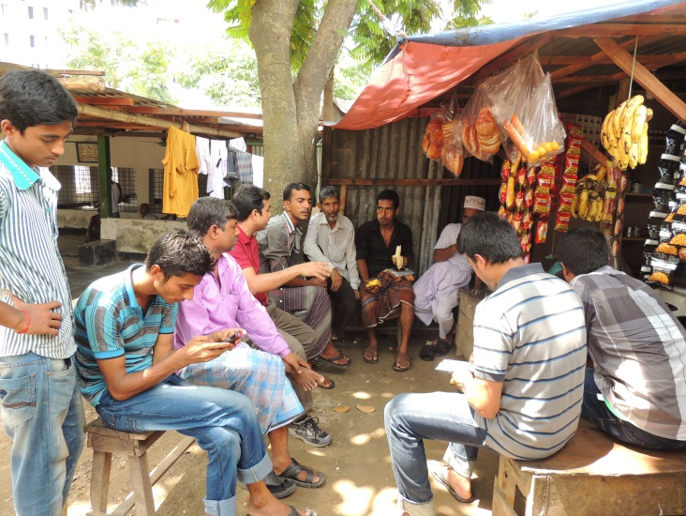 | 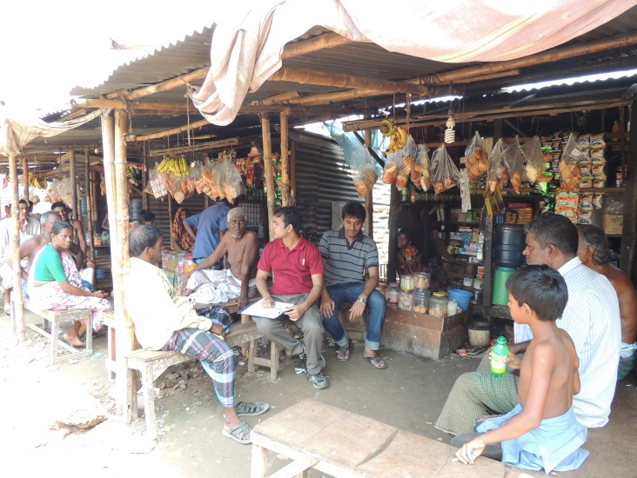
Photograph 8.1: Photos of Focus Group Discussions (FGD)

Stakeholder Consultations (SC)
Stakeholder consultations have been carried out with staffs of DOE, Bangladesh Atomic Energy Commission (BAEC) and Department of Archaeology. A formal conversation was conducted with them regarding the possible negative and positive impacts of proposed DOE office building. A summary of participants list is provided below in Table 8.3.
Table 8.3: Participation List of Stakeholder Consultations Undertaken
Institution | Name & Designation of Consulted Staff
Bangladesh Atomic Energy Commission (BAEC) | Sayed Ahmed, Senior Engineer
Department of Archaeology | Khondker Zahidul Karim, Archeological Executive Engineer  Firoz Ahmed, Sub Assistant Engineer
Department of Environment (DOE) | Md. Shahjahan, Additional Director General  Abul Monsoor, Director, Dhaka Division  Shah Rezwan Hayat, Deputy Director (Prog. Planning)  S. M. Tarique, Deputy Director (EIA)  Md. Shamsuzzaman Sarker, Assistant Director (EIA)  Miah Mohammad, Assistant Director
Sthapati Sangshad Limited | Md. Humayun Kabir, Principal Engineer

Mitigation and Management of Key Stakeholder Concerns
In order to address key issues and concerns identified through the consultation process a series of management and mitigation measures have been developed. Common questions and mitigation measures are provided in Table 8.4.
Table 8.4: Key Stakeholder Concerns and Management and Mitigation Measures
Key Issues | Proposed Mitigation/Management Measures
Potential environmental impacts:  - Impacts on air quality;  - Noise pollution  - General waste management. | - Develop and implement environmental management plans to address all aspects of the environment.  - The proposed building has been considered as ‘green building’. Thus, there should be provision of solar energy, day light use, proper solid waste management plan, and rainwater harvesting etc. to reduce potential environmental impact.
Potential for increased risk:  - Vibration due to piling activities  - Accidents on the access road as a result of the Project | - Analyse and select a suitable method of piling.  - Develop traffic management plan and implement traffic management controls around the Project site for approaching traffic to slow down.  - As a ‘green building’ there should be proper firefighting plan and emergency exit in case of any accident or natural hazards.
Potential damage to roads and other infrastructure. | - Undertake a survey on the status of local infrastructure prior to Project and following completion of Project.  - Repair or compensate for any damage caused by the project to local infrastructure such as roads.
Potential for the utilization of local labor. | - Policies to employ local labor where feasible, in accordance with skills requirements.

CONCLUSION AND RECOMMENDATION

Conclusion
The new office building of DOE is not expected to result in significant adverse environmental impacts. The results of the EIA support DOE’s Category ‘Orange B’ classification of the project. Effective mitigation measures will be taken to reduce impacts on air quality, water quality, and the physical environment. DOE is committed to implementing best practices and to meeting national/international standards for environment, health and safety. Significant benefits are expected as a result of the building construction and operation including comfortable and smooth work environment for the DOE employees.
As part of Environmental Management Plan, preventative measures will be implemented to mitigate the risk of adverse environmental impacts. For example, measures will include dust suppression techniques, use of appropriate emissions controls and regular maintenance of equipment. Potential impacts to drinking waters will be mitigated by regular monitoring and solid wastes will be managed under an integrated strategy that minimizes disposal requirements. Environmental performance will be a key factor in the selection of building designs and energy systems. Trees will be planted along the building sides and measures will be put in place to protect wildlife.
During construction, environmental performance will be monitored daily through visual inspections of the site and work activities. Environmental impacts associated with construction activities are anticipated to be minimal and this can be confirmed through monitoring. Noise monitoring will be carried out to ensure that noise impacts are not significant. Noise will be controlled through equipment maintenance and scheduling of activities. During operations, liquid effluent will be monitored at the discharge of the plant. The PIU will receive environmental and sustainability reports on progress being made, issues that may arise, as well as any grievances received.

Recommendations
Based on the findings of this EIA study, the following items are recommended:
- BNBC planning and norms and should be followed strictly during planning, design, construction and operation of DOE new office building;
- Solar panel installation on the roof top of the DOE building can be done to ensure sustainable energy use;
- To ensure that the proposed mitigation measures including occupational and community H&S will be included in the contract document and implement accordingly.
- With incorporation of the updated baseline data, the EIA report needs to be updated during detailed design of the DOE office building.
- Considering this project as “orange B” category under GOB, IEE is sufficient as the environmental assessment for this project. Other than updating during detailed design, no further detailed studies are required.

REFERENCES
Banglapedia, 2010. National Encyclopedia of Bangladesh Online [Online]. Available at http://www.banglapedia.org (accessed on 28-10-2013)
Banglapedia, 2006. National Encyclopedia of Bangladesh Online [Online]. Available at http://www.banglapedia.org (accessed on 28-10-2013)
Bangladesh Meteorological Department (BMD), 2013. Ministry of Defence, Government of the People’s Republic of Bangladesh. Climatic Database: Rainfall, Temperature, Relative Humidity and Wind Speed for Dhaka Weather Station 1991-2012, Dhaka.
Geological Survey of Bangladesh (GSB), 1979. Earthquake Risk Zone of Bangladesh. Geological Survey of Bangladesh, Ministry of Energy and Mineral Resources, Government of People Republic of Bangladesh
Initial Environmental Examination (IEE), 2012. SASEC Road Connectivity Project: Roads and Highways Department Headquarters Building Subproject. Available at http://www.adb.org/projects/documents/sasec-road-connectivity-project-roads-and-highways-dept-hq-building-subproject-iee
International Union for Conservation of Nature (IUCN), 2002. Bio-ecological zones of Bangladesh. Dhaka: IUCN Bangladesh.
IUCN Bangladesh. ed. 2002f. Bio-ecological Zones of Bangladesh. Dhaka: IUCN-The World Conservation Union.
Rashid, H. E., 1991. “Geography of Bangladesh”. University Press Limited, Dhaka.
Zahiruddin, S.A., 1993. Bangladesh National Building Code. Dhaka: Housing and Building Research Institute, Ministry of Housing and Public Works, Government of the People’s Republic of Bangladesh.

APPENDICES
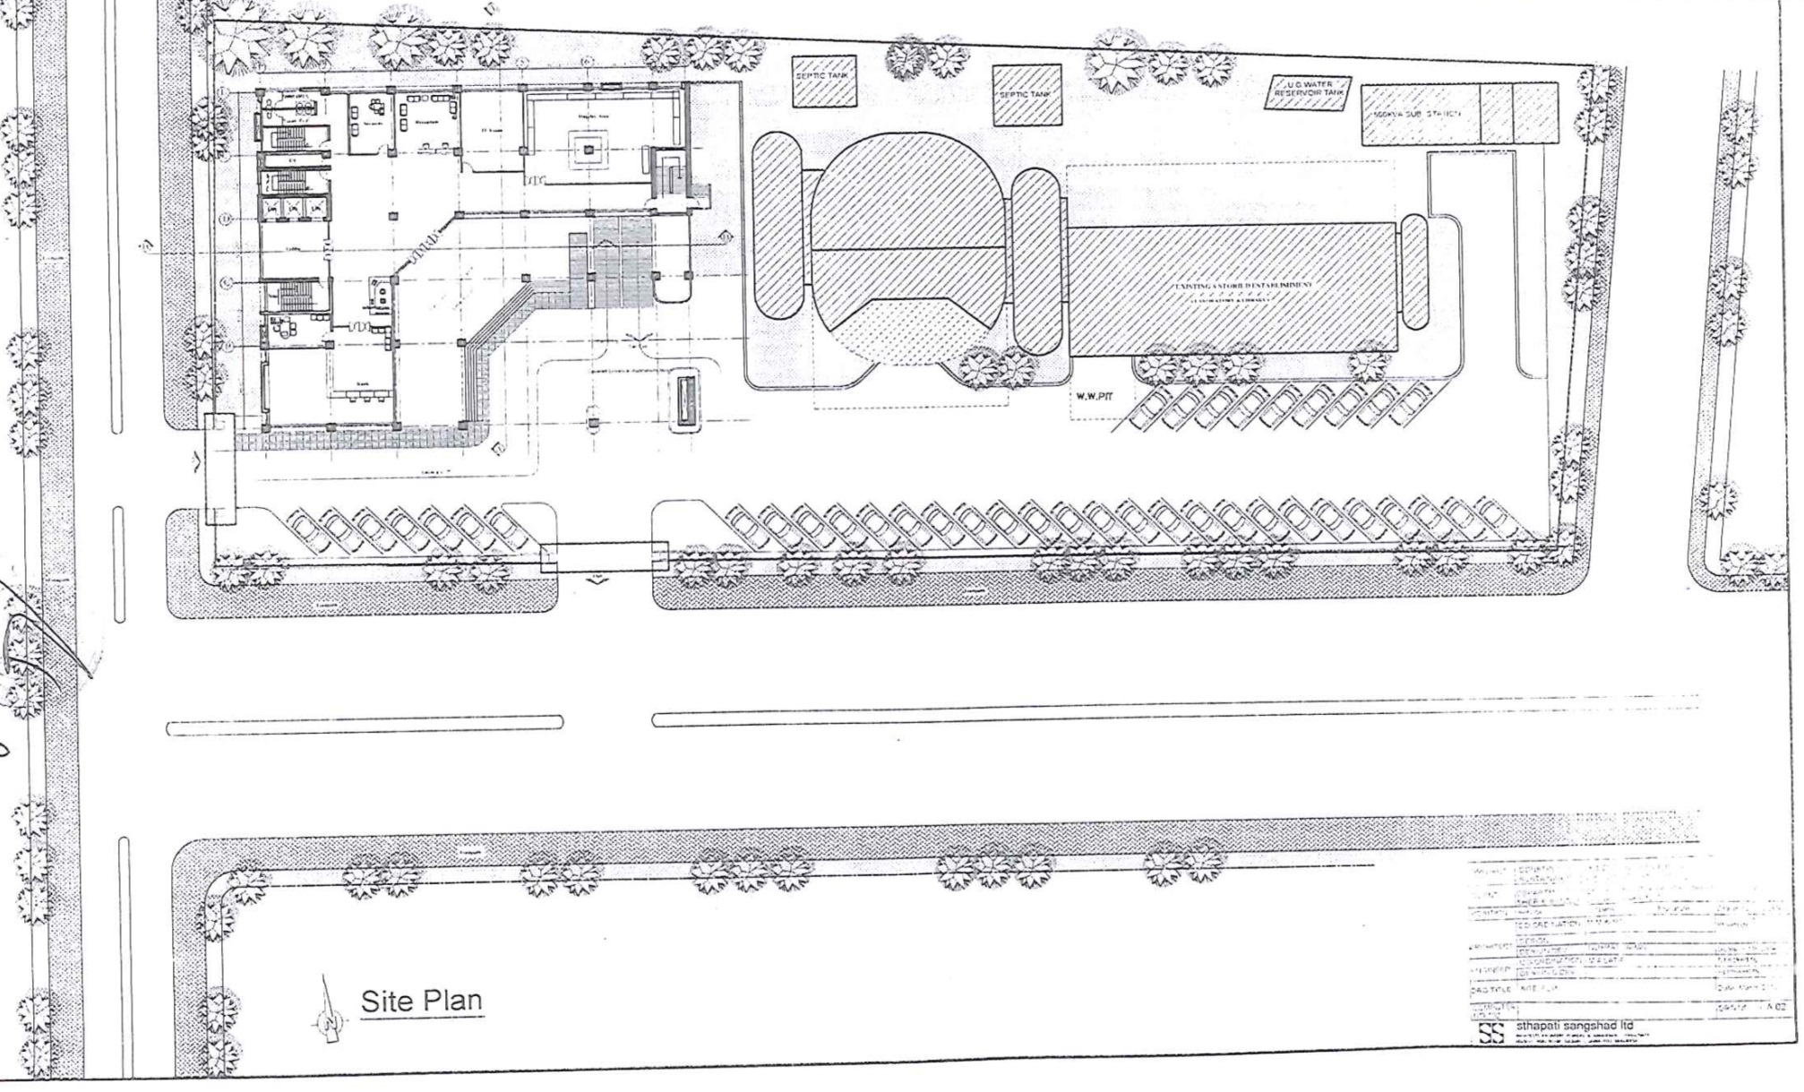
Appendix A: Detailed Design of Proposed Building with Floor Layout

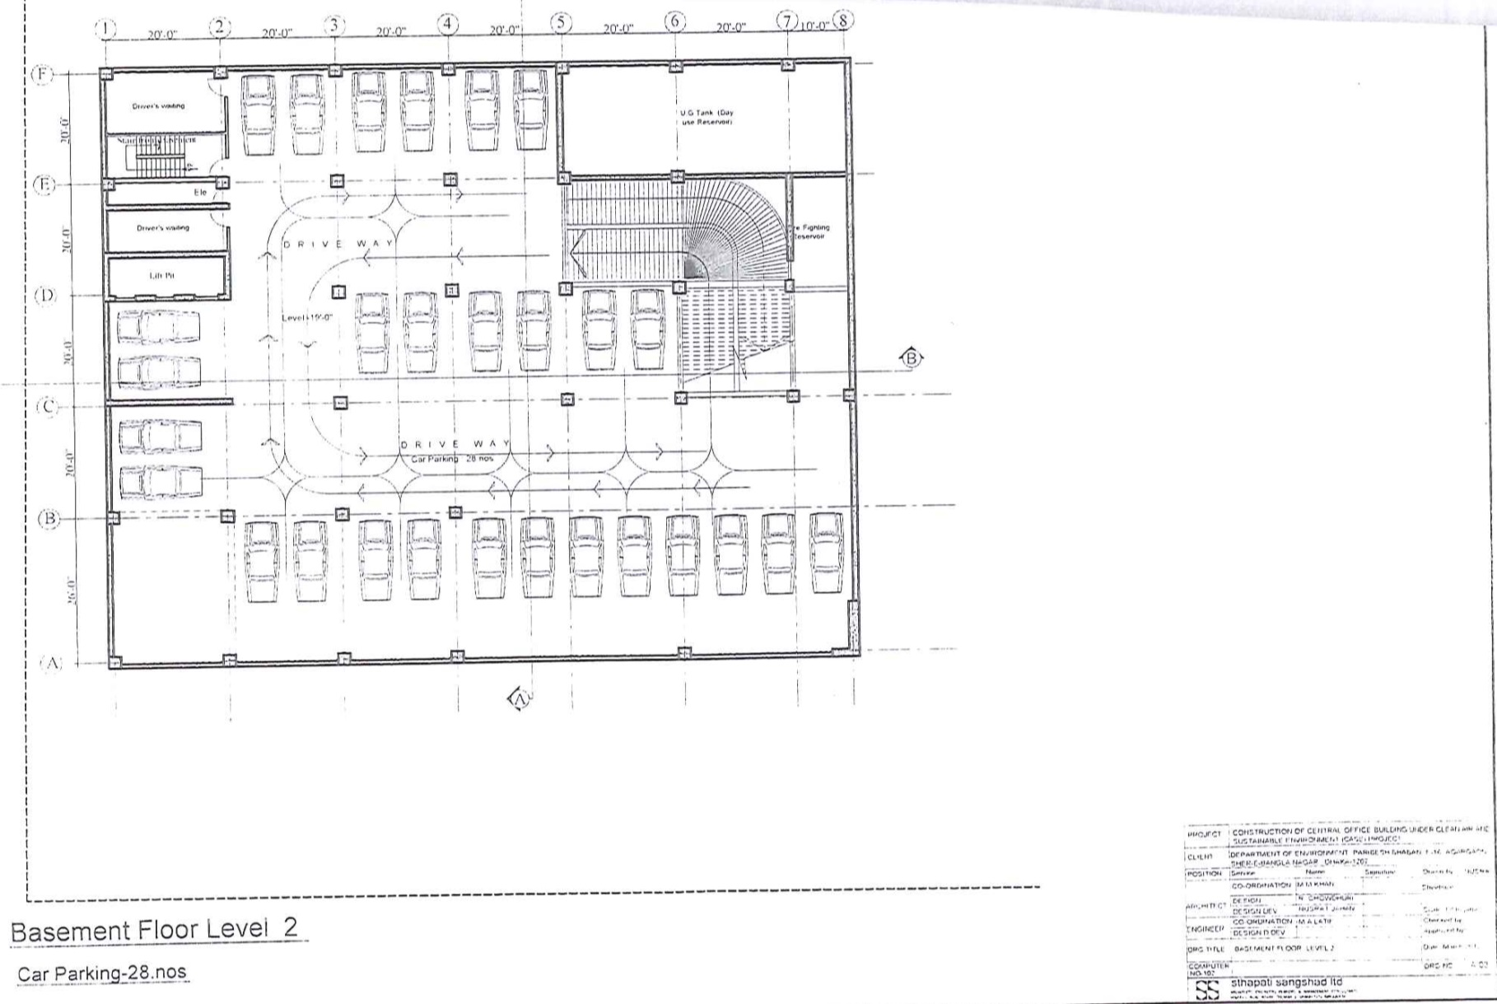

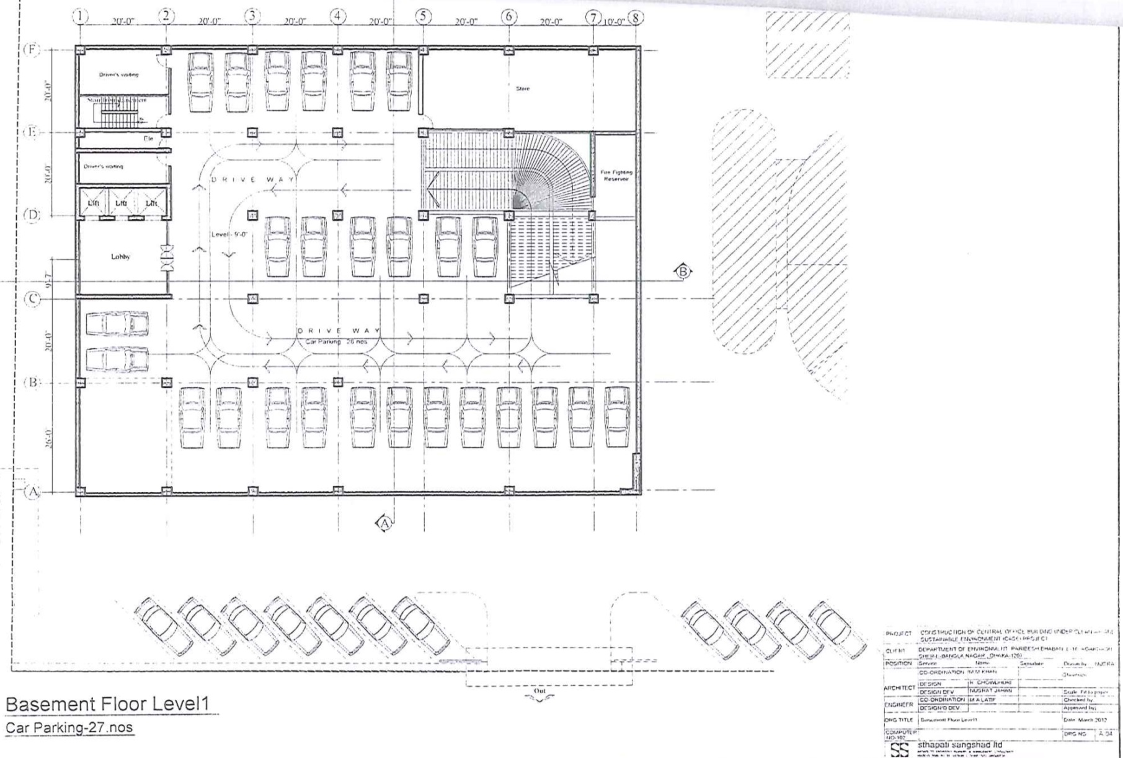

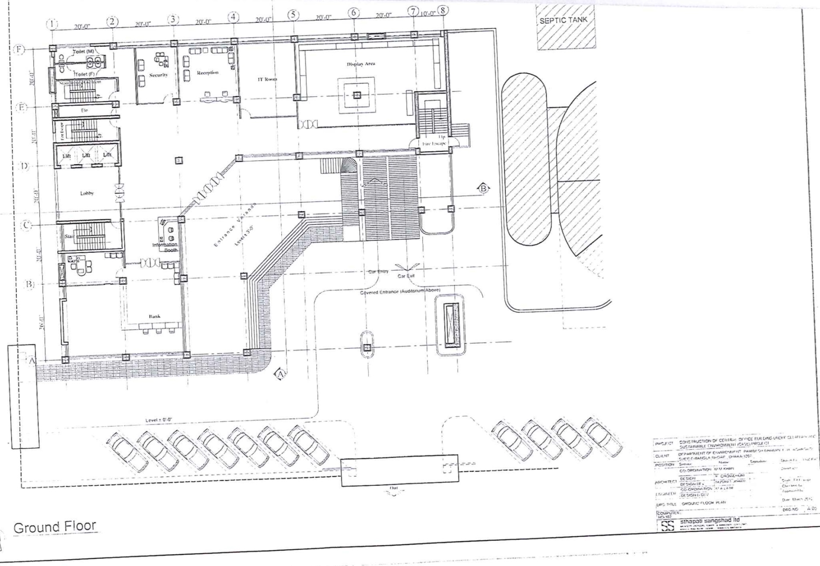

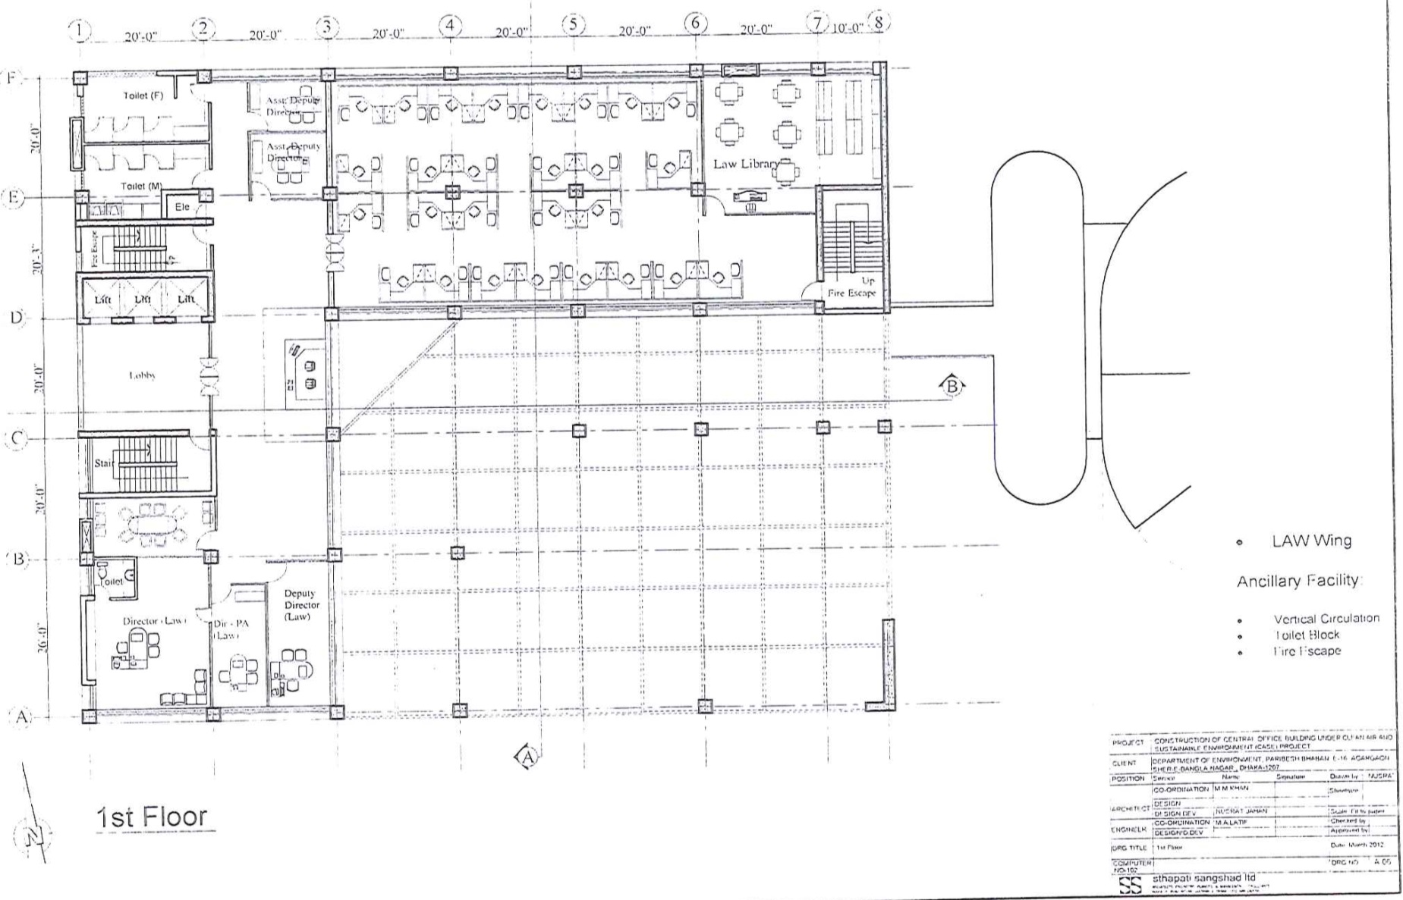

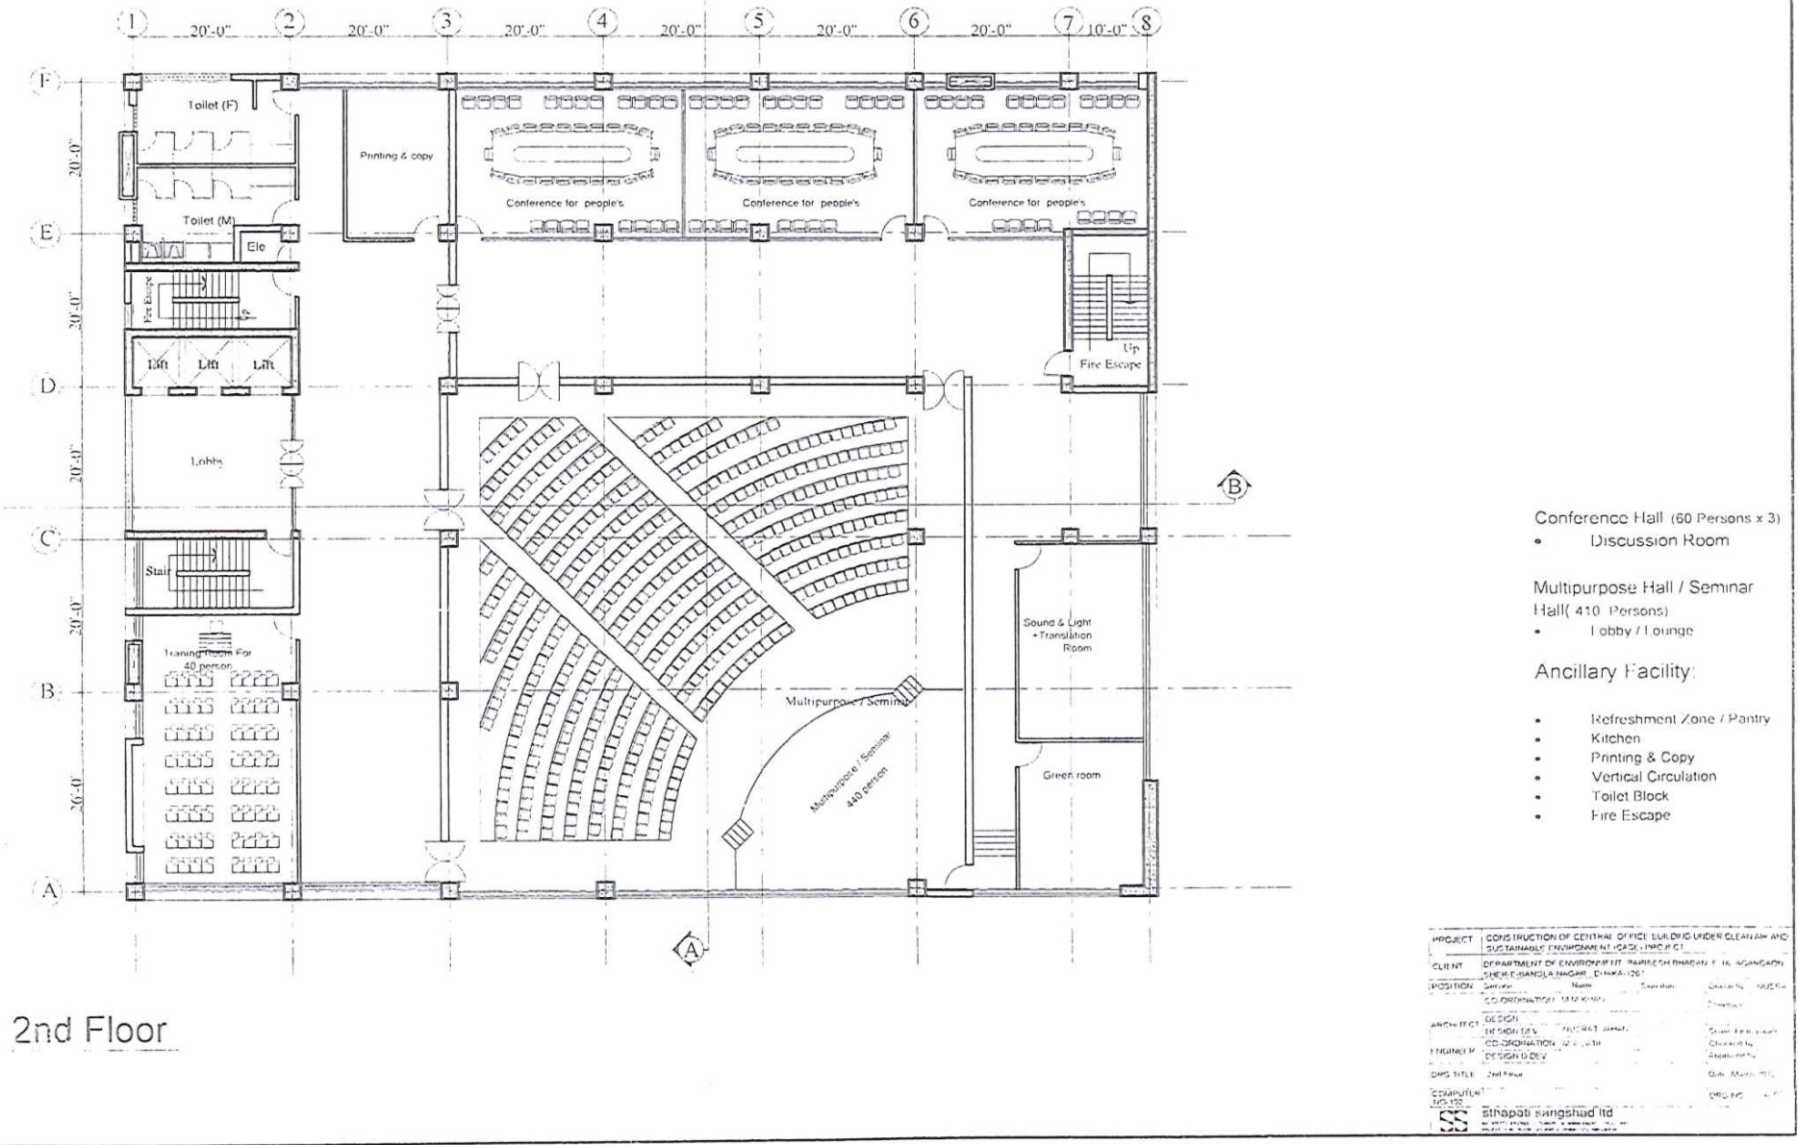

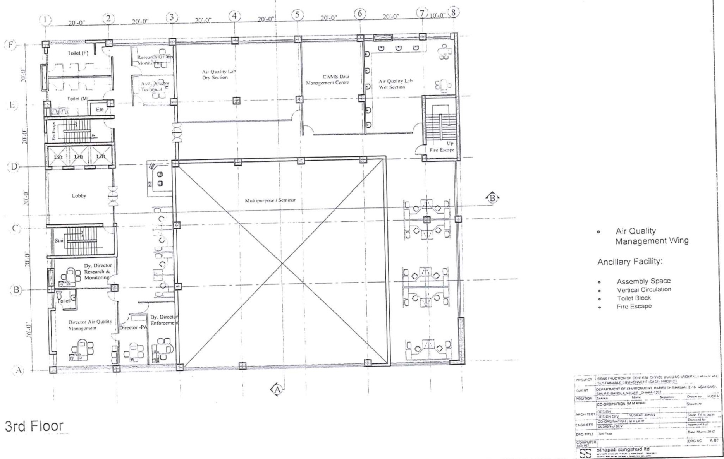

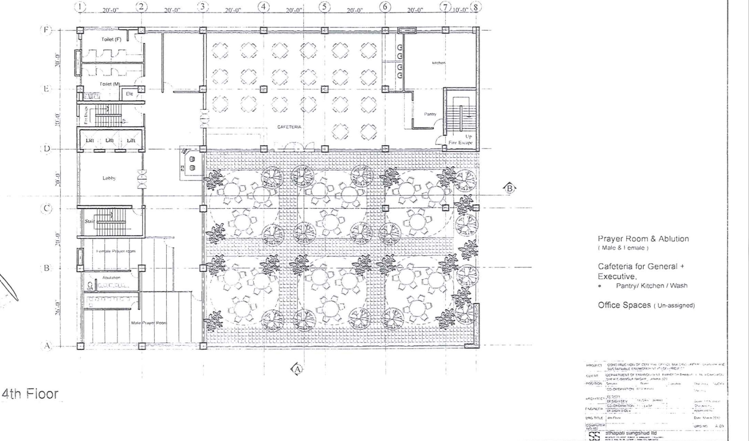

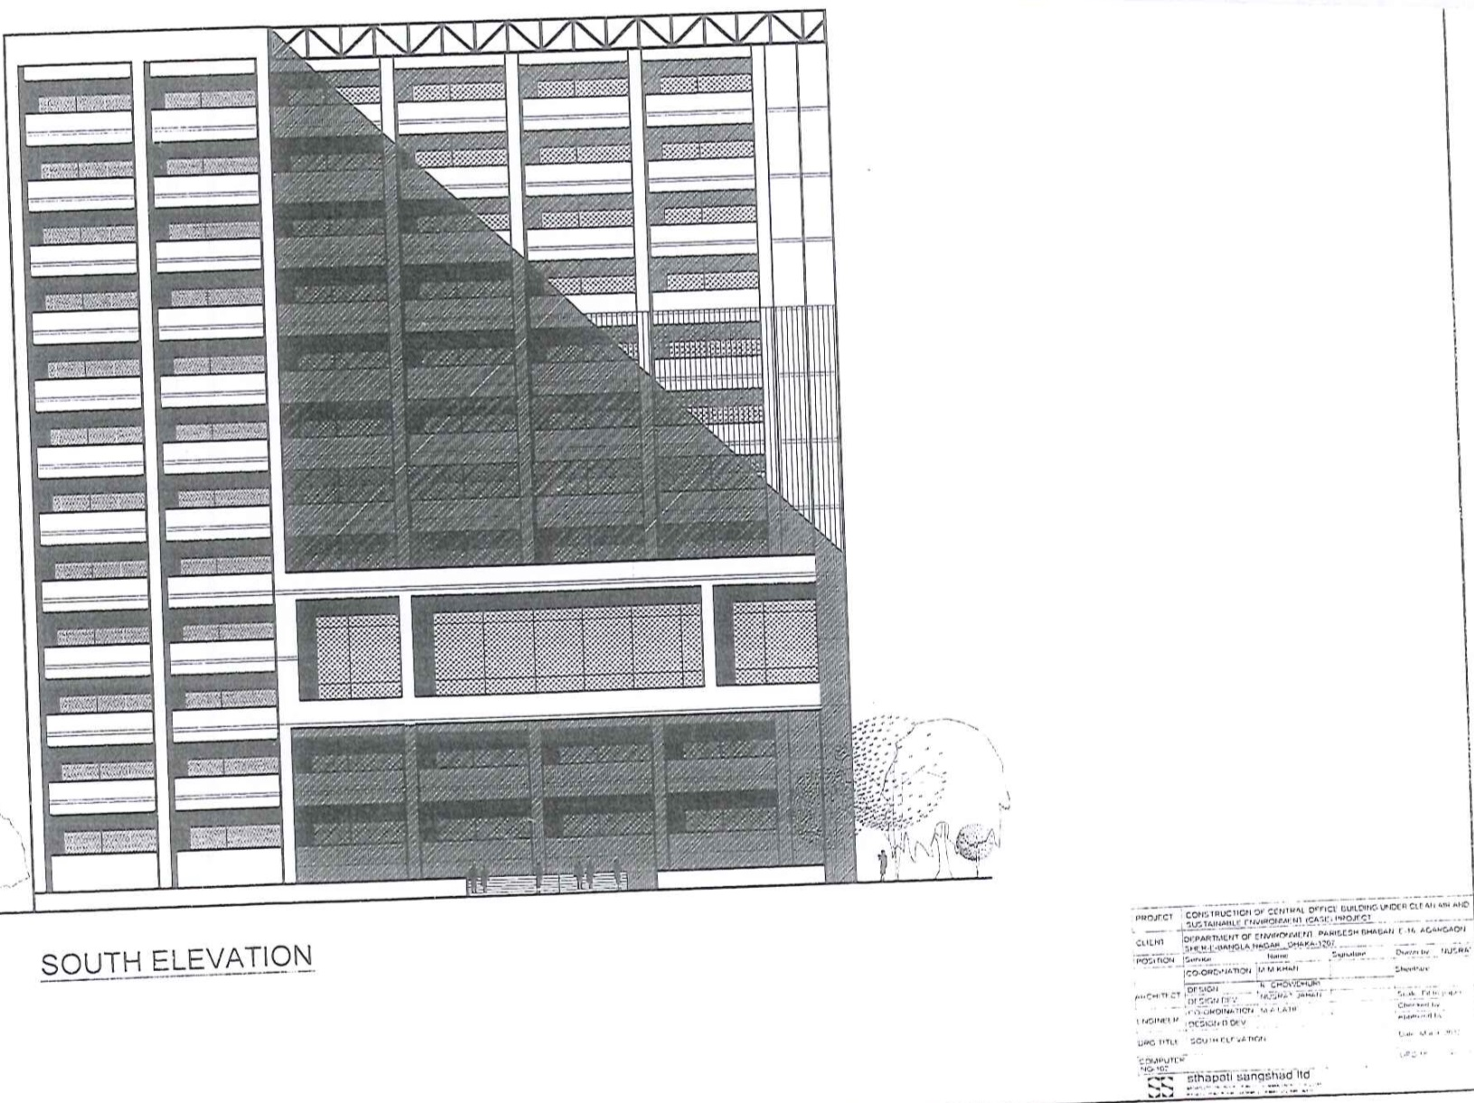

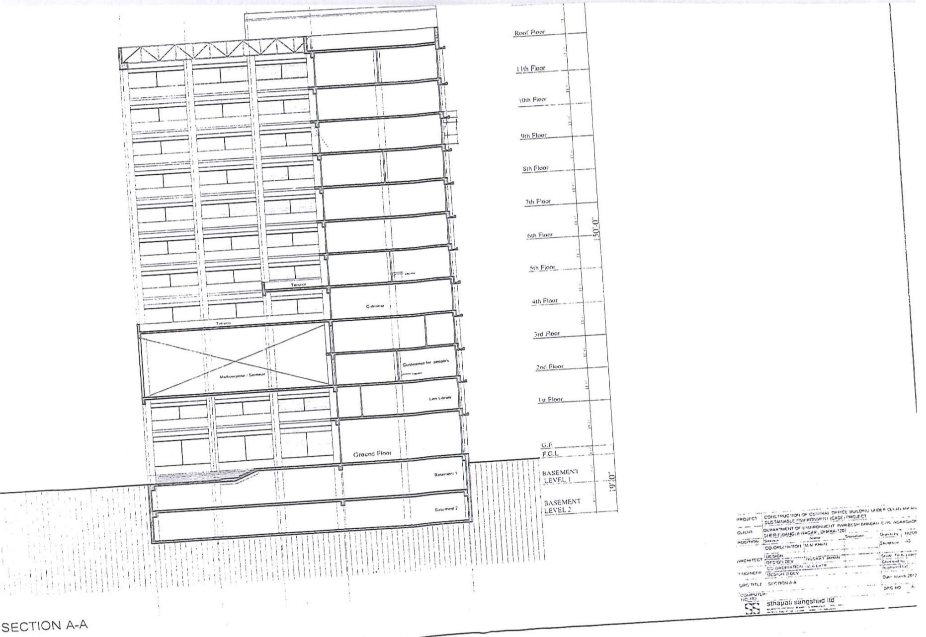

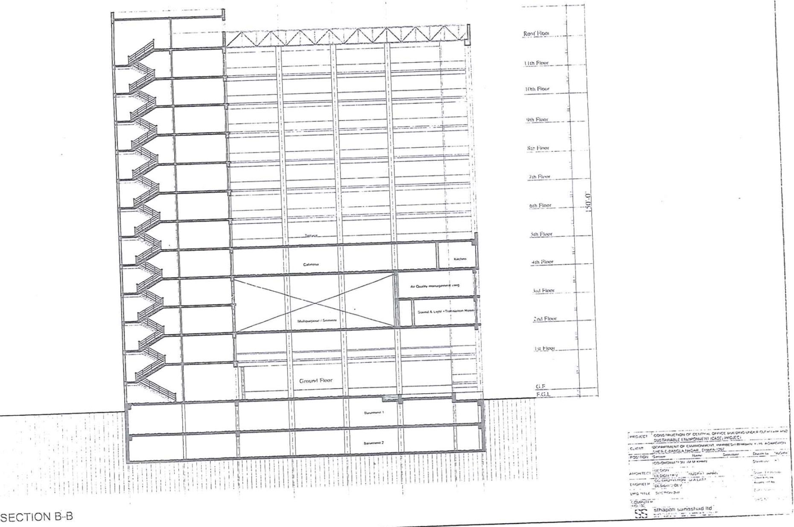
Appendix B: Checklist for Screening of Significant Impacts due to the Proposed DoE Office Building
 | Phase |  | Environmental Components/Parameters |  |  |  | Magnitude of Impacts |  |  |  |  |  |  |  | Comments/  Observations
 |  |  |  |  |  |  | None |  | Insignificant |  | Medium |  | Significant
 | Pre-construction Phase |  | Physical Component |  | Drainage |  | √
 |  |  |  |  | Noise Pollution |  |  |  | −
 |  |  |  |  | Air Pollution |  |  |  | −
 |  |  | Biological Component |  | Vegetation/tree cut |  |  |  |  |  |  |  | √ |  | 301 trees of different sizes will be needed to cut off.
 |  |  |  |  | Wetland loss |  | √
 |  |  |  |  | Endangered species |  | √
 |  |  | Socio-cultural Component |  | Land loss |  |  |  | √
 |  |  |  |  | Land value depreciation |  | √
 |  |  |  |  | Homestead loss |  | √
 |  |  |  |  | Landscape |  | √
 |  |  |  |  | Environmental protected/sensitive area |  | √
 |  |  |  |  | Hazardous natural or man-made conditions |  | √
 |  |  |  |  | Dislocation of resident pollution |  | √
 |  |  |  |  | Sanitation related disease |  | √
 |  |  |  |  | Change in profession |  | √
 |  |  |  |  | Damage of cultural sites |  | √
 |  |  |  |  | Traffic congestion |  | √
Construction Phase |  | Physical Component |  | Hydrology/flooding |  | √
 |  |  |  | Ground/drinking water pollution |  |  |  | _
 |  |  |  | Air & dust pollution |  |  |  |  |  | _ |  |  |  | Due to earthworks, breaking of stones & internal road works.
 |  |  |  | Noise pollution |  |  |  |  |  | − |  |  |  | Due to pile driving, crushing of stones etc.
 |  |  |  | Sewage disposal |  |  |  |  |  | _ |  |  |  | Due to involvement of many workers.
 |  |  |  | Liquid waste |  |  |  | _
 |  |  |  | Solid waste |  |  |  |  |  | − |  |  |  | Due to construction & general waste.
 |  | Biological Component |  | Vegetation/ tree cut |  | √
 |  |  |  | Endangered species |  | √
 |  |  |  | Wildlife |  | √
 |  | Socio-cultural Component |  | Landscape/land use |  |  |  | − |  |  |  |  |  | Due to construction of buildings.
 |  |  |  | Traffic congestion |  |  |  |  |  | − |  |  |  | Traffic congestion due to movement heavy vehicles used for construction.
 |  |  |  | Damage to nearby operation |  |  |  | − |  |  |  |  |  | Building of Atomic Energy Authority attached with boundary in north side.
 |  |  |  | Job opportunities |  |  |  |  |  |  |  | + |  | Job opportunities due to construction.
 |  |  |  | Business opportunities |  |  |  |  |  | + |  |  |  | New road side shops at road sides.
 |  |  |  | Road accidents |  |  |  |  |  | − |  |  |  | Due to movement of construction vehicles.
 |  |  |  | Occupational health & safety/Workers accident |  |  |  |  |  | _ |  |  |  | Mitigation measures will be taken
 |  |  |  | Utilities (electric) |  |  |  |  |  | _ |  |  |  | Electric line for the construction site.
 |  |  |  | Utilities (water supply) |  |  |  |  |  | _ |  |  |  | Water will be required for construction work.
 |  |  |  | Utilities (Gas) |  | √
Operation Phase |  | Physical Component |  | Drinking /ground water |  |  |  | _
 |  |  |  | Drainage congestion |  |  |  | _
 |  |  |  | Air pollution |  |  |  | _
 |  |  |  | Noise pollution |  |  |  | _
 |  |  |  | Solid waste |  |  |  |  |  | _ |  |  |  | General waste from the office building.
 |  | Biological Component |  | Tree plantation |  |  |  |  |  | + |  |  |  | Enhancement measures will be taken.
 |  |  |  | Wildlife/ Livestock |  |  |  |  |  | + |  |  |  | Habitat for world-life in the new tree plantation area
 |  |  |  | Endangered species |  | √
 |  | Socio-cultural Component |  | Transport linkage |  | √ |  |  |  |  |  |  |  | Enhancement measures will be taken
 |  |  |  | Traffic congestions |  |  |  | _
 |  |  |  | Cultural sites |  |  |  | _
 |  |  |  | Job opportunities |  |  |  |  |  | + |  |  |  | For O&M works, many workers will be involved.
 |  |  |  | Landscape |  |  |  |  |  | + |  |  |  | Enhancement measures will be taken.
 |  |  |  | Business facilities |  |  |  |  |  | + |  |  |  | Enhancement measures will be taken.
 |  |  |  | Occupational health & safety/Workers accident |  |  |  | _

Appendix C: Tree Plantation Plan
Objectives
The objective of the tree plantation program is to compensate for the loss of trees due to the implementation of the DOE office building project. Another major objective of the program is to enhance the health of the existing ecosystem.
Approximately 301 nos. of various trees of different sizes will be cut down due to preparing of project sites. The proposed Tree Plantation Plan (TPP) will plant a total number of 602 trees.
There are different areas have been identified for plantation sites. The required space for tree plantation might not cover from the open space inside the DOE office boundary. Thus the tree plantation programme should be carried out beyond the DOE office boundary. The possible areas for tree plantation might be as following.
- Inside the available open space of DOE office boundary;
- Open places of nearby office boundaries after their agree;
- Along the road side or in the road divider; and
- Any other private land with consultation of the owner.
Selection of Tree Species
The species for the proposed tree plantation have been selected based on the statistics of the lost vegetation and suitability for the intended purpose. The main considerations for selection of species are habitat for biotic species, improved aesthetics and ecological conservation as well as commercial benefits. Accordingly, the list of tree species proposed to be planted but not limited to be as follows:
- Timber Trees: Mehogani (Swietenia mahagoni).
- Fruit Trees: Olive (Elaeocarpus floribundus), Mango (Mangifera indica), Jackfruit (Artocarpus heterophyllus) Jamrul (Syzygiumsamarangense), Jam (Syzygiumcumini), Kamranga (Averrhoacarambola) etc.
- Aesthetic Trees: Jhaw (Casuarinalittorea), Gondhoraj (Gardenia coronaria), Mehendi (Lawseniainermis).
The species of tree for other places than DOE office boundary should be selected after the consultation with the responsible authority.
Tree Plantation Regime
According to the prevailing practice in Bangladesh, the FD has recommended to plant minimum 2 trees for each tree felled for the implementation of the project. The Table 1 is showing the number of trees should be planted accordingly to species. The number of trees for each category has been selected based on the present species and the number of trees will be cut.
Table 1. Total number of trees to be planted according to category
Tree species | No. of Trees
Fruit (25%) | 151
Timber (25%) | 151
Aesthetic (50%) | 300
Total | 602
Budget
The budget for the proposed tree plantation development plan is given in Table 2. The budget also includes maintenance for first five years of plantation to ensure that all planted saplings will survive and provision for an additional plantation. The budget also includes procurement and development of all facilities required to establish a nursery such as, collection of suitable soils, decomposing cow dung, procurement of fertilizers etc. The budget also includes measures required for maintenance of plantation, such as watering, weeding, fertilizer application, replacing of dead saplings (if any) etc. for first five years. Total approx. budget for tree plantation is 2,00,600 BDT.
Table 2: Cost estimates for the tree plantation plan
Item | Rate (Tk.) | Quantity | Amount (Tk.)
Cost of total trees | 300.00 | 602 | 180600
Miscellaneous |  |  | 20000
Total |  |  | 2,00,600

Appendix D: Participants Lists of Focus Group Discussions (FGD)

Appendix E: Guidance for Contractor on Environmental Issues during Construction Activities
As the contractor will carry out all the building construction activities, contractor's responsibilities as to what are to be done on environmental issues should be clearly delineated. Guidance for contractor on environmental issues will not only help the contracting firm to see its responsibilities, but also supervision of contractor's work will be made easier. The following information is intended for broad guidance in conjunction with local and national regulations during construction. As the construction activities could cause significant impacts on and nuisances to surrounding areas, careful planning of construction activities is critical. The following rules (including specific prohibitions and construction management measures) are directly/indirectly incorporated the WB bidding documents and are implicit in the contracts, and work orders.
1. Prohibitions
The following activities are prohibited on or near the project site:

- Use of unapproved toxic materials, including lead-based paints, asbestos, etc.
- Disturbance to anything with architectural or historical value;
- Building of fires;
- Use of firearms (except authorized security guards); and
- Use of alcohol by workers.

2. Construction Management Measures
2.1 Waste Management and Erosion:
Solid, sanitation, and, hazardous wastes must be properly controlled, through the implementation of the following measures:
Waste Management
- Minimize the production of waste that must be treated or eliminated.
- Identify and classify the type of waste generated. If hazardous wastes are generated, proper procedures must be taken regarding their storage, collection, transportation and disposal.
- Identify and demarcate disposal areas clearly indicating the specific materials that can be deposited in each.
- Control placement of all construction waste (including earth cuts) to approved disposal sites (>300 m from rivers, streams, lakes, or wetlands).Dispose in authorized areas all of garbage, metals, used oils, and excess material generated during construction, incorporating recycling systems and the separation of materials.

Maintenance
  - Identify and demarcate equipment maintenance areas.
  - Ensure that all equipment maintenance activities, including oil changes, are conducted within demarcated maintenance areas; never dispose spent oils on the ground, in water courses, drainage canals or in sewer systems.
  - Install and maintain an adequate drainage system to prevent erosion on the site during and after construction.

Erosion Control
- Erect erosion control barriers around perimeter of cuts, disposal pits, and roadways.
- Spray water on dirt roads, cuts, fill material and stockpiled soil to reduce wind-induced erosion, as needed.
- Maintain vehicle speeds at or below 10mph within work area at all times.

Stockpiles and Borrow Pits
- Identify and demarcate locations for stockpiles and borrow pits, ensuring that they are 15 meters away from critical areas such as steep slopes, erosion-prone soils, and areas that drain directly into drainage channels or pipes.
- Limit extraction of material to approved and demarcated borrow pits.

Site Cleanup
- Establish and enforce daily site clean-up procedures, including maintenance of adequate disposal facilities for construction debris.

2.2 Safety during Construction
The Contractor’s responsibilities include the protection of every person and nearby property from construction accidents. The Contractor shall be responsible for complying with all national and local safety requirements, WB health and safety guidelines and also any other measures necessary to avoid accidents, including the following:

- Carefully and clearly mark pedestrian-safe access routes.
- Maintain supply of materials for traffic signs (including paint, easel, sign material, etc.), road marking, and guard rails to maintain pedestrian safety during construction.
- Conduct safety training for construction workers prior to beginning work.
- Provide personal protective equipment and clothing (goggles, gloves, respirators, dust masks, hard hats, steel-toed and –shanked boots, etc.,) for construction workers and enforce their use.
- Post Material Safety Data Sheets for each chemical present on the worksite.
- Require that all workers read, or are read, all Material Safety Data Sheets. Clearly explain the risks to them and their partners, especially when pregnant or planning to start a family. Encourage workers to share the information with their physicians, when relevant.
- Ensure that the removal of asbestos-containing materials or other toxic substances be performed and disposed of by specially trained workers.
- During heavy rains or emergencies of any kind, suspend all work.
- Brace electrical and mechanical equipment to withstand seismic events during the construction.

2.3 Nuisance and Dust Control
To control nuisance and dust the Contractor should:

- Maintain all construction-related traffic at or below 15 mph on streets within 200 m of the site.
- Maintain all on-site vehicle speeds at or below 10 mph.
- To the extent possible, maintain noise levels associated with all machinery and equipment at or below 90 db.
- As there sensitive areas (i.e., hospital) nearby work hours should be limited to day time only as far as practicable to prevent undesirable noise levels.
- Minimize production of dust and particulate materials at all times, to avoid impacts on surrounding families and businesses, and especially to vulnerable people (children, elders).
- Place dust screens around construction areas, paying particular attention to areas close to housing, commercial areas, and recreational areas.
- Spray water as needed on dirt roads, cut areas and soil stockpiles or fill material.
- Apply proper measures to minimize disruptions from vibration or noise coming from construction activities.

2.4 Community Relations
To enhance adequate community relations the Contractor should:

- Following the country and EA requirements, inform the population about construction and work schedules, interruption of services and traffic detour routes as appropriate.
- Limit construction activities at night. When necessary ensure that night work is carefully scheduled and the community is properly informed so they can take necessary measures.

