Government of People’s Republic of Bangladesh

National Immunization Strategy (NIS) 2023-2027
  - for Expanded Program on Immunization (EPI) of Bangladesh

Table of contents
Executive Summary (Dashboard) i
1 Positioning of NIS in Changing Environment 1
1.1 Immunization Agenda 2030 and National Health Plan 2021-2025 1
1.2 From cMYP to NIS 1
1.3 The COVID-19 context 1
2 Situation analysis 2
2.1 Country context 2
2.1.1 Administrative and political structure 2
2.1.2 Demography 2
(1) Population estimates 2
(2) Population distribution and ethnic composition 3
2.2 Health system context 3
2.2.1 Governance 3
(1) Policy framework 3
(2) Health policy implementation instruments 4
(3) Leadership and management 4
2.2.2 Health Service delivery 5
(1) Health Care Service delivery organization and capacity 5
(2) Private Sector 9
2.2.3 Health workforce 9
(1) Overview 9
(2) Health workforce supply and distribution 9
(3) Staffing practices 11
(4) NGOs and private sector 12
2.3 Immunization system 12
2.3.1 Background of the national immunization program 12
2.3.2 Immunization system outcomes 13
(1) Immunization coverage trends 13
(2) Immunization coverage equity 14
(3) Neonatal Mortality Rate 18
(4) Under-five Mortality Rate 18
(5) Maternal Mortality Ratio 19
2.3.3 Immunization system performance by components 19
(1) Governance / decision making 19
(2) Immunization service delivery 20
(3) Program management 22
(4) Workforce 22
(5) Reporting 23
(6) Data quality 24
(7) Cold chain and vaccine management 24
(8) Surveillance, monitoring, and reporting 26
(9) Demand generation, communication, and advocacy 29
2.3.4 Accelerated disease control initiatives 30
(1) Polio 31
(2) Maternal Neonatal Tetanus Elimination 31
(3) Measles 31
2.4 Summary of situational Analysis 33
2.4.1 Root cause analysis of EPI Performance 33
(1) Current situation 33
3 Vision, Objectives and Strategies of the National Immunization Strategy 35
3.1 NIS Vision 35
3.2 Objectives and Strategic Interventions 36
3.3 Alignment with the Regional (RVIP 2022-2026) and Global Goals (IA 2030) 42
3.4 Monitoring and Evaluation 43
4 Costs and Financing National Immunization Strategy 43
4.1 NIS Resource requirements 43
4.1.1 Overview of the resource requirements’ structure 43
4.1.2 Description of cost drivers of the future resource requirements 43
4.1.3 Description of scenarios for introduction of new vaccines 48
4.2 Future financing and funding gaps 50
4.3 Funding gap analysis and sustainability 51
4.3.1 Implications of the funding gap on immunization system performance 51
4.3.2 Financial sustainability strategies 52
5 Annexes 54

Table of figures
Figure 1: Demographic profile of Bangladesh (2021) 3
Figure 2: Bangladesh population distribution per divisions 3
Figure 3: Health service delivery facilities and administrative arrangements 6
Figure 4: Public health facilities by levels and types of services 7
Figure 5: Provision of Essential Services in Bangladesh 8
Figure 6: Number of private hospitals, clinics and diagnostic centers in 2013 and 2021 9
Figure 7: Registered health workforce between 1997and 2021 10
Figure 8: National Immunization Coverage for selected antigens in last 5 years 14
Figure 9: MCV1-MCV2 vaccination drop-out rate by Sex and National Level¹ 14
Figure 10: Trends in drop-out rates between DTP1 -DTP3 and between BCG and MCV1 15
Figure 11: Penta3 valid coverage and Full Vaccinated Children Coverage by 12 months 16
Figure 12: Valid coverage by 12 months by DNCC and DNCC slum and DSCC and DSCC Slum, CES 2019 17
Figure 13: Reasons for Never Having Vaccination in Rural Areas, City Corporations and Munitipalities in 2019 17
Figure 14: Administrative Division of Bangladesh 20
Figure 15: Summary of the surveillance indicators 27
Figure 16: Surveillance Staff by Administration Level 28
Figure 17: AFP Surveillance Performance Indicator, 2011-2021 29
Figure 18: Reasons for never having vaccination by National, Rural and Urban Areas in 2019 30
Figure 19: Summary of the analysis of the accelerated disease control indicatives 30
Figure 20: Measles Outbreaks in 2020-2022 32
Figure 21: Survey MCV1 and MCV2 coverage, valid by 12 months and crude by 24 months of age, Bangladesh 2001-2016 32
Figure 22: CRS Surveillance Performance Indicators, Bangladesh 2012-2021 33
Figure 23: Root cause analysis of the current immunization preformance 34
Figure 24: National immunization program costs (USD) summary by system components and years – basic scenario 43
Figure 25: The future total resource requirement 2023-2027 by programme components (shared costs excluded) 44
Figure 26: The structure of future resource requirements by cMYP components and years (shared costs excluded) 45
Figure 27: Vaccine and injection supply cost projections (routine immunization. Scenario A (Rotavirus, HPV, JE and TCV from 2023) 46
Figure 28: The future resource requirements for “Program Management and Financing” component of EPI 46
Figure 29: Commparison of resource requirements for vaccines and injection supplies between the Baseline Scenario and Scenario A by years 48
Figure 30: Cost implication on State budget – Scenario A introduction 49
Figure 31: Commparison of resource requirements for vaccines and injection supplies between the Baseline Scenario and Scenario B by years 49
Figure 32: Cost implication on government budget – Scenario B introduction 50
Figure 33: Financing by sources and funding gap by years (with secured and probable funds, excluding shared health system costs) 51
Figure 34: Funding gap structure by years 51
Figure 35: Funding gap structure by the major cost categories 52
Figure 36: Population density by administrative units in Bangladesh 54
Figure 37: Bangladesh EPI Root Cause Analysis Diagram – Block A – Maintenance of High Coverage Rates in All Areas of the Country 55
Figure 38: Bangladesh EPI Root Cause Analysis Diagram – Block B – Vaccine Quality at the Service Delivery Points and Block C – Outbreak Prevention and control mechanisms 56
Figure 39: Links between the Root Causes Main Interventions and NIS Objectives 57
Figure 40: 4th HPNSP Results Framework 60
Figure 41: Detail Budget, Total available Funding, Total Funding Gap, Funding Sources and Secured Resources for NIS implementation 62

List of abbreviations
AH | Adolescent health
AEFI | Adverse Events Following Immunization
AFP | Acute Flaccid Paralysis
BCG | Bacillus Calmette-Guérin
BDHS | Bangladesh demographic and health survey
BDT | Bangladesh Taka
BHB | Bangladesh Homeopathic Board
BMDC | Bangladesh Medical and Dental Council
BMMS | Bangladesh Maternal Mortality and Healthcare Survey
BNC | Bangladesh Nursing Council
CBAW | Child Bearing Age Women
CCs | Community Clinics
CD | Communicable Diseases
CEmOC | Comprehensive Emergency Obstetrical Care
CEmONC | Comprehensive Emergency Obstetrical and Neonatal Care
CES | Coverage Evaluation Survey
cMYP | Comprehensive Multi-Year Plan
DGDA | Directorate General of Drug Administration
DGFP | Directorate General of Family Planning
DGHS | Directorate General of Health Services
DGNM | Directorate General of Nursing and Midwifery
DHS | Demographic and Health Survey
DHs | District Hospitals
DP | Development Partner
DQS | Data Quality Self-Assessment
DTP | Diphtheria, Tetanus and Pertussis (whooping cough) [vaccine]
DTP3 | Third dose of Diphtheria, Tetanus and Pertussis (whooping cough) [vaccine]
EPI | Expanded Programme on Immunization
FP | Family planning
FY | Fiscal year
FYP | Five-year plan
Gavi | Global Alliance for Vaccines and Immunization
GDP | Gross domestic product
GHED | WHO Global Health Expenditure Database
GNI | Gross national income
GoB | Government of the People’s Republic of Bangladesh
HDI | Human Development Index
HepB | Hepatitis B Vaccine
HFs | Health Facilities
Hib | Haemophilus Influenza type b vaccine
HTRA&VP | Services for Hard-to-Reach Areas and Vulnerable Population
HWs | Health Workers
ICC | Interagency Coordination Committee
IDA | International Development Agency (the World Bank)
IMCI | Integrated management of childhood illnesses
IMR | Infant Mortality Rate
IPF | Investment Project Financing
IPH | Institute of Public Health
IPHN | Institute of Public Health and Nutrition
KPI | Key performance indicators
LD | Line Director
M&E | Monitoring and Evaluation
MLGRDC | Ministry of Local Government, Rural Development and Cooperatives
MMR | Maternal Mortality Ratio
MNTE | Maternal and Neonatal Tetanus Elimination
MOF | Ministry of Finance
MoH&FW | Ministry of Health and Family Welfare
MOPA | Ministry of Public Administration
MPIR | Mid-term Program Implementation Report
MTBF | Medium Term Budget Framework
NIPORT | National Institute of Population, Research and Training
NMR | Neonatal mortality rate
NNT | Neonatal Tetanus
NPML | National Polio and Measles Laboratory
OPs | Operational Plans
OPV | Oral Polio Vaccine
PDO | Project development objective
PHC | Primary Health Care
PIP | Program Implementation Plan
RFW | Results framework
RI | Routine Immunization
SDG | Sustainable Development Goals
SIA | Supplemental Immunization Activity
SIMO | Surveillance and Immunization Medical officer
SIP | Strategic Investment Plan
SMF | State Medical Faculty
TBA | Traditional birth attendants
Td | Tetanus-diphtheria [vaccine]
TT | Tetanus Toxoid
U5MR | Under Five Mortality Rate
UH&FWC | Union Health and Family Welfare Centers
UHC | Upazila Health Complex or Universal Health Coverage
UNICEF | United Nations Children’s Fund
VDPV | Vaccine Derived Polio Virus
VPD | Vaccine Preventable Diseases
VVM | Vaccine Vial Monitor
WB | World Bank
WHA | World Health Assembly
WHO | World Health Organization
WICR | Walk in Cold Room
WPV | Wild Polio Virus

Executive Summary (Dashboard)
NIS 2023-2027 summary
National immunization objectives | Immunization program strategies
- Achieve and maintain target vaccination coverage rates among children under 24 months and CBAW  - At least 95% of full vaccination coverage of children at the national level  - At least 90% of full vaccination coverage of children at the sub-national level  - At least 80% coverage with Td5 at the national level  - At least 75% coverage with Td5 at the sub-national level  - Maintain polio free certification status  - Maintain MNT elimination status  - Elimination of measles, Rubella and CRS by 2024  - Maintain Hepatitis B control through vaccination  - Ensure access and use of high-quality vaccines  - Prevention of diseases protected by new and underused vaccines  - Sustain operations of immunization system critical components while transition from external to the domestic sources of financing | - Strengthening governance and management capacity of EPI  - Achieve coverage targets in urban areas (city corporations)  - Design and implement creative approaches for increasing coverage in hard-to-reach areas, urban slums and among zero-dose and missed communities, ethnic minority groups and refugees  - Improve performance and strengthen sub-national level capacity in VPD surveillance, recording and reporting, AEFI monitoring and management  - Ensure high performance of cold-chain and logistics systems  - Increase uptake of vaccination in the low performing areas through accelerating demand generation strategic interventions: communication, community mobilization, IPC capacity and etc.  - Strengthening capacity of NRA for accessing high quality vaccines  - Advocate for sufficient and timely allocation of the funding for implementation of all EPI components
Immunization performance indicators and targets to achieve by 2027 | Major risks and challenges
 | - Shortage of human resources for health with 20% of vacant posts in the health system  - Inadequate skills of the front-line service providers and mid-level-managers  - Training programs heavily dependent upon donor’s funding  - Workforce composing surveillance network fully depends on external funding  - Shortage of supply chain management staff at district and Upazila levels  - Heavy dependence on DP funding threatening financial sustainability  - Existence of hard-to-reach areas
  Indicator* | 2021 | 2027
  National (Children)
  Valid Fully vaccination Coverage by 12 months of age | 83.9 | >=95%
  Valid Fully vaccination Coverage by 23 months of age considering MR2 | 82.4 | >=95%
  Sub-District (Children)
  # of Districts & CC achieved Fully vaccination Coverage >=90% by 12 month | 9 | 76
  # of Districts & CC achieved Fully vaccination Coverage >=90% by 23 month | 11 | 76
  National (15-49 years Women)
  Valid Td5 vaccination coverage | 54.9% | >=80%
  Sub-District (15-49 years Women)
  # of Districts & CC achieved Td5 coverage >=75% | 2 | 76
  *Source : CES-2019
Resource requirement and financing projections
 | 2023 | 2024 | 2025 | 2026 | 2027 | Total
Total Resources Required (US$ millions) | 107 | 98 | 97 | 92 | 90 | 485
Cost per capita | 0.41 | 0.48 | 0.48 | 0.48 | 0.48 | 0.48
Total Secure Financing (US$ millions) | 81.2 | 83.2 | 82.8 | 83.9 | 85 | 416.2
Gap (US$ millions) | 26 | 15 | 14 | 9 | 6 | 70.4
% of total needs | 24% | 16% | 15% | 9% | 7% | 14%

Positioning of NIS in Changing Environment

Immunization Agenda 2030 and National Health Plan 2021-2025
The “immunization agenda 2030 – A global Strategy for Leave No One Behind” (IA2030) was developed with the purpose to address key challenges in immunization over the coming decade. In applying the strategic priorities of IA2030, immunization program of Bangladesh will address coverage and equity gaps by tracking zero-dose children and engaging representatives of local communities and health providers in designing interventions tailored to the needs of the immunization target groups. These innovative for Bangladesh aspects are reflected in the regional strategic frameworks (2021-2030) and are reflected in the present National Immunization Strategy developed by the country for the period 2023-2027.
Bangladesh developed the National Immunization Strategy following a renewed call for integrated primary health care system as the best and most affordable way to achieve Sustainable Development Goal (SDG) target 3.8 for achieving universal health coverage (UCH) by 2030. In the Immunization Agenda 2030, immunization has been emphasized as one of the possible entry points for strengthening primary health (PHC) by integrating immunization services with other health interventions in areas such as human resources, surveillance, supply chain, data and vaccine safety. Capitalizing on this, the WHO, together with health partners, advocates for strengthening the links between the NIS of Bangladesh and its national health sector development plans, in particular the Strategic Objective 7 “To improve equitable access to and utilization of quality health, nutrition and family planning services” in 4th Health, Population and Nutrition Sector Program (HPNSP) Component 3. EPI services are explicitly defined in the Essential Service Package, and the EPI is included in the 3rd Revised Operational Plan (ROP) on Maternal, Neonatal Child and Adolescent Health January 2017 – July 2023 as one of the priority areas of the ROP (specific objectives IV, V and VI of the 3rd ROP on MNC&AH).
This NIS was developed through the process of domestic budget negotiation, which was integrate in the NIS development process, and has been tailored to the expected resource envelope. All relevant government entities participated in the dialogue to ensure strong and sustained support for allocating sufficient budget for implementation of the National Immunization Strategy.

From cMYP to NIS
The National Immunization Strategy builds on the multi-year experience of Bangladesh in development of the comprehensive Multi-Year plans (cMYP) for immunization for the several five-year cycles. Similar to the multi-year plans, the National Immunization Strategy translates the global and regional immunization agendas into an immunization strategy tailored to the existing context of the country. The NIS Bangladesh 2023-2027 provides direction to the actions of both national and international stakeholders and to investments in immunization system of the country.

The COVID-19 context
The COVID-19 pandemic has reminded the world of the power of vaccines to fight disease, save lives and create a healthier, safer and more prosperous future. An urgent priority is the rapid and equitable scale-up of COVID-19 vaccines in all countries, as well as collective action to catch up on missed vaccinations and improve essential services. Improvement of immunization program in Bangladesh, required major contribution for strengthening various components of the immunization system of the country. Effective childhood and adult immunization programmes, including the COVID-19, have lied at the heart of resilient and sustainable PHC systems that were central to ensuring health security of the nation. Since the beginning of the COVID-19 pandemic, Bangladesh developed and revised the National Deployment and Vaccination Plan (NDVP). The aim of this document was to present Bangladesh’s plans for the deployment, planning, implementation, and monitoring of potential COVID-19 vaccine(s). The revision of NDVP was undertaken due to unprecedented progress in vaccine production against COVID-19 and its availability in the country through various sources within a short period of time, prioritization of target population and vaccination target set by the country. With the evolving evidence the interim guidance was provided for vaccination in pregnant women and lactating mothers. It was important to ensure that the plans were aligned to other national COVID-19 recovery and response and support plans. The implementation of the NDVP was fully integrated into national governance mechanisms. The details of the COIVD-19 vaccine deployment are provided in the attached NDVP for COVID-19 Vaccines in Bangladesh.

Situation analysis

Country context

Administrative and political structure
Bangladesh was divided into eight administrative divisions, each named after their respective divisional headquarters: Barisal, Chattogram, Dhaka, Mymensingh, Khulna, Rajshahi, Sylhet and Rangpur.
The divisions in Bangladesh are subdivided into districts (zila). In total there are 64 districts, each further subdivided into 495 Upazilas (sub-districts). The area within each upazila, except for those in urban areas, is divided into several unions (on average 10 unions: from 3 to 24 unions), with each union consisting of multiple villages. In contrast with the rural areas, in the City Corporations and Municipalities are divided into wards, which are further divided into mahallas. The urban areas are administered by the 12 city corporations and major municipalities.
The president of the country is indirectly elected by the National Parliament for a 5-years term and is eligible for second term. The president appoints Prime Minister the ruling party leader in the National Parliament. The Prime Minister, as the head of government, forms the cabinet and runs the day-to-day affairs of state.

Demography

Population estimates
Bangladesh shows one of the most rapid demographic transitions in the world. According to the National Census 2011 data, the population of the country was 170.32 million people in 2021, showing 14% increase over the last five years (total population in 2016: 149.77 million).
According to the UN estimates, population of Bangladesh will peak at 192.8 million in 2052.
Childbearing age women account for 0.28% of the total population in Bangladesh. The average household (HH) size in 2019 was 4.352 and remained constant from 2011.
Figure 1: Demographic profile of Bangladesh (2021)
Demographic Profile | Urban | Rural | Total
Population | 50,584,172  (29.7%) | 119,732,905  (70.3%) | 170,317,076  (100%)
Women of Childbearing Age | 10,324,416 | 33,986,381 | 44,310,797
Source: EPI Bangladesh, National Census 2011
In the baseline year (2021) the birth cohort was estimated at 3,082,739 million children and the annual population growth rate - at 1.3.

Population distribution and ethnic composition
About 70.3% of the population of Bangladesh lives in the rural areas while the residents of urban areas account for only 29.7%. Out of the 8 divisions, Dhaka division alone contains almost 25.3% of the country’s total population, reporting a total population count of 43,091,941 individuals. Chattogram, Rajshahi, Rangpur and Khulna are the other four most populated divisions with housing more than 74 million people (see details in Figure 2 below).
Figure 2: Bangladesh population distribution per divisions
# | Division | Total Population | % of Total Population
1 | Barishal | 9,100,102 | 5.5%
2 | Chattogram | 33,202,326 | 20.1%
3 | Dhaka | 44,215,107 | 26.8%
4 | Khulna | 17,416,645 | 10.5%
5 | Mymensingh | 12,225,498 | 7.4%
6 | Rajshahi | 20,353,119 | 12.3%
7 | Rangpur | 17,610,956 | 10.7%
8 | Sylhet | 11,034,863 | 6.7%
 | Total | 165,158,616
Source: Bangladesh Bureau of Statistics
The population of Bangladesh is unevenly distributed across the country. The density of population varies from 97 individuals per Sq. Km. in the lowest populated areas to 9,178 people per Sq. Km. in the highest populated areas.
The overwhelming majority of Bangladeshis are ethnic Bengali, comprising nearly 98% of the population. The remainder of the population are indigenous tribal groups. The indigenous tribal population groups are concentrated in the Chattogram Hills Districts in the southeast.
Nearly all Bangladeshis speak Bangla as their mother tongue and the official language in the country. It is an Indo-Aryan language of Sanskrit origin with its own script. English is used as a second language and also widely used in higher education and the legal system.

Health system context

Governance

Policy framework
The following policy documents compose a conceptual and legislative platform for health system organization, guiding interaction between actors in public and private domains and determining health care development agenda, responsibilities and functions of key actors: Perspective Plan of Bangladesh of 2021-2041 (Making vision 2041 a reality); 8th Five-Year Plan for the Period of 2020-2025; National Health Policy 2011; National Population Policy 2012; and National Nutrition Policy 2015.
Government Vision 2041 defines several economic and social outcomes for Bangladesh to achieve by 2041. “Perspective Plan of Bangladesh 2020-2025” converts “Government Vision 2041” into the long-term development targets and these targets, which are further realized through the implementation of the “8th Five Year Plan (2020-2025)” (FYP). This five-year plan outlines new strategies, institutions, and policies to achieve the social and economic outcomes of the Vision 2041.
The National Health Policy 2011 acknowledges “health” as a right of the citizens and aims at strengthening primary health and emergency care for all. In addition, there are two core guiding documents, the National Population Policy 2012 and National Nutrition Policy 2015, which have been taken into consideration while formulating health care sector development strategy and strategy implementation instrument – 4th Health, Nutrition and Population Sector Program (HNPSP) 2017-2023.

Health policy implementation instruments
In 2022, GoB revised the Fourth National Health, Nutrition and Population Sector Program (4th HNPSP) 2017-2023, which builds on a successful history and foundation created within the frameworks of the three previous sector programs, well-established planning and consultation processes and monitoring and coordination mechanisms. The programme encompasses the whole health sector and is relevant to all stakeholders working in health, nutrition, and population. At the same time, the 4th HPNSP is the first and the foundation stone of the three successive Sector Programs for realizing the SDG health targets by 2030.
The main goal of the 4th Health, Population and Nutrition (HPN) Strategic Investment Plan (SIP) is to ensure equity and effectiveness in delivery of HPN services to all. The SIP identifies the key investment areas required for acceleration of the pace of development in the health, nutrition and population sector for achieving the targets of the strategies of Government’s 8th Five Year Plan (2020-25). In the long run, the SIP aims to move towards achieving universal health coverage (UHC) as targeted in SDGs.

Leadership and management
The Ministry of Health and Family Welfare (MOHFW) of Bangladesh takes the lead in implementation of the 4th Health, Nutrition and Population Sector Program (HPNSP). The MOHFW is responsible for implementation, management, coordination and regulation of national health, family planning and nutrition related policies, programs and activities.
The MOHFW organizational structure comprises 2 divisions: (i) Health Services Division responsible for management of nine functional wings/units and seven Directorates/Units/Institutes and (ii) Medical Education and Family Welfare Division responsible for management of NIPORT, Medical Education and Family Planning Directorate. Through these functional wings/units and executing agencies the MoHFW implements its policies all over the country.
MOHFW, Directorates General of Health Services (DGHS) and Family Planning (DGFP)), manage a dual system of general health and family planning service delivery through District Hospitals (DHs), Upazila Health Complexes (UHC) at sub-district level, Union Health and Family Welfare Centers (UH&FWC) at union level, and Community Clinics (CCs) at ward level.
The Ministry of Local Government, Rural Development and Cooperatives (MLGRDC) manages primary health care and family planning service delivery in the urban areas of the country mostly through NGOs beside their own staff.
The Ministry of Health and Family Welfare implements its programs through different executing and regulatory authorities. The executing authorities include five Directorates of the Ministry and some other organizations: Directorate General of Health Services (DGHS); Directorate General of Family Planning (DGFP); Directorate General of Drug Administration (DGDA); Directorate for Nursing and Midwifery (DGNM); Health Economics Unit (HEU) and the Health Engineering Department (HED). The and the DGDA are attached to the Health Services Division of the Ministry of Health and Family Welfare. The DGNM is responsible for nursing/midwifery education and services, while the DGDA implements drug regulations. Other executive organizations implementing other important activities of the Ministry include technical and implementing agencies and Specialized Entities of MOHFW responsible for maintenance of medical equipment and transport.
The Directorate General of Health Services (DGHS), Family Planning (DGFP) and Drug Administration (DGDA) have a separate presence at the divisional level, providing administrative and regulatory oversight. Technical agencies provide specialized services, including capacity development, disease surveillance and research and autonomous bodies are responsible for fulfilling specified governance and stewardship functions for different professional groups in the Health, Nutrition and Population Sector within the MOHFW structure, as envisaged by the existing legislation.
The Expanded Program on Immunization (EPI), as the part of Maternal and Neonatal health is implemented within the framework of Operational Plan (OP), of Maternal Neonatal Child and Adolescent Health (MNC&AH) services.
Responsibility for implementation of EPI at the national and sub-national levels is assigned to the Directorate General of Health Services. The overall management of EPI is provided by the Line Director of the MNC&AH operational plan (OP), who is also responsible for overseeing implementation of other major components of the operational plan such as: Maternal health, National Newborn Health Program (NNHP), Integrated Management of Childhood Illness (IMCI), Adolescent Health and School Health. Responsibility for routine (day-to-day) management of EPI at the national and sub-national levels is assigned to the EPI Program Manager and four Deputy Program Managers (DPM-EPI): DPM- EPI and Surveillance, DPM- procurement and supplies, DPM- Field Services and DPM-IEC and SBC.

Health Service delivery

Health Care Service delivery organization and capacity
The Ministry of Health and Family Welfare (MOHFW) and the Ministry of Local Government, Rural Development and Cooperatives (MLGRDC) manage health service delivery in rural and urban areas of the country.
- Directorate General of Family Planning is primarily responsible for managing and ensuring Family Planning service delivery in collaboration with other directorates and departments, particularly Directorate General for Health Services.
- Directorate General of Health Services is responsible for delivery of health care services in close collaboration with all directorates and departments of the MOHFW, particularly Directorate Genera of Family Planning.
- Provision of HPN services in the urban areas is a prerogative of the Ministry of Local Government, Rural Development and Cooperatives (MLGRDC), while the MOHFW provides the technical oversight and logistics.
Details of health service delivery organization in Bangladesh are presented in Figure 3 below:
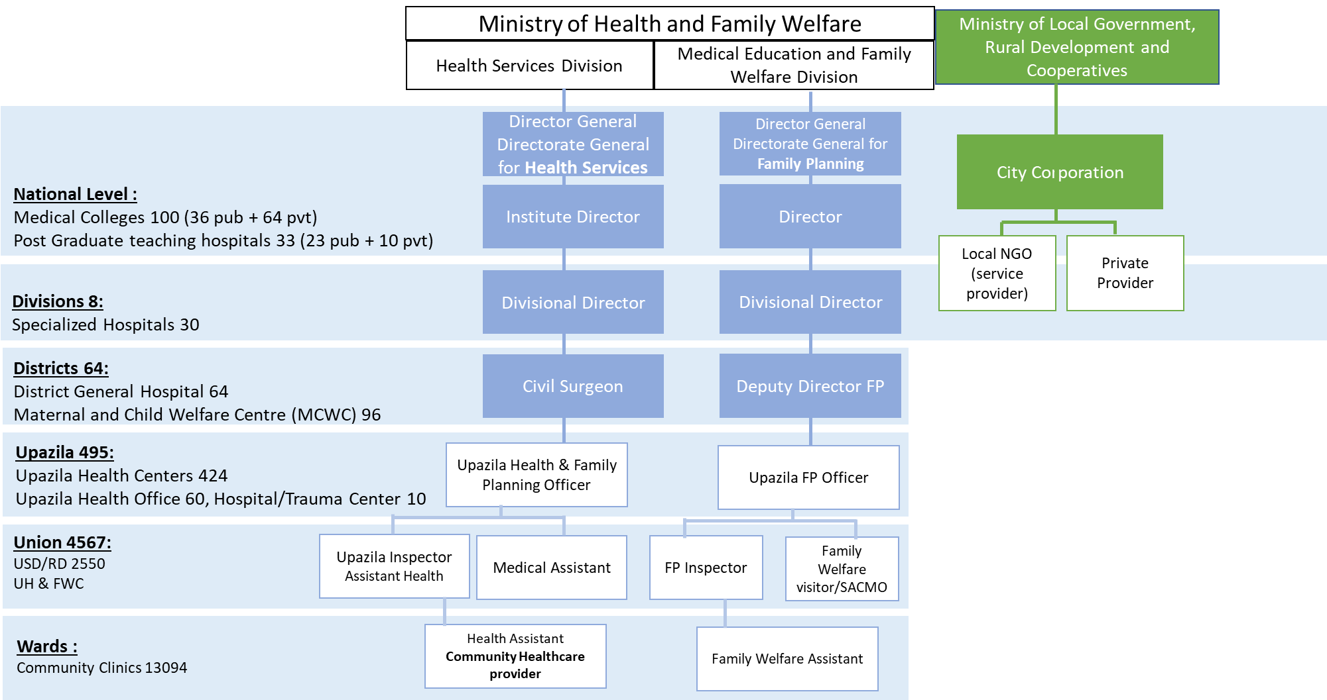

Figure 3: Health service delivery facilities and administrative arrangements
Management responsibility for public sector hospitals and rural health facilities within the country is divided between MOHFW and local governments of City Corporations.
Figure 4: Public health facilities by levels and types of services
Facility | Location, Level | Number | Type of Services
Post-graduate Teaching Hospitals | City Corporation/Municipalities | 33 | Tertiary HC
Medical Colleges | City Corporation/Municipalities | 100 | Tertiary HC
Specialized Hospitals | Division | 30 | Tertiary HC
Maternal and Child Welfare Centre (MCWC) | District | 96 | PHC/FP
District General Hospital | District | 64 | PHC & Secondary HC
Hospital/Trauma Centre | Upazila | 10 | PHC & Secondary HC
Upazila Health Office | Upazila | 60 | PHC/FP
Upazila Health Complex | Upazila | 424 | PHC/FP
Union Health & Family Welfare Centers | Union | 3,975 | PHC/FP
Satellite Centers | Union | 2,550 | PHC/FP
Community clinics | Ward | 13,094 | PHC/FP
The field level HPN service delivery has multiple layers of service provision entities corresponding to different administrative tiers. The grass-root level service point of MOHFW is the Community Clinic at ward level, serving approximately 6,000 people. At union level, there are Union Health & Family Wellness Centers, Union Sub-Centers/RD with an average coverage of 30,000 people. Union Health Centers are located at the Union level of each Upazila. These three layers provide Primary Health Care and Maternal, Neonatal, Child and Adolescent Services.
The secondary layer of service provision is delivered from the District Hospitals. These health care institutions also provide primary care and work as a referral site for the Union Health Centers. On top of these health care facilities, there are specialized hospitals and medical college hospitals, mostly located at divisional headquarters and in major cities and providing tertiary care services. Figure 4 above shows structure of health care provider facilities of the MOHFW.
Details of the types of HPN services provided at each tier of the health care system are presented in the Figure 5 below:
Figure 5: Provision of Essential Services in Bangladesh

Health Care System Tier | Service Provider
Tier 1 : Community Level | Domicilary services  Satellite clinics  Outreach services  Community Clinics
Tier 2 : Union Level | Health and Family Welfare Centers (FCWC)  Sub-centers;  Maternal and Child Welfare Centers (MCWC)
Tier 3 : Upazila Level | Upazila health complex (UHC)  Maternal and Child Welfare Centers (MCWC)
Tier 4 : District Level | District hospitals (DH)  Maternal and Child Welfare Centers (MCWC)

Family Planning services at the domiciliary level are provided by the Family Welfare Assistants (FWAs) through the household visits and include registration of eligible couples, providing counselling and distribution of contraceptives. Maternal and child services at the community level are also provided through the approximately 30,000 Satellite Clinics (SC), which are organized every month to cover rural population with the MCH services.
Community Level Facilities
At the community level domiciliary visits are provided through the Satellite clinics and outreach. The field staff both from DGHS and GHFP conduct house-to-house visits in the community for providing services to the patients in their respective geographic area. Satellite clinics (8 in each union per month) and EPI outreach services (24 per months in each union) are providing designated services through health and family planning field workers. Community Clinics cover 6,000 people to provide health care services to the doorstep of the community. Each Community Clinic is served by Community Health Care Provider (CHCP0, a Health Assistant (HA) and a Family Welfare Assistants (FWAs).
Union Level Facilities
Union level services are provided through the Union Health and Welfare Centers and Maternal and Child Welfare Centers These facilities are located at the union level and are staffed with a Doctor, a Family Welfare Visitor (FWV); a Sub-Assistant Community Medical Officer (SACMO) and a Pharmacist. There is provision of residential accommodation for SACMO and FWVs and office space for the Family Planning Inspector (FPI) in the upgraded UHFWCs.
Upazila Leve Facilities
The health services at the Upazila level are provided through the Upazila Health Complexes (UHC) and Maternal and Child Welfare Centers (MCWCs). The UHC is the first level referral center established at Upazila and providing both in- and out-patient services to the population. UHCs are mostly 50 to 100 bedded facilities and are staffed with: Upazila Health and Family Planning Officers (UHFPO), Resident Medical Officers (RMO), Medical Officers (MOs), Medical Office Disease Control (MODC), Medical Officer-MCHFP, Upazila Family Planning Officers (UFPO), Specialist Doctors (consultants), Staff Nurses, Lab. Technicians and designated field staff.
District Level Facilities
Out of 64 districts 59 have District Hospitals and these are in the process of being upgraded from 100 to 200-250 bed hospitals in phases, with provision of trained manpower and necessary equipment. District hospitals are specialized health care facilities with consultants from relevant disciplines to provide services. The district hospitals will serve as the secondary referral center. Maternal and Child Welfare Centers (MCWCs) in the districts are providing maternal, neonatal, child and family planning services. These facilities are staffed with trained Medical Officers and Family Welfare Visitors (FWVs).

Private Sector
Health service delivery of the country is significantly contributed by the private health service providers, associations and other non-government organizations. The number of private hospitals and clinics and diagnostic centers registered at DGHS has significantly increased over the lats several years (see Figure 6)
Figure 6: Number of private hospitals, clinics and diagnostic centers in 2013 and 2021
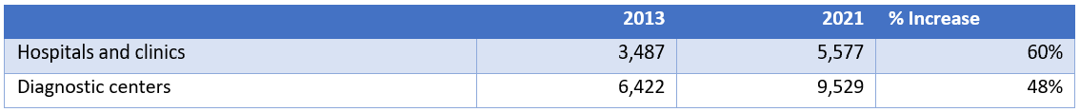
During the last eight years, the number of hospitals and clinics registered at DGHS increased by 60% (from 3,487 in 2013 to 6,422 in 2021) and the number of private diagnostic clinics increased by 48% during the same period (from 6,422 to 9,529).
About 75% of rural and 84% in urban population depend on private, small, informal health-care service providers who are mostly semi-skilled with no professional training. In Bangladesh, 13% of treatment-seekers use government services, 27% use private/ NGO services, and 60% use unqualified services.

Health workforce

Overview
In 2015, the Government of Bangladesh elaborated “Bangladesh Health Workforce Strategy” to support the health sector in achievement its strategic objectives.
Administration Wing of the MOHFW Secretariat is primarily responsible for most of the personnel management functions such as post creation, recruitment, selection, deployment (e.g., transfer, posting, and deputation), leave and promotions. The HRM Unit of the MoHFW provides health workforce policy, plan and strategy formulation support to the Ministry including HW data and information generation.
Healthcare services in Bangladesh are provided by different categories of workforce who can be divided under different sectors such as public, private (both profit and non-profit), NGOs, associations and informal sectors (e.g. ‘kobiraj’, ‘village doctor’, ‘drug-sellers’, herbalists, ‘totka’, faith healer’ and others who do not have any formal education). Major formally trained health workforce can be denoted as physicians, dentists, nurses, midwives, medical assistants, health technologists, trained domiciliary workforce, alternative medical care professionals and other allied health professionals attached with management, finance, and administration functions.

Health workforce supply and distribution
A rapid growth of the private sector in terms of the health workforce production is observed during the last decade. The number of MBBS seats in public sector in 2021 was 4,350 and the number of MBBS in private sector amounted to 6,289. For Diploma Nurses the increase was 408% in the private sector and 128% in the public sector.
By 2021, the total health workforce in the formal sub-sector approached 531,454 (estimate for all categories), which accounts for about 52% increase from the 2015 estimate (350,000 health workers). Over the same period, Bangladesh’s population increased by nearly 9% and reached more than 170 million individuals.
The number of doctors registered with Bangladesh Medical and Dental Council (BMDC) increased by 54.5 thousand in 9 years as shown in Figure 7 below. In 2021 the number of registered doctors increased by 92% and nurses – by 152% doubled compared to 2012.
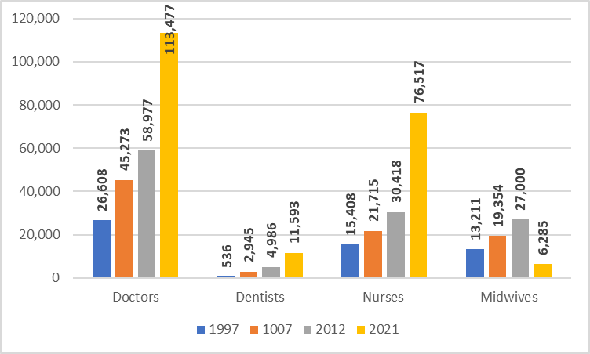
Figure 7: Registered health workforce between 1997and 2021
Source: Bangladesh Medical and Dental Council (BMDC) 2022
In the public sector, there are several institutional actors providing health and family welfare services. Out of them MOHFW bears the major responsibilities of formulating policy, planning and strategic development, as well as implementing, monitoring and evaluating implementation of programs and evaluation of service delivery. About 35% of the total graduate medical doctors are employed by the MOHFW and about 3% of them works under other Ministries such as Social Welfare, Home, Local Government and Cooperatives, Railway, Women and Children Affairs, Defense and others.⁴⁷
The major portion (approximately 56%) of the total health workforce is employed by the Department General for Health Services (DGHS) of MOHFW and approximately 29% - by Department General for Family Planning (DGFP). 13 per cent of the total health workforce is employed by the DGNM and rest 2 percent - by other implementing agencies. MOHFW has one of the largest public health service networks covering all levels from door-step domiciliary services in the field to the health facilities at the Division and Capital City level. Despite such robust and extended infrastructure, the full potential of this network is not realized, which remains one of the most burning challenge for the MOHFW.
The health workforce in Bangladesh is predominantly linguistically and culturally homogenous and transferable across the country although individual circumstances affect deployment in practice.

Staffing practices
Proper utilization of health workforce mainly depends on how best it is planned and managed. Recruitment, selection and deployment of HR are among the most serious challenges in Bangladesh. According to the current regulations, responsible agency for formulation, review, update and approval of all sorts of laws, rules and regulations related to the public sector employees is the Ministry of Public Administration (MOPA).
Technically the ministries can propose to MOPA all necessary changes to any of the rules and regulations upon ensuring compliance, however consideration of these proposals may take several years. For instance, DGHS and DGFP of MOHFW have formulated and submitted proposals to change many recruitment rules and promotion policies in 1980s and 1990s, but MOPA has not taken any significant action for addressing these proposals. Since 1977 DGNM of MOHFW has been trying to revise its recruitment rules, but similarly to DGHS and DGFP, these efforts were unsuccessful and led to the situation when recruitment and/or promotion of experienced and qualified nurses have been impossible during the decades due to absence of an appropriate recruitment rule. According to the commitment of honorable Prime Minister, about 2,996 midwife posts were going to be created during the period 2015-2020, MOHFW was able to create only 600 posts at Upazila and Union Sub-center level to date.
There are many positions in the DGNM, NIPORT and DGFP which have not been filled in since their creation, including a good number of Director level positions. In the DGNM almost all permanent positions are temporarily filled by “current charge or in-charge” mechanisms. Regularization of the individual employee into the post has not yet been taken place.
One of the main priority concern of policy makers is skill-mix balance. The National Health Policy (2011) sets the skill mix composition, which includes 1 physician, 3 nurses and 5 allied professionals according to the international standards. The current scenario of workforce pattern, however, is reverse, i.e. the total number of registered medical doctors (MBBS – 113,477) is nearly 1.5 times more than that of nurses (diploma – 76,517), which leads skill mix composition 1.00 (physician): 0.5 (Nurse).
Unfilled of sanctioned positions are common phenomenon at the public health facilities accounting for approximately 20% of the total sanctioned posts, which significantly limits ability of these facilities to provide high quality and required volume of health services. Absenteeism and timely attendance of the health workers at the workplaces particularly situated in rural, remote and hard to reach areas are frequently reported in the mass media and thus cause rural retention of the workforce as a challenge for the Ministry.
Deputation and deployment practices in the public health system frequently attract attention. Studies show that the density of physicians and nurses are significantly skewed in the urban areas (mostly in the capital city) compared to the rural. Sometimes health workforces (especially physicians) take advantage of the deputation policy for studying postgraduate courses, which leads to the increase of absenteeism. Absenteeism in turn makes impossible to achieve improvement of health care system performance and meet needs of the care seekers. Unauthorized absence is regarded as a misconduct as per service regulation, but due to the weak monitoring and supervision mechanisms response of the system is insufficient.

NGOs and private sector
“According to an estimate of 2003, around 50% of the doctors, 42% of the nurses and 65% of the paramedics work in the private sector exclusively, besides those public-sector employees who also practice privately after office hours. The involvement of the health workforce in the private sector is increasing, as revealed by an estimated 62% of the medical doctors working in the private sector in 2013”
Along with the national NGOs, there are several international NGOs and Development partners directly or indirectly involved in health care service delivery across the country.
Private sector institutions, NGOs, associations and other informal sector organizations are collectively the largest employers of the health workforce in the country as well as they are significant contributors in improvement of health sector performance.
However, it is still unclear how much these institutions contribute in equity and quality of the currently provided services. Up to this date the MOHFW has not been able to develop a comprehensive database of the non-state actors working in the health care field as well as collect information on types, qualification and specialties of health workers employed in non-government sector, which leads to the difficulties in formulation of national HWF plan and projections of required human resources.
Professional associations play a critical role in terms of formulation of HWF related policy-making process. Bangladesh Medical Association (BMA) has a long history for the growth and development of the medical profession in the country, closely working with the Government for rendering health services. Similarly, Bangladesh Nurses Association, Bangladesh Midwifery Association, Bangladesh Physiotherapy Association and others play an important role in decision making process related to the national level decisions on the HWF development.

Immunization system

Background of the national immunization program
National immunization program entitled as “Expanded Programon Immunization” (EPI) is an integral part of the national health policy framework, and serves as an instrument for the implementation of health policy under the extended 4th Health, Nutrition and Population Sector Program Component 3 “Quality Health Services”, Strategic Objective 7 “To improve equitable access to and utilization of quality health, nutrition and family planning services” (as described in details in section 2.2.1 Governance above). EPI services are explicitly defined in the Essential Service Package, and its objectives and strategies are reflected in the Revised Operational Plan on Maternal, Neonatal Child and Adolescent Health 2017-2023.
Since its establishment, the EPI has been a priority and one of the most successful public health programs. The Government showed strong commitment to reach every child and mother with quality immunization services to reduce maternal and child mortality and morbidity arising from vaccine preventable diseases. The 4th HPNSP, elaborated by the Government of Bangladesh identified improvement of child survival through vaccination of children and women as one of its key priority areas for achieving targets of national health strategy.
EPI aims at realizing commitment of the GoB to the Global Universal Child Immunization Initiative. The government of Bangladesh has been regularly developing a comprehensive Multi-Year Plans for Immunization (cMYP) for national immunization program of Bangladesh. Based on the global recommendations and new methodology for development of the immunization strategies, the government decided to replace cMYP with the National Immunization Strategy (NIS) from 2023. The NIS is one of the key documents of the immunization sector of the country, providing a framework for design and implementation of strategic interventions to achieve important objectives of the Expanded Program on Immunization, to contribute in implementation of the national health policy. The NIS sets out the Vision, strategic objectives (medium-term/five-years) and main strategic interventions of the national immunization program. In addition, the NIS provides costing and financing analysis of the strategy and highlights resource requirements for NIS implementation, secured sources of funding and funding gap analysis that supports strategic planning process for ensuring financial sustainability of NIS implementation.
During the period of 2018-2022 EPI has been aiming at achievement of the 6 strategic objectives as defined in the cMYP 2014-2018 that contributes to the achievement of respective targets of the 3rd HPNSP results framework: Objective 1: Improve Immunization coverage among children under one and child bearing age women (CBAW); Objective 2: Maintain polio free status; Objective 3: Maintain maternal and neonatal tetanus elimination status; Objective 4: Measles elimination and rubella control; and Objective 6: Strengthen the immunization health system.

Immunization system outcomes

Immunization coverage trends
Bangladesh has a high performing immunization program, with the established capacity to set and achieve targets and deliver immunization services through well-structured network of service providers, monitor programme implementation and create evidence basis for design and implementation of corrective measures through the well-established surveillance system.
The immunization programme in Bangladesh under the strong government ownership has made tremendous progress in recent years through maintenance of high national coverage levels and reduced drop-out rates. Reported immunization coverage rates and WHO&UNICEF coverage estimates have remained over 90% for more than ten years and more than 80% of children under 12 months of age are fully immunized.
  - According to the CES 2019 national coverage estimate for Penta3 was estimated is 99.8%. MR/MCV1 coverage was estimated at 89.5%, and fully vaccinated child (BCG, TT, DTP3, OPV, MCV) - at 83.9% as shown Figure 8 below.
According to CES 2019 preliminary findings, more than 80 percent of children under 12 months of age were fully immunized as shown Figure 8 below.
Figure 8: National Immunization Coverage for selected antigens in last 5 years
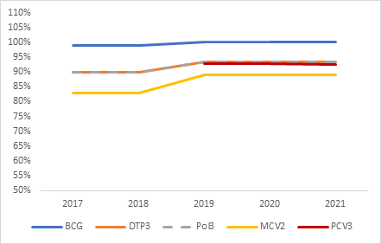
Source: WUENIC, 2021
WHO/UNICEF official estimates of national immunization coverage (WUENIC) for DTP3 was 93.4%, while DTP3 coverage based on administrative data reports was 110% in 2020; Official estimates of MCV1 and MCV2 coverage were 93% and 89% respectively, while administratively reported data showed 108% and 107% respectively. The high administrative coverage owes mostly to the longstanding and unresolved denominator issue. The denominator at district and upazila levels based on population projection from 2011 census is mostly underestimation and the reaching to a realistic denominator was not possible even after seeking assistance from nationally and internationally reputed demographists in the recent past. Alternate suggestion is to use the available micro-plan data till the next census, which initially was scheduled for 2021, but was postponed due to the COVID-19 pandemic. Unresolved denominator issue remains a challenging problem in EPI.

Immunization coverage equity
Drop-out rates have been substantially reduced during the recent years. However, drop-out cases from the subsequent dose(s) of the same antigen or different antigen were the most notable obstacle in achieving the desired coverage targets.¹ According to the CES, 2019 findings the MCV1-MCV2 drop-out rate accounted for 4.5%, with almost the same rate in the rural and urban areas (4.4% and 5% respectively). There was almost no difference in the MCV1-MCV2 drop-out rates among the males and females across the country. Among the eight divisions, the MCV1 – MCV2 drop-out rate was the highest in Mymensingh (8.3%) and the lowest in Rajshahi (0.4%). In the other divisions, the rate ranged between 7.1% and 3.5%:
Figure 9: MCV1-MCV2 vaccination drop-out rate by Sex and National Level¹
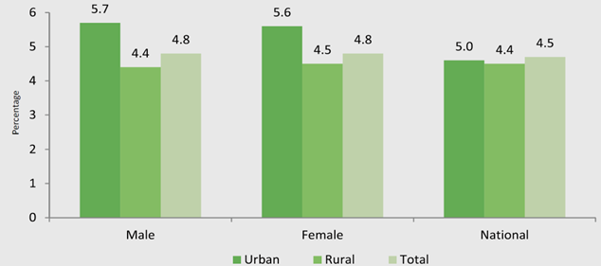
Source: CES 2019
According to the WIENIC data, drop-out from BCG to MCV1 increased from 2% in the period 2017-2019 to 7.2% in 2021, and the drop-out rate for DTP1-DTP3 – from 1% in 2017-2019 period to 6.3% in 2021, as shown in Figure 10 above.
Figure 10: Trends in drop-out rates between DTP1 -DTP3 and between BCG and MCV1
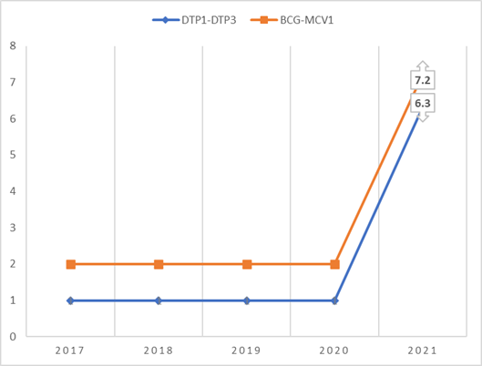
Source: WUENIC 2022
Despite strong programme performance, progress is in some cases uneven, and it remains a challenge for the programme to reach all children across different socioeconomic groups and geographical locations.
The national Coverage Evaluation Survey (CES) 2019 reports coverage of the third dose of pentavalent vaccine at 90.1%; the first dose of measles-rubella vaccine at 87.5%, and fully vaccinated children at 82.3%.
In 2019 a little variation was observed in crude full vaccination coverage between rural and urban areas (95.9% vs. 93.3% respectively).
Geographical inequities
According to the Coverage Evaluation Surveys (CES) of 2019 the EPI performance has been variable across the districts and city corporations. Overall, the equity of immunization services improved from 2016 to 2019: the number of districts achieving higher than 90% coverage for the fully immunized child increased from 4 to 28, and 62 out of 64 districts achieved above 80% valid full vaccination coverage among the children of 23 months. However, sustaining the high coverage rates remains a challenging task which requires the special attention from EPI. The results of urban/rural coverage analysis showed that rural children (85%) were more likely to receive the valid doses compared to their urban counterparts (79.2%).
Full Vaccination Coverage (FVC) was found to be lower in urban, slum and hard-to-reach areas than national average indicating the need for the implementation equity focused interventions.
Differences in coverage between the districts are quite significant. The gap in coverage of the first dose of the measles-rubella vaccine (MR1) between the district with the highest DTP3 coverage (Pirojpur: 98.1%) and the district with the lowest DTP3 coverage (Khagrachari: 87.8%) was 12 percent. In terms of fully vaccinated children (FVC), the gap between the highest performing district (Bhola: 97.1%) and the lowest performing district (Khagrachari: 77.3%) was more than 13.9 percent. Only 60 out of 64 districts achieved higher than 90% coverage for MR1, and 24 districts higher than 90% coverage for MR2 vaccine.⁴.
Rural / urban inequalities
Contrary to some other countries, in Bangladesh the full vaccination of children in urban areas (79.2%) is lagging behind rural coverage (85%). Nine out of 12 City Corporations of the country achieved FVC coverage less than 80 percent.
In the city corporations (CC) only 1 out of 12 CCs achieved higher than 90% valid coverage of the fully immunized child and 4 out of 12 – achieved above 80% valid coverage of fully immunized child. Seven city corporations achieved equal or more 90% DPT3 coverage and all CCs reached reach 80% DPT3 valid coverage, as it is shown in the Figure 11 on below:
Figure 11: Penta3 valid coverage and Full Vaccinated Children Coverage by 12 months
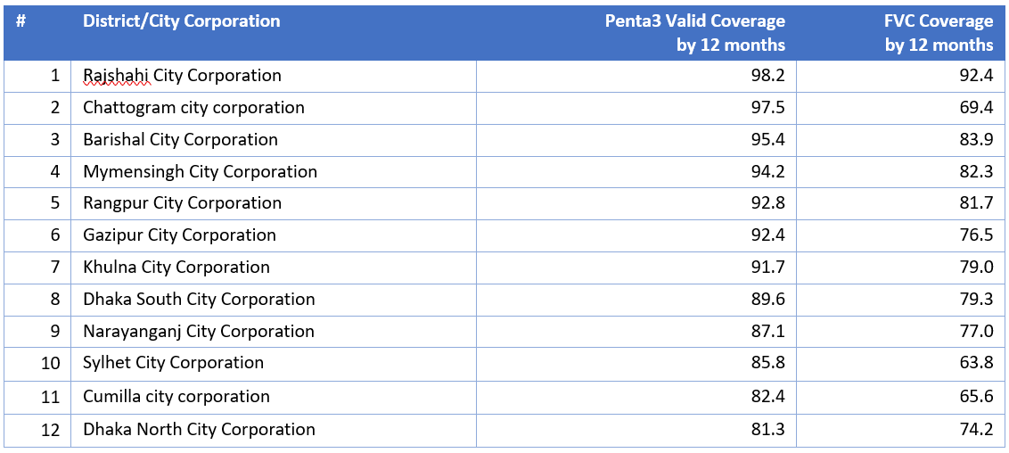
Source: CES 2019
The urban areas of Sylhet City Corporation (CC), Cumilla City Corporation, North and South Dhaka City Corporations and Chattogram City Corporation are the lowest performing areas in the country, with FVC coverage of around 63-70 percent, therefore improvement of coverage in urban areas is one of the factors to ensure the equity in service delivery. It is estimated that a quarter of population in Dhaka, or about 14 million individuals, lives in slum areas. According to the results of CES in 2019 there is some insignificant difference in vaccination coverage in slum and non-slum areas in Dhaka North, Dhaka South and Chattogram City Corporations, indicating the need for more in-depth analysis and defining the real causes for low immunization coverage in urban settings.
Figure 12: Valid coverage by 12 months by DNCC and DNCC slum and DSCC and DSCC Slum, CES 2019
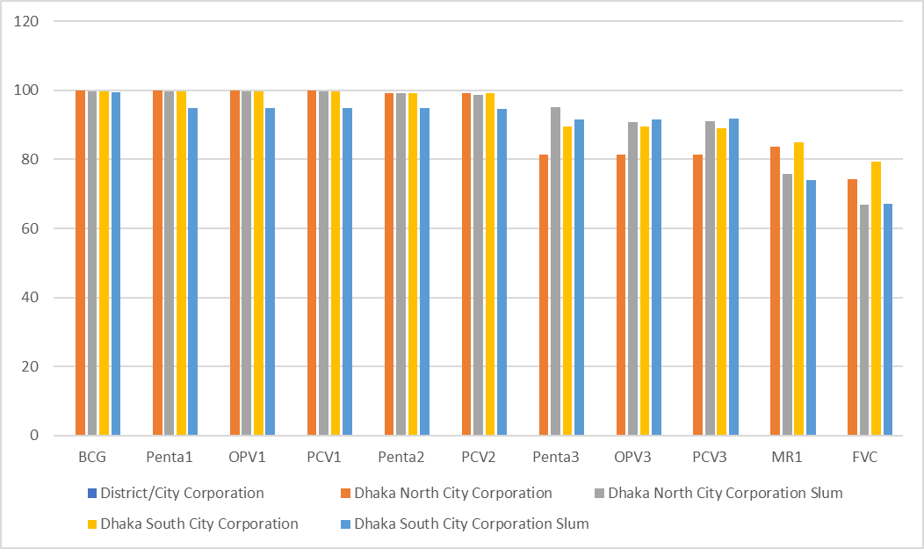
Source: CES 2019
One of the main challenges of the EPI Bangladesh are remaining pockets of unvaccinated and unprotected children and CBAW living in urban slums and hard-to-reach areas. Therefore, one of the key priority actions for EPI Bangladesh is to improve performance of the immunization system in the urban slums through the identification and reaching out these vulnerable groups and protecting underserved groups of population against VPD and preventing potential outbreaks.
CES 2019 revealed that the main reasons for low coverage in both urban and rural areas is low knowledge of target communities of the vaccination schedule of their children (didn’t know that my child should be given vaccine) (24% in urban and 33% in rural areas), leading to the low or lack of demand for immunization services among these population groups. The analysis of CES results the reasons of non-immunization showed that in nearly 39% of cases in rural areas and 24% of urban areas the reason of non-vaccination was that the caregivers didn’t know that their child should be given vaccine, which in rural areas followed by the vaccine hesitancy (don’t believe in vaccination) and in urban areas with the lack of knowledge about the vaccination process and vaccination points (didn’t know where to go for vaccination (see Figure 13 below).
Figure 13: Reasons for Never Having Vaccination in Rural Areas, City Corporations and Munitipalities in 2019
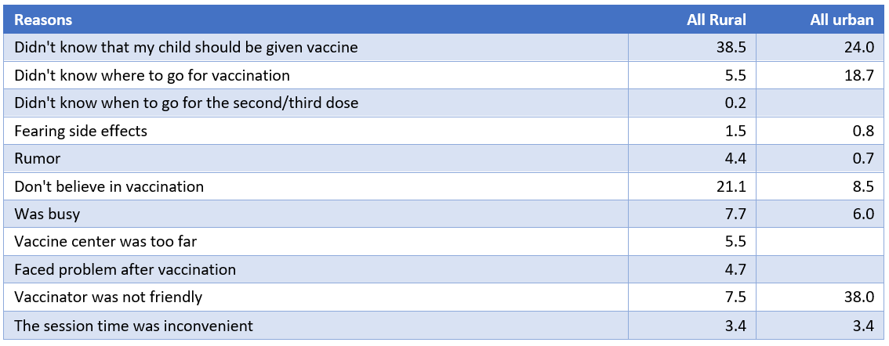
Source: CES 2019
Another key reason for insufficient immunization coverage in the urban areas could be related to the weaknesses in the health system and service delivery, which in urban areas are delivered as part of Health, Nutrition and Population services.
EQUIST analysis
The Government of Bangladesh’s 4th Health, Nutrition, and Population Sector Development Program (HNP) is designed to achieve universal coverage for maternal, newborn, child, and adolescent health (MNCAH). Despite the overall progress towards achievement of the program objectives, inequities in health and nutrition remain unresolved problem, especially among disadvantaged groups. Improvement equity in health service delivery, therefore, remains one of the most critical challenges of the Government to promote and achieve universal coverage of population and contribute into the Sustainable Development Goals (SDG3).
The Government of Bangladesh (GoB), with the support provided by the UNICEF (Dhaka) conducted the equity analysis through application of EQUIST. The main objectives of the analysis was to analyze existing inequity in neonatal, under-five and maternal mortality rates by division, residence and wealth quintiles; identify the extent of the inequity and drivers of inequity; identify the amenable under-five deaths and maternal deaths among the deprived population groups; identify the causes responsible for these amenable deaths and the high impact interventions that could avert these deaths; and develop scenarios for addressing the need of the deprived population and conduct a bottleneck analysis using the Takahashi model.
The results of the Equity analysis confirmed common perceptions related to the overall situation in the divisions of Bangladesh and performance of these divisions in MNCH service delivery including delivery of immunization services. The analysis highlighted high inequities in neonatal mortality rate by divisions, residence, and wealth quintiles.

Neonatal Mortality Rate
The results of EQUIST confirmed that the policy makers should plan and implement specific interventions to further reduce neonatal mortality rate in Sylhet, Rajshahi and Rangpur divisions to catch up with national trends and help the country to achieve Sustainable Development Goals (SDG3). EQUIST also showed that the special interventions will be required for population groups residing in slum areas, as well as for the households from the poorest three income quintiles. If the country wishes to reduce the total number of neonatal deaths, then the Dhaka and Chattogram divisions should also be considered, as the number of neonatal deaths was highest in Dhaka division with 13,197 deaths followed by Chattogram division with 10,131 deaths.

Under-five Mortality Rate
According to the EQUIST results, to improve equity policy makers should take various steps to reduce further under-five mortality rate in Syhet, Rangpur and Chattogram divisions. Special interventions are needed for population residing in slum areas and households belonging to the poorest three income quintiles, whose figure is higher than the national average.
But if the country wishes to reduce the total number of neonatal deaths, then the Dhaka and Chattogram divisions should also be considered. The number of under-five deaths was highest in Dhaka division with 32,993 deaths followed by Chattogram division with 25,962 deaths.

Maternal Mortality Ratio
EQUIST results confirmed the need for implementation of the various steps to reduce maternal mortality ratio in Rajshahi, Rangpur, Barisal and Sylhet divisions. Special interventions are needed for population residing in rural areas and households belonging to the poorest three income quintiles, whose figures are higher than the national average. But if the country wishes to reduce the total number of maternal deaths then the Dhaka and Chattogram divisions should also be considered.
The equity frontier analysis identified the factors that most contribute to addressing inequity and reducing the disparity between the different groups of population.
Overall the EQUIST analysis revealed four major bottlenecks for MNCH service delivery (including immunization): 1) inadequate provision of emergency drugs and supplies; 2) vacant posts and manpower and lack of trained health personnel; 3) the long distance from the BEmOC facilities and insufficient transport facilities and 4) lack of education, knowledge and awareness of communities, which led to the conclusion that the effective interventions related to the strengthening of the HR capacity, improvement of supply and logistics systems will significantly improve access and utilization of the MNCH interventions, including immunization.

Immunization system performance by components

Governance / decision making
The principal agency for making technical recommendations on the immunization schedule, immunization practices, and new vaccines and technologies is the National Committee for Immunization Practice (NCIP). The NCIP appoints sub-committees for immunization related programs for disease prevention and control, elimination, eradication, and safety.
The main agency for regulation and licensing of vaccines in Bangladesh is the Directorate General of Drug Administration (DGDA). It is the policy commitment of the MOHFW that all licensing and registration of vaccine production and marketing should come under the single regulatory umbrella of the DGDA.
The MOHFW upgrades and maintains the capacity of DGDA to undertake the six core regulatory functions of (i) a published set of requirements for licensing, (ii) surveillance of vaccine field performance, (iii) introduction of systems of lot release, (iv)use of laboratory when needed, (v) regular inspections for good manufacturing performance and (vi) evaluation of clinical performance.
The DGDA takes the primary responsibility for post marketing pharmaco-vigilance. The principal mechanisms for coordination of national and international resources for immunization is the Inter Agency Coordination committee, or any other sector coordination agency appointed by the Government.
The principal agency responsible for ensuring the quality and safety of implementation of the routine public immunization schedule and immunization campaigns is the National Immunization Program, Directorate General of Health Services of MOHFW.
The Department of communicable Disease Control, Directorate-General of Health Services, MOHFW has the primary responsibility for implementation of non-EPI vaccination programs (rabies prevention, seasonal influenza vaccination and traveler’s vaccination, (including for Haj Pilgrims in collaboration with the Ministry of Religious Affairs and with overseas workers through Ministry of Expatriates Welfare and Overseas Employment). Overall coordination of national immunization services remains the primary responsibility of the National Immunization Program, Directorate-General of Health Services, MOHFW.
NGOs supplying immunization services through City Corporations or Municipalities provide immunization services that conform to public sector immunization policies and standards in relation to cold-chain vaccine management, safe injection practices, and routine surveillance and immunization reporting and other immunization standard operating procedures.
According to the MOHFW policy the City Corporations and Municipalities identify and mobilize immunization human resource numbers and operational costs that meet the standard and procedures for management of the public-sector immunization services elsewhere in the country.
Changing the Immunization Schedule
Changes to the routine immunization schedule are technically reviewed and recommended by the National Immunization Technical Advisory Group (NITAG) and endorsed by Interagency Coordination Committee (ICC)
New vaccine introduction
The decisions on introduction of new vaccines into the national routine immunization schedule is made by the Ministry of Health and Family Welfare based on existing procedure and according to the NITAG and ICC recommendations.

Immunization service delivery
EPI Services in Rural Areas
The immunization service delivery in rural areas is managed by the government under the MOHFW. The Directorate of Health Services and the Directorate of Family Planning have assigned staff from district to field level for delivery of immunization services. The EPI services are provided within the Essential Service Package and service provision is based on the administrative structure of the country which is presented in the Figure 14 below:
Figure 14: Administrative Division of Bangladesh
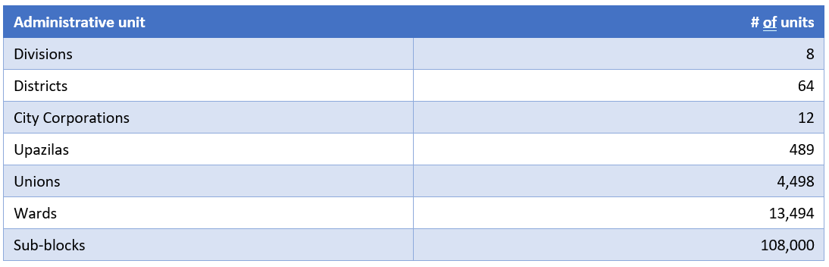
Source: EPI Bangladesh
There is an EPI outreach/vaccination site in each sub-block where routine EPI services are provided monthly. The catchment area of these outreach/vaccination sites is approximately 1,000 people. During a calendar week, the vaccination sessions are provided in two outreach/vaccination sites to cover eight sites of a ward in a month.
The vaccinations are administered by the Health Assistant (HA) under DGHS who usually is assisted by the Family Welfare Assistant (FWA) under DGFP. The porters have been engagement as casual labor for transporting vaccines and logistics from the EPI store to the vaccine distribution points. Health workers carry the vaccines and logistics from the distribution points to the immunization sessions.
The Medical Technologist (MT-EPI) at the Upazila Health Complex is the key person in providing technical support to the front-line staff. Thus, the Health Assistant, Family Welfare Assistant, Porters are the driving force of the EPI service delivery infrastructure in rural areas.
The immunization service provision in rural areas is supported by the field workers and volunteers who are involved in mobilizing communities and parents for vaccination sessions.
The immunization service provision is based on application of annual micro-plans, which are prepared basis on the REC (reach every community) strategy. The Micro-plans are updated annually at ward and Upazila levels and submitted to district and higher levels for approval and allocation of funding, vaccines, injection supplies and logistical requirements for supportive supervision.⁷²
EPI Services in Urban Areas
The service delivery in urban areas is managed by city corporations and municipalities under the Ministry of Local Government, Rural Development and Cooperatives (MLGRDC). Vaccines, immunization supplies, and equipment are provided by the national EPI, which also provides programmatic support for immunization service delivery.
MOLGRD&C employ Health personnel and service providers for delivery of a range of public health services in City Corporations and municipalities. These services include, PHC services, vector control, food and sanitation, waste management and immunization services.
Due to inadequate number of permanent health workers and health care infrastructure, a greater part of the HPN services is provided through the network of NGOs, contracted for this purpose by the local governments.
The service delivery is organized through the network of clinics and outreach posts established across the administrative zones of City Corporations. The NGO facilities operating in an urban slum and non-slum areas, covering 58% of slum and 53 % of non-slum communities. The remaining areas are covered by the government and private health facilities.
A number of recent surveys found general improvement of public health service delivery in urban areas of the country, but also revealed critical weaknesses and need for major improvements for achievement of health and immunization system objectives in city corporations and municipalities.
Internal migration: Internal migration to the larger cities and towns raises ongoing concerns with regard of effectiveness of service delivery and its outcome in urban slum areas. According to the Urban Health Survey (2013) crowded living conditions and chronic malnutrition remains persistent public health problem, which is aggravated by the growth of peri-urban populations around the developing city Centers, taking into account that these areas lack adequate basic health care infrastructure and health personnel.
Registration: Inadequate systems for effective recording and registration and lack of capacity among urban service providers to maintain registration systems, limits capacity of immunization system to reach out the migrant population with immunization services.
Organization of Service delivery and communication: In most of the urban areas service delivery is not coordinated. The work performed by satellite/outreach centers is not properly organized leading to the overlapping of immunization activities by different providers. According to the documented evidence, in many of urban areas, the number of satellite/outreach centers is not sufficient to cover all target geographic areas in a ward, however the immunization sessions are conducted are conducted 3-4 times in the same location rather than in hard-to-reach areas. The number of immunization target population in the urban areas is much lower than in the rural parts of the country. The awareness and knowledge of parents on immunization and vaccination sessions is lower than in rural areas. No attempts are made by service providers to follow-up and reach missing children.
Financial sustainability: There are concerns regarding the over reliance on international financing and NGO service provision in urban areas, raising concerns regarding the vulnerability of the urban health care systems to external political or financial shocks.

Program management
The National EPI of Bangladesh has strong, centralized management system. The overall management functions of EPI are assigned to the Line Director of the MNC&AH OP, who is also responsible for overseeing implementation of the other major components of the MNC&AH OP such as: Maternal health, National Newborn Health Program (NNHP), Integrated Management of Childhood Illness (IMCI), Adolescent Health and School Health (AH&SH).
Responsibility for day-to-day management of EPI at all levels is assigned to the EPI Program Manager and four Deputy Program Managers (DPM): DPM-EPI and Surveillance, DPM- Procurement and Supplies, DPM- Field Services and DPM- IEC and SBC.
At the district level, Civil Surgeon is responsible for implementation of EPI program. The District EPI superintendent is responsible for management of vaccine, cold-chain operations, and logistics, while the Assistant Storekeeper carries out all vaccine logistics related activities. Cold chain technician specially maintains the functionality of the cold chain equipment.
At Upazila level, Upazila Health and Family Planning Officer (UHFPO) is overall responsible for implementation of EPI program. Medical Technologist-EPI maintain immunization supply chain and supervise vaccine distribution and cold chain management issues and reporting. Health Inspector at the upazila level supervise the health activities of the Assistant Health Inspectors.
Union level supervision of immunization service delivery is provided by the Assistant Health Inspector (AHI), employed by the DGHS and Family Planning Inspector (FPI) – employed by the DGFP.

Workforce
Routine vaccination coverage is high in Bangladesh, however high rates of staff turnover remain problematic for adequate implementation of high-quality immunization services at all levels. Although the NGOs provide substantial support for immunization service delivery in urban areas, but the shortage of health assistant is very difficult to overcome in rural areas.
As per Strategic Plan for Measles, Rubella and CRS Elimination, other human resource issues relate to the insufficient allocation of funds for human resources. During the formative years of EPI (until the mid-2000s), in additional to the EPI National Staff, every Upazila health complex had the EPI Medical Officer (MO) and Medical Officer-Disease Control (MODC) (for surveillance). Now there are only two MO posts at the National EPI Office and there are no sanction posts of MO and MODC at the Upazila.
Since 1998 approximately 32 WHO-supported Surveillance Medical Officers (SMO) and approximately 32 Gavi-supported District Maternal Child Health and Immunization Officers (DMCHIOs providing service since 2013) have been providing technical and operational assistance to the immunization program in various fields, such as surveillance, outbreak investigation, supplementary immunization activities, and response activities at the district, city corporation, municipality and Upazila level. Direct management of SMOs was provided by the WHO CO and the government was responsible for management of the DMCHIOs. To optimize immunization, function the term of reference of SMO were changed and title was changed to Surveillance and Immunization Medical Officer (SIMO) and started implementation of the plan for deployment of 64 SIMOs in all districts of the country.

Reporting
Bangladesh shows ongoing commitment for strong monitoring and evaluation of its immunization program, maintaining administrative data on immunization and implementing Coverage Evaluation Surveys(CES) on an annual basis to strengthen in-country capacity for evidence- based planning, progress monitoring and decision making. Routine immunization data management is maintained through the strong and effective Management Information System which has been established in 1995.
The information on the immunization target population (newborns and CBAW) and their vaccination status are recorded, collected, and analyzed at all levels of the immunization system. At the union level, two separate registers are maintained by the Health Assistants, for registration of immunization target groups in their respective wards and sub-blocks. These records are used as basis for targeting, tracking and following-up children for vaccination as well as for building and maintenance of communication between the immunization service providers and parents. Similarly, the CBAW register is used to record and track TT vaccination status of the childbearing age women, as well as for monitoring of outcome of the pregnancies. Two separate tally sheets are maintained for reporting daily vaccination from routine vaccination sessions for immunization target groups. Based on these daily reports the immunization service providers develop monthly reports for each reporting site. The reports are developed separately for children and CBAW.
The registration system on house-to-house visits, detailed tally sheets of daily vaccination records and a monthly report on vaccination are the key components (instruments) of the ward level management information system.
The wards prepare and submit daily reports to the respective Upazilas, through a tally form. In addition, the wards prepare monthly reports for submission to Upazilas monthly.
Upazilas forward these reports to the upper level of the system – districts. At the district level reports are computerized and the electronic version, with supporting hard copies are sent to the central (national) level. A computer-software for data entry and analysis is efficiently used in all 64 districts.

Data quality
WHO and UNICEF have been facilitating the implementation of data quality self-assessments across the country and more than a half of all districts have been covered in this effort. Trainings are provided to help orientation of the district and Upazila immunization managers in data collection and reporting. In addition, EPI seeks to validate the data quality self-assessments by requiring surveillance immunization medical officers (SIMOs) to re-conduct data quality self-assessments (at least two times per month). Results of the self-assessments are regularly compared for consistency and all issues are discussed between the district and immunization managers. The monitoring continues until the improvements are documented by IENIC estimates and CES.
Over the recent years administrative coverage has been repeatedly reported over 100%, which could be attributed to the denominator related problems. Data management of health statistics across a number of disciplines in Bangladesh is undergoing major reform with good progress made towards an eHealth system.
Bangladesh is progressing with DHIS2 as a health information system management package. This data warehousing and data integration package is well adapted to the real time dynamic needs of EPI data.
The number of substantial improvements were made to ensure smooth transition and integration of a paper-based system into the DHIS2:
DHIS2 is upgraded with real-time Immunization Supply Chain and Logistics (ISCL) management Information System (MIS) that includes data management for vaccine, cold-chain equipment, storage, temperature, distribution, vaccination coverage and other logistics. Cold chain and logistics MIS system (DHIS2) implemented across the country in 2016 and all the cold-chain equipment are part of this database and being monitored.
Online immunization data management system initially to district level and progressively to Upazila level and linked or integrated this with DHIS2. UNICEF supported the BoG for capacity building in 64 District Supervisors and Cold-chain personnel. Recruited national MIS consultant to support and oversee the process of transition to DHIS2 data management and timely entry of EPI data at all levels. Established functional dashboard on EPI Reporting, Cold-chain, Vaccine and Logistics Management system in national live dashboard portal of DGHS, MOH&FW. Organized one orientation on Stock Management and Online reporting for EPI supervisor and storekeeper of 64 districts. Provided computer support for urban areas (9 Corporations) to facilitate data management in urban areas.

Cold chain and vaccine management
Vaccine and Logistics procurement
According to the national policy, the country procures only WHO pre-qualified vaccine to ensure the quality and safety of vaccines used by the EPI.
The annual forecast for vaccines and supplies is based on the number of target population that is calculated based on the National Census 2011 data and data provided by the Bangladesh Bureau of Statistics. Procurement and distribution of vaccines and supplies is carried out by the national EPI based on the request received from all districts. The Government covers costs for the procurement of traditional vaccines included in the routine immunization schedule: BCG, OPV, MR and Td while DTP-Hib-HepB and PCV vaccines are co-financed by the National Government and Gavi and costs of IPV vaccine is fully covered by Gavi. According to the existing plans, the newly introduced vaccines will also be co-financed by the Government and Gavi: Rotavirus, HPV, TCV and JE vaccines.
Cold Chain procurement & Management
According to the national practice, the country procures only WHO pre-qualified Cold Chain Equipment (Walk In Cold Room (WICR), Walk in Freezer Room (WIFR), Ice Lined Refrigerator (ILR), Deep Freezer (DF), Cold Boxes, Vaccines Carrier, Solar Refrigerator, Remote Temperature Monitoring Device (RTMD)) to ensure the quality and safety of vaccines during transport and storage at different level used by the EPI.
The Cold Chain operation and management is performing based on the country existing three tier supply chain system (Central (PR), District (LD) and Upazila (SP)). The temperature of the WICR at district level is monitored both centrally and individually (district). The maintenance of the cold chain equipment in both district and upazila is performed with the help of government’s owns fund. Till now the maintenance of the WICR at district level beyond warranty period is supported by UNICEF. The maintenance of the Cold chain equipment at central level is conducted by third party agency in collaboration with the Government.
For improvement of cold chain, solar powered energy will be used in some selected cold chain points. Cold chain inventory system will be modernize using updated computerized system. Research and development of cold chain equipment will be carried out local educational institution. Feasibility studies will be carried out as to assess the production of local cold chain equipment.
There will be a considerable extension and expansion of cold chain points in urban areas. A system of condemnation and safe disposal of cold chain equipment beyond economic repair will be established.
Effective vaccine management
The most recent EVM assessment in Bangladesh was implemented in 2021. The assessment confirmed that the country maintained a laudable three-tier based immunization supply chain system that has demonstrated consistent progress since preceding EVMs in 2011 and 2014. Bangladesh implemented the recommendations of the previous EVMAs, met almost all key strategic recommendations and scored above or close to the WHO recommended 80% in all the criteria. Overall performance of the country is above the WHO requirement of 80%. The assessment highlighted that PR has an acute shortage of the dry storage capacity and remains responsible for conducting MLM training, refresher training, and strengthening supportive supervision at all levels, including LD and SP levels.
The recent EVM assessment identified following areas for improvement over the course of the next five-year cycle:
- Temperature management including temperature mapping at PR and LD. Special emphasis needs to be given to the temperature management during transportation.
- Waste management at all levels, requiring a long-term sustainable solution for mitigation of problems related to this component.
- Preventive and corrective maintenance of Cold Chain Equipment including WICR, WIFR, ILR etc. need to be sustainable by the transfer of ownership of the maintenance work to EPI DGHS.
- Cold chain Equipment beyond economic repair, occupying usable space, needs to be systemically disposed of.
- Cold Chain Volume capacity to be assessed at each level considering new vaccine introduction and capacity to be augmented accordingly.
- Filling up vacant posts at all levels – a problem that poses a vital weakness with a lack of adequate, skilled, and trained HR.
The EVMA 2021 depicted a good history of success of the Bangladesh EPI program with ample scope for sustainable improvement elaborated in the recommendations of the EVM 2021 report. In addition to the recommendations the EVMA 2021 developed and provided the comprehensive improvement plan, which was incorporated in the NIS Bangladesh and was included in the costing and financing analysis of the NIS 2023-2027.

Surveillance, monitoring, and reporting
Surveillance is very important for monitoring the status of vaccine preventable diseases. It requires that all reports are received complete and timely, from service provision to the central level.
In Bangladesh Polio Eradication and Elimination of Maternal & Neonatal Tetanus (MNT) activities started in 1995. Acute Flaccid Paralysis (AFP) and Neonatal Tetanus (NT) surveillance system was established in 1997. In 1995 WHO supported the surveillance activities through deployment of five divisional surveillance officers. Surveillance included AFP, Measles and NT with the focus on AFP and NT surveillance. In 1997 additional, urban surveillance officers were deployed in five city corporations.
Since 1998 approximately 32 WHO-supported Surveillance Medical Officers (SMO) and approximately 32 Gavi-supported District Maternal Child Health and Immunization Officers (DMCHIOs providing service since 2013) have been providing technical and operational assistance to the immunization program in various fields, such as surveillance, outbreak investigation, supplementary immunization activities, and response activities at the district, city corporation, municipality and Upazila level. Direct management of SMOs was provided by the WHO CO and the government was responsible for management of the DMCHIOs. Recently, the management responsibility of both SIMOs and DMCHIOs was assigned to WHO CO. To optimize immunization, function the term of reference of SMO were changed and title was changed to Surveillance and Immunization Medical Officer and started implementation of the plan for deployment of 64 SIMOs in all districts of the country (48 positions are filled as of August 2017). An external review of the value added by the WHO SMO network in 2016 concluded that SMOs were critical to the ongoing success of the EPI programme and should be continued for at least the next 5 years. However, considering gradual decrease of global polio eradication initiative (GPEI) funds by 2019 and availability of GAVI funds until 2019 a transition plan will be needed eventually to integrate all posts of surveillance and immunization medical officers into government health structures, taking into account critical importance of technical and operational support provided by SIMOs in achievement of EPI strategies and achievement of key objectives of the national immunization program. Until the full integration into government system the SIMO network should continue with support from government SWAp/GAVI fund after 2019.
The current state of the surveillance system of the country against the surveillance indicators is presented in the Figure 15 below:
Figure 15: Summary of the surveillance indicators

Component | Suggested indicators | 2021 | Remarks
Routine surveillance | % (Completeness) of surveillance reports received at national level from districts/city corporations | 99%
Routine surveillance | AFP detection rate / 100,000 population under 15 years of age | 2.55
Routine surveillance | Percentage suspected measles cases for which a laboratory test was conducted | 90.2%
Routine surveillance | Sentinel surveillance for rotavirus established
Routine surveillance | Sentinel surveillance for meningitis (Hib / PCV) established | Yes
Routine surveillance | Percentage of suspected meningitis cases tested for Hib / pneumococcal diseases according to standard protocol. | Yes
Routine surveillance | % weekly timeliness of reports | 97% | Weekly reporting system established
Routine surveillance | % weekly completeness of reports | 99% | Weekly reporting system established
Coverage monitoring | % gap in match between DPT3 survey coverage and official reported figure | 118-97.9=20.2 | Reported DPT3 is 118% and as per CES 2016, DPT3 crude coverage is 97.9%
Immunization safety | Percentage of states that have been supplied with adequate number of AD syringes for all routine vaccines
Adverse events | National AEFI system is active with a designated national committee | Yes
Adverse events | Number of serious AEFI cases reported and investigated | 54

Source: WHO CO 2022
VPD and AFP Surveillance System
Currently Bangladesh operates AFP and VDP Reporting systems:
            - Internal system of notifying and reporting of cases within all public hospitals (UHC, District and Medical College hospital) and selected 792 major private health facilities.
              - Routine/passive reporting of AFP and VPD is conducted on a weekly basis through application of structured format, including ZERO reporting.
              - Active case search reporting for AFP, NT, Measles & CRS from selected 167 health facilities (20 of these facilities are CRS specific specialized facility) is conducted on a weekly basis through application of the structured format, including ZERO reporting.
            - EPI Disease reporting is carried out monthly, as well as MIS information system reporting.
The following key personnel is involved in AFP and VPD surveillance:
- Disease Surveillance Focal Person (DSFP) is the local health official responsible for disease surveillance activities and serves as key focal point. At the district level, these functions are assigned to the Civil Surgeon (CS), while at the City Corporation and Upazila levels the Chief Health Officer (CHO) of Upazila Health and Family Planning Office is responsible for coordination of surveillance activities. The same functions in Municipalities are assigned to the Municipal Medical Officer (MMO).
- Local Surveillance Officer (LSO) functions include implementation of following surveillance activities: conduct active surveillance, monitor passive surveillance, carry out case/outbreak investigation, ensure sample collection, response and prepare reports for submission to the DSFP. In districts LSO functions are assigned to the Medical Officer Civil Surgeon (MO-CS) while in the City Corporations these functions are performed by Health Officer (HO) and Assistant Health Officer (AHO). At the Upazila level, LSO functions are performed by the Medical Officer Disease Control (MO-DC). The Municipal Medical Officers are responsible for the LSO functions in some of municipalities of the country.
- Hospital Surveillance Officer (HSO) is responsible for implementation surveillance activities such as: facilitation and coordination of surveillance activities at hospital, development, and submission of Weekly Reports (routine passive reporting) to DSFP, RMO/RP supporting and monitoring entire process.⁷⁸
- Surveillance and Immunization Medical Officer is responsible in providing technical and operational support as well as monitoring the entire surveillance and reporting process.
Figure 16: Surveillance Staff by Administration Level
Admin. Level | DSFP | LSO
Upazila | UH&FPO | MO-DC
City Corporation | Chief Health Officer (CHO) | AHO)/Health Officer (HO)/ EPI-MO
Municipalities with MO | Municipal Medical Officer (MMO) | Municipal Medical Officer (MMO)
District (including district without MMO) | Civil Surgeon | MO-CS or as designated by local health authority
The reporting forms are completed at all levels. Surveillance and Immunization Medical Officers (SIMO) conduct active surveillance. Supervision for surveillance activities is sufficient in most reporting centers and AFP is well established. Specific performance indicators are monitored on a regular basis. Public health staff is motivated and well trained and aware about AFP notification and investigation procedures at all levels. Laboratory surveillance is well linked to the field surveillance with timely collection and transportation of stool samples to the national laboratory. The national Laboratory has been accredited over the years and reports are sent to the national programme on time. Surveillance system is depending on Surveillance Medical Officers recruited by WHO, who are providing technical support since 1999. The government has a good structure for AFP surveillance to be implemented by local surveillance officer and guided by Disease Surveillance Focal Persons. At present, however, the structure is not fully functional, and its utilization is not fully explored.
Figure 17: AFP Surveillance Performance Indicator, 2011-2021
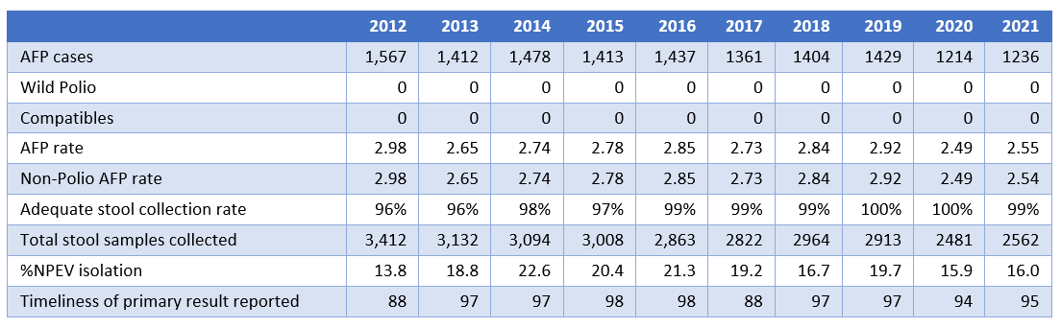
Source, EPI Fact Sheet 2017
Measles surveillance
Bangladesh has made significant progress in measles control. Measles surveillance is fully integrated with AFP and other VPDs surveillance. All activities of measles case-based surveillance (case identification, reporting, investigation, and specimen collection) are conducted by staff at health facilities indicating a step forward towards developing a sustainable surveillance system.
Neonatal tetanus surveillance
Active surveillance for neonatal tetanus is also carried out by SIMOs/LSOs. The country has a successful MNT elimination programme and was validated for elimination of maternal and neonatal tetanus in 2008. Surveillance will continue at required quality levels to complete eradication of tetanus, finding and detection of the NT cases through sensitive and reliable surveillance system to implement corrective measures and prevent further cases.
AEFI Surveillance
Bangladesh has a well-established system for Adverse Events Following Immunization (AEFI) surveillance. As vaccine coverage increases over the time, and new vaccines being introduced, reports on AEFI also increases. Rapid and effective response to any serious AEFI is pivotal to boost the confidence in the administered vaccine and prevent negative impacts on the immunization coverage and the incidence of the diseases targeted by the vaccine.
AEFI management guidelines and reporting forms are available at all facilities and HCWs respectively. HCWs knowledge on AEFI appears to be adequate and they know how to report and refer AEFI cases.
During the Post-Introduction Evaluation of PCV/IPV introduction the evaluation team assessed the AEFI monitoring and reporting in Bangladesh in the context of new vaccine introduction. The assessment results highlighted most critical problems in terms of AEFI reporting. Particularly, these problems were related to the inability of NGO staff providing immunization services in the urban areas to perform basic activities related to the AEFI, absence of supportive supervision and etc., which was indicating essential need for enhancing the capacity of NGO managers of middle-level managerial skills (management, coordination and supervision), as well as critical need for training of vaccinators employed by NGOs in immunization practices and reporting.

Demand generation, communication, and advocacy
The recent coverage evaluation survey 2019 (CES), carried out in Bangladesh, revealed inadequate knowledge and education of population in immunization area, which had direct impact on immunization coverage trends (see Figure 18 below) and indicated urgent need for strategic interventions for generating sufficient demand for vaccination and increase uptake of immunization services by the target population groups.
Figure 18: Reasons for never having vaccination by National, Rural and Urban Areas in 2019
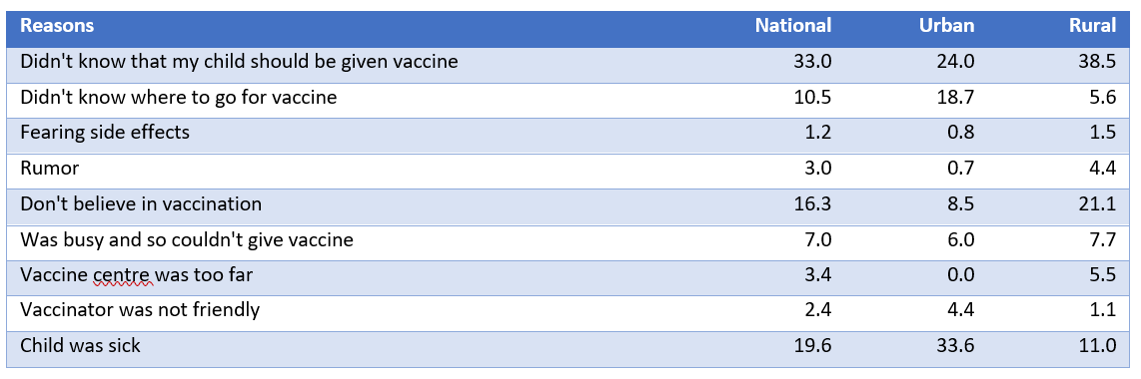
Source: CES 2019
With the financial and technical support provided by the international development partners, the country plans and implements demand generation, innovation and communication interventions within the framework of the existing communication strategy.

Accelerated disease control initiatives
Achievements of EPI in accelerated disease control against the set targets are represented in Figure 19 on page 30 below:
Figure 19: Summary of the analysis of the accelerated disease control indicatives
EPI Strategic Objectives | Indicators | cMYP Target | Achieved results by 2021
Measles | MCV1 (MCV at 9 month) national coverage | 95% | 117.9%
Measles | % Districts with MCV2 coverage >90%: | >95% | 100%
Measles | MCV SIAs national coverage | >95% | 104%
Measles | % Districts with MCV SIAs coverage >95% | >80% | 100%
Measles | National Non- Measles suspected case reporting rate | ≥ 2 / 100,000 | 2.17
Measles | % District reporting at least one suspected measles case / 100,000 population per year | >80% | 100%
Measles | % Measles cases with adequate investigation* within 48 hours of report: | >80% | 97%
Measles | % Adequate serum samples (from suspected measles cases) with laboratory results within 7 days of receipt: | ≥ 80% | 100%
Polio | OPV 3 national coverage: | >80% | 118.3%
Polio | % Districts with OPV3 coverage >80%: | >90% | 100%
Polio | Non-polio AFP rate (/100 000 children under 15 years of age): | >1 | 2.54
Polio | % AFP cases with adequate stool samples within 14 days of onset: | >80% | 99%
Polio | % AFP cases reported within 14 days of onset: | > 80% | 99%
Polio | OPV in SIAs national coverage: | 80% | 99% (administrative coverage, 2014)
Polio | % Districts with OPV in SIAs coverage >90%: | > 90% | 100%
MNTE | DTP3 national coverage (DTP-HepB-Hib 3 national coverage): | >90% | 118%
MNTE | % Districts with TT 2+ coverage >80%: | >90% | 0%
MNTE | # Districts with NT / 1000 live births > 1: | 0 | 0
MNTE | # High-risk districts conducting SIAs with TT: | 23 in 2014 and 40 in 2015 | no data
MNTE | % School-aged children receiving TT through the routine school health programme: | >80 (Denominator school enrolled children) | no data

Source: WHO CO, Bangladesh, 2021

Polio
Bangladesh successfully stopped transmission of indigenous wild poliovirus in August 2000 and has been maintaining polio free status since the last polio case detected on 22 November 2006 following an importation from Western Uttar Pradesh (UP) of India. At that time, India was the only polio endemic country in WHO SEAR. During that outbreak, Bangladesh detected 18 cases from 12 districts in all the then 6 Divisions. Bangladesh successfully tackled that situation. Finally, on 27 March 2014 all member states under WHO SEAR were certified as polio-free.
The main objective of the current NIS in the period of 2023-2027 is to Maintain Polio Free Status which will be ensured through the implementation of the set of strategic interventions to ensure:
            - Early detection and appropriate response to outbreak of poliovirus of any type through certification of standard AFP surveillance, environmental surveillance and outbreak response plan.
            - high population immunity against poliovirus through high routine OPV and IPV coverage.
            - containment of poliovirus as per GAP III and polio certification; and
            - Ensure appropriate transition of polio surveillance network and assets.
For implementation of the above strategic interventions, the country defined sets of activities, which will be included in the operational plans of the country.

Maternal Neonatal Tetanus Elimination
Bangladesh has achieved and maintained MNT elimination status (<1 case per 1,000 live births in each district of the country since 2008. As of 2021, 33 NT cases have been reported from 26% of units (20/76). National incidence rate is 0.009 per 1,000 live births with the highest accidence in Mymensingh district (0.082/1,000 live births).
As part of NT surveillance protocol, Case Response Immunization (CRI) through which 19,927 women of childbearing age (15-29 years) were screened for TT/Td eligibility of those 3,431 found eligible followed by vaccination of 3,19 as per TT/Td-5 schedule. Through the same efforts additional case finding which includes searching of neonatal deaths also were carried out. Number of identified cases was 0.

Measles
Epidemiologic trends
The epidemiology of measles, rubella and CRS in Bangladesh shows that the country is making progress towards elimination of MR&CRS. Following the 2014 catch up MR SIA, the number of measles and rubella outbreaks dropped sharply during 2014 and 2015. Similarly, the actual number of rubella cases dropped and has remained low, with annual incidence of 1.0 – 1.2 confirmed cases per million population since 2014. However, the number of measles outbreaks has picked up in 2016, 2017 and 2022.
The detail information about the measles outbreaks during the period 2020-2022 are provided in Figure 20 below:
Figure 20: Measles Outbreaks in 2020-2022
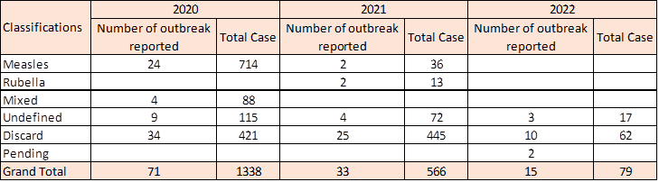
Source: WHO CO Bangladesh 2022
Coverage details
Routine MCV1 and MCV2 coverage have progressively increased over time. According to the Coverage Evaluation Survey 2019 valid coverage with MCV1 by 12 months and MCV2 by 24 months is lower than crude coverage by 24 months (as shown in Figure 21 below).
Figure 21: Survey MCV1 and MCV2 coverage, valid by 12 months and crude by 24 months of age, Bangladesh 2001-2016
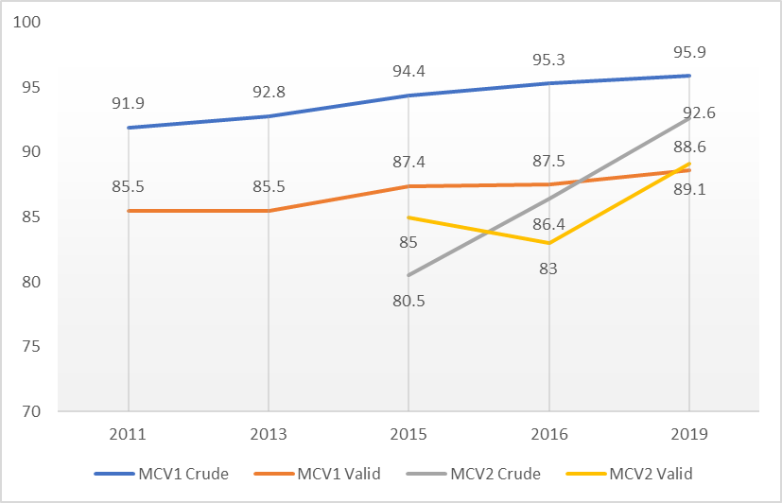
Source: CES 2019
The number of districts and city corporations achieving high levels of routine MCV1 and MCV2 coverage is also steadily increasing, suggesting an increasing homogeneity of high coverage. From 2013 to 2019, the number (and percentage) of districts and city corporations achieving at least 95% crude MCV1 coverage increased from 23 (31%) to 76 (100%).
Improvement in valid coverage of MCV1 by 12 months was not as impressive. However, it is worth noting that the number of districts with 70-79% coverage decreased from 8 in 2013 to 6 in 2019; however, the number of city corporations with this level of coverage increased from 3 in 2013 to 5 in 2019.
MCV2 was introduced in 2012 and since that time has seen a rapid increase in coverage, 92.6% crude coverage by 24 months according to the 2019 CES. The number of districts and city corporations that achieved at least 90% coverage increased from 29 (39%) in 2016 to 56 in 2019. Still, coverage is not homogeneous: in 2019, 41 (54%) districts and city corporations had 80-89% coverage and 3 had coverage <80%. The authors of the 2019 CES defined a valid MCV2 dose as one received at 15 months of age or later, i.e., according to the EPI Schedule. However, it is not clear that MCV2 provided earlier than 15 months is substantially less immunogenic than MCV2 administered at 12 months of age. Therefore, we shall rely on the crude MCV2 coverage as an indicator of protection.
Measles and Rubella surveillance
Bangladesh’s measles and rubella surveillance has satisfied most performance indicator targets for several years. CRS surveillance began in Bangladesh in 2012 and currently is conducted through 167 active VPD surveillance sites throughout Bangladesh that includes 20 cardiology and ophthalmology specialty clinics/hospitals. The 625 passive VPD surveillance sites may also report and refer suspected CRS cases for further evaluation. These sites identified 1,397 suspect CRS cases from 2012 - 2021. Of these 76 were IgM positive. No virologic testing is required in the surveillance protocol used in Bangladesh.
The sensitivity of the CRS surveillance system has increased over time from 0.06 to 0.5 cases per 10,000 live births, indicating an improving surveillance system (Figure 22 below). Laboratory specimen collection, testing and reporting is performing well.
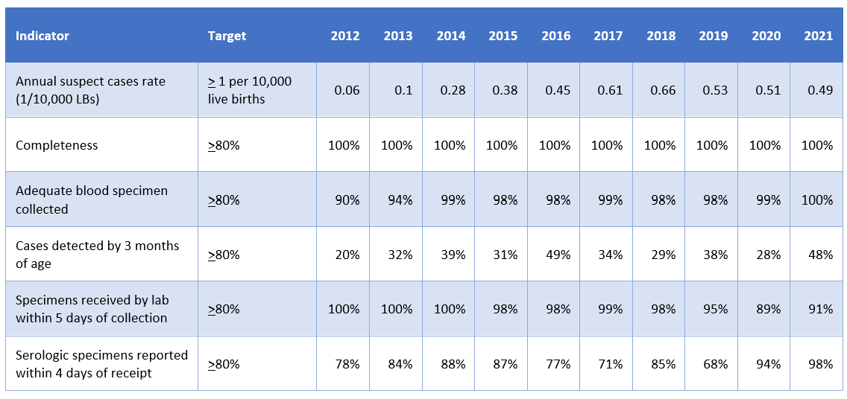
Figure 22: CRS Surveillance Performance Indicators, Bangladesh 2012-2021
Source: WHO CO Bangladesh 2022

Summary of situational Analysis

Root cause analysis of EPI Performance

Current situation
The major issues of the performance of EPI were defined and analyzed through the application of the specific methodology for the Root Cause Analysis (RCA), which encompassed three main steps:
            - Building a “Problem tree”: considered development of the logical scheme with the primary problem and underlying causes presented as assumptions.
            - Collection of evidence: collection of information to substantiate each cause in the problem accompanied with the assessment of:
              - Evidence (Strong, weak or no evidence) and
              - relative Importance of the cause (high, medium and low);
            - Finalization of the root cause analysis diagram, through validation with stakeholders followed by the respective narrative (see Figure 37 and Figure 38 on pages 55 and 56 below).
The results of the RCA analysis, and importance of each root cause preventing system from the high-quality performance have been assessed during the stakeholder workshop and are presented in the Figure 23 below:

Figure 23: Root cause analysis of the current immunization preformance
 |  | Evidence | Importance
 | Maintenance of High Coverage Rates in All areas of the country
 | Missed opportunities for vaccination
 | Valid RI vaccination rate | Weak | Medium
 | Availability of well-organized high-quality services | Weak | Medium
 | Capacity in micro-planning | Weak | High
 | Capacity and skills of service providers in quality service delivery | Weak | Medium
 | Service providers are not motivated to achieve high coverage rates in valid vaccination | Weak | Low
 | Non-financial incentives and/or motivating factors for increasing valid vaccination coverage rates | Weak | Medium
 | Supportive supervision systems for improving quality of provided services | Weak | Medium
 | Recording and reporting systems | Strong | High
 | Manual recording and reporting systems at the service delivery level | Strong | Medium
 | Skills of front-line service providers in record keeping and development of the reports | Strong | High
 | Lack of equipment for maintenance records and produce reports in electronic format | Absent | High
 | Staff shortage at vaccination points | Strong | High
 | Full reliance on fixed service delivery in urban slums | Strong | High
 | National Immunization Policy and HR strategy for Immunization | Strong | Low
 | High staff turn-over and availability of service providers in urban settings | Strong | High
 | Capacity for Defaulter Tracking | Strong | High
 | Defaulter tracking and reminder systems | Strong | High
 | Staff capacity for defaulter tracking | Strong | High
 | uptake of vaccination services | Weak | Medium
 | Demand for vaccination in low performing districts and city corporations | Weak | Low
 | Knowledge of caregivers about availability of immunization services | Strong | High
 | Engagement of communities in community mobilization | Strong | High
 | Staff capacity for IPC
 | Barriers for vaccination | Strong | High
 | Mobile and outreach service delivery in urban settings | Strong | High
 | Effective strategies for improving service delivery in hard-to-reach areas including urban settings, specific groups | Strong | High
 | Access to specific groups | Strong | High
 | Vaccine quality at the service delivery points
 | EVM Practices | Strong | Medium
 | Lack of training opportunities for cold-chain staff | Strong | Medium
 | Shortage of CC staff | Strong | Medium
 | Quality of existing Cold-chain equipment | Strong | Medium
 | CCE maintenance and repairs capacity | Strong | High
 | Immunization waste management
 | Policy/Regulations for medical/immunization waste management | Strong | High
 | Staff capacity for implement immunization waste management policy | Strong | High
 | INADEQUATE OUTBREAK PREVENTION MECHANISMS
 | Insufficient management of prevention mechanisms | Weak | Medium
 | Lack of outbreak prevention strategy and strategy implementation plan | Strong | High
 | Inadequate outbreak response capacity | Weak | High
 | Inadequate resource and systems – commodities and logistics | Weak | Medium
 | No strategic reserves of vaccines for rapid response | Strong | Medium
More details about the links between the root causes of the immunization system and NIS objectives and interventions are presented in Figure 39 on page 57 below.

Vision, Objectives and Strategies of the National Immunization Strategy

NIS Vision
Vision: “Healthy life of people of Bangladesh is ensured through equitable vaccination, leaving no one behind”.

Objectives and Strategic Interventions
The NIS objectives are based on the Immunization Agenda 2030, Regional Vaccine Implementation Plan (RVIP 2022-2026) and Bangladesh 4th HPNSP policy and implementation framework for EPI:

Objective | Priority Strategic Interventions
Objective 1:  Achieve and maintain at least 95% full vaccination coverage at National level and 90% at Sub-national among under two years children and achieve and maintain at least 80% Td5 coverage at national level and 75% at sub national level | - Strengthen governance and management capacity of EPI through appropriate immunization policy that also includes. Integration of immunization with other Primary health care services, vaccination beyond current age, private vaccination, catch-up vaccination and booster doses) at all levels  - Achieve immunization target rates in City Corporations and Municipalities  - Achieve immunization target rates among zero-dose children and missed communities  - Improve EPI performance and achieve coverage targets in the under-served and high-risk areas such as: geographically hard-to-reach areas; ethnic minorities and migrant population (refugees)  - Update, formalize and implement data quality improvement plan to ensure high quality data management and monitoring supported by periodic assessment and survey, and establish linkage with HMIS, CRVS and birth registration  - Ensure effective vaccine and iSC and cold-chain management including R&D of CCE and uninterrupted supply of high-quality, potent vaccines and injection supplies at all levels  - Ensure adequate and effective human resource capacity at all levels of all districts, municipality and city-corporations through development and implementation of HR strategy and building capacity of existing HR  - Increase uptake of immunization services in the low performing districts and city corporations through implementation of the demand generation and community mobilization intervention  - Strengthening the outbreak preparedness and response mechanisms during emergencies, disaster and humanitarian crisis. Strengthen and expand high quality VPD surveillance as a component of public health surveillance supported by laboratory  - Procurement of Vaccines  - Introduction of booster doses
Objective 1: Areas of Intervention
The strategic interventions of the Objective 1 of the NIS will be implemented through the implementation of the sets of specific measures that are carefully selected and custom-tailored to the local context. The implementation of these interventions will be instrumental for addressing root causes and weaknesses identified in the different areas of immunization system performance:
- Development and institutionalization of the National Immunization Policy will be one of the key interventions aiming at strengthening of Governance and Management capacity of EPI which in turn will contribute in strengthened performance of the immunization system in both rural and urban areas, improved coordination between all actors of the immunization system and achievement of main objectives of the NIS in increasing vaccination coverage among the underserved population groups. The immunization policy will also address Integration of immunization with other Primary health care services, vaccination beyond current age, private vaccination, catch-up vaccination, and booster doses) at all levels.
- Strengthened capacity in supportive supervision, will contribute to increased quality of immunization services and performance of the front-line service providers in coverage monitoring, VPD and AEFI surveillance and monitoring, as well as improved communication with the immunization target population groups.
- Institutionalization of the Urban Immunization Strategy will further contribute to improved performance of the immunization system in the city corporations and municipalities. The strategy will be fully aligned with the national immunization policy and will serve as the key planning and guiding document for contributing to improved service delivery in urban areas.
- Development and advocacy for institutionalization of the HR development and deployment plan (HDDP). The HDDP will be based on the two key documents: National Immunization Policy and Urban Immunization Strategy and will be instrumental in identification of the HR resource requirements for ensuring access to the equitable immunization services in all parts of the country. The HDDP will also provide information on the quantities and qualification of the immunization service providers and required resources for continuous capacity building of the immunization service providers at all levels.
- Achieving immunization coverage targets among the underserved population groups. Design and implementation of the innovative and creative strategies for achieving vaccination coverage targets among the high-risk and underserved groups is one of the most critical challenges faced by the immunization program in Bangladesh.
As it is shown in the hierarchy of the strategies proposed by the NIS, the strategic intervention “development, formalization and implementation of specific, creative and strategic interventions for reaching out to the different types of the high risk, and/or underserved groups” aims at acceleration of immunization services among the underserved population groups, i.e. (pockets of unvaccinated people) in city corporations and municipalities (urban slums), geographically hard-to-reach areas, zero-dose children and missed communities and ethnic minority groups and migrants (refugees).
Considering diversity of these groups, NIS 2023-2027 proposes design and implementation of the innovative Specific Focused Strategies that are custom tailored to the needs of these risk groups,that have different locations, cultural roots and/or behavior for achieving immunization targets. These Specific Focused Strategies will be built upon analysis of specific root causes of absence of or partial vaccination of each group.
The corrective intervention of the Strategy will be designed the way that it will address the needs of a particular group and thus, contributes to the achievement of the program goals. For instance, in the ethnic groups, emphasis will be done on Social mobilization through supporting community leaders, while in the hard-to-reach areas, the key component of the Strategy might be increasing access to the immunization services through establishment of the fixed site etc.
Based on the situational analysis, the NIS identified four types of the risk groups that have different risks and require tailored approach for the effectiveness of Specific Focused strategy implementation:
- Children / child-bearing age women (CBAW) living in Urban slums
- Ethnic minorities and Tribal communities living in mountainous areas
- Zero-dose children and missed communities
- Refugees
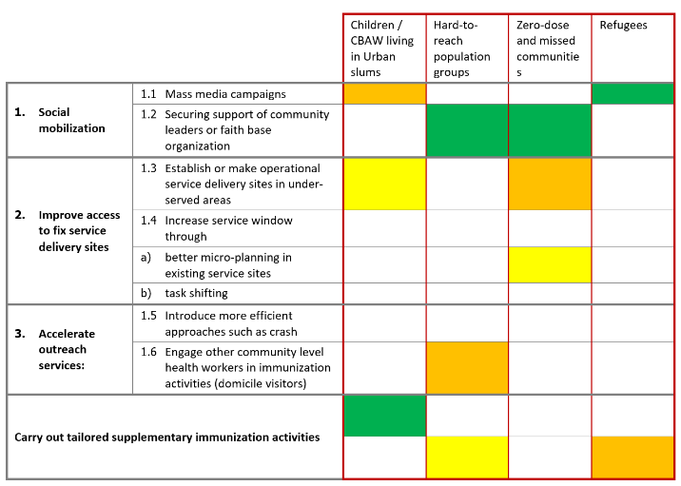
The logic for distribution of Specific Focused Strategies and interventions tailored to hard-to-reach groups are presented in the table below

- The NIS considers significant improvement of the data management capacity that will include training of the MLM and front-line service providers in the data management; equipping the service providers in urban areas with the set of equipment for data recording and reporting in electronic format; development and institutionalization of the defaulter tracking system,
- Surveillance system strengthening will be one of the focus areas of the NIS. The interventions in this area will include integration of the VPD surveillance platform into the e-surveillance platform which will improve data management and its quality.
- Improvement of the Vaccine Management and logistics systems and processes is one of the most critical areas for achievement of the objectives of this NIS. The specific intervention in this area includes upgrade of the EVM system through the implementation of the EVM improvement plan, development of the different SOPs and guidebooks for improving cold-chain and logistics system operations and deployment of the new types of equipment ensuring precise temperature monitoring during the storage and transportation of vaccines.
- HR capacity building is traditionally one of the main areas in the Bangladesh immunization system, that requires significant and regular investments to ensure availability of the qualified staff in all parts of the country. The specific interventions of the NIS will aim at developing HR capacity in immunization service delivery, micro-planning, vaccine monitoring, VPD and AEFI surveillance and monitoring, improvement of the cold-chain operations at all levels as well as significantly improving inter-personnel communication skills of the immunization staff.
- Demand for immunization services will be one of the focus areas of the NIS. Critical interventions of this area will improve communication with the communities on the immunization related issues and mobilization capacity of the target communities. The communication and demand generation activities will focus on the low performing and underserved areas to ensure achievement of the key objectives of this NIS.
- Over the course of the NIS implementation, the specific interventions will be carried out for assessment of the outbreak preparedness and response system, mapping of the existing problems and development of the specific “improvement plan”, that will be instrumental for updating the existing outbreak preparedness and response plan.
Objective | Priority Strategic Interventions
Objective 2:  Maintain Polio Free Status | - Ensure early detection and appropriate response to outbreak of poliovirus of any type through certification standard AFP surveillance, environmental surveillance and outbreak response plan in place  - Ensure high population immunity against poliovirus through high routine OPV and IPV coverage  - Ensure containment of poliovirus as per GAP III and polio certification  - Ensure appropriate transition of polio surveillance network and assets
Objective 2: Areas of Intervention
- Achievement of the Objective 2 of the NIS is planned through implementation of the following specific measures which will consider organization of the regular orientation of the health staff (including private providers of the health services) on AFP surveillance, conducting regular visits to active and passive sites and analysis of AFP performance indicators, as well as implementation of the follow-up actions to achieve progress against the indicators at the national and sub-national levels. The interventions also include update of the outbreak response plan (synchronized with the revision of the outbreak preparedness and response system and expanding environmental surveillance to other sites as it will be appropriate.
Objective | Priority Strategic Interventions
Objective 3:  Maintain MNT Elimination Status | - Ensure periodic review of MNTE status and implementations of review outcomes  - Achieve and maintain high Td coverage level  - Strengthen MNT surveillance and outbreak response  - Ensure ANC screening for Td vaccination of Pregnant women and Promote institutional delivery and safe delivery practice
Objective 3: Areas of Intervention
- Strategic interventions of the Objective 3 of the NIS will be implemented through the periodic review of MNTE status and implementation of the recommendations, elaboration of the School Td Immunization Strategy, through coordination with Maternal and Child Health Programs and an active participation of the communities. The coordination with education sector and immunization partners will be improved through the development and institutionalization of the specific SOPs.
Objective | Priority Strategic Interventions
Objective 4:  Elimination of Measles, Rubella and CRS by 2024 | - Achieve and maintain 95% equitable coverage with 2 doses of MR vaccine at the national and sub-national levels through routine and supplemental immunization  - Achieve Elimination Standard case-based measles, rubella and CRS surveillance and programme performance indicators  - Maintain an accredited measles and rubella laboratory to conduct serologic and virologic/molecular testing for measles rubella and CRS  - Ensure update of measles, rubella elimination action plan and monitoring of implementation  - Ensure early detection and adequate response to measles and rubella outbreak
Objective 4: Areas of Intervention
- The Strategic Interventions for achieving Measles and Rubella and CRS by 2024 will be implemented through overall and significant improvement of the measles coverage in both rural and urban areas of the country, improvement of the real time monitoring of MR vaccination and strengthening supportive supervision capacities and practices will be significant contribution in addressing coverage challenges. NIS considers significant investments for improving service delivery through improving service delivery infrastructure and building HR capacity for equitable and effective delivery of immunization services. The areas of focus also include improvement of the data management and reporting capacity. Finally, the planned interventions consider update of measles and rubella elimination action plan with the participation of all key national and international stakeholders.
Objective | Priority Strategic Interventions
Objective 5:  Maintain Hepatitis B control through vaccination | - Maintain high coverage rate of HepB3 vaccination (Penta3) at all levels especially high risk and hard to reach areas  - Conduct sero-survey when required  - Develop and implementation of the Hepatitis B elimination strategy in coordination with other relevant sectors
Objective 5: Areas of Intervention
- The strategic interventions for maintenance of the Hepatitis control through vaccination will include achievement and maintenance target coverage levels of HepB3 vaccination and conducting early virological investigation, with immediate reporting, sample collection and adequate response and case management and monitoring.
Objective | Priority Strategic Interventions
Objective 6:  Ensure access to the High-Quality Vaccines | - Strengthen capacity of NRA to undertake all NRA functions for ensuring selection of high-quality vaccines  - Strengthen AEFI surveillance  - Explore and support domestic production of vaccines
Objective 6: Areas of Intervention
- The NIS will be focused on strengthening NRA capacity to assure high quality of vaccines used by the immunization system. These interventions will include costing and implementation of the NRA institutional development plan, set of activities for seeking “Maturity Level III” according to the WHO Global Benchmarking and HR development. The interventions will also aim at strengthening post-marketing surveillance and lab testing capacity to empower NRA for performing all standard functions.
Objective | Priority Strategic Interventions
Objective 7:  Enhance Protection of Population Against VPD by New and Underused Vaccines | - Introduce Rota vaccine in 2023  - Roll out HPV vaccination at the national level in 2023  - Conduct HPV MAC SIA in 2023  - Introduce JE vaccine into the national immunization schedule in 2023  - Introduce TCV into the national immunization schedule in 2023 year
Objective 7: Areas of Intervention
- In total four different vaccines will be introduced over the course of NIS implementation. For ensuring smooth and effective introduction of all planned vaccines, EPI will implement standard set of activities which include revision of the national immunization schedule, revision of the standard guidelines and forms, introduction of vaccines among the vaccination target population groups. The introduction of vaccines will follow by the implementation of the Post-Introduction Evaluation (PIE).
Objective | Priority Strategic Interventions
Objective 8:  Sustain Operation of Critical Immunization System Components While Transitioning from Foreign to Domestic Sources of Financing | - Ensure sufficient government fund allocation under Operational Plan to support immunization activities including new vaccine introduction for sustainable program and financial sustainability  - Ensure high political and financial commitment demonstrated by increased budget space and increased domestic fund for immunization Programme  - Advocate for the establishment of separate Immunization Directorate incorporating in 5th HPNSP
Objective 8: Areas of Intervention
- Strengthening of the financial sustainability of the NIS and national immunization system will be one of the most critical challenges of the Bangladesh EPI considering the phase out of GAVI in the final year of the strategy. From 2027 government of the country will be responsible for allocating 100% of financial resources for procurement, import and management of the routine immunization vaccines, as well as vaccines for Supplemental Immunization Activities, if such SIAs are planned by the EPI.
- Considering the gradual increase of resource requirements for implementation of the NIS, the EPI will organize multiple advocacy meetings at different levels (MoH&FW, Ministry of Finances and Ministry of Planning) for mobilization of sufficient funding for ensuring financial sustainability of the strategy and implementation of all planned interventions of the NIS. In addition, the EPI will assess the cost benefit economic analysis of comprehensive investment in live-course vaccination and its alignment with the Polio transition plan as well as will carry out feasibility assessment of use of vaccines produced in Bangladesh. In addition, the number of interventions will be implemented for advocating EPI reform and establishment of the separate directorate for EPI.

Alignment with the Regional (RVIP 2022-2026) and Global Goals (IA 2030)
Bangladesh NIS 2023-2027 is fully aligned with the global and regional goals provided in the main strategic documents as well as with the national goals and objectives of the health sector program. Alignment of the NIS with the Strategic objectives of the 4th Sector Plan and Regional Vaccine Implementation Plan is highlighted in the table below:
RVIP 2022-2026 | National Goals / Objectives
RVIP 2022-2026 | 4th HPNSP Strategic Objectives | NIS 2023-2027 Objectives and Sub-objectives
Reducing overall mortality and morbidity from VPD for all across the life course | Strategic Objective 7: To improve equitable access to and Utilization of Quality Health, Nutrition and Family Planning Services | Objective 3: Maintain polio free status
Pursuing elimination and control goals regional priorities:  - Achieving measles and rubella elimination  - Sustaining polio free status  - Maintain MNTE status  - Achieving Hepatitis B control |  | Objective 2: Td5 coverage among women of childbearing age to be reached at least 85% at national level and 80% at each district
 |  | Objective 3: Maintain MNTE Status
Objective 4: Elimination of Measles, Rubella and CRS by 2020
Objective 5: Maintain HepB control through immunization
Leaving no one behind by increasing equitable access and use of new and underused vaccines |  | Objective 1: Improved full immunization coverage among children under one and CBAW  Strategic intervention: Achieve target coverage rates of zero-dose children and missed communities with all RI vaccines
 |  | Sub-objective 1.1: At least 95% full immunization coverage among under one at national level and 90% full immunization coverage at each district level
 |  | Sub-objective 1.2: TT5 coverage among CBAW reached at least 80% at national level and 75% at each district level
 |  | Objective 6: Sustain operation of critical immunization system components while transitioning from foreign to domestic sources of financing

Monitoring and Evaluation
The Planning Unit of MOHFW is responsible for Monitoring and Evaluation of the 4th HNPSP through the routine data collection for all impact and most of outcome level indicators. In addition to administrative data collection and reporting, the MOHFW collects data on immunization coverage and equity indicators from the household surveys such as national immunization Coverage Evaluation Surveys and BDHS.
The M&E of EPI will be carried out as part of routine M&E activities of HNPSP (see Error! Reference source not found. in Annexes presenting 4th HNPSP results framework).
The indicators of national EPI were elaborated and selected by HNPSP. The EPI and MOHFW team will be directly involved into M&E process of EPI implementation. Notably, VPD surveillance system based on the web-software will be developed and integrated into routine HMIS. Consequently, data will be collected as part of the country’s MIS (HMIS) supplemented by the EPI from its own data sources until they are fully integrated. The data collection will be computerized and will include information from regular surveys such as BDHS, MICS, CES and immunization Program Reviews. From city corporations and municipalities, the data will be collected from LGD/MLGRDC.

Costs and Financing National Immunization Strategy

NIS Resource requirements

Overview of the resource requirements’ structure
The total resource requirements for implementation of the National Immunization Strategy during the period 2023-2027 were estimated at 485 million US$ as shown in Figure 24 below:
Figure 24: National immunization program costs (USD) summary by system components and years – basic scenario
The details of future resource requirement by NIS/EPI components are presented in Figure 41 on page 62 below.

Description of cost drivers of the future resource requirements
For the NIS period (2023-2027) the resources required for “vaccine supply, quality and logistics” will account for approximately 90% of the total immunization specific costs as shown in Figure 25 below. “Human Resource Management” is the second major cost driver, which will account for approximately 3.5% of immunization specific resource requirements and is followed by “Service Delivery” component of the NIS, accounting for approximately 2.5% of total resource requirements for NIS implementation. “Program Management and Financing” and “Disease surveillance” will account for 1.6% and 1.1% of total resource requirements respectively and “Demand Generation” will account for 0.26% of the National Immunization Strategy resource requirements.
Figure 25: The future total resource requirement 2023-2027 by programme components (shared costs excluded)
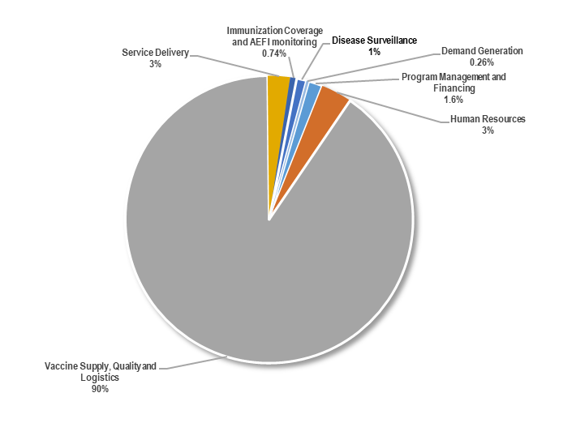
During the NIS projection period (2023-2027) the resource requirements for NIS implementation per five projection years will vary between 91 million US$ in 2027 and 107 million US$ in 2023:
- In the first projection year (2023) the resource requirements will be 107 million US$.
- In the second year of NIS (2024) the resource requirements will decrease by nearly 9% (or 9 million US$), which could be explained by the finalization of specific NIS interventions in the areas of “Service Delivery”, “Immunization Coverage and AEFI monitoring” and “Program Management”.
- In the third year of projection (2025) the resource requirements will decrease by approximately 1.3% (or 1.2 million US$) which could be attributed to the concentration of the program on implementation of routine activities of the EPI and absence of innovative strategic interventions during this year.
- In the year four of the NIS (2026) the resource requirement will continue to decrease by approximately 5% (or 4.6 million U$S), and during the final year or projection (2027) will further decrease by 1.7%% (or 1.6 million US$), which also could be attributed to the finalization of the specific interventions and stabilizing the EPI implementation process.
- The analysis of resource requirement fluctuation shows that in general it will be driven by the major investment of EPI in the Service Delivery, AEFI system strengthening and Human Resources component of the NIS as shown in Figure 26 below.
Figure 26: The structure of future resource requirements by cMYP components and years (shared costs excluded)
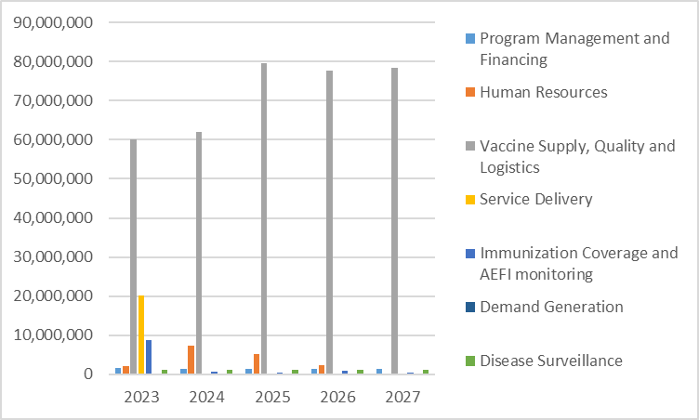
Vaccines and injection supplies
The following assumptions were used for projection of vaccine and injection supplies’ requirements:
- Coverage rates were set in line with the objective and targets of National EPI (>=95% by 2027.
- Wastage rates are estimated at 80% for BCG; 40% for MR vaccine (routine immunization); 30% for OPV and TT vaccines; 10% for IPV and PCV vaccines and 5% for Pentavalent and Rotavirus Vaccines.
The present projections are based on vaccine price estimates provided by the UNICEF Supply Division and include UNICEF handling fee (3-4%), freight, insurance, and inspection (5-15%) costs.
The resource requirement projections for routine immunization vaccines (basic scenario) envisages costs of following vaccines:
- Traditional vaccines: BCG, bOPV and Td vaccines.
- Underused vaccines: Pentavalent and MR vaccines.
- New vaccines: IPV (introduced in the routine immunization schedule in 2015) (fractional IPV i.e. fIPV) and PCV10 (introduced in the routine immunization schedule in 2015) (baseline scenario)
- For Scenarios A and B the projections are based on the following:
  - Baseline scenario – the vaccine schedule is not changed, and no new vaccines are introduced.
  - Scenario A – In addition to the baseline scenario, the nation-wide scale-up of the HPV vaccine among 10-year-old girls, implementation of the HPV SIA in the selected communities and nationwide introduction of the rotavirus vaccine.
  - Scenario B – In addition to the Scenario A: Introduction of the JE and TCV vaccines among the surviving infants.
Figure 27 below illustrates the cost structure of vaccines included into the Scenario B by vaccines and years (including Rotavirus, JE, TCV and HPV introduction) during the NIS projection period.
Figure 27: Vaccine and injection supply cost projections (routine immunization. Scenario A (Rotavirus, HPV, JE and TCV from 2023)
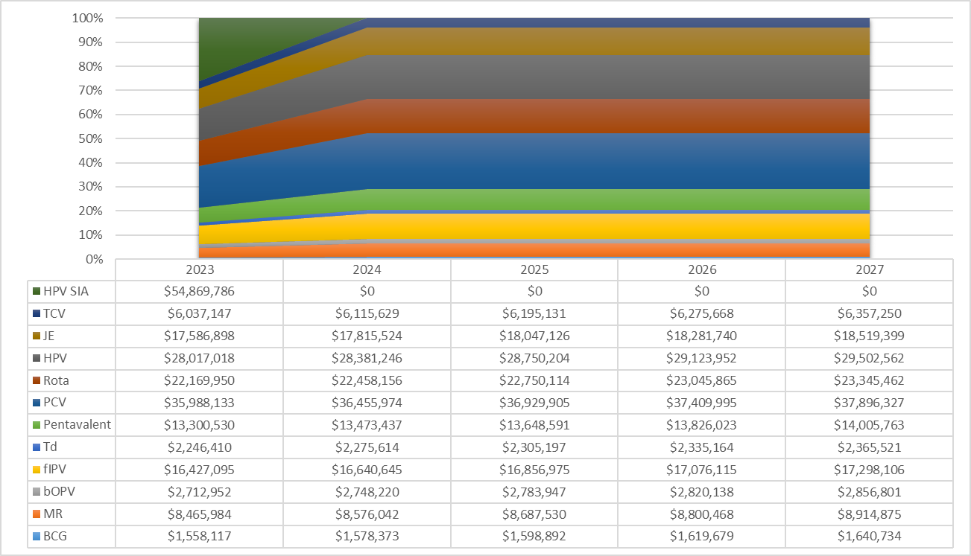
Program management and financing
Total resource requirement for implementation of interventions related to the Program Management and Financing related component of EPI amounts to 7,708,831 US$. These funds are required for implementation of various interventions and activities for improving Policy and guidance, Government and Accountability, Planning and procurement, Partner coordination, budgeting and financing and multi-sub-components of Program management and financing. The detail information is provided in Error! Reference source not found. on page Error! Bookmark not defined..
Figure 28: The future resource requirements for “Program Management and Financing” component of EPI
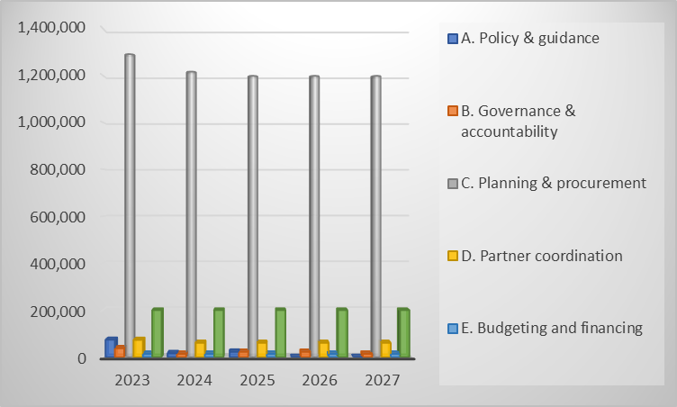
Human resources Management
HR development and management will be one of the most critical components of the NIS 2023-2027, which will be under particular focus of EPI and will be area of the major investments.
In total 16 million dollars is required for implementation of all interventions of NIS that are related to the HR development and capacity strengthening. Out of this amount 99.9% is required for HR capacity building activities and 1% required for the development of the HR development and deployment plans.
Vaccines Supply, Quality and Logistics
The total resource requirement of this component is 357,683,964 US$. The amount was calculated based on the financial needs for procurement of the Routine Immunization Vaccines according to the existing national immunization schedule and does not include resource requirements for procurement of the vaccines that are planned for introduction during the projection period. The total amount also includes financial resource requirements for implementation of the specific interventions related to the improvement of the cold-chain and logistics systems.
Service delivery
The total resource requirements for implementation of the planned interventions for improving service delivery component of the national immunization system amounts to 20.1 million US$.
Immunization coverage and AEFI monitoring
The total amount required for Immunization coverage and AEFI monitoring component of the immunization system in Bangladesh was estimated at 11.7 million US$. These resources required for improving HR and systems for immunization coverage monitoring, improving reporting and recording procedures and processes, establishment of the mechanisms for the data quality control, strengthening of the coverage monitoring capacity and practices and strengthening AEFI monitoring and management capacity at all levels.
Disease surveillance
The total resource requirements estimated for implementation of the disease surveillance related interventions of the NIS amounted to 5.4 million US$. These requirements consider strengthening of the detection and response capacity of the system and ensuring implementation of all surveillance related activities.
Demand Generation
In total approximately 1.3 million US$ was estimated for implementation of the demand generation activities, which considers design and implementation of specific interventions for strengthening advocacy, communication, and community engagement at the national and sub-national levels.
Details of resource requirements estimated for implementation of each component and sub-components of the National Immunization Strategy are provided in Error! Reference source not found. on page Error! Bookmark not defined.

Description of scenarios for introduction of new vaccines
Scenario building parameters
Costing and financing analysis developed four different scenarios for Bangladesh NIS 2023-2027:
- Basic Scenario – envisions implementation of existing routine immunization program without introduction of any new vaccine in the national routine immunization schedule.
- Scenario A – considers nationwide roll out of HPV vaccine targeting a single cohort of 10-year-old girls, implementation of SIA among the Multi-Age Cohort (girls 10-14 years) in specific areas of the country and introduction of Rotavirus vaccine in 2023 in addition to the Basic Scenario.
- Scenario B – considers nationwide introduction of JE and TCV vaccines in 2023 in addition to the Scenario A.
Results – financial implications of new vaccine introduction
The implication of resource requirements for vaccines and injection supplies by scenarios and years is presented in Figure 29 and Figure 31.
Analysis of Scenario A (HPV nationwide roll out among the single cohort of 10-year-old girls, HPV SIA in selected areas and Rotavirus introduction at the national level) considers costs and financial implications of vaccines and injection supplies, as well as the costs of other introduction-related activities such as operational costs for introduction and program management activities.
All cost implications related to the implementation of the Scenarios A presented in this NIS are “indicative” and should be used for strategic decision making and advocacy purposes only. Therefore, in case of selection of A or B scenario, it will be mandatory to assess readiness and capacity critical components of EPI such as Program Management and Cold-chain to ensure effective roll-out of HPV vaccine at the national level, implementation of the HPV catch-up SIA and introduction of Rotavirus vaccine at the national level.
Figure 29 below compares the resource requirements for vaccines and injection equipment of the Baselines scenario and Scenario A and shows that introduction of Scenario A will increase annual resource requirement for vaccines and injection supplies by 130% (or approximately 105 million US$) in the first year of introduction (2023), and by 62% in the second, third, fourth and fifth year of projection (or 51, 52, 52.2 and 52.8 million US$ respectively).

Figure 29: Commparison of resource requirements for vaccines and injection supplies between the Baseline Scenario and Scenario A by years
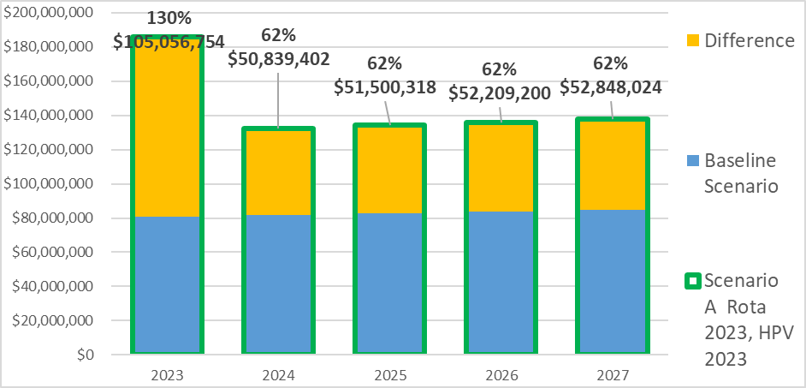
Overall, implementation of the Scenario A will increase required financial resources for vaccines and injection supplies by 75% or 312.4 million US$ over the NIS projection period – 2023-2027.
Further and more detailed analysis of the Scenario A introduction examined cost implications on the national budget, considering that the country will be supported by GAVI in introduction of Rotavirus and HPV vaccines. As it is presented in Figure 30 below the implementation of the Scenario A will increase the government contribution for procurement of vaccines and injection supplies by 44% (or 103 million US$);
Figure 30: Cost implication on State budget – Scenario A introduction
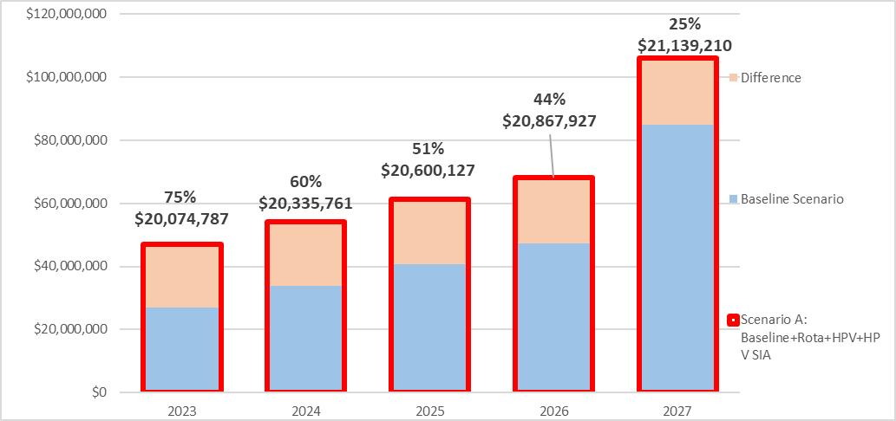
Figure 31 shows comparison of resource requirements for vaccines and injection supplies between the Baseline Scenario and Scenario B.
Targeting JE and TCV introduction in addition to the scenario A (described above) will increase annual resource requirement for vaccines and injection supplies by 159% (or 128 million US$) in the first year of introduction (2023).
Overall implementation of the Scenario B will require by 104.7% (or 168 million US$) more resources for vaccines and injection supplies than implementation of the Baseline Scenario.
Figure 31: Commparison of resource requirements for vaccines and injection supplies between the Baseline Scenario and Scenario B by years
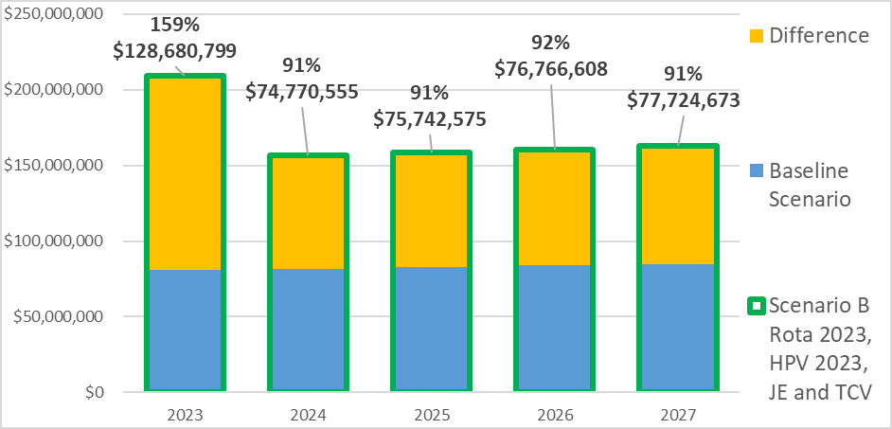
Further analysis of the cost implications of the Scenario B introduction on the Government budget showed that if government decides to introduce all four vaccines according to the Scenario B, then government has to increase current budget for procurement of vaccines and injection supplies by 85% over the five year period and allocate in addition 198 million US$.
Figure 32: Cost implication on government budget – Scenario B introduction
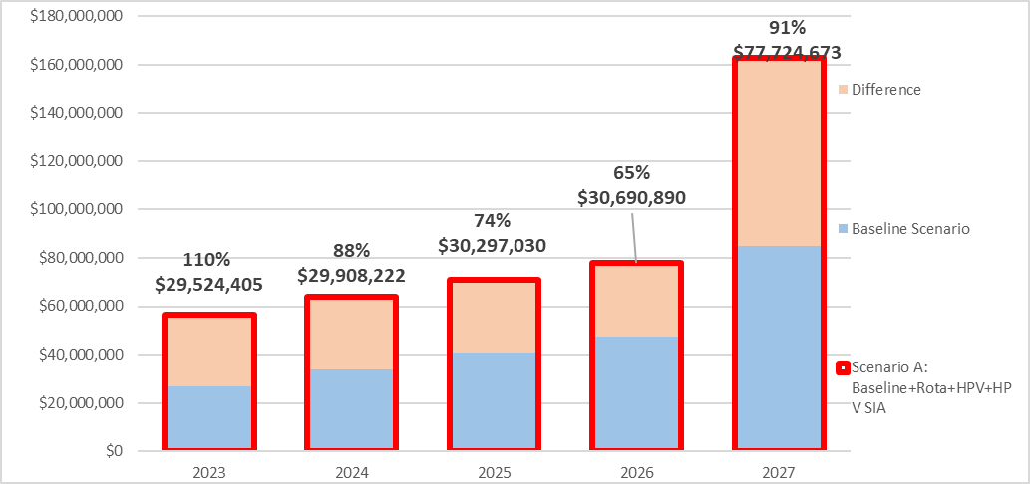
Comparison of costs of vaccines and cold chain across all three different scenarios (Baseline, A and B scenarios) shows that introduction of vaccines according to the Scenarios A and B will require significant increase of EPI funding for vaccine procurement alone. Moreover, introduction of these new scenarios will be related to the substantial investments for i) assessment and identification of cold-chain and supply system requirements, ii) upgrading cold-chain system to meet standards and capacity for accommodation of the new vaccines and (iii) strengthening EPI service delivery capacity, through undertaking complex efforts for building system capacity in different areas such as HR development, service delivery, cold-chain upgrade and delivery and VPD surveillance and demand generation.

Future financing and funding gaps
The detail information on Baseline program funding is presented in Figure 41 on page 62.
The total budget required for implementation of NIS during the period 2023-2027 is estimated at 421 million US$.
Government of Bangladesh will be the major source of financing of NIS implementation contributing to total 233.913 million US$ which will constitute 47% of total funding.
Gavi will be the second major source of financing of Bangladesh EPI contributing approximately 180 million US$ accounting for 36% of total funding.
WHO secured resources for the NIS implementation will amount 588,836 US$ (or 0.12% of total secured funding as shown in Error! Reference source not found. Error! Reference source not found.):
Figure 33 illustrates funding conditions of NIS 2023-2027 financial sustainability considering available funding.
The size of the funding gap by years, varies between 7% (in 2027) and 24% (in 2023) of total NIS budget. The more detailed analysis of the funding gap is provided in the next section.
Figure 33: Financing by sources and funding gap by years (with secured and probable funds, excluding shared health system costs)
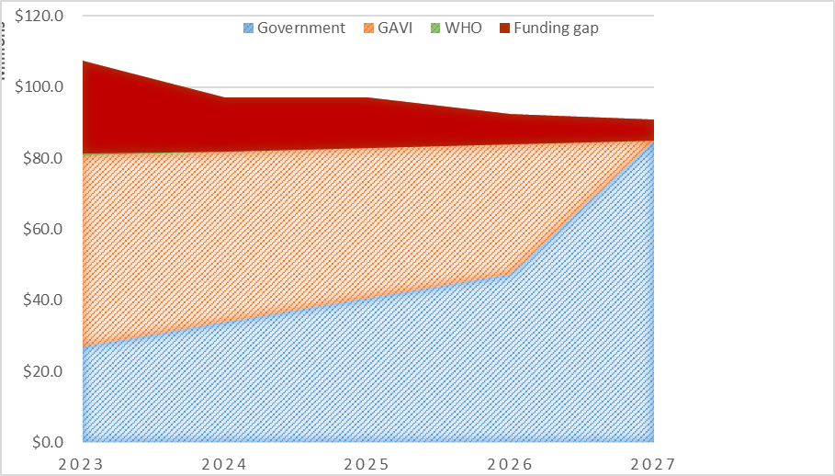

Funding gap analysis and sustainability

Implications of the funding gap on immunization system performance
Analysis of funding gap showed that the funding gap in the amount of approximately 70 million US$ will affect all components of the immunization system. With the current financing of the immunization system, there is 100% funding gap for implementation of interventions in the areas of “Program management”, “Human resources management”, “Service delivery”, “Disease Surveillance” and “Demand generation” and the funding gap for these components accounts for 100%. (see Figure 34 below). The funding gap for “vaccine supply, quality and logistics” component accounts for 6%, however this calculation assumed that the Government will continue allocation for sufficient funding for procurement of routine immunization vaccines and co-financing of the vaccines provided by Gavi. This also included assumption that the government will significantly increase the budget for procurement of Routine immunization vaccines after graduation from Gavi financing and taking responsibility for procurement of all vaccines of the national immunization schedule.
Figure 34: Funding gap structure by years
The results of the funding gap analysis suggests that if additional funds are not mobilized EPI will not be able to realize National Immunization Strategy implementation, which will put under the risk improvement of performance of the immunization system and achieve NIS objectives.
Figure 35: Funding gap structure by the major cost categories
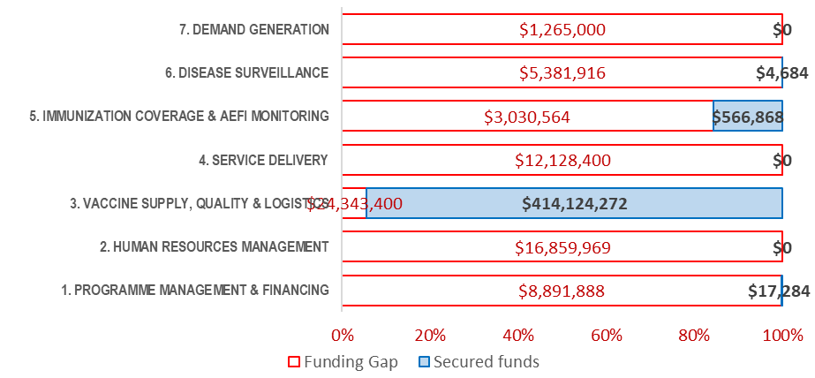

Financial sustainability strategies
The main and most important strategies to ensure financial and programmatic sustainability of the National Immunization Strategy during the period of 2023-2027 will be focused on the following main directions:
- Mobilizing additional funding through:
  - Increasing government allocation for strengthening capacity of the immunization system of the country (EPI) and meeting increased resource requirements in the context of expansion of Routine Immunization schedule with the new vaccines.
  - Advocate with government for timely and fully releasing funds for financing all critical components of EPI outlined above.
  - Conducting fundraising and advocating activities to secure additional financial support for introduction of the new vaccines in the national immunization schedule of Bangladesh according to the objectives and strategies outlined in this NIS.
- Select the most balanced and feasible scenario for introduction of Rotavirus, JE, TCV vaccines and scaling-out HPV vaccine as well as implementation of the HPV catch-up campaign among the selected population groups to decrease disease burden of cervical cancer in the country.
- Increasing reliability of financing from the domestic sources.
- Improve the service delivery and revise service delivery strategy to avoid the costs related to SIAs, which has been the major cost driver for immunization budgets in Bangladesh.
- Optimization of and selection of the most cost-effective modality for implementation of the “program activities” – the major cost driver for expected funding gap.
This could include following:
- Advocate for increase of budget allocations and timely release of funds for implementation of all components of the national immunization strategy at all levels, including budget allocations for introduction/roll-out of the new vaccines.
- For mobilizing additional financial resources, accelerate communication and collaboration with international development partners to provide evidence-based information and strong justification of the need in implementation of all planned program activities over the course of NIS 2023-2027.
- Provide national level decision makers with evidence-based information on the essential need in introduction of new vaccines for meeting objectives of national EPI as well as regional and global goals in terms of sufficient coverage of population against the VPD and management of the accelerated disease control initiatives (Polio, Measles, Rubella and CRS, Hepatitis B and MNT);
- Revision and development of alternative and more cost-effective Annual Operations Plan, which will be implemented over the period 2023-2027.
- Conducting fundraising activities and work with donor community over the course of NIS cycle to secure alternative funding for filling program funding gaps;
Immunization program sustainability indicators are presented in Error! Reference source not found. on page Error! Bookmark not defined. Error! Reference source not found.

Annexes
Figure 36: Population density by administrative units in Bangladesh
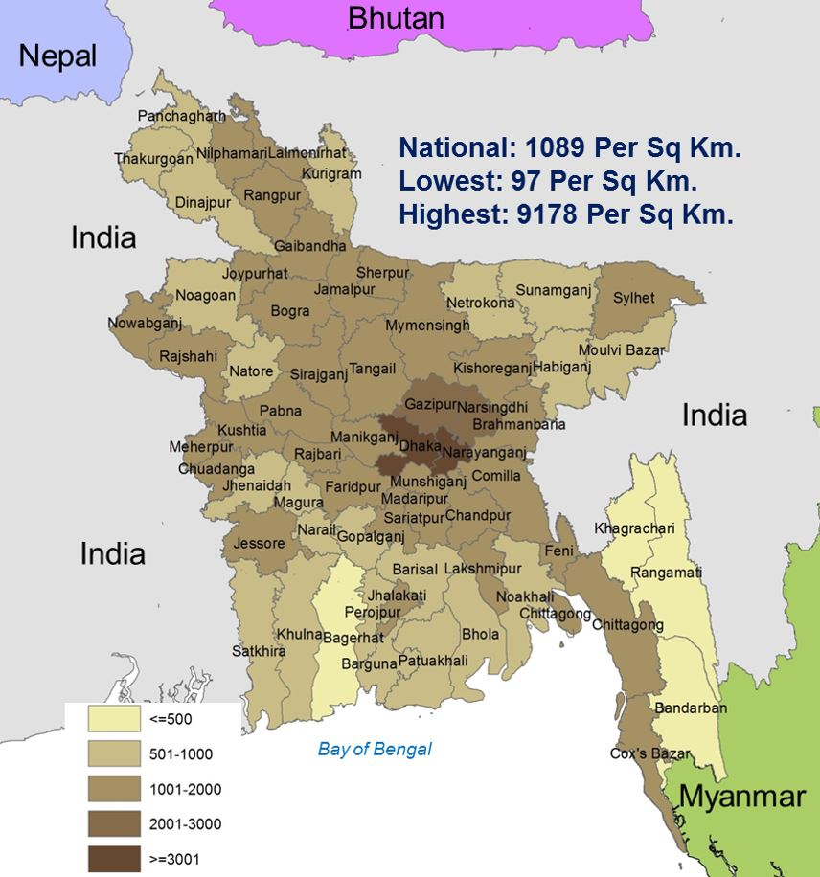
Source: EPI, 2016

Figure 37: Bangladesh EPI Root Cause Analysis Diagram – Block A – Maintenance of High Coverage Rates in All Areas of the Country

Figure 38: Bangladesh EPI Root Cause Analysis Diagram – Block B – Vaccine Quality at the Service Delivery Points and Block C – Outbreak Prevention and control mechanisms
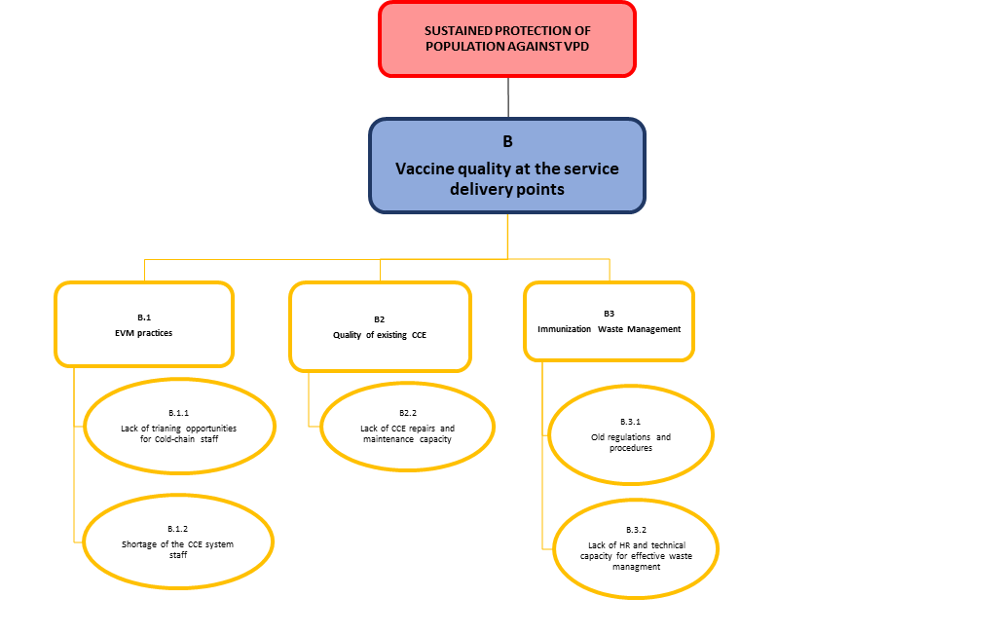 | 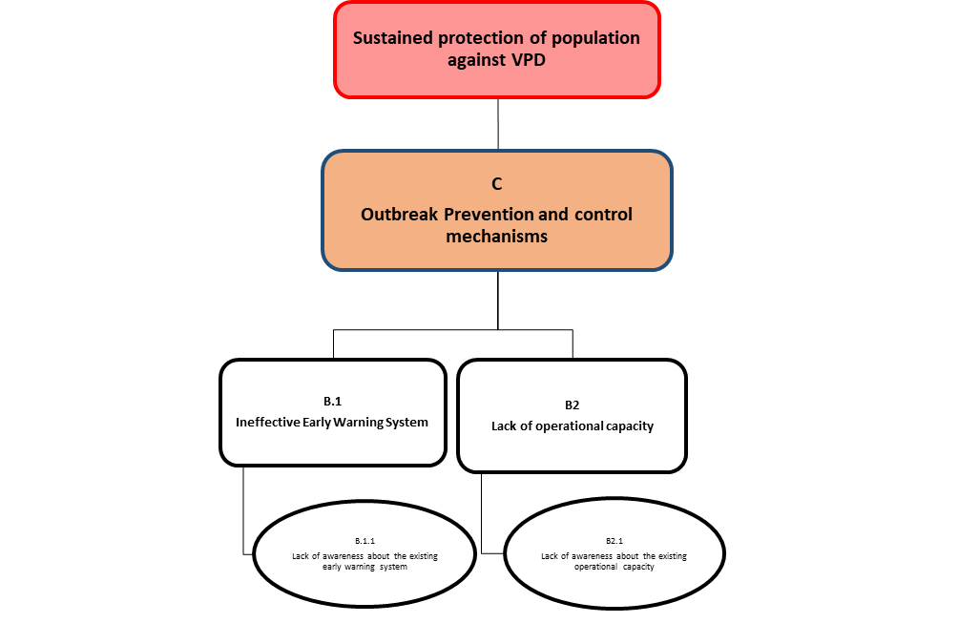

Figure 39: Links between the Root Causes Main Interventions and NIS Objectives
Root cause |  | Intervention | NIS Objective
Block A | Maintenance of High Coverage Rates in All areas of the country | Intervention | NIS Objective
A1 | Missed opportunities for vaccination |  | Objective 1:  Achieve and maintain at least 95% full vaccination coverage at National level and 90% at Sub-national among under two years children and achieve and maintain at least 80% Td5 coverage at national level and 75% at sub national level  Objective 6:  Ensure access and Use of the High-Quality Vaccines  Objective 7:  Enhance Protection of Population Against VPD by new and underused vaccine introduction  Objective 8:  Sustain operation of Critical Immunization System Components While Transitioning from Foreign to Domestic Sources of Financing
A1.1 | Valid RI vaccination rate | 1.1: Strengthen governance and management capacity of EPI through appropriate immunization policy that also includes. Integration of immunization with other Primary health care services, vaccination beyond current age, private vaccination, catch-up vaccination and booster doses) at all levels  1.2: Achieve immunization target rates in City Corporations and Municipalities  1.3: Achieve immunization target rates among zero-dose children and missed communities  1.4: Improve EPI performance and achieve coverage targets in the under-served and high-risk areas such as: geographically hard-to-reach areas; ethnic minorities and migrant population (refugees)  1.10: Procurement of Vaccines  1.11: Introduction of booster doses  6.1: Strengthen capacity of NRA to undertake all NRA functions for ensuring selection of high-quality vaccines  6.2: Strengthen AEFI surveillance  6.3: Explore and support domestic production of vaccines  7.1: Introduce Rota vaccine in 2023  7.2: Roll out HPV vaccination at the national level in 2023  7.3: Conduct HPV MAC SIA in 2023  7.4: Introduce JE vaccine into the national immunization schedule in 2023  7.5: Introduce TCV into the national immunization schedule in 2023 year  8.1: Ensure sufficient government fund allocation under Operational Plan to support immunization activities including new vaccine introduction for sustainable program and financial sustainability  8.2: Ensure high political and financial commitment demonstrated by increased budget space and increased domestic fund for immunization Programme  8.3: Advocate for the establishment of separate Immunization Directorate incorporating in 5th HPNSP
A1.1.1 | Availability of well-organized high-quality services
A1.1.1.1 | Capacity in micro-planning
A1.1.1.2 | Capacity and skills of service providers in quality service delivery
A1.1.2 | Service providers are not motivated to achieve high coverage rates in valid vaccination
A1.1.2.1 | Non-financial incentives and/or motivating factors for increasing valid vaccination coverage rates
A1.1.2.2 | Supportive supervision systems for improving quality of provided services
A1.2 | Recording and reporting systems | 1.5: Update, formalize and implement data quality improvement plan to ensure high quality data management and monitoring, and establish linking with HMIS, CRVS and birth registration
A1.2.1 | Manual recording and reporting systems at the service delivery level
A1.2.2 | Skills of front-line service providers in record keeping and development of the reports
A1.2.3 | Lack of equipment for maintenance records and produce reports in electronic format
A1.3 | Staff shortage at vaccination points | 1.7: Ensure adequate and effective human resource capacity at all levels of all districts, municipality and city-corporations through development and implementation of HR strategy and building capacity of existing HR
A1.3.1 | Full reliance on fixed service delivery in urban slums
A1.3.2 | National Immunization Policy and HR strategy for Immunization
A1.3.3 | High staff turn-over and availability of service providers in urban settings
A1.4 | Capacity for Defaulter Tracking | 1.5: Update, formalize and implement data quality improvement plan to ensure high quality data management and monitoring, and establish linking with HMIS, CRVS and birth registration
A1.4.1 | Defaulter tracking and reminder systems
A1.4.2 | Staff capacity for defaulter tracking
A2 | Uptake of vaccination services | 1.8: Increase uptake of immunization services in the low performing districts and city corporations through implementation of the demand generation and community mobilization intervention
A2.1 | Demand for vaccination in low performing districts and city corporations
A2.1.1 | Knowledge of caregivers about availability of immunization services
A2.1.2 | Engagement of communities in community mobilization
A2.1.3 | Staff capacity for IPC
A2.2 | Barriers for vaccination
A2.2.1 | Mobile and outreach service delivery in urban settings
A2.2.2 | Effective strategies for improving service delivery in hard-to-reach areas including urban settings, specific groups
A2.2.3 | Access to specific groups
Block B | Vaccine quality at the service delivery points | 1.6: Ensure effective vaccine and iSC and cold-chain management including R&D of CCE and uninterrupted supply of high-quality, potent vaccines and injection supplies at all levels
B1 | EVM Practices
B1.1 | Lack of training opportunities for cold-chain staff
B1.2 | Shortage of CC staff
B2 | Quality of existing Cold-chain equipment
B2.1 | CCE maintenance and repairs capacity
B3 | Immunization waste management | 1.1: Strengthen governance and management capacity of EPI through appropriate immunization policy that also includes. Integration of immunization with other Primary health care services, vaccination beyond current age, private vaccination, catch-up vaccination and booster doses) at all levels  1.7: Ensure adequate and effective human resource capacity at all levels of all districts, municipality and city-corporations through development and implementation of HR strategy and building capacity of existing HR
B3.1 | Policy/Regulations for medical/immunization waste management
B3.2 | Staff capacity for implement immunization waste management policy
Block C | INADEQUATE OUTBREAK PREVENTION MECHANISMS | 1.9: Strengthening the outbreak preparedness and response mechanisms during emergencies, disaster and humanitarian crisis. Strengthen and expand high quality VPD surveillance as a component of public health surveillance supported by laboratory
C1 | Insufficient management of prevention mechanisms
C2 | Lack of outbreak prevention strategy and strategy implementation plan
C2.1 | Inadequate outbreak response capacity
C2.2 | Inadequate resource and systems – commodities and logistics
C3 | No strategic reserves of vaccines for rapid response

Figure 40: 4th HPNSP Results Framework
Results | Indicators | Baseline value | Source, Year | Target, 2022
- MOHFW's governance and stewardship roles strengthened
- Legal and operational framework on governance and stewardship in place | - Governance and stewardship action implemented in line with the milestones | GSAP developed and approved | Planning Wing 2016
- Overall sector governance improved | - Number of public and non-public facilities accredited | Process initiated | Planning Wing 2016
- Overall sector governance improved | - % of DPs submitting annual performance reports on off budget activities | 54% | MPIR 2014 | 100%
- Overall sector governance improved | - Incremental budget for MOHHFW ensured | 14% increase of MOHPW budget | MOF, FY 15-16 | Annual increment of MOHFW budget >15%
- Health systems strengthened to increased performance and efficiency
- Quality workforce made available in health sector | - % of service provider positions functionally vacant in district and upazila-level public facilities, by category (physician, nurse /midwife) | Physicians: 37.8%  Nurse/Midwife: 19.3% |  | Physicians: 19%  Nurse/Midwife: 10%
- Core systems (FM, infrastructure, procurement) strengthened | - Increase in the number of Operational Plans (OPs) with annual budget execution over 80% | 13 | APIR 2015 | 19
 | - Procurement lead time reduce fore packages tracked through SCMP | 573 weeks | SCMP 2014-15 | 40 weeks
- Strengthened performance monitoring to promote evidence-based decision making | - Number of performance monitoring reports prepared and disseminated annually | 3 (HB, APRI, SmPR) | APIR 2015 | 08 (APIR, SmPR, MISs, NIPORT, DGDA, DGNM, HEU)
 | - Number of UHFWCs under e-MIS scale up | 30 | 2016, E-MIS / DGFP | 1,500
 | - Number of districts implementing comprehensive maternal and newborn death review | 10 | CIPRB / DGHS 2014 | 64
- Quality basic services reach the disadvantaged population to progress towards UHC
- Public health services strengthened to promote healthy behavior | - % of newborn received essential newborn care (ENC) | 6.1% | BDHS 2014 | 25%
 | - % of infants age 6-23 month are fed with minimum acceptable diet | 22% | BDHS 2014 | 4%
 | - % of women age 15-19 who have begun childbearing | 30.8% | BDHS 2014 | 25%
 | - % of population of age 35 years or above use tobacco | 51% | NCD-RF | 45%
- Equitable coverage of ESP ensured | - Contraceptive prevalence rate (CPR) | 62.4% | BDHS 2014 | 75%
- Equitable coverage of ESP ensured | - CPR (modern methods) in lagging regions | Syl: 49.9%, Ctg 47.2% | BDHS 2014 | 60%
- Equitable coverage of ESP ensured | - Antenatal care coverage (at least 4 visits) | 31.2% | BDHS 2014 | 50%
- Equitable coverage of ESP ensured | - % of delivery attended by skilled birth attendant (SBA) | 42.1% | BDHS 2014 | 65%
- Equitable coverage of ESP ensured | - % mothers with non-institutional deliveries receiving postnatal care from a medical trained provider within 2 days of delivery | 5.4% | BDHS 2014 | 100%
- Equitable coverage of ESP ensured | - Ratio of birth in health facilities of the rich wealth quintile to the poorest quintile (Q1-Q5) | 14.9% : 70.2% = 1: 4.7 | BDHS 2014 | 1 : 3.5
- Equitable coverage of ESP ensured | - % of public health facilities/public service delivery points without stock-out of essential medicines/FP supplies | Drugs: 66%, FP Methods: >98% | BHFS 2014 | Drugs: 75%, FP methods >98%
- Equitable coverage of ESP ensured | - Tuberculosis case detection rate | 53% | GTBR | 75%
- Equitable coverage of ESP ensured | - Measles-Rubella (MR) immunization coverage among children under 12 months | 86.6% | CES 2014 | 90%
- Quality of care improved | - % of public health facilities with at least one staff trained in pregnancy and childbirth | 9.9% | BHFS | 50%

Figure 41: Detail Budget, Total available Funding, Total Funding Gap, Funding Sources and Secured Resources for NIS implementation
EPI Components | Year 1 | Year 2 | Year 3 | Year 4 | Year 5 | Total
Grand Total | 107,349,270 | 98,159,723 | 96,919,289 | 92,272,025 | 90,694,455 | 485,394,762
1. PROGRAMME MANAGEMENT & FINANCING | 1,687,146 | 1,520,975 | 1,517,375 | 1,494,696 | 1,486,296 | 7,706,489
A. Policy & guidance | 71,850 | 16,679 | 22,679 |  |  | 111,209
B. Governance & accountability | 38,052 | 14,052 | 22,452 | 22,452 | 14,052 | 111,060
C. Planning & procurement | 1,289,700 | 1,215,300 | 1,197,300 | 1,197,300 | 1,197,300 | 6,096,900
D. Partner coordination | 73,492 | 60,892 | 60,892 | 60,892 | 60,892 | 317,060
E. Budgeting and financing | 14,052 | 14,052 | 14,052 | 14,052 | 14,052 | 70,260
F. Multiple Sub-Components of Program Management & Financing | 200,000 | 200,000 | 200,000 | 200,000 | 200,000 | 1,000,000
2. HUMAN RESOURCES MANAGEMENT | 2,161,431 | 7,229,634 | 5,102,505 | 2,238,239 | 128,160 | 16,859,970
A. HR planning | 4,684 | 13,084 | 4,684 |  |  | 22,452
B. Capacity-building | 2,156,747 | 7,216,550 | 5,097,821 | 2,238,239 | 128,160 | 16,837,518
C. Supervision & performance monitoring
D. Multiple Sub-Components of Human Resources Management
3. VACCINE SUPPLY, QUALITY & LOGISTICS | 89,231,621 | 87,278,805 | 88,352,037 | 86,384,082 | 87,221,127 | 438,467,672
A. Cold chain | 8,032,400 | 4,993,000 | 4,966,000 | 1,959,000 | 1,743,000 | 21,693,400
B. Supply management | 80,699,221 | 81,748,305 | 82,811,037 | 83,887,582 | 84,978,127 | 414,124,272
C. Transport
D. Waste management
E. Multiple Sub-Components of Vaccine Supply, Quality & Logistics | 500,000 | 537,500 | 575,000 | 537,500 | 500,000 | 2,650,000
4. SERVICE DELIVERY | 12,056,400 | 48,000 | 24,000 | 0 | 0 | 12,128,400
A. HR & strategies | 48,000 | 48,000 | 24,000 |  |  | 120,000
B. Session quality
C. Integration
D. Multiple Sub-Components of Service Delivery | 12,008,400 |  |  |  |  | 12,008,400
5. IMMUNIZATION COVERAGE & AEFI MONITORING | 882,352 | 687,488 | 571,552 | 867,688 | 571,552 | 3,580,631
A. HR & systems Immunization Coverage |  | 100,000 |  |  |  | 100,000
B. Recording & reporting | 292,800 |  |  | 292,800 | 0 | 585,600
C. Data quality | 4,684 | 17,284 | 4,684 | 4,684 | 4,684 | 36,020
D. Coverage monitoring & use | 18,000 |  |  |  |  | 18,000
E. AEFI monitoring | 566,868 | 570,204 | 566,868 | 570,204 | 566,868 | 2,841,011
F. Multiple Sub-Components of Immunization Coverage & AEFI Monitoring
6. DISEASE SURVEILLANCE | 1,077,320 | 1,077,320 | 1,077,320 | 1,077,320 | 1,077,320 | 5,386,600
A. HR & systems Disease Surveillance
B. Detection and response | 9,368 | 9,368 | 9,368 | 9,368 | 9,368 | 46,840
C. Performance | 1,067,952 | 1,067,952 | 1,067,952 | 1,067,952 | 1,067,952 | 5,339,760
D. Multiple Sub-Components of Disease Surveillance
7. DEMAND GENERATION | 253,000 | 317,500 | 274,500 | 210,000 | 210,000 | 1,265,000
A. Demand
B. Advocacy & communication | 150,000 | 150,000 | 150,000 | 150,000 | 150,000 | 750,000
C. Community engagement | 103,000 | 167,500 | 124,500 | 60,000 | 60,000 | 515,000
D. Multiple Sub-Components of Demand Generation

https://worldpopulationreview.com/countries/bangladesh-population
Bangladesh Bureau of Statistics, 2020
Originally prepared and approved in 2017
formerly known as the Construction Management and Maintenance Unit)
Social and Behavioral Change
23 public, 10 private
36 public, 64 private
In eight divisions
Situated at “Sadar Upazila” which do not have indoor facility and managed by the headquarters from co-located district town
WHO, 2015
Cockcroft, Milne et al., 2004
BNG Health Workforce Strategy, 2015
Bachelor of Medicine and Bachelor of Surgery
DGHS, 2014
HRH Data Sheet, 2014
Total health workforce includes the health workforce registered with BMDC, BNC, PCB, SMFB, BHB, UABB and domiciliary and support workforce working with MOHFW (HRH Country Profile, Bangladesh)
Health related background paper for the 7th Five-year Plan, Planning Commission, Ministry of Planning, GOB, 2014.
Rules of Business, 1996 of the Government
HRH Data Sheet, 2014
The Government Servants (Discipline & Appeal) Rule, 1985
Asia Pacific Observatory on Health Systems and Policies. Bangladesh Health Systems Review. Health Systems in Transition Vol. 5 No 3. 2015
According to CES (20;15), crude vaccination coverage was defined as the vaccine given to the children where the exact age for starting vaccinations and/or interval between dose(s) do not meet the EPI recommended schedule
According to CES (2019), a child is considered as fully vaccinated if the child has received one dose of BCG, 3 doses of Pentavalent (diphtheria, pertussis, tetanus, Hep-B and Hib), 3 doses of OPV, 3 doses of PCV, and one dose of MR (Measles and Rubella) vaccines.
CES 2019
CES 2016 is unpublished
Urban Health Survey 2013
Dhaka North City Corporation
EQUIST Bangladesh IHE, UNICEF, 2020
National Immunization Policy, 2014
Urban immunization strategy, BGD
EPI and VPD Surveillance Review and Post-Introduction Evaluation of Hib, 2012
According to the EPI and VPD Surveillance Review and Post introduction Evaluation on HIB, 2012
Urban Immunization Strategy. Draft 3 February 2017
Social and Behavioral Change
From 2017 called SIMOs – Surveillance and Immunization Medical Officers
Originally called District Immunization Medical Officers or DIMOs
Coverage Evaluation Surveys are provided through external financial support provided by the Implementing Partners
Formerly known as SMOs – surveillance medical officers. Changed in January 2017
Report on Bangladesh Sample Vital Statistics 2020, Statistics and Informatics Division (SID) of Ministry of Planning, Bangladesh Bureau of Statistics (BBS)
From 2017 called SIMOs – Surveillance and Immunization Medical Officers
Originally called District Immunization Medical Officers or DIMOs
Strategic Plan for Measles, Rubella and CRS elimination
In those municipalities which have MMO
The Root Cause Analysis Diagram is presented in Figure 44, Figure 45 and Figure 46 in the Annexes section of the document
Measles Outbreak, 2017, 2018, 2022
Measles Outbreak, 2017, 2022
Green color denotes that the intervention is deemed the most effective for the effectiveness of the Specific Strategy for a particular hard-to-reach group. Orange/brown color corresponds to medium importance of the intervention, and yellow – to relatively low importance.
Basic program details are presented in Baseline Scenario description in the section 1.3.3 Description of scenarios for introduction of new vaccines

