National Social Security Strategy (NSSS)
Leakages, overlapping, under-coverage, duplication, fragmented implementation.



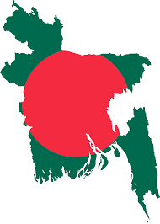
Since the independence ...
Poverty
Strong and consistent political commitments.
143 SSN programmes
23 ministries/divisions
Vulnerability
SSNPs as core strategy

On average 12.5% of the budget allocation and 2.5% of the GDP every year.
Marginalization


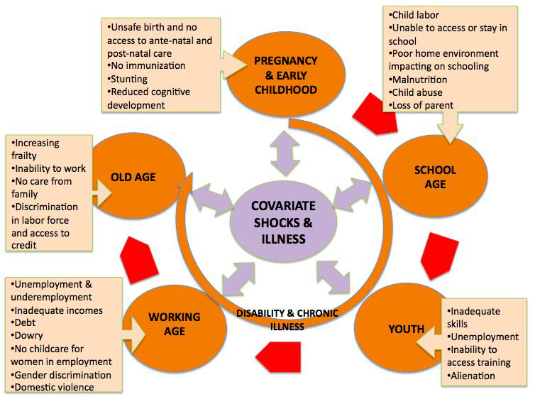
Vision

Inclusive Social Security System
Broader human development
Increase employment
Prevent poverty
and inequality
Increase
economic growth
Life Cycle Risks






Social allowances
MoSW
MoCA, MoWCA, MoLWA, MoHFW, MoLGRD&C, MoL&E. MoCHTA
MoPME,
MoE, MoSW,MoHFW, MoWCA, ICT Div., MoEWOE, MoLE, MoI, MoYS

HD & Social empowerment
Bank & inst. Div.
Fin. Div., MoH FW, MoL&E

Social insurance
Clustering
Implementation
MoFood,
MoDMR, MoHFW, MoA, MoWCA, MoF&L, Fin. Div.

Food security and DA
Labour/Livelihood interventions
MoDM&R,
MoLGRD&C, MoWCA, MoSW, MoFin, MoLE, MoF&L

Livelihood interventions
MoDMR,
MoLGRD&C, MoWCA, MoSW, MoFin, MoL&E, MoF&L

Programme consolidation
Social security for Children
Social security for Working age
Social security for Vulnerable women
Pension for elderly
Social security for disable people
Social security for urban poor
Reformed food security programme
Consolidated special schemes

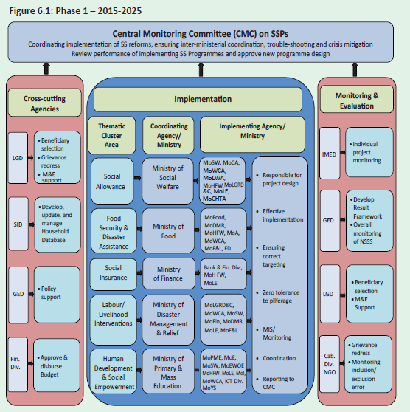
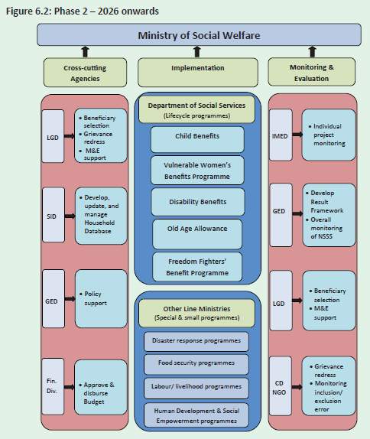

Institutional
Reforms
Strong G2P system
Grievance
redress mechanism
Result-based M&E
Single
registry MIS
reforms
Strong
selection process
2 phased governance reform

