
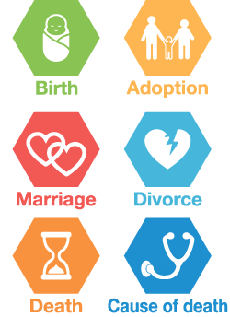
Global Summit on CRVS
– April 2013, Thailand
Permanent and continuous registration of various vital events of a person’s life.
Production of various appropriate statistics based on CR required for policy making.
Civil Registration and Vital Statistics (CRVS) is a fundamental administrative function of a government.

CR= Civil Registration VS= Vital Statistics


Civil registration and vital
statistics (CRVS) is the
continuous, permanent,
compulsory and universal
recording of the occurrence
and characteristics of vital
events of the population
in accordance with the law.
VS
Legal Documents
CR
CRVS in Global Context


Ministerial Conference on CRVS in Asia and the Pacific – November 2014, Thailand
Examples of Vital events


CRVS in Bangladesh – The Context


2014 (August)
CRVS related Steering Committee formed
CRVS in Bangladesh – A brief history
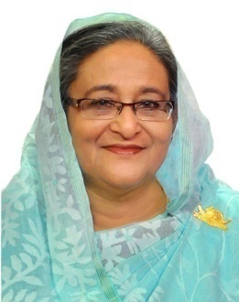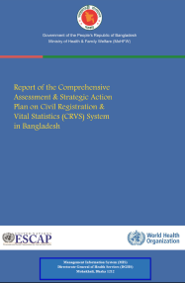



2013
Comprehensive
Assessment done
2010
Instructed for NPR
Multiple identities, legal complications
Unconnected citizen databases, no uniformity
No identity, invisibility in national statistics

2015 (February)
CRVS Secretariat Established in the Cabinet Division
High TCV and complicated service delivery
Huge national wastage of resources to generate VS

CRVS in Bangladesh – CRVS + +

Integrated Service Delivery Platform

Integrating all
CR and VS processes
Central
authentication
Convergence of all IDs into Unique ID

Linking with service delivery

