



National Workshop on
Achieving Food and Nutrition Security in the context of Sustainable Development Goal (SDG-2)

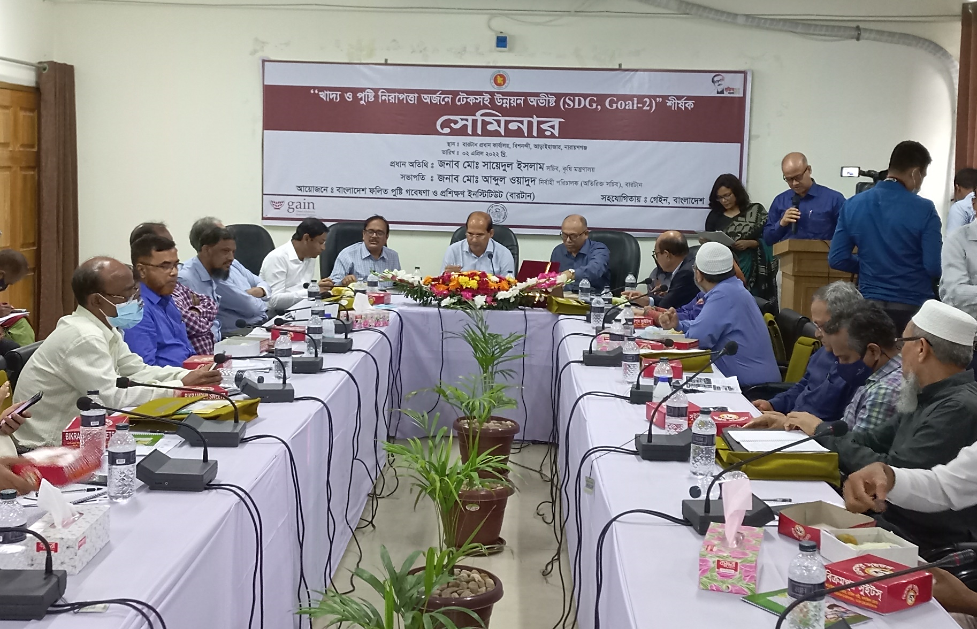
Date: April 2, 2022

Organized by:

Bangladesh Institute of Research and Applied Nutrition (BIRTAN)

Supported by:

Global Alliance for Improved Nutrition (GAIN)
Introduction:

SDG-2 highlights the inter-linkages between food security, nutrition, rural transformation, and sustainable agriculture. The Sustainable Development Goal to “End hunger, achieve food security and improved nutrition and promote sustainable agriculture” (SDG2) recognizes the inter linkages among supporting sustainable agriculture, empowering small farmers, promoting gender equality, ending rural poverty, ensuring healthy lifestyles, tackling climate change, and other issues addressed within the set of 17 Sustainable Development Goals in the Post-2015
Development Agenda.

Bangladesh Institute for Research and Training in Applied Nutrition (BIRTAN) under ministry of Agriculture is working to enhance the nutritional status of people of Bangladesh through research and training. It is also working on different agriculture development issues which eventually contributing to achieve SDG goals specially for goal-2 including nutrient enriched crops.

GAIN’s mission is well aligned to the Sustainable Development Goals (SDGs) as nutrition and the SDGs are interlinked. Good nutrition is both a means to and a result of attaining the SDGs. It is a fundamental cross-cutting investment for countries and the global community. GAIN’s work in alleviating the burden of malnutrition in all its forms. GAIN’s work activities contribute to the advancement of other SDGs, and particularly of SDG-2 (zero hunger)

Biofortified crops, naturally rich in micronutrients, are a subsistence commodity with the potential to nourish the world, especially the population at the bottom of the pyramid. Bangladesh Rice Research Institute (BRRI) has released high-yielding varieties of paddy like BRRI dhan74, BRRI dhan84, and BRRI dhan100, which contain a high amount of zinc. Studies have demonstrated impacts of the consumption of these crops on functional, cognitive, health outcomes, work efficiency, and contributing to productivity (P S Biswas and M A Hossain, BRRI).

The national seminar was facilitated in disseminate the knowledges on nutrient enriched crops relating towards eliminating zinc deficiency and thus ensure food and nutrition security for the vulnerable groups of populations considering SDG 2. Policy level high officials from different ministries, development partners and private sectors will participate in the national workshop and BIRTAN will facilitate the event.

Objectives:

- Organize a national seminar on “Achieving Food and Nutrition Security in the context of SDG-2 through Biofortified Crops”.
- Review the target of SDG-2 and dissemination of Biofortified crops in government forum.

Description:

The chief guest of this seminar was Md. Sayedul Islam, Secretary, Ministry of Agriculture and chaired by Md. Abdul Wadud, Executive Director (Additional Secretary) BIRTAN. Seminar was divided into two parts; 1st part was introductory where all participants introduced themselves and welcomed speech about BIRTAN by chair. He informed the overall activity and organizational structure of BIRTAN.

In the second part, the 1st presentation was ‘BIRTAN’s activity related to SDG’ placed by Tasnima Mahjabin, Senior Scientific Officer, BIRTAN. The presentation showed that BIRTAN is working for SDG Goal-2, end hunger, achieve food security, improved nutrition and promote sustainable agriculture. BIRTAN is conducting training on food based applied nutrition to scaleup nutritional knowledge through all over Bangladesh emphasised the vulnerable people as male and female farmers, fisherman, small scale businessman. It also conducts trainng on adolescent girls, pregnant and lactating women and older persons which has the potential to increase nutrition knowledge and impact stunting and wasting which address the SDG target specially 2.1 and 2.2.

Second presentation ‘Commercialization of Biofortified Crops’ was delivered by Md. Abul Bashar Ahmed Chowdhury, Project Manager, CBC, GAIN. He mentioned Bangladesh where 36% of children under 5 (BDHS 2014) 57% of women of child-bearing age (ICDDR,B 2013) is suffering from zinc deficiency. Zinc is essential for growth and development; it also prevent diarrhoea and NCD’s. He also mentioned that nutrient enriched crops are needed for maintaining good health and improving nutrition, prevent micronutrient deficiencies. Bangladesh has already introduced biofortified zinc rice varieties for example BRRI dhan62, 72,74,84, BINA dhan84, Bangabandhu dhan100. These all varieties are drought tolerant and high yield varieties. He mentioned that considering the present status of zinc deficiency in Bangladesh, Biofortified crops can be vehicle to prevent zinc deficiency and government can take initiative to inclusion of zinc rice through public procurement system, also government can take initiative to distribute zinc rice/ biofortified crops through social safety net program.

Third presentation was delivered by Md. Munirul Islam, Joint Secretary (SDG Cell), Prime Minister’s Office. He showed the overall SDG achievement of Bangladesh. He mentioned that Bangladesh government is doing best for achieving SDG goals, still there are many indicators have to address. He also told that from SDG cell of pm office there is a SDG action plan for every ministry, and the workplan is related with eight fifth year plan and delta plan. It is also under consideration to add SDG in APA of government office. It is needed to work together to achieve SDG targets.

Fourth and final presentation was delivered by Md. Ruhul Amin Talukdar, Additional Secretary (ppc wing), Ministry of Agriculture (MoA). He showed the interlink among agriculture, nutrition and SDG. He mentioned that out of 17 Goals and 169 targets, 10 goals and 33 targets are related with MoA . He also mentioned that MoA is playing lead role in SDG goal 2. In the presentation he discussed about BIRTAN’s role and activity for scaling up nutrition. He emphasized on necessary research which should be done by BIRTAN for example: prevent stunting, desirable dietary pattern, calorie intake, food security, minimum dietary diversity for women and children. Moreover, he mentioned that in Bangladesh we have to increase the research on bio-fortified nutritional crops. There are different research organizations which are already working for high value crops so we can conduct more baseline survey and introduce these variety in field level.

After completion of all presentation, panel discussion started and there were 5 discussants as Dr. SM Mustafizur Rahman, Line Director, NNS, expressed briefly about four presentations. Bangladesh is doing well in SDG health related indicators, now it is important to seek available source of micronutrient because deficiency of micronutrient is hidden hunger. Biofortification as Zinc rice with essential nutrient is a good source to avail it. We can conduct health impact research on biofortified crops.

Dr. Zubaida Nasrin, Director General, BNNC mentioned the activity of Bangladesh Natiotional Nutrition Council and stated that this organization is working on the Second National Plan of Action for Nutrition which is coordinated by 22 ministries. This platform is working with multisectoral approach which is a good way to combat malnutrition.

Dr. Md. Shajahan Kabir, Director General, Bangladesh Rice Research Institute (BRRI) told that rice is our staple food so Biofortified rice is good way to address micronutrient deficiencies. BRRI has developed many nutrient rice varieties, now BIRTAN, BRRI and GAIN can work together for more nutrition related research.

Md. Benzir Alom, Director General, Department of Agriculture Extension mentioned that DAE is encouraging farmers to grow safe and nutritious crops which is helping to achieve SDG goal 2. GAIN is working Ministry of Agriculture to promotion and commercialization of Biofortified crops in the country to address malnutrition. We can support them from our best considering the micronutrient status of Bangladesh.

After ending an informative panel discussion floor was opened for discussion. Every Participant express gratitude for inviting them in this seminar, took part in the open discussion and gave valuable recommendations and suggestions. Principal Scientific Officers from Bangladesh Agriculture Research Institute said that we can promotion of biofortified pulses parallelly with rice. Research Director from FPMU, Ministry of Food told that we can use the Biofortified rice in nutrition sensitive social protection programme. Upazila Livestock Officer, Narayangonj told that we have to emphasize on livestock rearing programme to meet up the needs of animal protein. Dr. Akhter Imam, Deputy Director, BNNC told that though we are sufficient in crop production we must look at carefully to postharvest loss.

After ending a fruitful open discussion, the closing ceremony stated. In this part Dr. Ashek Mahfuz, Portfolio Lead, LSFF and Value Chain, GAIN gave a speech and said that GAIN works to enable the food and nutrition situation in Bangladesh. He wished to work for health, nutrition as well as the occupational risk of farmers with BIRTAN, DAE, Ministry of Agriculture. He thanked BIRTAN for organizing such an important seminar and wish to work more issues with BIRTAN.

Special guest, AFM Hayatullah, Chairman, BADC told that BIRTAN is working for improving nutrition for many years, he expressed his wish that in future there will be more research conducted by BIRTAN for improving nutrition situation.

Chief Guest Md. Sayedul Islam, Secretary started his speech with the Article 18 (1) where states that ‘raising the level of nutrition and improvement of public health are among the primary duties of the State’ by Bangabandhu Sheikh Mujibur Rahman, Father of the Nation. He also told that Bongobondhu always emphasized agriculture sector and worked to introduce modern agriculture. Following him, our honourable prime minister sheik Hasina is working hard to improve the agriculture sector as result Bangladesh is now self-sufficient in food production. Already Bangladesh government got the SDG achieving prize leading by PM. But Bangladesh is still behind about food security and safe food. He also told that agriculture ministry is leading organization for achieving SDG goal-2, so it is our big challenge to ensure safe and nutritious food for such a huge population. BIRTAN has to take lead to address situation. BIRTAN is conducting applied nutrition training to the grassroot level, so they have to expand research work and transfer the result into root level beneficiaries. Now it’s time to emphasize on value added products and reach the foreign export markets. To scaling up nutrition situation, public private partnership is very much important, every institute has important role to meeting up the SDG goal. At last, he expressed his warm gratitude to GAIN for coordinating with BIRTAN for such a wonderful programme. Also thanked BIRTAN for arranging this seminar about time demanding and important topic.

In the closing speech, Chaired Md. Abdul Wadud, Executive Director (Additional Secretary) BIRTAN gave heartful gratitude to chief guest for giving his valuable time and speech. He also thanked all resource persons, panel members and distinguish guest for their kind presence. He expressed his warm gratitude to GAIN for helping and coordinating this seminar. He also hoped that like GAIN other organizations will also come forward to strengthen BIRTAN so that BIRTAN can work more efficiently to achieve SDG goals as well as improving nutrition situation of Bangladesh through Biofortified crops.

Conclusion:

Considering the nutrition status of Bangladesh and prevent malnutrition deficiencies in Bangladesh, this seminar was very fruitful, and all participants, discussants and guests have delivered their valuable suggestions on SDG-2 and Biofortified crops.

Annex-I (Some event photo)

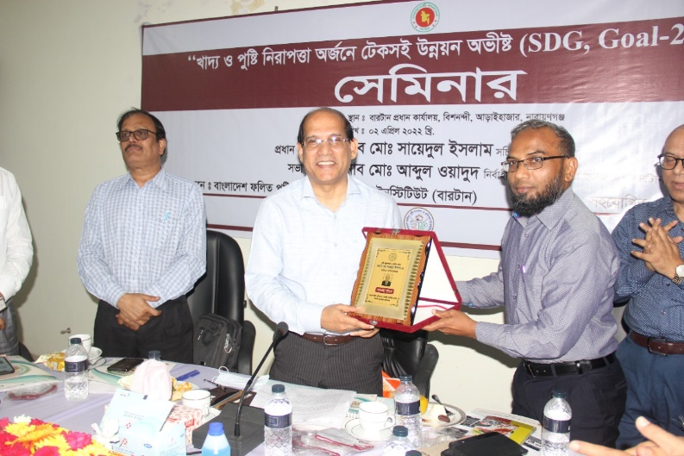

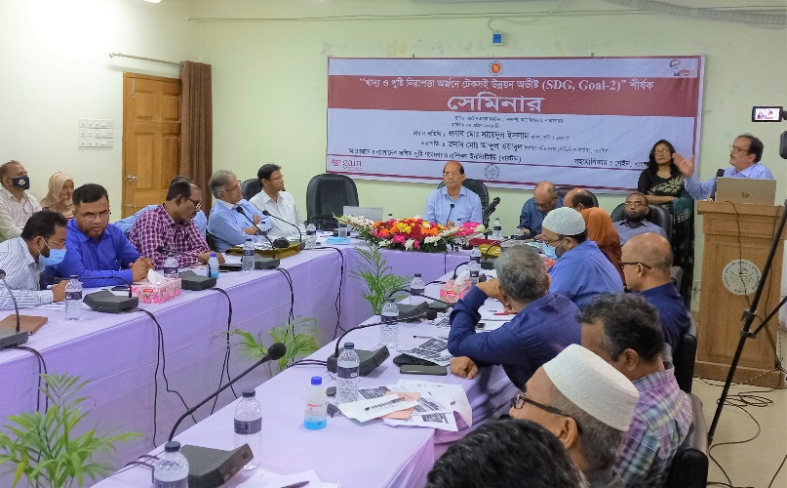
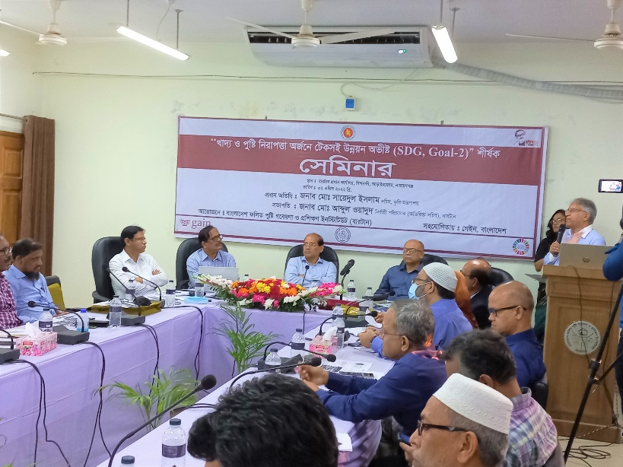
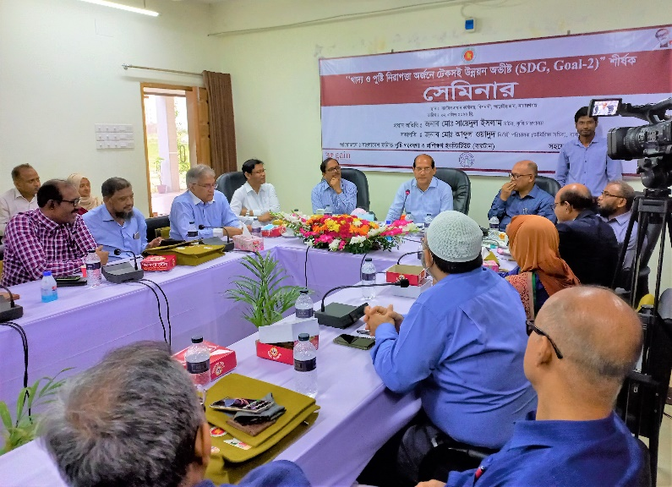
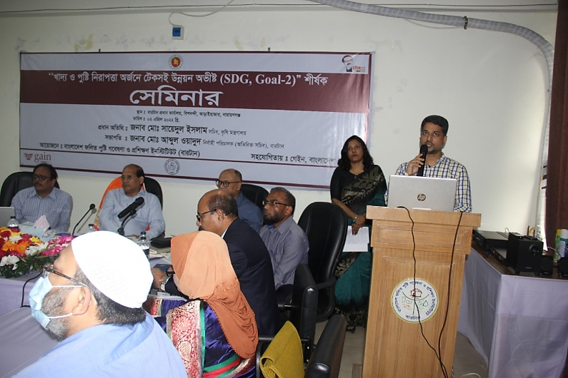

Annex-II (Program Schedule)

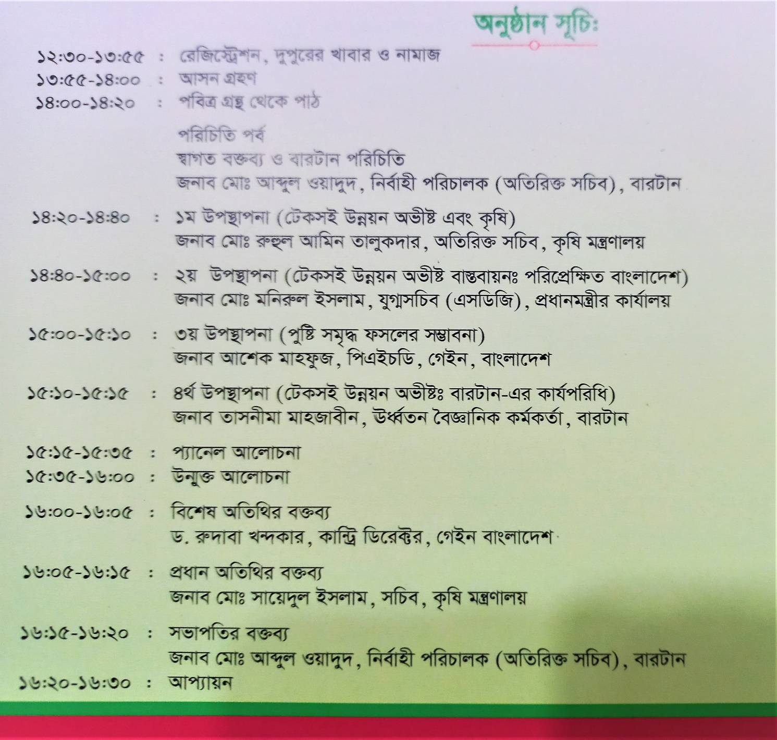

Annex-III (List of Participants)

