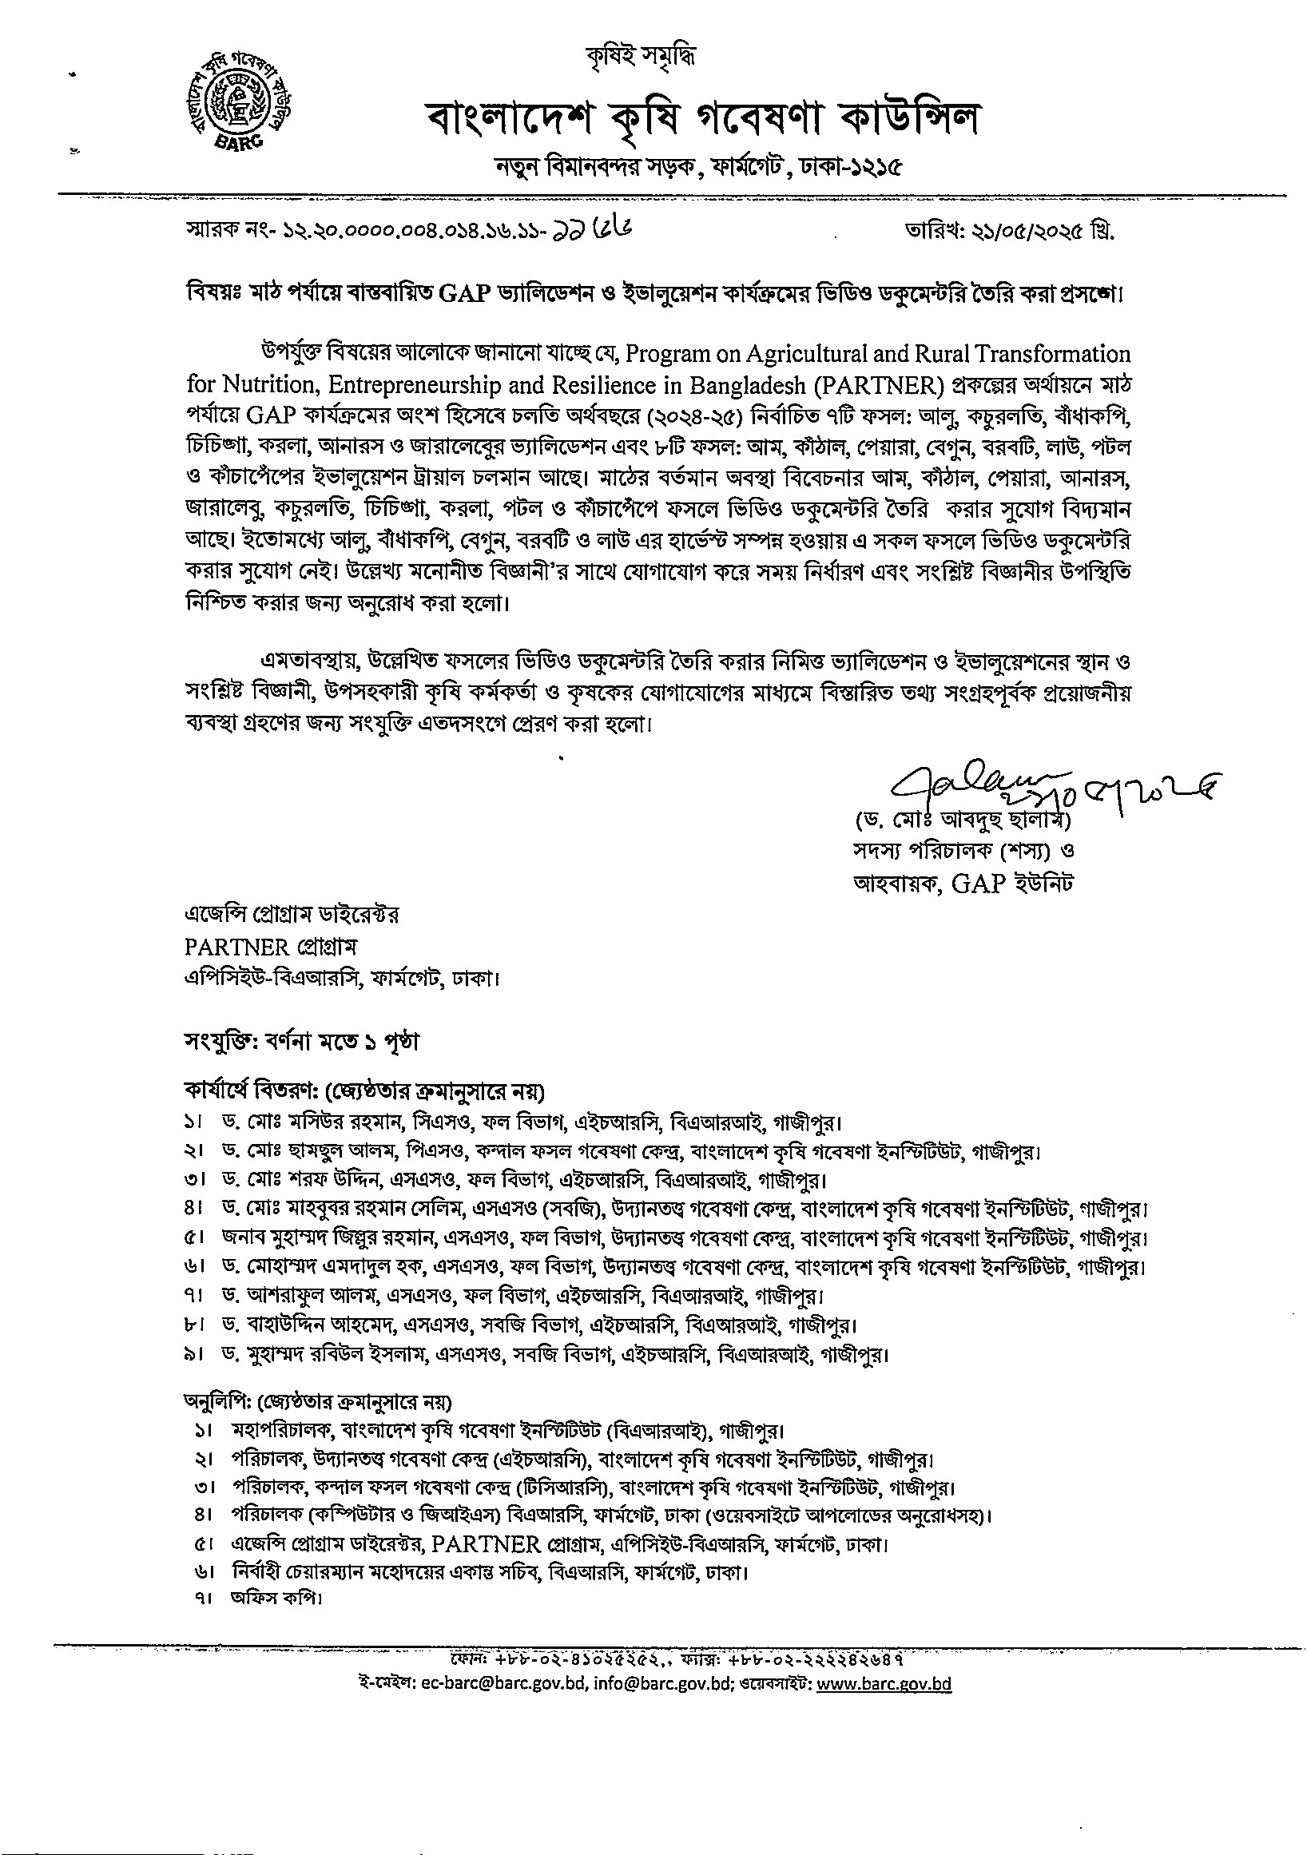
¥tû-q:
ec-barc@barc.gov.bd,
info@barc.gov.bd;
www.barc.gov.bd
List of Crops and Contact details for Video Documentary for GAP Trails
Cro | Place | Scientist | Farmers | UAO/SAAO
Mango | Kendobona, Nachole, Chapinawabgonj | Dr. Md. SorofUddin  SSO, Pomology  Division, HRC, BARI,  Gazi ur, 01712157989 | Mr. Md. Rafiqul Islam 01730194743 | LIAO: Soleh Akram 01741778158  SAAO: Md. Rakibul  Hasan 01717866809
2. Jackfruit | Valuka, Mymensingh Chanpur | Dr. Md. Moshiur  Rahman  CSO, Fruits, I-IRC,  BARI, Gazipur  01716838586 | Md. Abu! Hashem  01731940576 Md. Abdul Awal  01740622690 Md. Abu! Khair  01771907180 | UAO: Nusrat  01717426929  SAAO: Abdullah Al  Maswod 01712378750
3. Guava | Doriapur  Kodomsohor  Goadagari, Rajshahi | Dr. Md. SorofUddin SSO, Pomology Div  HRC, BARI, Gazipur  01712157989 | Md. Alamin  01716141544 Dec) | UAO: Mrs. Morium  Ahmed, 01714679110  SAAO: Atanu Sarker 01715997761
Pineapple | Patpocha, Jangalia  Modhupur, Tangail | Dr. Mohammad  Amdadul Haque, SSO,  Pomology Division  Horticulture Research  Centre, BARI, Gazipur  1728782745 | Md. Kitab Ali 1708959144 | IJAO: Rakib Al Rana  01318973880  SAAO: Md. Faroque  Hossain  01777278730
5. JaraLebu | Uttar Bagherkhal  Fatehpur-2 Jaintapur  District: Sylhet | Md. Zillur Rahma  SSO, Pomology  Division, Horticulture  Research Centre, BARI  Mobile : 01712167432 | Md. Sofikur Rahman  01712 389057  Md. Ismail Ali 01748 672927  Abbas Uddin  01749315926 | UAO: Shamima Akhter  Mobile: 0191 1697651  SAAO: Md. Istiak  Mobile: 01612064525
Stolen of Aroid | Khasbaguri  Panchbibi, Joypurhat | Dr. Md. Shamshul Alam  PSO, Tuber Crops  Research Centre  BARI, 01914-217691 | Md. Azizar Rahman 01715505082,  Md. Mojibor Rahman  01734232865  Md. Sundur Ali  01303689734 | UAO: Md. Lutfor Rahman, 01767002714  SAAO: Ms. Sufia  Khatun, 01744-576351
7. Snake gourd | Nunachara,  Pourashova,  Sitakunda, Chattogram | Dr. Mohammad Rabiul  Islam, SSO, Vegetable  Division, Horticulture  Research Centre, BARI,  01717039670 | Md. Abu Tahir  01812859898  Mur Ahmed  0 1822263587  Md. Gias Uddin  0183397855 | UAO: Md. Habib Ullah  01775881404 SAAO: Md. Shah Alam  01817771489
8. Bitter gourd | Parer Tong Ashidron, Sreemongal | Dr. Mohammad Rabiul  Islam, SSO, Vegetable  Division, Horticulture  Research Centre, BARI,  01717039670 | Md. Nazmul Hassan 01713810978 | UAO: Md. Mohiuddin 01700716106 SAAO:
9. Pointed Gourd | Haibotpur Jashore Sadar, Jashore | Dr. Bahauddin Ahmed  SSO, Olericulture  Division, Horticulture  Research Centre, BARI,  Gazipur  O] 556363901 | Raju Ahmed  01738411416  Md. Zillur Rahman  01642961199 Md. Anisur Rahman  01639381158 | UAO: Md. Hassan Ali 0 1722352236  SAAO: Ashiq Mahamud  Palash 01715847604
10. Green  Papaya | Atghoria, Pabna | Dr Ashraful Alam  SSO, Olericulture  Division, Horticulture  Research Centre, BARI 01712224479 | Md. Masud Rana  01774914434  Mokbul Hossain 01757906660 | UAO: sagib al Maruf  01723269873 SAAO: Zahidul Haq  01748772732
