Final Report

Name of the Project:
Improvement of Rural Agricultural Technology Extension System in Asia
(RATES)

Period | 2022.12~2025.11
Budget (USD) | $90,000
Country | The People’s Republic of Bangladesh
Organization | Bangladesh Agricultural Research Council, Dhaka, Bangladesh
Name | Dr. Suraya Parvin, Director, Technology Transfer and Monitoring Unit (TTMU)

17 August 2025

Summary:
The agricultural extension system in Bangladesh plays a crucial role in transferring knowledge, technologies, and innovations from research institutions to farmers. Agricultural Technology generated every year from research institutes were scattered and farmers were not aware of the generated technologies. To expedite technology dissemination, this project is implementing by the Bangladesh Agricultural Research Council (BARC) in collaboration with Bangladesh Agricultural Research Institute (BARI) and Department of Agricultural Extension (DAE). This project aims to disseminate high yielding varieties and associated package of practices developed by BARI in 5 crops namely Onion, Chili, Garlic, Turmeric and Mustard through field demonstrations, training of field extension staff and farmers and organizing field days. Through research trials, the project will also identify the yield gap between farmer fields and research field. All these are expected to enhance linkages between agricultural research and extension through identifying the limitations. Training for Sub-Assistant Agricultural Officers (SAAOs) and farmers are organized at three crop stages, namely the initial demonstration stage, field management phase and harvest stage. The project developed 7 technology manuals (5 crops and 1 general manual), 2 leaflets, and 1 video documentary. This project also developed Khamari App (National Platform) as digital tools. From this project, quality seed production demo plots also established to make available the quality seeds and farmers are trained up to build up the capacity for quality seed production. For each crop, a group comprising 30 farmers has been formed. Trial plots in research field and demonstration plots for 5 crops in farmers’ field initiated to determine the yield gap. A survey to evaluate the adoption of the transferred technologies conducted and the report also generated. Adoption helped to identify how technologies contributed to higher yields and efficiency for sustainable agricultural systems.

1. Introduction:
Bangladesh is predominately an agricultural country. Eighty percent of the rural people depend on agriculture. Day by day population is increasing with land decreasing. Government has given emphasis to increase production and productivity through dissemination of generated technologies in a sustainable manner. In fact, the information on agricultural technology (varietal development, production, management etc.) generated by different institutions are scattered around and not exactly known and not disseminated at farmers’ level. Research institutes, including BARI, undertake research endeavors aimed at generating technologies for both oil seeds and spices crops. Actually to enhance production of spices and oil seeds, related technologies need to transfer at farmers’ hand while Department of Agricultural Extension (DAE) is responsible for disseminating these technologies to farmers to boost up the yield of crops. DAE possesses ample manpower and institutional capacity. However, several constraints hinder its effectiveness including lack of training of extension personnel’s and farmers, information exchange platform, Only project based co-ordination meeting, delayed technology transfer process, lack of Res.-Extension-Farmer linkage, Joint Research Program planning, Joint Extension planning and Joint monitoring of Research and Extension program.
Spices have assumed a noteworthy role in promoting human health. To attain the highest possible yield from these crops, dissemination of high yielding varieties including smart management technologies are essential tools. To enhance the production of spices including onion, turmeric, chili, garlic and oil seeds like mustard, the adoption of recently developed high-yielding varieties, smart management techniques, and capacity-building initiatives are crucial. Not only food production, government owned and private sector seed producing farms provide only few percentage of the total seed requirement in the country needs to increase quality seed production of new varieties at farm level. Quality seed production and preservation at farmers’ level following the modern techniques can minimize the seed shortage as well as storage losses. But the farmers’ knowledge about the modern technology on seed production, processing and storage are very limited, as they do not follow the appropriate techniques from the beginning of crop production to post-harvest processing. As a result, the farmers’ homegrown seed is of poor quality in terms of purity, germination capacity, vigor, disease and insect resistance. Therefore quality seed production and storage of spices and oil seeds varieties at farm level to enhance seed security is necessary.
Adoption of BARI generated technologies like climate resilient new varieties, timely seeding, use of recommended irrigation, fertilizers are very important to increase yield. But those varieties and other technologies are not being adopted by the farmers in a satisfactory rate due to their inadequate knowledge about the varieties and technologies and insufficient extension efforts. Training on quality seed production and storage technique to the farmers can overcome the constraints that cause farmers to use old or obsolete varieties and technologies. Information at farmers’ level regarding technology is needed. The procedure of disseminations of these technologies to the farmers, researchers and Ext. personnel some time does not follow the appropriate and effective way. No detail study is available on transferring the technologies from BARI to farmers in collaborative ways. So, it is a burning issue to transfer the technologies at farmer’s level through research extension linkage. The use of mobile apps to disseminate agricultural technology in Bangladesh holds significant importance due to the country's unique agricultural context, challenges, and rapid digital transformation. The involvement of personnel from National Agricultural Research System (NARS) and the DAE in specialized regions of Bangladesh, with the support of the RATES project will play a pivotal role in this endeavor.
Under the coordination of TTMU, BARC, extension workers and researchers will enhance linkages by incorporating educational and marketing aspects. This study focuses on enhancing the extension system by incorporating advancements in spices and oil seeds technologies and minimizing the yield gap through improving Research-Extension-Farmers linkage.
Project Goal:
To improve agricultural extension and capacity building system for farmers’ & agricultural extension professionals to increase the yield and production of spices and mustard in BD and establishment of global network and cooperation through RATES project.

The objectives of the project are:
1. To increase the yield of onion, chili, garlic, turmeric and mustard using recently BARI generated high-yielding varieties and smart management practices in particular locations of Bangladesh.
2. To find the causes of yield gap between research and research field for sustainable development.
3. To increase extension professionals and farmers' knowledge and skills for spices and oil seed cultivation.

4. To reinforce the linkage between research-extension-farmers with the enhancement of existing extension system in Bangladesh.
2. Methodology

- This project is being implementing by the PI from Bangladesh Agricultural Research Council (BARC) in in coordination with and two Co-PIs from the Bangladesh Agricultural Research Institute (BARI) and Department of Agricultural Extension (DAE).
- The PI of Technology Transfer and Monitoring Unit (TTMU), BARC have overall responsibility to compilation of all collected information transferred technology, coordination, monitor and evaluation of the project
Activities:
Year | Description
Year 1  (Dec 2022-Nov 2023) | 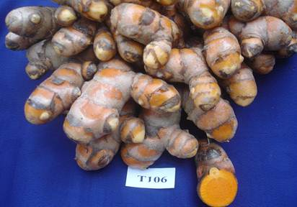  Activity-1: Baseline Study  - Baseline study on agricultural extension and capacity building system in Bangladesh was performed in association with DAE. It evaluated DAE’s capacity, staff training, resource allocation, infrastructure, and use of ICT. Baseline report was generated as output.  Study Design  Type: Mixed-methods approach  Scope: National coverage with focus on regional/divisional representation  Sampling Strategy  Target groups: Extension officers (DAE staff and Farmers: small, medium, large; women and youth included)  Sample Size (1 District, 2 upazilas): 100 farmers (quantitative survey) and 100 extension workers and Key stakeholders: 25 (researchers, seed dealers, NGOs, private sector etc.)  Tools Used: Structured household questionnaire and FGD  Activity-2: Establishment of improvement strategy and action plan was prepared and submitted to AFACI.  Activity-3: Selection of Project site:  - The PI with the 2 Co-PIs of the project visited the project location to establish the demonstration plot (15 in Ghatail Upazila and 10 in Dhanbari Upazila, 0.13 hec/plot) in Tangail district.  Activity-4: Selection of crop:  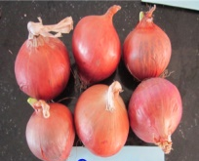  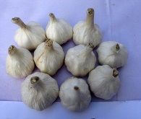  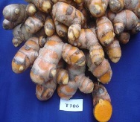  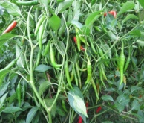  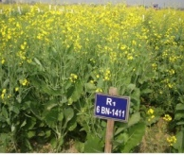  - Selected4 spices and 1 oil seed varieties for demonstration:  BARI-Peaz-6 BARI Rosun-2 BARI Holud-4 BARI Chili-2 BARI Sharaisha-18  Activity-5: Farmers selection and group formation:  - On the basis of crop, 5 farmers group (30 farmers in a group) was formed with the assistance of DAE in the Dhabari and Ghatail Upazila.  Activity-6: Preparation of Questionnaire for farmers baseline study  - Questionnaire have been prepared to collect the relevant information including existing spices and oil seed technologies (Varieties and management technologies) that have been practicing by the farmers of that location. Secondary information was also collected from websites, reviewing published literatures etc. for preparing baseline study report. The collected information through questionnaire was collated and analyzed for quality output.  Activity-7: Reporting  - Annual Report and Country report submitted to AFACI.
Year 2  (Dec 2023-Nov 2024) | Activity-1: Establishment of demo Plots:  - The PI with the 2 Co-PIs of the project accomplish the objectives of the project visited the project location to establish the demonstration plot (15 in Ghatail Upazila and 10 in Dhanbari Upazila, 0.13 hec/plot).  Activity-2: Selection of co-operator farmers:  - Co-operator farmers were selected for Researcher Managed Trial (RMT), Extension Managed Trial (EMT) and traditional Farmers Managed Trial (FMT) based on land and crop suitability, farmers willingness to grow the selected crops, local demand, farmers choices, market access etc.  Activity-3: Analysis of Yield Gap:  - On the basis of the recommendation of the inception workshop, studies to find out the causes of yield gap between farmers field and research field was included in the objective. To attain this objective, 22 no. trial plots were established in Research Field. The research trial experiment conducted in the same location OFRD, BARI Tangail. 5 crops, >3 replications, Total no. of plots: 22  - Demo plot in farmers’ field with extension services (20), without extension services (20) for each variety in same location were established. The demonstration in the farmer’s field was managed by the farmers with technical support form PI of this project along with the team of Bangladesh Agricultural Research Institute (BARI) and Department of Agricultural Extension (DAE).  Activity-4: Sharing of the inputs for different trials  - Quality seeds collected from BARI and other inputs (fertilizers, pesticides etc.) were distributed among the selected farmers for RMT and EMT while only quality seeds were provided to the farmers for FMT.  Farmers practice with extension services:  - Followed production handbook  - On time field transplanting  - Practiced optimal and timely irrigation for the specific variety  - Followed recommended fertilizer doses for the specific variety  - Followed intercultural operation and other management practices  - All demo farmers seat together for group meeting twice in a month for their problems and detail discussions, supervised by SAAO  Conventional plots without extension service:  - Farmers receive latest variety seeds from OFRD, BARI, Tangail  - Late transplanting  - Irregular irrigation  - Inappropriate use of fertilizer  - Irregular weeding and soil management  - No collaboration among same type crop producing farmers  - Less idea about market price and value chain system  Activity-5: Service providing for the production domain under Researcher and Extension managed Trial  - Production of spices and oil seed crops requires huge operational activities like sowing, fertilizer application, irrigation, weeding, pest and disease management, harvesting, post-harvest operations. For getting optimum yield different operations at the suitable crop growth stages is deemed imperative. In this regard participatory and collaborative approaches were carried out.  Activity-6: Research-Extension collaborative Training for capacity buildup of the farmers  - Participatory training was provided to the selected farmers under RMT and EMT using audio-visual tools. Expert Researcher and Extension Personnel were facilitated for effective learning on the production technologies of spices and oil seed crops prior to onset of the trial. Field level research and extension staff were also sharpened their knowledge through participation with the farmers.  Activity-7: Organizing Field days and Group Meetings:  - Farmers’ field days were organized in selected one field per upazila with 100 farmers and concerned DAE, research and NGO personnel to show the performance of new spices and oil seed varieties and recommended technologies.  - Farmers’ Group meetings were organized in demonstration sites with the participation of scientists, extension personnel and farmers.  Activity-8: Research-Extension collaborative field monitoring  - During the implementation of the trial Researcher and Extension personnel jointly monitored the crops field and provided valuable suggestions to the cooperator farmers and necessary solutions for ensuring optimum crop growth and yield.  Activity-9: Preparation of Video documentary of RATES project and uploaded in the BARC website  Activity-10: Publications of Manuals and Distribution:  - Three (3) Technology manuals published in assistance with the BARI and DAE components. Published manuals are distributed among the concerned stakeholders.  Activity-11: Reporting  Annual Report and Country report submitted to AFACI.
Year 3  Dec 2024-Nov 2025) | Activity-1: Quality seed production demo plots  - Two upazilas were selected in Tangail district– the most concentrated spices and mustard growing areas of the country for quality seed production. In selected upazilas, a focus group discussion with 30 farmers, DAE and related NGO personnel of the areas was organized in October 2024. One interested farmer was identified to cultivate seeds and to collaborate cordially with the farmers and other partners in conducting project activities. For seed production 4 varieties (BARI Piaz-6, BARI Rosun-2, BARI Holud-4 and BARI Sharisha-18) breeder seeds were supplied to 4 farmers (for 0.33 acre areas per farmer).  - The selection of farmers and land, establishment of seed demo. plots, crop management, data collection, analysis, and training programs are being organized by OFRD, BARI, Tangail.  Activity-2: Farmers Training on seed production  - Training was conducted in six batches, with 30 farmers per batch, across two upazilas on seed production, processing, and preservation from February to April 2025.  Activity-3: Follow up demo plots in farmers field  - The selection of farmers and land, establishment of demo plots, crop management, data collection, training programs and Field Days are being organized by the local Upazila Agriculture Office, Tangail.  Activity-4: Technology Adoption study  - The questionnaire was prepared, data collected, and analyzed to prepare the adoption report for five transferred technologies.  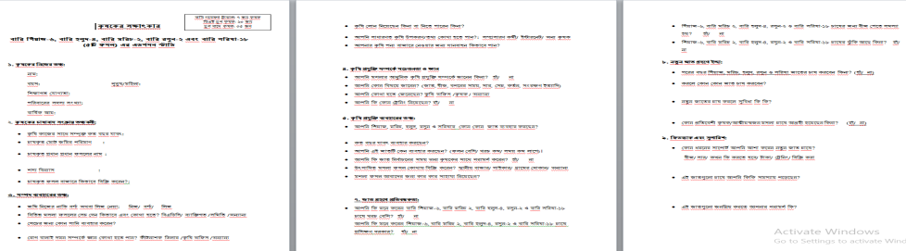  Questionnaire  Questionnaire  Activity-5: Development and Use of Mobile app known as Khamari app  - The integration of technological features into the existing mobile app (Khamari) of BARC was currently being developed.  Activity-6: Farmers Group Meeting  - Farmers' group meetings were organized by the local DAE Office  Activity-7: Publication and Distribution of Training Manual and leaflets  - 3 Training manuals, 2 leaflets of mobile app user direction and market linkage and value chain were published by BARC with assistance from the BARI and DAE components. These manuals are distributed to the relevant stakeholders by the local Agriculture Office.  Activity-7: Market orientation and linkage establishment workshop  - One Market orientation and linkage establishment workshop was conducted by Local DAE Office.
3. Results:
3.1 Results of Year 1:

3.1.1. Baseline study on agricultural extension and capacity building system in Bangladesh
This baseline study assesses the current state of the agricultural extension and capacity building system in Bangladesh. It examines the institutional structure, service delivery mechanisms, capacity of extension staff, adoption of technologies by farmers, and key gaps in outreach and performance. The findings provide a benchmark for monitoring the impact of future interventions and inform policy and programming strategies aimed at improving the extension system in Bangladesh.

Key Findings

The Department of Agricultural Extension (DAE) has been established in 1982 by merging six agencies responsible for technology transfer. It is the largest extension service provider in Bangladesh having considerable human and financial resources. DAE is the core organization under Ministry of Agriculture (MoA) and has been playing an important role in providing best extension service to improving agricultural growth and development of the country, especially in crop sector. DAE is headed by the Director General (DG), who is assisted by the Directors of eight wings such as) Field Service; ii) Horticulture; iii) Cash crop iv) Plant Protection v) Plant quarantine vii) Training and viii) Administrative and Finance. Field service wing is mainly responsible for providing agricultural extension service to the farmers at the field level through two-way (problem identification and planning & offering solution) mechanisms with the technical support of other seven wings. There are administrative set-ups of field service wing at the region, district, Upazila (sub-district) and block levels controlled by the Additional Director (AD), Deputy Director (DD), Upazila Agriculture Officer (UAO) and Sub-Assistant Agriculture Officer (SAAO) respectively. The lowest unit of DAE field service wing is the block level. There are about 12832 blocks of DAE in Bangladesh and one SAAO is responsible to provide technical information to the farmers of a particular block. The block is the smallest operational unit for frontline services. Approximately 12,800+ blocks across the country each block is supervised by one SAAO, serving roughly 1,200–4,500 farm households. In each union, there are 3 SAAOs, and each municipality (pouroshova) also has at least one SAAO

Human Resources
Total Manpower Approx 26000 where Total Cadre Official number is 3131 and Sub Assistant Agriculture Officers up to block level and office support stuffs.
- National Level: Office of Director General & 8 Wing Director’s Office
- Regional Level: 14 Offices
- District Level: 64 Offices
- Upazila Level: 502 Offices
- Block level Sub Assistant Agriculture Officers: 14,002
- Horticulture Center: 78
- Plant QuarentineCenters: 30
- Agricultural Training Institutes: 18
- Mashroom Development Center: 1

Strength of DAE:
- DAE plays a vital role in agricultural development and food security through technology transfer, farmer education, and extension services. It has extensive nationwide network and operates in all 64 districts and most upazilas. It reaches into remote and rural areas, helping to bridge the gap between research and farmers. It has well-structured human resources. Many staff trained in modern extension methods, ICT, and climate-resilient agriculture. It promotes technology transfer and farming training. DAE collaborates with research institutes and international agencies like FAO and CIMMYT. DAE operates platforms like DAE MIS, mobile apps, call centers, and SMS-based advisories. It implements the national programme, policy and plays a critical role in boosting rice, maize, vegetable, and fruit production

Weakness of DAE:
- Institutional Structure: The DAE operates at national, divisional, district, upazila, and union levels. Coordination between DAE, NARS, NGOs and private sector actors remains limited and informal.78% of upazila extension offices reported shortages of qualified staff. Only 40% of field extension workers had received training on modern digital tools. Women representation in extension staff remains below 10%. Staff-to-farmer ratio remains critically low (1 officer per 1,200–1,500 farmers).
- Delivery and Farmer Access: 54% of surveyed farmers reported having interacted with an extension worker in the past 12 months. Only 32% of farmers received information through digital or mobile-based platforms. Farmers reported higher satisfaction when services included on-field demonstrations and participatory training.
- Capacity Building Initiatives: 60% of upazila offices had conducted training programs for farmers in the last year. Topics mostly focused on crop production, with limited focus on climate resilience, post-harvest, processing or market linkage. Post-training follow-up was found lacking in most cases.
- Inadequate funding, resources at the field level. Limited transportation, communication facilities for extension workers and weak linkages between research institutions and extension offices are the key barriers of DAE.
- Baseline Indicators: Table-1
Sl. No. | Indicator | Baseline Value
1 | % of farmers accessing extension services (past year) | 54%
2 | % of extension officers trained in last 12 months | 45%
3 | Average number of training events per upazila (last year) | 5
4 | % of female farmers accessing training | 27%
5 | Farmer satisfaction with services (rated good or above) | 48%
6 | % of extension officers using ICT-based tools | 38%
- Budgetary analysis of the Department of Agricultural Extension:
Opportunities of Budget of DAE: Enhancement of Agricultural Productivity, Wider Outreach to Farmers, Capacity Building and Training, Digital Extension Services, Climate-Resilient Agriculture, Public-Private Partnerships (PPPs).
Budgetary Constraints: Inadequate Budget Allocation, Delayed Fund Disbursement, Rigid and Centralized Budgeting, Poor Budget Planning and Forecasting, Lack of Proper Budget Distribution and Management, Limited Investment in Capacity Building, Dependence on Development Projects are the key barriers.
Opportunities, constraints and Suggestions from Baseline study of Current Extension system:
Opportunities | Constraints | Recommendations
Enhancement of Agricultural Productivity | - Lack of climate smart technologies  - Inadequate Budget Allocation | - Conduct research to generate climate resilient technologies by research institutes is necessary and handed over these technologies to DAE.  - Increase annual budget allocation and explore alternative funding sources such as donors, climate funds, private sector investment, NGOs, INGOs etc.
Wider Outreach to Farmers | - Inadequate Farmers outreach programmes | - More Farmers outreach programmes (training, field days, demonstration, FFS etc) could be incprporated.
Capacity Building and Training | - Inadequate Capacity Building programme.  - Lack of investment in human resource developlment | - Integrate modern agricultural technologies, climate-smart practices, and digital extension tools into training programs.  - Allocate dedicated funds for continuous professional development of extension staff, incorporating climate-resilient practices, post-harvest processing, market linkage etc.
Research-Extension Linkage | - Inadequate research-extension linkage | - Increase the research-extension linkages through the involvement of researcher in extension activities and monitoring
Digital Extension Services | - Lack of digital extension services  - Centralized Budgeting | - Invest in mobile applications, e-learning platforms, and remote advisory services to reach a larger farmer base.  - Strengthening Agriculture Information System (AIS) through resource allocation.  - Decentralize budget management.
Public-Private Partnerships (PPPs) | - Lack of collaboration to manage public-private partnership | - Engage private sector expertise in supply chain development, mechanization, and market access.
Development Projects | - Dependence on Development Projects | - Integrate successful project initiatives into regular DAE budgets to ensure sustainability beyond donor funding.  - Ensure institutional ownership and sustainability beyond donor-funded project cycles.
Table-2: Activities result of Year 1:
Activities details in TCP | Activities (As per Work Plan) | Progress
1. Baseline study on agricultural extension and capacity building system in AFACI member countries | 1. Country Report will be submitted to AFACI | Submitted (as on 14/04/23)
 | 2. Baseline study on Agricultural Extension and capacity building system in Bangladesh | Completed (on January/23)
2. Training on agricultural extension system in Korea | 3. To attend in the Workshop in Korea regarding Agricultural Technology Extension service; | Attended (24-28/04/23)
3. Establishment of action plan | 4. Establishment of improvement strategy and action plan | Established (5/04/23)
3. Establishment of action plan | 5. Inception workshop will be organized at BARC | Organized on 16.06.2023
3. Establishment of action plan | - Generation of Inception Report and sent to BARI & DAE | Sent as on 10/09/23
3. Establishment of action plan | 7. Project sites will be selected with the coordination of BARC, BARI and DAE project personnel | Selected
3. Establishment of action plan | 8. Questionnaire will be prepared for Baseline Study | Prepared
3. Establishment of action plan | 9. Filled out Questionnaire will be collated & Analyzed | Ongoing
3. Establishment of action plan | 11. Farmers Group Formation | Completed
3. Establishment of action plan | 7. Capital items (Laptop, 1 and Colour Printer, scanner etc.) will be procured as TCP | Procured
3. Establishment of action plan | 12. Annual report will be prepared and submitted to AFACI. | Submitted

Table-3: Activities performed to address the specific Objectives (for the Year-1):
SL. No. | Specific Objectives | Activity | Progress
1 | To facilitate the dissemination of BARI generated high-yielding varieties of Onion, Chili, Garlic, Turmeric & Mustard in Bangladesh | - Team formation with local extension workers and farmers leader | Completed
1 |  | - Baseline study with the questionnaire developed by BARC, BARI and DAE | Completed
1 |  | - Site selection and farmers selection | Completed
1 |  | - Spices and oil seed crop variety selection | Completed
Activity Photos:
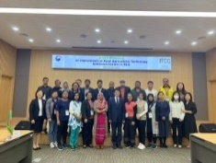 | 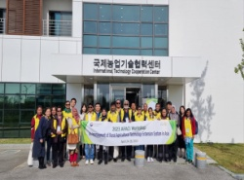 | 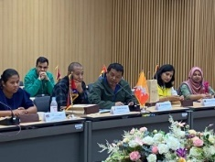 | 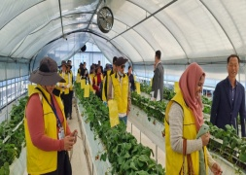
Attended in the Workshop in Korea on 24-28 April/2023
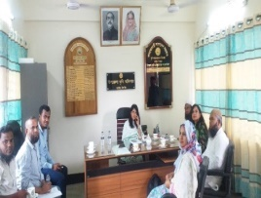 | 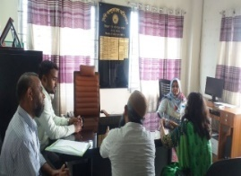 | 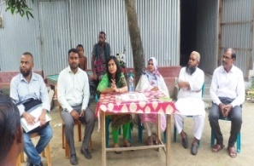 | 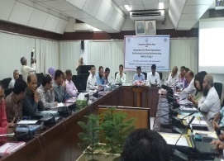
Visited Upazila Agril. Office at Ghatail | Visited Upazila Agril. Office at Dhanbari | Focus Group Discussion with farmers | Inception Workshop at BARC

3.2 Results of Year 2:
3.2.1 Results: Establishment of 50 demo Plots: 5 plots with extension service & 5 conventional plots
In 2nd year 5 crops variety were evaluated with and without extension services through farmers demo plots in the project location. All varieties showed the increased yield with the extension services. The performance of the transferred varieties are shown in the table-4.The table indicated that mustard, onion, chilli, turmeric and garlic variety increase the yield of 15.20, 42.86, 17.65, 6.72 and 18.64% respectively with extension services..
Table-4:
Crop | Variety | Average Yield (t/ha) |  | % Yield increase
Crop | Variety | Without Ext. Services | With Ext. Services | % Yield increase
Mustard | BARI Sharisha-18 | 1.58 | 1.82 | 15.20
Onion | BARI Piaz-6 | 7.00 (Bulb) | 10.00 (Bulb) | 42.86
Chili | BARI Morich-2 | 17.00 | 20.00 | 17.65
Turmeric | BARI Holud-4 | 11.90 | 12.70 | 6.72
Garlic | BAR Rosun-2 | 4.80 | 5.90 | 18.64

- All crops showed to increase yield with the extension services. The percent of increment of mustard, onion, chilli, turmeric and garlic yield was 15.20, 42.86, 17.65, 6.72 and 18.64%, respectively with extension services compared to without services.

3.2.2 Assessment of yield gap
- The productivity of four different crops (mustard, onion, chilli and turmeric) was evaluated under three management options viz. Research, Extension and Farmers aiming to find out the impact on case of Research Managed Trial (RMT), Extension Managed Trial (EMT) and Farmers Managed Trial (FMT). On-Farm Research Scientists Team followed their scientific approaches with modern management technologies for attaining the potential yield of the tested crops. However, in case of EMT necessary extension approaches and mechanisms were followed. Farmers adopted their own management approaches using local community connectivity. The relevant data on the yield, economic return and necessary feedback regarding the gaps of different management system were collected and presented in graphs. The results revealed that RMT exhibited significantly higher crop yield of mustard (2.40 t ha⁻¹), onion bulb yield 14.79 t ha⁻¹, chilli 22 t ha⁻¹ and turmeric 16 t ha⁻¹ as compared to EMT and FMT. The lowest yield was recorded in FMT. However, EMT demonstrated lower yield of both crops relative to RMT but higher over FMT.

3.2.2.1 Impact of Management approach on yield gap
- The results indicate that a relatively lower yield gap was documented between RMT and EMT that is 24.16%, for mustard and 32.38% for onion, and 20.62% for turmeric rhizome yield as compared to yield gap between EMT and FMT except chili (9.09%). The alignment of some joint innovative research-extension approaches with existing extension system such as direct quality seed supply at the farmers level from research organization, research-extension participatory planning, preparing comprehensive action plan, research-extension-farmers participatory training, joint field monitoring, quick information flow through digital platform in research-extension channel, participatory farmers group discussion, distribution of quality printed materials and other collaborative services might be the reason for lowering the yield gap between RMT and EMT.
3.2.2.2 Evaluation by stakeholder regarding yield gap
- Yield gap is the resultant effect of many factors like biological, environmental, management issues, land criteria, social and others. Stakeholder assessment suggests that some activities like fertilizer management, optimum time of sowing, availability of seeds and training were the most important factors for minimizing the yield gap between RMT and EMT. Their opinion reflects some positive changes with improvement of production process due to research-extension collaborative functions eventually minimize the yield gap.
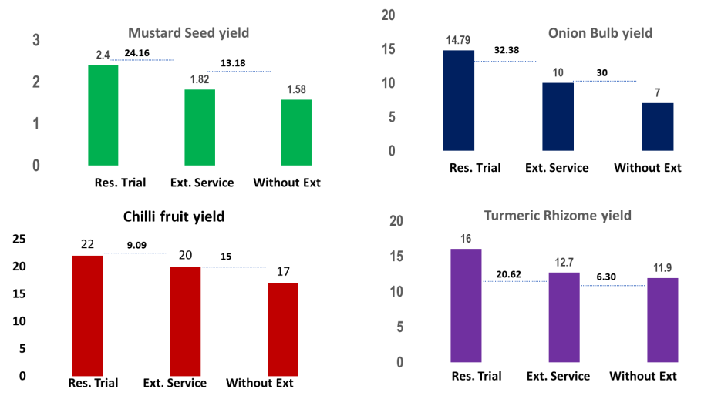

Fig 1: Mustard seed yield
Fig 2: Onion bulb yield

Fig 3: Chilli fruit yield
Fig 4: Turmeric Rhizome yieldyield

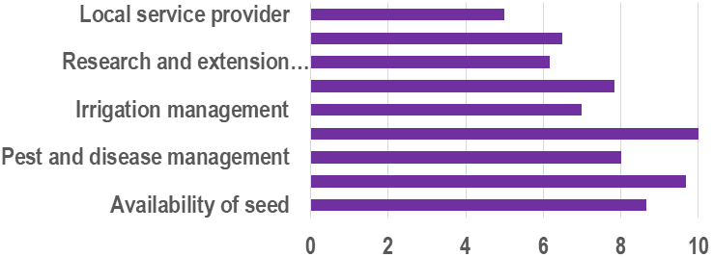
A

Fig 5: Stakeholder analysis result
- Stakeholder assessment suggests that some activities like fertilizer management, optimum time of sowing, availability of seeds and training were the most important factors for minimizing the yield gap between RMT and EMT.
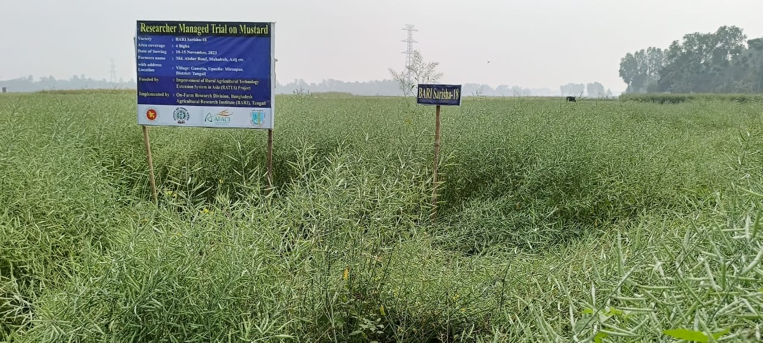
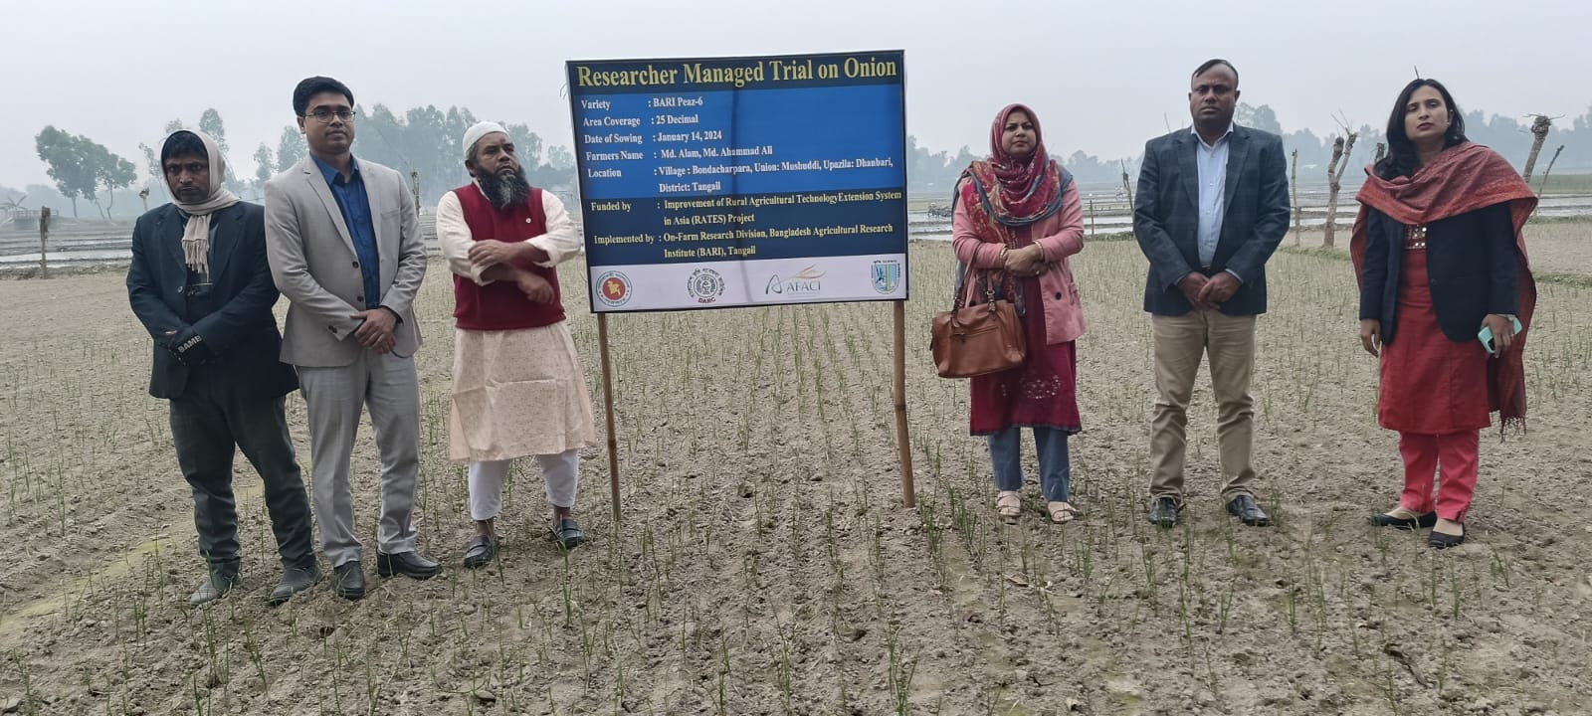
Table-5: Results of Year-2:
Qualitative goals:
Activities details in TCP | Activities  (As per Work Plan) | Progress
2. Implementation of Action Plan | 1. Establishment of trial plots in research field (22 no.) | 16 trial plots established (6 plots remaining)
2. Implementation of Action Plan | 2. Farmers group will be formed. Each group consists of 30 farmers Group meeting will be conducted. | 5 groups formed. Group meeting conducted by the supervision of SAAO
2. Implementation of Action Plan | 3. 3 Spices & 1 oil seed (5 for each=20) Crop Demonstration Plots will setup in farmers field in two selected upazilas with extension services | 20 demo plots established
2. Implementation of Action Plan | 4. 3 Spices & 1 oil seed (5 for each=20) Crop Demonstration Plot will setup in farmers field in two selected upazilas without extension services | 20 demo plots established
2. Implementation of Action Plan | 5. 3 steps training will be provided to farmer during plot selection & cultivation, after cultivation & before harvesting | 4 Batches of training conducted
2. Implementation of Action Plan | 6.Training and meeting will be conducted for extension personnel | Training conducted
2. Implementation of Action Plan | - End of the production season, field day will be organized. Total field day program number will be 5. | - Field days organized
2. Implementation of Action Plan | - Field Monitoring and field visits will be done by PI and Co-PIs. | 3 Field Monitoring were completed
2. Implementation of Action Plan | - Any project related Manual/information will be published | - Manuals published
2. Implementation of Action Plan | - Preparation of RATES project related video documentary | Prepared
2. Implementation of Action Plan | - Annual Meeting/ workshop will be organized at BARC | Organized
2. Implementation of Action Plan | - Annual Report will be prepared and submitted to AFACI | Submitted
3. Participate in interim evaluation workshop | 13. Participation in AFACI RATES Project Evaluation workshop in Hanoi, Vietnam on 26-30 August 2024 | Attended

Table-6: Activities performed to address the specific Objectives (Year 2):
SL. No. | Specific Objectives | Activity | Progress
1 | To facilitate the dissemination of BARI generated high-yielding varieties of Onion, Chili, Garlic, Turmeric & Mustard in Bangladesh | - Establishment of 40 Demo plots in farmers field | 4 crops Completed
1 |  | - Capacity building of Extension personnel through training | 1 Batch completed
1 |  | - Capacity building of farmers through training | 4 Batch Completed
1 |  | - Spices and Oil seeds Manual publication | 3 Manuals published
1 |  | - Sharing the manuals to local farmers | 80 farmers received the manual
02 | To study the causes of yield gap between farmers field and research field | - Establishment of demo plot in research fields for each variety | 16 plots (4 crops) completed
02 |  | - Establishment of demo plot in farmers field with extension services | 16 plots (4 crops) completed
02 |  | - Establishment of demo plot in farmers field with the traditional management practices | 16 plots (4 crops) completed
02 |  | - Intensive Field visit and monitoring with research and extension personnel together | 3 Field visit and monitoring were done by PI and Co-PI
02 |  | - Information collection: reason behind the yield gap | Ongoing

Activity Photos:

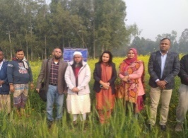 | 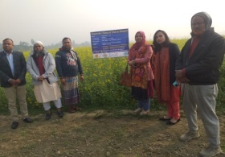 | 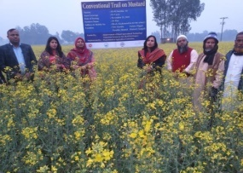 | 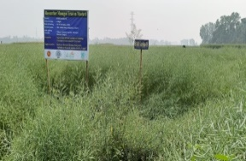
Researcher managed plot of Mustard at Ghatail, Tangail |  | Fig-2: Field Trial of BARI Sharisha-18 without extension services at Ghatail

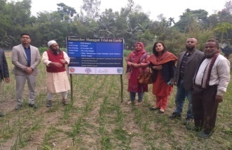 |  | 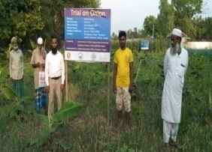 | 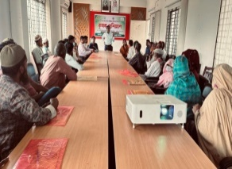 | 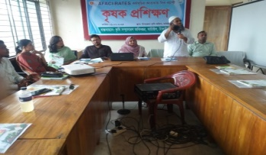
Fig-3: Farmers demo plot of BARI Piaz-6 with extension services at Dhanbari |  |  | Fig-5: Phase 1: farmers Training at Dhanbari&GhatailUpazila

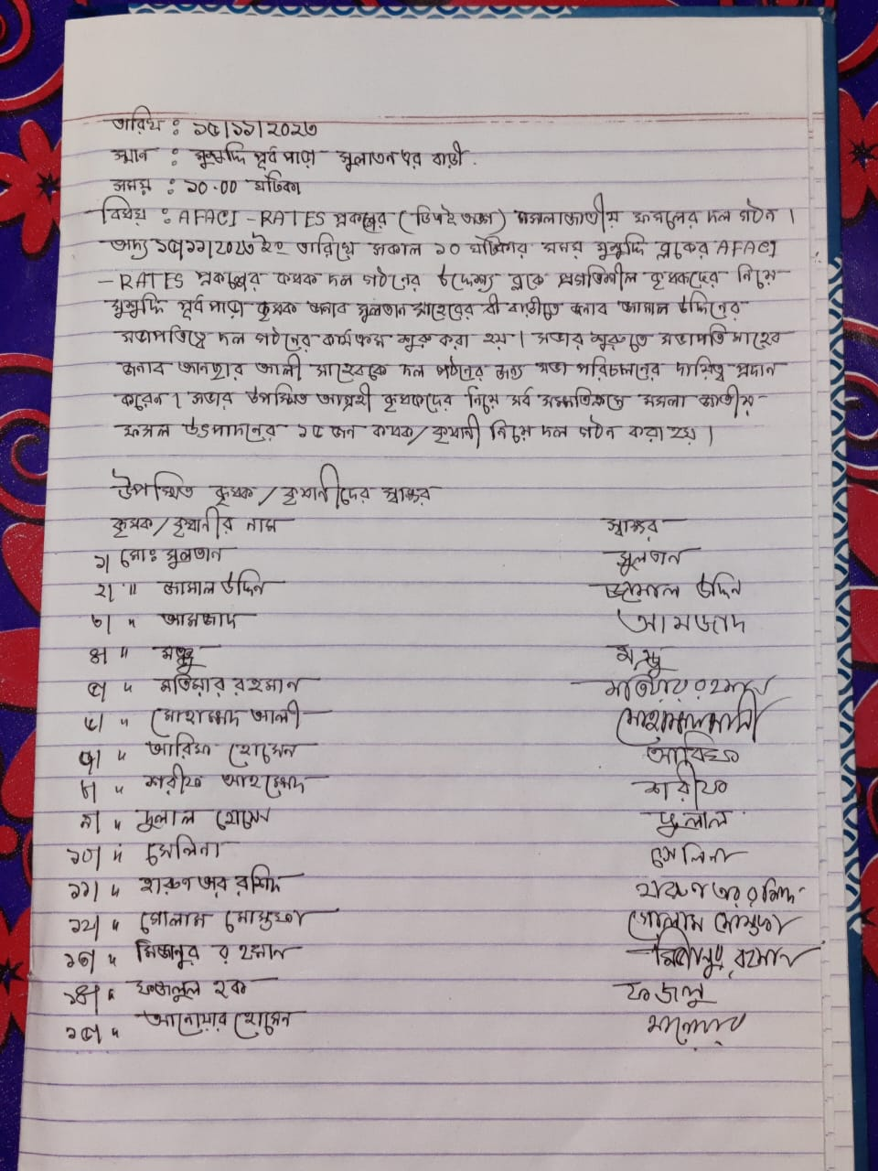
Field Day Photos (year 2):
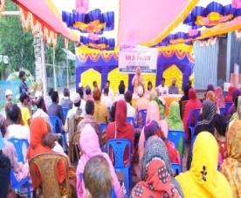 | 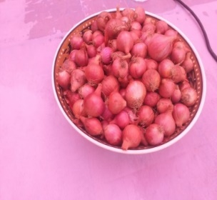 | 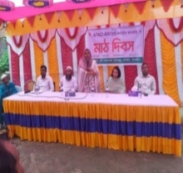 | 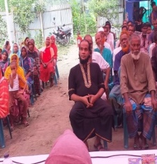
Fig-9: Field Day at Dhanbari & Ghatail Upazila Tangail on BARI Piaz-6 & Mustard

3.3 Results of Year 3:
3.3.1: Table-7: Analysis of Yield Gap
Crop | Variety | Average Yield (t/ha)
Crop | Variety | Res. Trial with Ext. Services | DAE Trial With Ext. Services | Yield Gap (Res. & Ext.)
Mustard | BARI Sharisha-18 | 2.4 | 1.82 | 0.58
Onion | BARI Piaz-6 | 14.79 | 10 (Bulb) | 4.79
Chili | BARI Morich-2 | 22 | 20 | 2
Turmeric | BARI Holud-4 | 16 | 12.7 | 3.3
Garlic | BAR Rosun-2 | 7.40 | 5.9 | 2.5
Table-7 indicates that more yields were observed at research trial and yield gap persist between research trial and extension trial. This result may be accounted by management practices (time of transplanting, irrigation, weed control, pesticide management, disease control etc,).
3.3.2: Results of Follow up demo plots in farmers’ field and Comparison of 2 Years yield: Table-8: Area: 0.33 (Acre)
Crop | Average Yield (t/hec) |  |  |  | % Yield Increase
Crop | Without Extension |  | With Extension
Crop | Y 2 | Y3 | Y2 | Y3 | Y2 | Y3
Mustard | 1.58 | 1.20 | 1.82 | 1.66 | 15.20 | 38.33
Onion (Bulb) | 7 | 12.87 | 10 | 13.57 | 42.86 | 5.44
Garlic | 4.80 | 8.70 | 5.90 | 9.50 | 18.64 | 9.20
Turmeric | 11.9 | 14.8 | 12.7 | 17.5 | 6.72 | 18.24
Chilli | 20.0 | - | 20.0 | - | 17.65 | -
The results indicate that crop yield increased with the use of extension services compared to farmers’ conventional practices in Year 2, consistent with the findings from Year 1
3.3.3 Establishment of Quality Seed production demo plots (4 demo plots):
Mustard, Chilli, Garlic and Turmeric demo plots for quality seed production was established in two upazilas having the plot size 0.33 acre during November 2024 to February 2025. The seed producing farmers are supervised by the researcher.
Table-9: Seed production results of 3 crops:
Crop | Variety | Sowing/ planting date | Harvesting Date | Yield  (t ha⁻¹) | Farmers’ opinion
Mustard | BARI Sarisha-18 | 07 Nov. 2024 | 13 February 2025 | Seed:2.34  Straw: 3.64 | Gave satisfactory yield. Boro rice can be grown easily, if mustard seed sown in optimum time.
Onion | BARI Peaz-6 | 04 December 2024 | 10 March 2025 | Bulb yield: 12.40 | Profitable cash crop. Will be cultivated in the next year.
Garlic | BARI Rashun-2 | 06 December 2024 | 7 April, 2025 | Clove yield: 6.86 | Profitable cash crop. All cloves will be stored for cultivation in more area in the next year.
The demonstration plots for quality seed production of mustard and spice crops were successfully established in selected locations. Farmers actively participated in all stages of production, from land preparation to harvesting. The performance of newly introduced crop varieties was found to be superior in terms of yield potential, disease resistance, and adaptability to local conditions compared to existing varieties.
On average, the mustard demonstration plots yielded 2.34 ton/ha of quality seed, similarly, onion and garlic demonstration plots produced 12.40 ton/ha and 6.86 ton/ha showing improved uniformity and market quality.
The demonstrations also served as a practical learning platform, where participating and neighboring farmers observed and adopted key practices for quality seed production, including proper seed selection, isolation distance maintenance, pest and disease management, and post-harvest seed processing and storage.
3.3. 4 Quality Seed production Training:
- Farmers enhanced their skills and experience in quality seed production of mustard and spice crops through two training batches (30 farmers’ per batch). The training included demonstrations on the performance of new crop varieties and key techniques for quality seed production.
- This training contributed to farmers’ capacity building, increased awareness of quality seed standards, and promoted adoption of improved seed production techniques.
3.3.5 Report for adoption Study: In accordance with the decision made by the GFRAS Online meeting held on 22 October 2024, a technological adoption study was conducted in 3rd year in the project location.
This report presents findings from a study conducted in April–June 2025 to assess the adoption of 4 spices and mustard crop technology among smallholder farmers at Dhanbari and Ghatail Upazila in Tangail district. The aim was to evaluate the extent of adoption, key drivers, barriers, and early outcomes of using these variety and smart management practices for spices and oil seed farming.
Sample: 60 farmers (30 adopters, 30 non-adopters); Methods: Structured interviews, by questionnaire.
- Technological information on traditional spices crop cultivation
Table-10: Technology used for growing spices in the project location before implementation of the project
Topic | Present status
Name of spices crop | Onion and Chilli
Varieties used | Local
Average area of spices crops | 10-15 decimal
Land preparation | Land preparation is done with power tiller
Planting material | Bulb for onion and local seeds for chilli
Source of seeds/seedling | Local market
Yield of spices crop | 19-20 ton/ha
Storage facility for spices crop | No cold storage for spices crops only preserve at household level under room temperature

Table11: Problems faced by the farmers for growing traditional spices crops
Topic | Present status
Collection of seeds/seedling | High price of seeds/seedlings in the local market
Growing period at farmers field | Pest and disease severity particularly Thrips and Purple blotch disease
Harvesting of spices crops | Labour crisis during harvesting period
Storage facility | Bulb roting in traditional household storage
Market | Low price of the produce during harvesting period
Application of Apps | Not use Apps/Web portal/Smart phone

- Farmers response after intervention of the project activities
Farmers’ response on the adoption of spices and oil seed crops was evaluated through the analysis of surveyed data collected using structured questionnaire. The results are presented in Fig. 6 to Fig. 14.
- Knowledge gain on spices and oil seed crop production and sources of knowledge

Most of the farmers gained knowledge on the new varieties and modern production technologies of spices and oil seed crops with the assessment of 95.24% respondents. Only 4.76% respondents did not show clear understanding on improving knowledge. Extension service exhibited the most important learning source for the farmers with 61.90% response followed by research (19.05%). However, farmers also acquire their knowledge on spices crops from other sources such as dealer, farmers and internet as indicated by the response of 9.52, 4.76 and 4.76% respectively. Farmers’ engagement with training, field day, group discussion under extension and research system results in satisfactory knowledge gain by the spices and oil seed crop growers.
Fig: 7
Fig: 6

ii. Source of necessary inputs and information for growing spices and oil seed crop
Extension service department is the main pillar who assists the farmers for necessary inputs like seeds/ seedlings of different crops, fertilizers, pesticides, assist in credit facility and other mentioned by 66.67% response. Seed and fertilizer dealer in the community level showed a good source for the farmers for collecting different inputs as noted with 14.29% response. On-farm research also provided good quality inputs as stated by 9.52% respondents. According to response of 4.76% farmers, they collected inputs from neighboring farmers and online sources.
Fig: 8
iii. Supply chain of seeds/seedlings of latest HYV of spices and oil seed crop
Extension service and on-farm research is the dominant source for seeds and seedlings of the latest varieties of spices and and oil seed crops for the spices and oil seed crop growing farmers as indicated by more than 95% response. Farmers also collect seeds from Bangladesh Agricultural Development Corporation (BADC) as shown by 4.76% response. The on-farm
Fig: 9
research, extension service and BADC are considered the main pillar for supplying the planting materials of latest varieties of spices and oil seed crops.
iv. Farmers interest for growing new varieties of spices and oil seed crops
In the study the results indicate that high yield of crops is the main option for farmers to cultivate spices and oil seed crop. In addition, 9.52% respondents claim less time and quality seeds of new varieties also make them interested for growing spices and oil seed crops.
Fig: 10
However, low cost of production also one of their consideration for growing new varieties.
v. Farmers to Farmers sharing on new varieties and technologies
In the community level farmers are connected each other for their agriculture practices. The result of the study exhibited that most of the farmers shared different knowledge with their neighboring farmers prior to cultivate the new varieties and modern production technologies of spices and oil seed crops with the assessment of 95.24% respondents. Only 4.76% respondents did not have any discussion with their neighboring farmers. This result suggest that for the adoption of new varieties
Fig: 11
farmers group approach with their neighboring partners should give emphasize.
vi. Market source for spices and oil seed crops produce
Local market emerged as the most dominating market option for selling the produce of the community farmers as indicated by 71.43% response. Purchasing by the retailer is also an important option for the farmers as noted by 19.05% response. Presently there is little changing in marketing system specially for new produce. Retailers are directly connecting to the farmers for purchasing the produce at farm level. However, about 9.52% farmers also purchase the produce from the growers house.
Fig: 12
vii. Stakeholder engagement in marketing of the produce
The survey results showed that mostly farmers sell their produce with own initiative as understood by 42.86% response. Extension service also provide good market support for the farmers with the development of local entrepreneurs. However, retailer and local market support as demonstrated by 9.52% response each category
Fig: 13
help farmers with purchasing new produces of spices and oil seed crops.
viii. Recent market opportunity for spices and oil seed produce
Presently some new opportunity for marketing of new produce is visible in the community level. The results indicated that retailer access to farmers field, relatively higher market price, more consumer demand, good communication with roads and selling from the farmers house opened good scope for selling the farmers produce.
Fig: 14
3.3.6: Development and Use of Mobile app known as Khamari app
The integration of technological details with the existing mobile app (Khamari) is currently being carried out by BARC. It’s now available in the Google play store.
- The ‘Khamari’ mobile app (national platform) is designed as a crop production consulting tool to help farmers optimize fertilizer use, reduce input costs, and increase crop yields, thereby promoting sustainable agricultural productivity.
- Its eco-friendly approach enhances soil health, supports sustainability, and improves agricultural productivity.

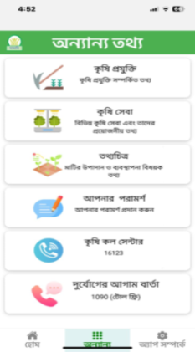
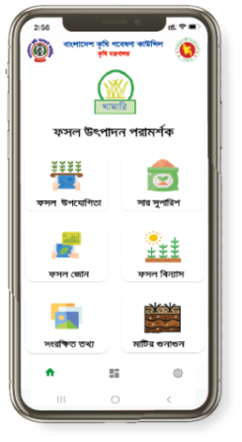

3.3.7: Market orientation and linkage establishment workshop
In accordance with the decision made in the GFRAS online meeting, one Market orientation and linkage establishment workshop was conducted by Local DAE Office.
A market linkage workshop was organized for different stakeholders under RATES Project on May 24, 2025 at the Upazila Parishad Conference Room, GhatailUpazila, Tangail District. This workshop was Chaired by Mohammad Ali Jinnah, Additional Director, DAE part of the AFACI-RATES project. Different layers of stakeholders from implementing two upazilas including farmers, dealers, NGO professional, private company field officers, Sub Assistant Agricultural Officers and as designated officers from BARC, BARI, and DAE attended the workshop.
However, after in brief discussion, the lists of recommendations/suggestions are short listed:

- Timely and accessible availability of newly released, research-based varietal seeds for spices, pulses, and oil crops should be ensured through enhanced coordination
- Market linkages by mapping crop-specific value chains, identifying viable markets, and facilitating multi-stakeholder platforms should be strengthen.
- Capacity building should be emphasized through targeted training for farmers, field extension personnel and market actors on value chain development, market literacy, and smart farming technologies.
- Integrate market analysis into seasonal crop planning to align production with demand, avoid gluts, and ensure better price realization for farmers.
- Institutionalize and strengthen project-formed farmer groups for sustainability by linking them with credit, input support, and market actors.
- Establish a follow-up and monitoring mechanism at the Upazila level to track progress, document lessons learned, and support continued stakeholder engagement.

3.3.8: Pathway of Stakeholder engagement for technological information flow on Spices and oil seed crops production, input supply chain and market linkage: A stakeholder network analysis

Progressive farmers achieved knowledge on new varieties and technologies from:  - Pesticide Dealer  - Seed Dealer  - SAAO  - SA  - N. Farmer  - Group meeting  - Relatives  - TV  - Internet  - Mobile Apps  - TTMU, BARC  - OFRD, BARI  - UAO  - AEO  - BADC  - SRC  - NGO  - Training  - Field Day  - Fertilizer Dealer | 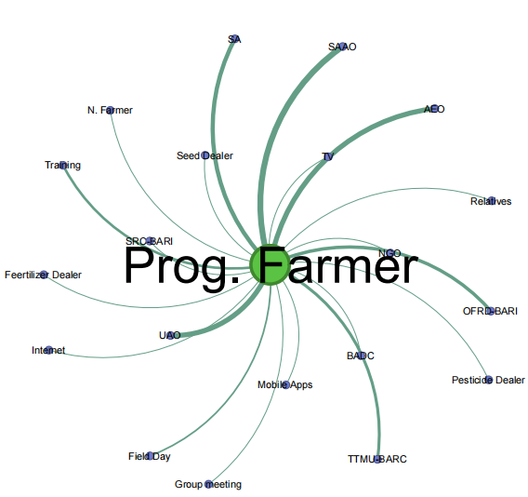  Progressive farmer centric stakeholder network:
Vector (Node) Tie (bonding)
Fig 15
The results of stakeholder network indicate:
- Strong bonding (indicating thick line in network graph) has been made among Research (TTMU-BARC, OFRD-BARI, SA), Extension (FSW-DAE, UAO, AEO, SAAO) and Progressive Farmer for all necessary information flow on Production, input supply chain and market linkage of spices and oil seed crops.

- Main information delivery system has been developed through the connectivity of FSW-DAE, UAO, AEO and SAAO to Progressive Farmers back up by Research Organization (OFRD-BARI and TTMU-BARC).

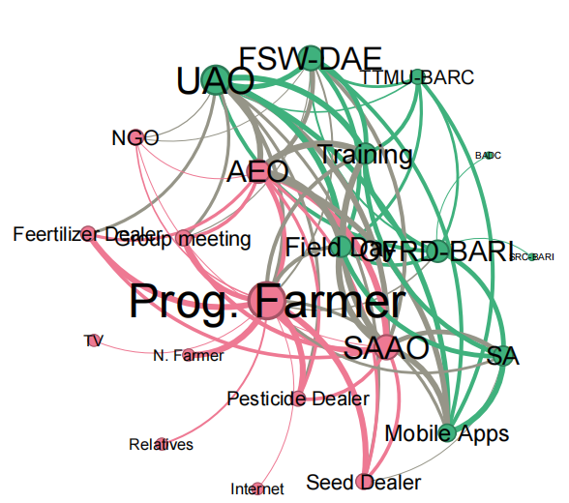

Photos of Year 3:
Fig 16

Activity Photos of Year 3:
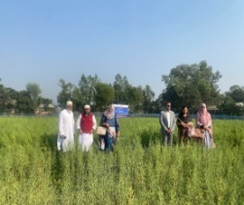 | 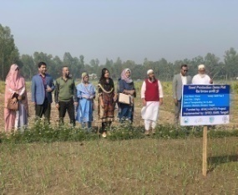 |  | 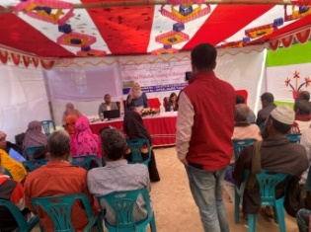 | 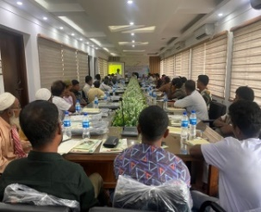
Seed Demo plot of Mustard and garlic |  |  | Seed Production Training programme on 13 Feb 2025 | Market Linkage Workshop held on 24 June 2025
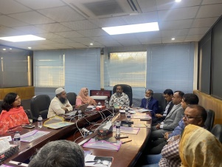 |  | 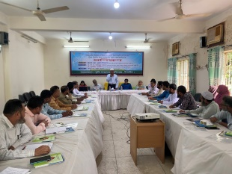 | 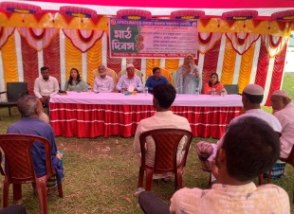 | 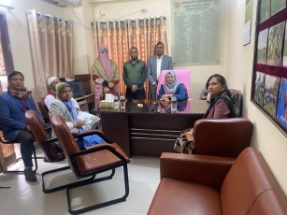
Progress Review meeting at BARI on 28 December 2024 |  | Ext. Personnel Training held on 19 October 2024 | Field Day on BARI sharisha-18 | Local OFRD Office visited

Report of the meeting with GFRAS/APIRAS team with PI/Co-PI of RATES project Funded by AFACI (02 February 2025)

Summary
The meeting focused on promoting new and improved varieties of spices and oilseed in Bangladesh to enhance their production and productivity. Discussions covered the project's objectives, work plan, methodology, and achievements, including the development of a mobile app and demonstration plots. Challenges and solutions were addressed, such as market-related training and collaboration with organizations to improve extension services and bridge the yield gap.
Progress Review
The project introduced new varieties of 4 spices and 1 oilseed and smart management techniques to enhance their production and productivity. The specific goals included closing the yield gap, improving extension services, and strengthening farmer knowledge through training and technology.
The third-year plan includes establishing quality seed production demo plots, developing a mobile app for spice and oilseed cultivation, and conducting farmer training programs. The improved scientific cultivation practices are currently integrated with the Khamari mobile app, which is an existing platform available on the Google Play Store, which Bangladeshi farmers are familiar with.
There exists a yield gap, as revealed from the data fromextension-managed plots (in comparison with research trials that gave higher yields). Identifying underlying causes for the yield gap and strengthening extension efforts could significantly improve crop productivity. The project’s key interventions include training programs for farmers and extension staff, developing technology extension manuals, and organising demo fields. A short video was also produced on the project. Challenges include limited availability of quality seeds and researchers’ low involvement in extension efforts due to several reasons.
Future plans include establishing seed production demo plots, integrating data with the mobile app and conducting surveys and farmer training.
Rasheed proposed a manual publication on spice seed production, but budget limitations constrain doing that. A compromise was suggested—incorporating training content into a manual or supplementing training with video documentaries.
The DAE team is focused mostly on production, but farmers need training on market aspects too. Plans include inviting and involving market experts, entrepreneurs, and wholesalers to strengthen value chain interventions.
Suraya agreed to share a video documentary on the BARC website and provide links to published manuals. Collaboration between DAE and BADC was suggested for future projects, with plans to invite top officials to the final workshop.
Next Steps
- Suraya to share a video documentary and published documents with Rasheed.
- Suraya to incorporate BADC in future project proposals and invite them to the exit workshop.
- Suraya to invite DAE top officials to the final project workshop.
- Suraya to develop a manual or video on quality seed production for spices.
- Suraya to include private sector expertise in market linkage training.
- DAE to involve seed businessmen, entrepreneurs, and market specialists in market training.
- Project team to analyse lessons from the DAE-BARI collaboration.

4. Project achievements:
- A baseline study of the current extension system was conducted, and the existing situation and gaps were identified.
Results of Baseline Study:
Agricultural extension system in Bangladesh has a long history of evolution which has taken different shapes over time. There is a well organizational set up of agricultural extension system composed of large number of expert personnel and financial resources. While DAE’s reach is notable, systemic challenges such as inadequate staff, limited training, gender gaps, and weak integration of ICT hinder effective service delivery. Farmers express a clear demand for practical, localized, and timely information of technologies, indicating the need for capacity enhancement at both institutional and field levels.
It needs to increase budget allocation for extension services and infrastructure at field levels as well as Strengthen Capacity Building of extension staff, especially in ICT, climate-smart practices, and participatory training methods. Promote Public-Private Partnerships (PPPs) to leverage private sector expertise and reach. Enhancement of Research-Extension-Farmer-Market linkages to ensure field relevance of technologies promoted is crucial. It’s necessary to introduce Gender-Inclusive Approachesto ensure women farmers are equally reached and served. Develop Monitoring & Evaluation Systems for continuous performance assessment needs to be developed.
Development of Mobile app as digital tools
In accordance with the decision made during the GFRAS online meeting held on 22 October 2024, technological information related to the RATES project has been integrated into the existing mobile application, ‘Khamari App’. This app is being nationally promoted by the Ministry of Agriculture as a digital tool for technology dissemination.
List of Publications:
Sl. No. | Title
Manuals/Books
1 | A Manual on Varietal Identification and Production Technologies of BARI Sarisha-18
2 | A Manual on Onion Bulb and Seed Production Technologies of BARI Piaz-6
3 | A Manual on Turmeric Rhizome and Seed Production Technologies of BARI Halud-4
4 | A Manual on Garlic Bulb and Production Technologies of BARI Roshun-2
5 | A Manual on Varietal Identification and ProductionTechnologies of BARI Morich-2
6 | Introduction of Spices and Oil seeds crop Varieties and their Production Technologies
7 | Farmers Training Manual on Quality Seed Production of BARI Generated Spices and Oil seed Crops
2 Leaflets:
8 | Khamari Mobile App User manual
9 | Value Chain and Market Linkage of Agricultural Products
Video Documentary
10 | Video documentary On RATES Project uploaded in BARC website
- Press Media | Published RATES project activity in the in Daily newspaper

Training information:
Date | Topic/Title | Target | No. of held | No. of Participants
12.02.25  24.06.25 | Training on Seed Production Technologies and Khamari App | Farmers | 4 | 30
30.01.24  24.03.24 | Field selection, preparation and planting | Farmers | 6 | 30
21.03.24 and 01.07.24 | Training on intercultural operation and pest and disease management | Farmers | 6 | 30
19.10.24 | Training on Production Technologies of Mustard, Spices crop and Khamari app | SAAOs’ (Ext. personnels) | 1 | 30
20.5.24  23.10.24  10.07.24  19.10.24 | Field day on onion, Chilli, Mustard and Turmeric | Farmers, Ext. pesonnels, NGO, private sector, seed dealer, local ledaer etc. | 4 | 100
24.06.2025 | Market linkage Workshop 06/06/2024 | Farmers, Ext. personnel, NGO’s, Seed dealer etc. | 1 | 56
17.07.2023 | Focus group Discussion | Farmers | 02 | 15

- BARI generated high yielding oil seed and spices crop technologies i.e. BARI Sharisha-18, BARI Piaz-6, BARI Rosun-2, BARI Morich-2, BARI Holud-4 (Variety and Management practice) were disseminated.
- Extension personnel/Farmers knowledge and skills are developed through
training.
- The reason behind the yield gap between research field and farmers field were identified.
- Research-Extension-Farmers linkage was developed through involvement of researcher and extension worker in the project activities.
- 7 Manuals and 2 leaflets on spices and oil seed crops were published and shared with farmers.
- Two newsletter on AFACI-RATES project activities were published in the Daily Newspaper
- A video documentary on RATES Project were prepared and uploaded in BARC website.
- Khamari app developed with integration of all technological documents of RATES project.
- Technology adoption study was conducted in the project location.
※ Quantitative goals (specimen)
Quantitative Goals (Year-2):
Indicators | 1st year  (Dec. 2022-Nov. 2023) |  |  |  | 2nd year  (Dec. 2023-Nov. 2024) |  |  |  | 3rd Year (Dec. 2024-Nov. 2025)
Indicators | Plan  (A) |  | Output  (B) | Rate  (%) | Plan  (A) | Output  (B) | Rate  (%) |  | Plan  (A) | Output  (B) |  | Rate  (%)
General Activities
- Analyses of current state of infrastructure in rural extension system | 1 |  | 1 | 100
- Establishment of action plan for rural extension | 1 |  | 1 | 100
- Education and training for capacity building related to rural extension |  |  |  |  | 4 | 4 | 100 |  | 2 | 2 |  | 100
- Establishment of technology extension manual related to AFACI projects |  |  |  |  | 3 | 3 | 100 |  | 2 | 2 |  | 100
- Development of technology extension manual (General) |  |  |  |  | 1 | 1 | 100
- Development of Technology Extension Leaflet |  |  |  |  |  |  |  |  | 2 | 2 |  | 100
- Development of Technology Extension Video documentary |  |  |  |  | 1 | 1 | 100
Activities for the 1^{st Year}
- Survey and analysis of existing agricultural system for technology dissemination | 1 | 1 |  | 100
- Orientation on Korean Agricultural Extension System through the Workshop in Korea | 1 | 1 |  | 100
- Sharing of Project activities among the stakeholder and seeking valuable suggestions for the improvement of project action plan through Inception Workshop | 1 | 1 |  | 100
- Setting up improvement strategies for existing extension system and action plan | 1 | 1 |  | 100
- Selection of project site through field visit and sharing with relevant stakeholder | 2 | 2 |  | 100
- Selection of Spices and Oil seeds crops for demo | 5 | 5 |  | 100
- Attaining baseline information through survey with prescribed questionnaire, focus group discussion and secondary sources | 1 | 1 |  | 100
Activities for 2nd Year
- No. of farmers group formed (30) |  |  |  |  | 5 | 5 |  | 100
- No. of Demo fields organized in research field |  |  |  |  | 22 | 16 |  | 72.73 | 3 | 3 | 100
- No. of Demo fields organized in farmers field with extension services |  |  |  |  | 25 | 20 |  | 80 | 05 | 05 | 100
- No. of Demo fields organized in farmers field without extension services |  |  |  |  | 25 | 20 |  | 80 | 05 | 05 | 100
- No. of Training Organized for farmers |  |  |  |  | 6 | 4 |  | 80 | 02 | 02 | 100
- No. of farmers gathered knowledge and skill on modern cultivation techniques of Spices & oil seed crop |  |  |  |  | 180 | 120 |  | 66.66 | 60 | 60 | 100
- No. of Training Organized for extension personnel (SAAO) |  |  |  |  | 1 | 1 |  | 100
- No. of Field Day organized |  |  |  |  | 5 | 2 |  | 40 | 3 | 2 | 100
- No. of farmers attended in Field Day |  |  |  |  | 250 | 200 |  | 80 | 300 | 300
- No. of meeting organized for Extension personnel |  |  |  |  | 15 | 10 |  | 66.66 | 05 | 05 | 100
- No. of Group meeting organized for farmers |  |  |  |  | 120 | 70 |  | 58.33 | 40 | 40 | 100
- No. of Stakeholders received the extension manual |  |  |  |  | 200 | 80 |  | 40 | 120 | 120 | 100
- Preparation of RATES project related video documentary |  |  |  |  | 1 | 1 |  | 100
Activities for 3rd Year
- Seed production demo plots for 4 crops will be established in the respective farmers field |  |  |  |  |  |  |  |  | 4 | 4 | 100
- Establishment of Follow up Demo plots in Farmers Field |  |  |  |  |  |  |  |  | 5 | 5 | 100
- Integration the information with the Existing Mobile App as technology hub |  |  |  |  |  |  |  |  | 1 | 1 | 100
- 2 batch farmers training for quality seed production will be organized |  |  |  |  |  |  |  |  | 2 | 2 | 100
- Survey and analysis of adoption rate of disseminated new technologies of oil seeds and spices crop in the project location |  |  |  |  |  |  |  |  | 1 | 1 | 100
- One Market orientation and linkage establishment training cum workshop will be conducted at Upazila level. |  |  |  |  |  |  |  |  | 1 | 1 | 100
 |  |  |  |  |  |  |  |  | 4 | 5 | 125
  - Publication of 3 Training manuals and Leaflet for using the mobile app will be documented
- 1 Exit plan meeting/workshop with Res./Ext personnel will be organized |  |  |  |  |  |  |  |  | 1 | - | Will be organized
4-1 Achievement evidence:
  - 7 manuals (6 formal books and 1 is photocopy): Uploaded in BARC & DAE website
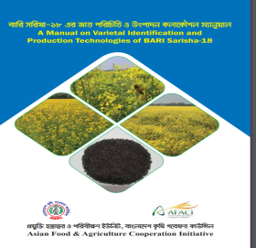 |  | 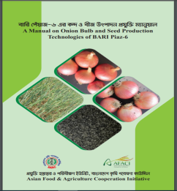 |  | 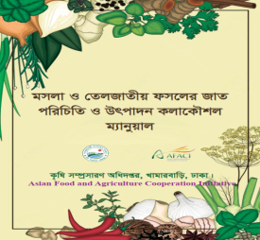 | 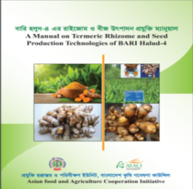
 |  |  |  | 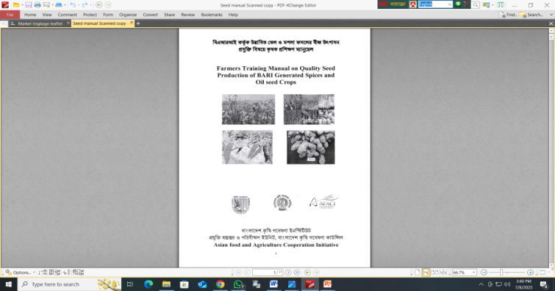
  - 2 leaflets (1 Market linkage and Value chain, 1 Khamari app user direction) and 1 video documentary
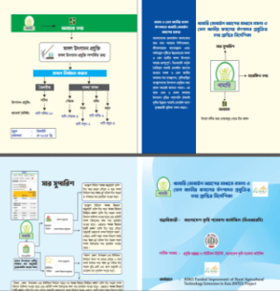 |  | 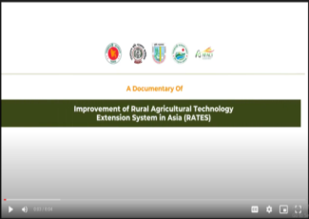  Link: https://youtu.be/B6TpjRDLwfk

  - Development of Khamari Mobile App: Now available at Google Play Store:
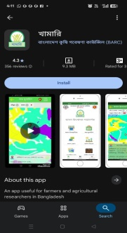
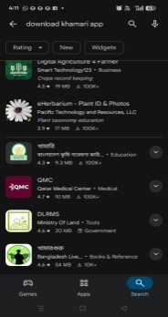

- Conclusion
- The knowledge, skills of extension personnel and farmers improved through the promotion of modern agricultural practices and targeted training initiatives.
- Farmers will adopt the modern seed production and preservation technologies of mustard and spices crop which ultimately will contribute to the increase production and productivity of these crops.
- The yield of BARI generated varieties of 4 spices and 1 oil seed crops were increased with the extension services.
- Fertilizer management, optimum time of sowing, availability of seeds and training were the most important factors for minimizing the yield gap between Researcher Managed Trial (RMT) and Extension Managed Trial EMT.
- From the adoption study, it can be concluded that mostly farmers sell their produce with own initiative (42.86%). Extension service supported by 38.10% and rest by the retailer and local market supported.
- Research and extension linkage was strengthened through joint extension programme, monitoring, training by the coordination of BARC using the support of RATES project.

- Future plan and Recommendations
- If the project period is extended, the project is supposed to be expanded to additional regions based on lessons learned and proven best practices of technologies and updated Research-Extension-Farmers approaches.
- Enhance the use of digital tools such as Khamari mobile apps to ensure timely and inclusive dissemination of information among the Extension agent and farmers.
- Provide ongoing training to extension workers, local leaders, and farmer groups to maintain and update their skills with evolving technologies.
- Joint approach of technology transfer system as implemented by this project, could be adopted in the current extension system.
- Major changes in AFACI project-related
Year 1: Yield gap between Research field and farmers’ field is a national concerning issue. So, for the estimation of Yield Gap a separate trial has been included the project activities aiming to identify the main reason behind the yield gap. For this reason, this objective is incorporated “To study the causes of yield gap between farmers’ field and research field’’
Year 2: 3rd year activity plan was revised. Technology adoption study, quality seed production demo plots, training on quality seeds, use of digital tools for technology transfer were planned.
Year 3: Activity was performed as work plan. Khamari app was developed as digital tools, market linkages workshop were conducted

7-1: Challenges and Suggestions
Challenges | Suggestions
Weak linkages between research and extension. | Future efforts should prioritize undertaking joint programs and projects on Technology generation and dissemination in collaboration with BARC.
Lack of capacity building programme on recent technologies under climate change vulnerable environment. | Research and extension institutes should integrate additional capacity-building activities for extension personnel on newly developed varieties and technologies into their regular programs.
- There is a shortage of high-quality oilseed and spices crop seeds, Seeds often do not reach farmers on time, leading to delays in planting and negatively impacting crop production cycles. | Farmers may cultivate and store their own seeds, while cooperatives can be established to streamline seed distribution. Progressive farmers could act as central hubs for seed collection, preservation and dissemination.
- Lack of joint monitoring and evaluation of field level extension programme. | Joint monitoring and evaluation plan will be established with researcher, extension personnel and market actors.

