Memorandum of Understanding Signed Between Bangladesh Accreditation Board (BAB), Ministry of Industry and U.S. Department of Agriculture-Funded Bangladesh Trade Facilitation Project (BTFP)
Dhaka, May 4, 2025 (21 Boishakh 1432)
A Memorandum of Understanding (MoU) was signed between the Bangladesh Accreditation Board (BAB), the Ministry of Industries and the Bangladesh Trade Facilitation (BTF) Project, funded by the U.S. Department of Agriculture. Mr. Md Obaidur Rahman, Honorable Secretary of the Ministry of Industry was present in the signing ceremony as the chief guest. While Mr. Michael J. Parr, Director of the Bangladesh Trade Facilitation (BTF) Project was present as the special guest. The event was chaired by Mr. Md. Anwarul Alam, Director General (Additional Secretary) of BAB. Senior officials from the Ministry of Industry, BAB, and BTFP were also present.
Mr. Md. Anwarul Alam, Director General (Additional Secretary) and Mr. Michael J. Parr, Project Director of BTF, signed the MoU on behalf of their respective organizations.
The chief guest stated that despite Bangladesh’s vast agrarian prospects, technical barriers have hindered the desired success in this sector. He emphasized the need for collaborative efforts among relevant ministries, departments, and stakeholders to expand the export market for domestically produced food and agricultural goods. He expressed optimism that this MoU would enhance Bangladesh’s long-term competitiveness in international trade by ensuring the quality of food and agricultural products.
Mr. Md. Anwarul Alam highlighted that accreditation is globally recognized as a vital mechanism to address technical barriers in international markets. BAB is committed to expanding exports of locally produced food and agricultural goods. He noted that BAB has already signed Mutual Recognition Arrangements (MRAs) with the Asia Pacific Accreditation Cooperation (APAC) and the International Laboratory Accreditation Cooperation (ILAC). This ensures acceptance of test reports from BAB-accredited organizations across the world. He also added that this MoU would strengthen BAB’s capacity to implement new accreditation schemes aligned with export market demands.
Mr. Michael J. Parr stated that a key objective of BTF is to build trust among domestic and international buyers and consumers by enhancing the technical capabilities of quality assurance organizations operating in the country. He expressed confidence that the project would achieve this goal, fostering greater confidence in Bangladeshi food and agricultural products.
The program concluded with a shared commitment to advancing Bangladesh’s trade facilitation and quality assurance frameworks through sustained collaboration.

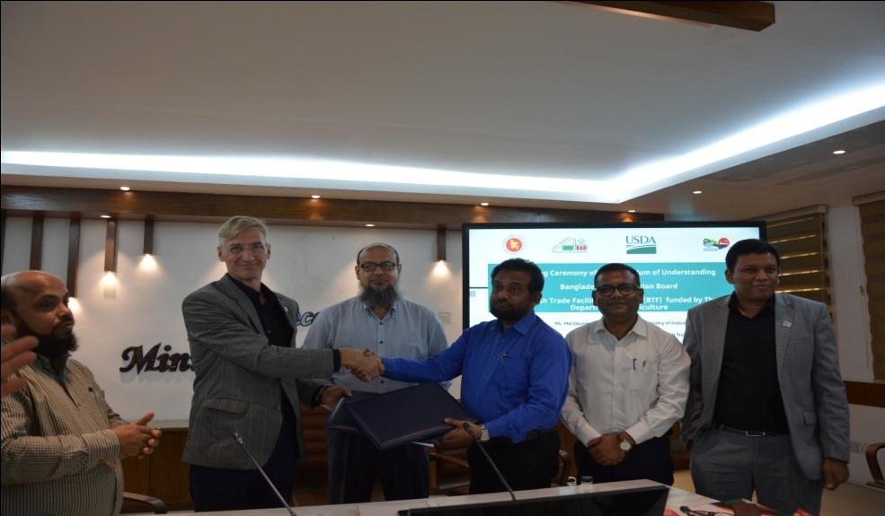

Photo: The Honorable Secretary of the Ministry of Industries, Mr. Md Obaidur Rahman, along with the Director General (Additional Secretary) of BAB, Mr. Md. Anwarul Alam; Project Director of BTF, Mr. Michael J. Parr; Additional Secretary (Administration) of the Ministry of Industries, Mr. Md. Nuruzzaman ndc; and senior officials from the Ministry of Industries, BAB, and BTF in the program.

