Report for Seminar on Skills and Technical Education for Economic Transformation of Bangladesh by 2041
Introduction
The seminar on “Skills and Technical Education for Economic Transformation of Bangladesh by 2041” was organized by the Accelerating and Strengthening Skills for Economic Transformation (ASSET) project, which is implemented by the Directorate of Technical Education, Technical and Madrasah Education Division, Ministry of Education with the financial support of the Government of Bangladesh and the World Bank at Hotel Le Méridien, Dhaka on February 11, 2023. The seminar aimed to highlight the significance of technical and vocational education and skill development for the economic development of Bangladesh.
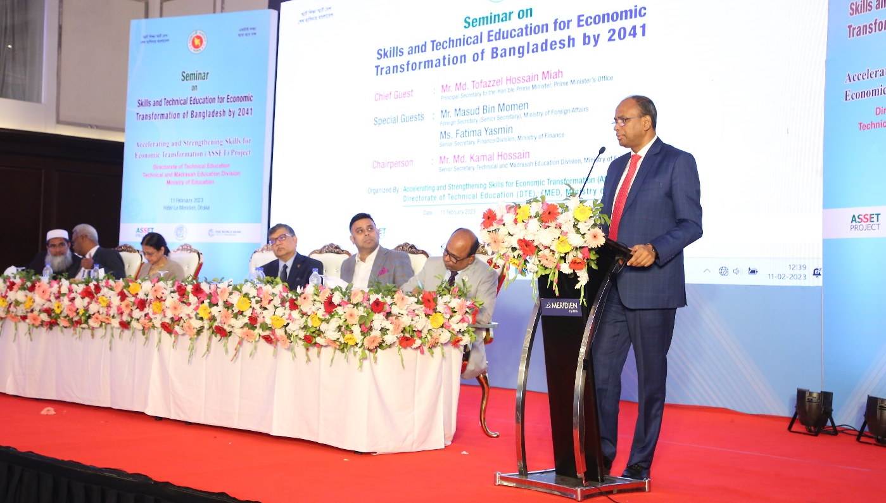
Mr. Md. Kamal Hossain, Senior Secretary, Technical and Madrasa Education Division, Ministry of Education presided over the seminar where Mr. Md. Tofazzel Hossain Miah, Principal Secretary to the Hon’ble Prime Minister was the Chief Guest. Foreign Secretary (Senior Secretary) Mr. Masud Bin Momen and Ms. Fatima Yasmin, Senior Secretary, Finance Division were the special guests. Dr. M. Masrur Reaz, Chairman, Policy Exchange presented the keynote paper in the seminar.
Figure 1: Mr. Md. Tofazzel Hossain Miah, Principal Secretary to the Hon’ble Prime Minister, the Chief Guest delivering his speech
Content
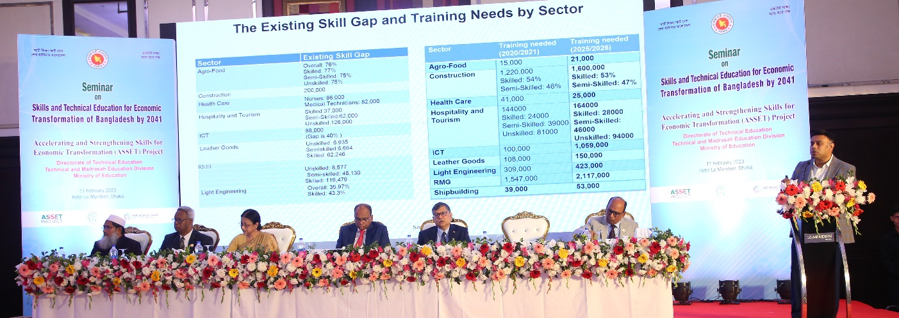
In the seminar, several senior secretaries of the government, secretaries, additional secretaries, and joint secretaries of various ministries, high-ranking officials, and heads of the diploma and higher technical education institutions participated. Dr. Md. Omar Faruque, Director-General (Additional Secretary), Directorate of Technical Education, welcomed the guests and highlighted the importance of technical education and skill development for the desired economic development of the country. He also mentioned that the current government has taken various initiatives for technical and vocational education and skill development, including the establishment of a separate technical and madrasa education division under the Ministry of Education, formulation of the National Skill Development Policy, and establishment of the National Skill Development Authority.
Figure 2: Dr. M. Masrur Reaz, Presenting keynote at the seminar.

In his keynote paper, Dr. M. Masrur Reaz, Chairman, Policy Exchange, presented various data and said that technical and vocational education and skill development are crucial to transforming the 2.2 million people joining the labor market every year into human resources to achieve the target of making Bangladesh an upper middle-income country by 2031 and a developed
Bangladesh by 2041. Economic diversification is required for export-oriented growth, and the development of value chains and creation of improved jobs and workplaces are necessary for diversification. He highlighted the importance of carrying out research studies and reskilling and upskilling to identify skill gaps.
Dr. M. Masrur Reaz suggested six policy recommendations for technical and vocational education and skill development. These are – raising standards in technical and skill development, formulating technical support policies, infrastructure development, enhancing public-private partnerships, ensuring demand-based technical and vocational education, and improving skill development.
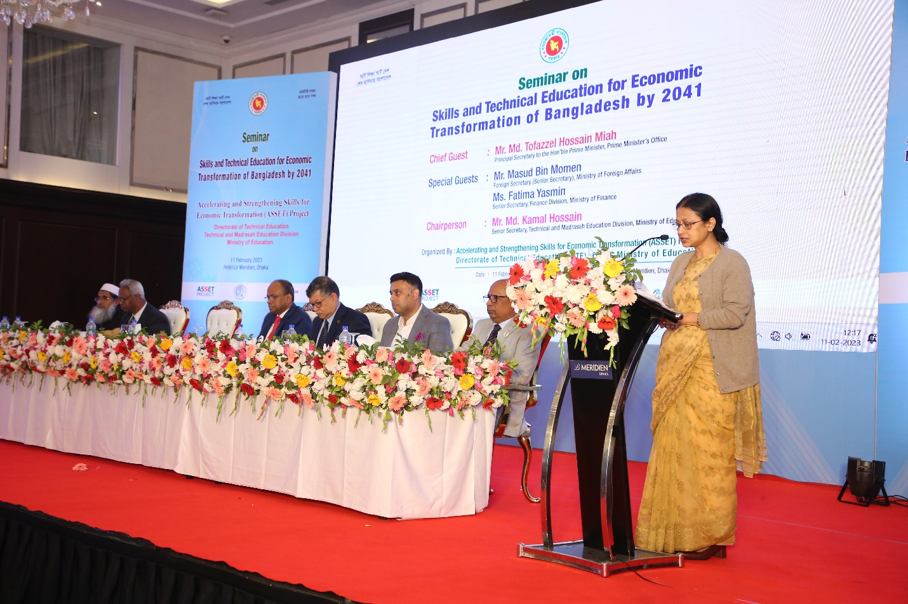
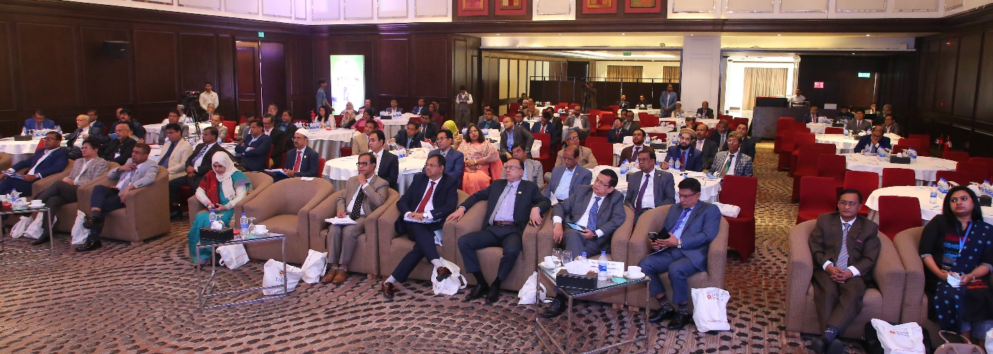
During the open discussion, NSDA Executive Chairman Nasreen Afroz, Director-General of the Bureau of Manpower, Employment, and Training Md. Shahidul Alam, and Vice-Chairman of Export Promotion Bureau A.H.M. Ahsan emphasized the inclusion of artificial intelligence in the curriculum for technical and vocational education and skill development. They also drew
Figure 3: Glimpse of the guests
Figure 4: The special guest of the seminar Ms. Fatima Yasmin, Senior Secretary, Finance Division delivering his speech
attention to the need for effective measures to implement the National Qualification Framework on Technical and Vocational education and the creation of freelancers with superior knowledge and skills.
The special guest of the seminar Ms. Fatima Yasmin, Senior Secretary, Finance Division said in her speech that by transforming the 2.2 million new youth entering the workforce every year into human resources through skill development, it will be possible to be transitioned to a developed Bangladesh by 2041. Special Guest Mr. Masud Bin Momen, Senior Secretary, Ministry of Foreign Affairs in his speech emphasized on skill based education to eliminate skills mismatch in the labor market. He said research is needed to determine the exact demand in the labor market and a demand-supply databank needs to be created. He opined that massive publicity and campaigning is needed to increase social acceptance and eradicate ignorance on technical and vocational education and skill development.
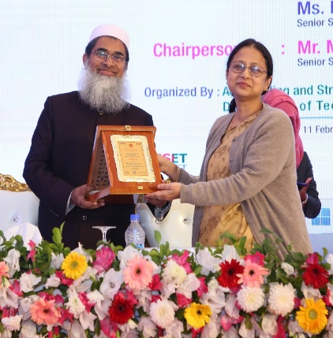 | 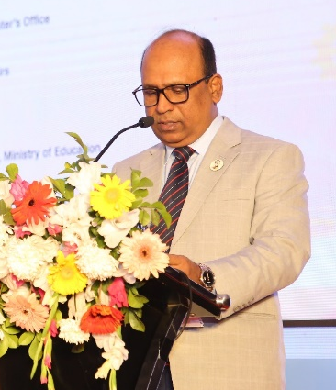 | 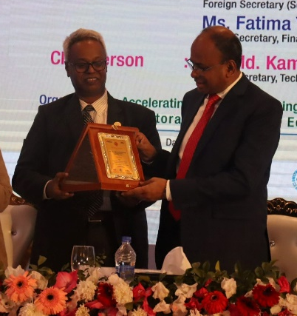
The Chief Guest of the program, Principal Secretary to the Hon'ble Prime Minister Md. Tofazzel Hossain Miah said in his speech, there is no alternative to overall development of technical education in the light of the economic transformation of Bangladesh by 2041 in line with the real needs in the labor market of the country and abroad. Noting that currently 23 ministries and 29 divisions/ directorates /departments are working on skill development in the country, he emphasized on coordination among them. he expressed hope that, this slogan 'if people's job opportunity increases by skill development, salary and wages also do increase on a par with social status', is propagated in the society, the stigma of the society regarding technical and vocational education and skill development will be reduced. He expressed his opinion to give serious consideration to the proposed recommendations in the light of the main theme of the seminar. He emphasized that due importance is to be given to increasing social acceptance of technical education, upskilling and reskilling, composite development of the technical contents, increasing linkages with the industry, increasing communication skills of trained graduates in technical and vocational sector and other soft skills in order to ensure a sustainable position in the current competitive job market.

Objective
The objective of the seminar was to highlight the importance of technical and vocational education and skill development for the economic development of Bangladesh and suggest policy recommendations for technical and vocational education and skill development.
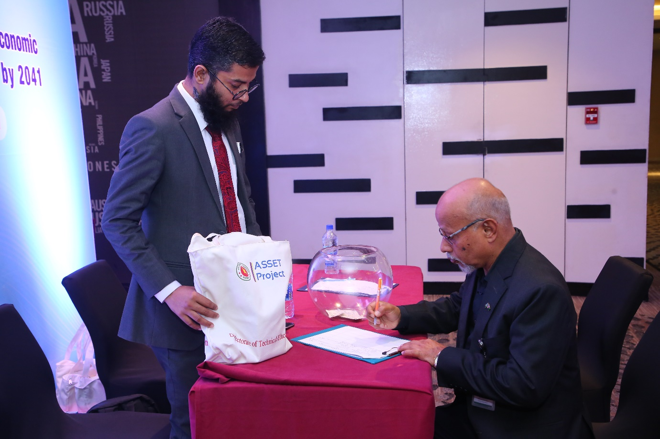
Figure 5: Guest getting registered.

Outcome
The seminar raised awareness among policymakers and stakeholders about the importance of technical and vocational education and skill development for the economic development of Bangladesh. The policy recommendations suggested by Dr. M. Masrur Reaz will guide policymakers in developing strategies and plans for technical and vocational education and skill development.
Recommendation
Based on the key points discussed in the Seminar, the following recommendations are suggested to increase the effectiveness of TVET in Bangladesh:
Increase female participation: Special initiatives should be taken to encourage more female participation in TVET. Gender biases and cultural barriers should be addressed and removed to promote female enrollment in TVET programs.
Eradicate social stigma/low acceptance: The social stigma associated with TVET needs to be addressed through awareness campaigns, highlighting the potential benefits of vocational education and training.
Modern technology incorporation: Incorporating modern technology into TVET programs should be prioritized to prepare the workforce for the 4th industrial revolution.
Comprehensive need assessment: A comprehensive need assessment based on the economic growth drivers should be conducted to reach the target for 2041.
Quality assurance: Quality assurance mechanisms should be established to ensure the quality of TVET programs and the competencies of graduates.
Public-Private Partnership (PPP): PPP should be encouraged to increase private sector participation in skill development.
Widening partnership: Partnership between employers, workers, and the government should be widened to ensure the relevance of TVET programs to the needs of the labor market.
Expanding access: Access to TVET programs should be expanded, particularly for women, to achieve the goal of 40% of the workforce being skilled by 2035.
Making TVET demand-led: TVET programs should be designed based on demand-led curriculum to bridge the skills gap in the labor market.

Conclusion
In conclusion, the seminar on "Skills and Technical Education for Economic Transformation of Bangladesh by 2041" was a successful event that brought together senior officials, policymakers, and experts to discuss the critical role of technical and vocational education and skill development in achieving Bangladesh's vision for economic transformation by 2041. The keynote paper presented by Dr. M. Masrur Reaz highlighted the need for economic diversification, reskilling, and upskilling to identify skill gaps, and public-private partnerships to ensure demand-based technical and vocational education and improve skill development. The open discussion provided valuable insights and recommendations from experts and policymakers, emphasizing the importance of curriculum development, infrastructure development, and effective implementation of the National Qualification Framework on Technical and Vocational education. It is hoped that the recommendations made in the seminar will be implemented effectively to ensure the desired economic transformation of Bangladesh by 2041.
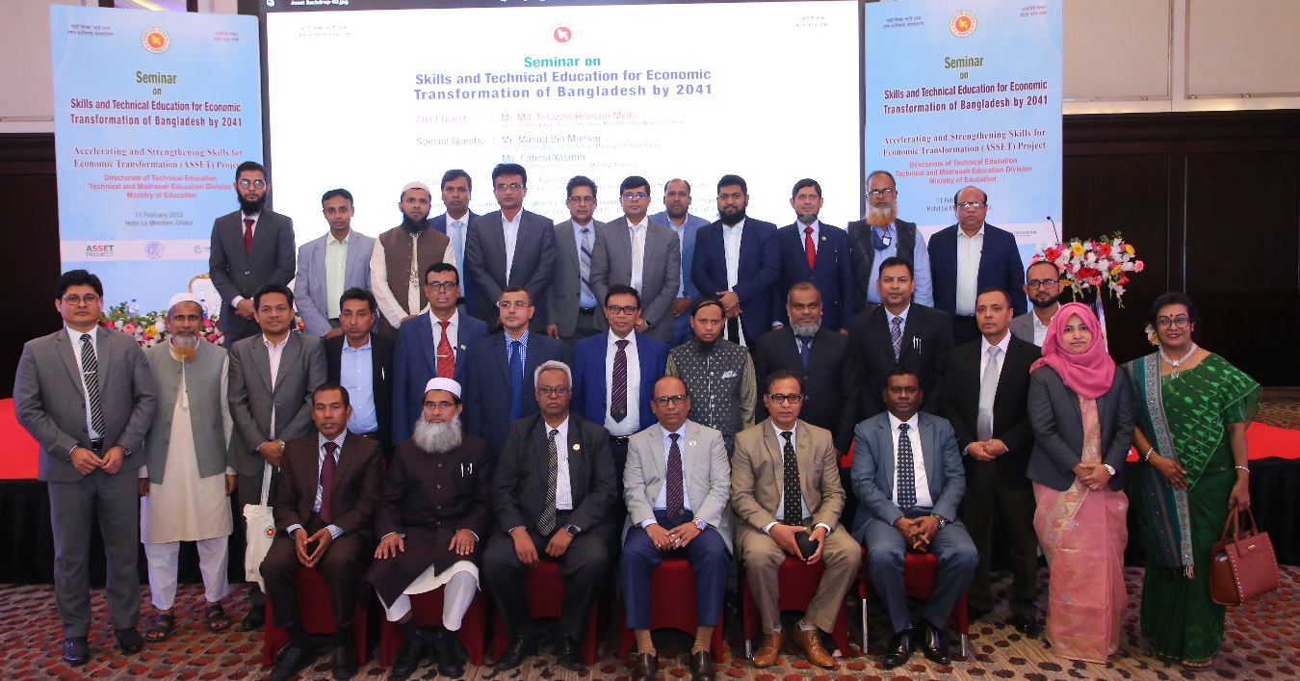
Figure 6: Group photo of part of the Guests
Annexures
1: Guest List
2: Keynote Paper
3: Budget

