The Japanese Language Proficiency Course (JLPT – N5) for interested and eligible female VDP members is going to commence soon. The online registration process through TRPMS (Training Preference Management System) is now ready and operational.
Interested participants will be able to complete registration through the mobile application available on the Google Play Store. Therefore, you are requested to make wide-scale announcements and motivate eligible female VDP members in your respective areas to register through the app within the stipulated timeframe.
The registration list and applicant information will be available in TRGMS under AVSSO (avsso.ansarvdp.gov.bd) for monitoring, verification, and trainee selection purposes.
Kindly follow the attached diagrams and workflow guidelines carefully to ensure effective scrutiny, transparent selection, and quality trainee management. Priority should be given to genuinely interested, disciplined, and eligible candidates who demonstrate commitment toward overseas employment and language learning opportunities.
Your proactive coordination and supervision in this regard are highly expected for successful implementation of the program.
For any query please contact @~Director Proj-Trg
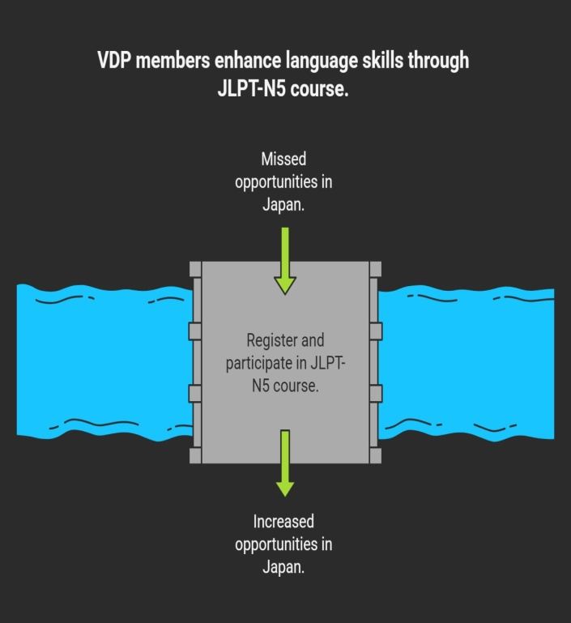 | 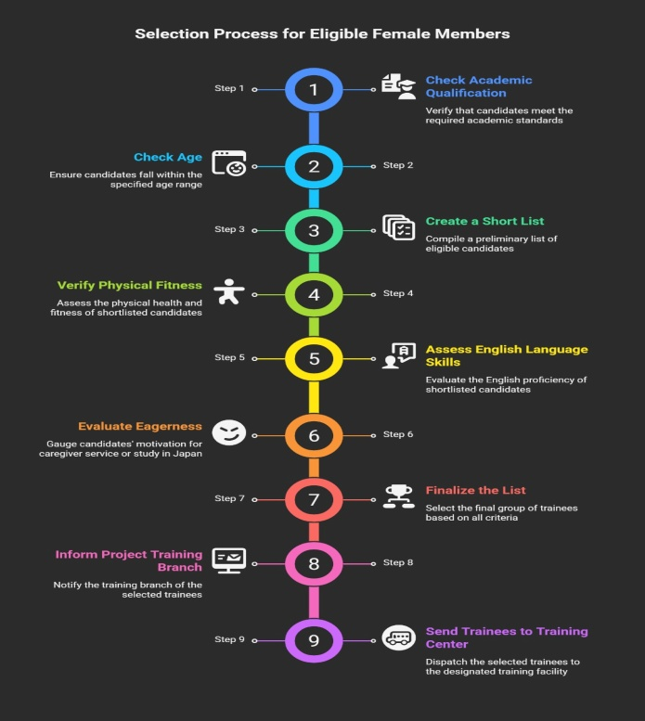
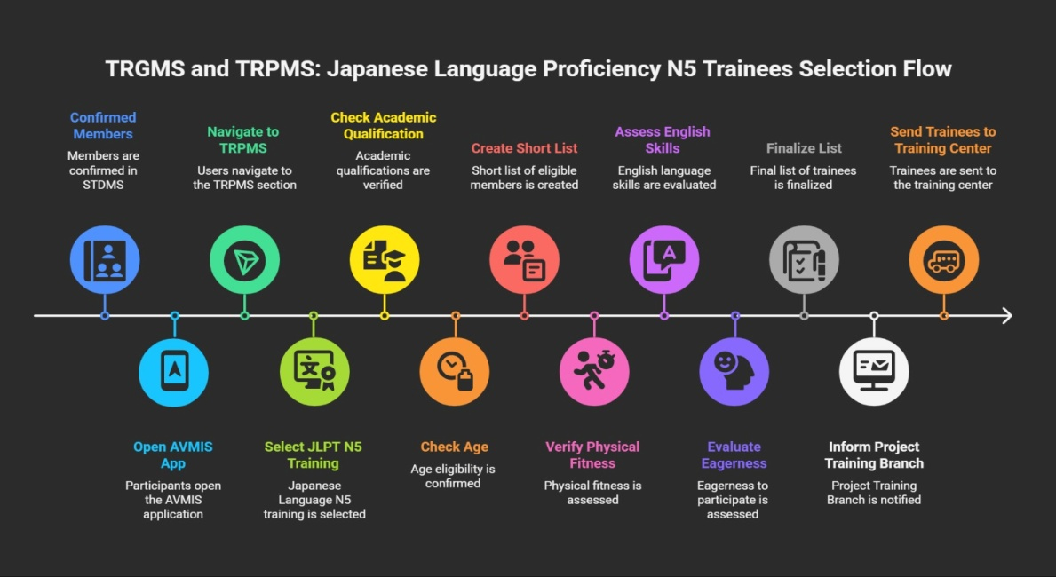 | 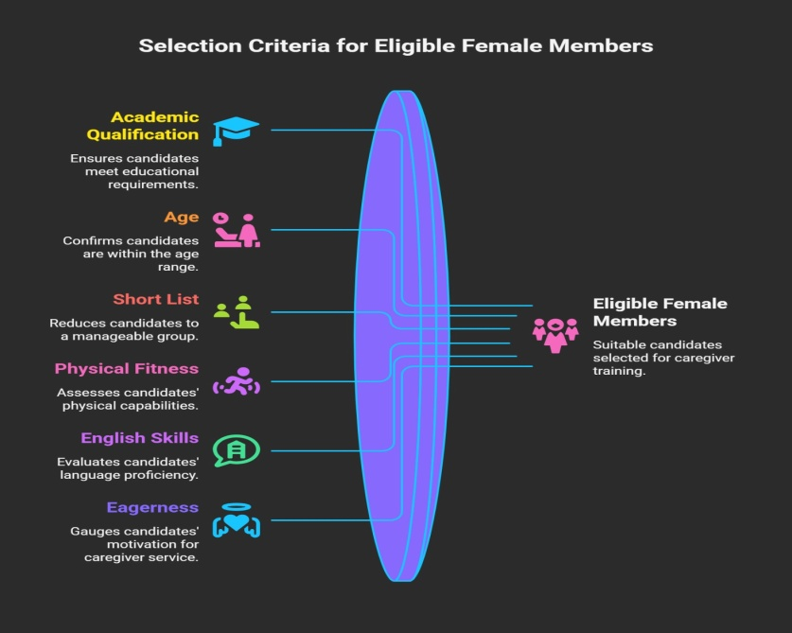
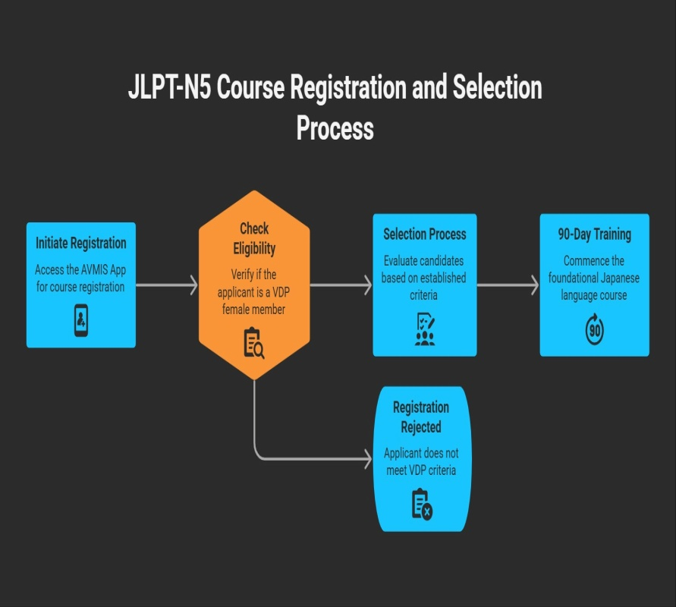 | 